Anti-Repost Tool for Cosplay Photos
core-backup (business; creating and restoring backups, locations, automatic backups, emergency kit)
Edition 1 (Draft) 2026-09-29 · Ishikawa Sou
Nagareyama Software Development Co., Ltd. (NRSD)
© 2026 Nagareyama Software Development Co., Ltd. (NRSD), Lead Developer: Ishikawa Sou (石川宗). Copyright in this document belongs to Nagareyama Software Development Co., Ltd. (NRSD). Rights in the third-party standards, software, commentaries on laws, and other materials referred to in this document belong to their respective holders. This is a translation of the Japanese original; where they differ, the Japanese original prevails.
Contents
Sections taken
Dependencies
Class diagram
Bridges (operations owned by this block)
Algorithms (behind traits)
Data design

Sections taken
- Chapter 2, 7.3 Multiple devices
- Chapter 8: 5.1 Format, 5.2 How to create, 5.3 How to restore (import), 5.5 Backup locations and automatic backups, 5.6 Guidance on where to keep backups, 8 Handling of failures
- Read-only: the “included in backups” column of Chapter 8, 2.1 “Arrangement” (what goes in), the reconciliation of 5.4 (merging is by core-work's Merge and core-store's Chain).

Dependencies
- Below: core-common (Qr, AppUrl::Recovery, Clock, error numbers), core-store (Chain (reconciliation and verification), AtomicFile, ZIP checks, Space, Settings (the recovery key's public key, the date/time of the last backup, locations), Retention::sweep_assets), core-hash (SHA-256), core-identity (current, export_keys / import_keys, os_user_verify), core-render (the emergency kit's PDF/A-2u + PDF/UA-1), core-work (Merge::merge_remote (merging templates and work sessions), Templates::assets_gc_candidates), core-sign (Works: estimating the Original diff).
- Above: app-client (G-05, G-07 Home's “Last backup”, G-20 Settings, run_due at start, on close). The location of Device is wired by app-client from core-sync's backup_folder (this block does not depend on core-sync).
- Outside: detection of the OS's removable media and the default locations of Cloud sync folders (Chapter 8, 5.5; this block calls the OS APIs directly).

Class diagram
- BackupFile
  - +Path path backup-<YYYYMMDD-HHMMSS>-<seq>.nrsdbak
  - +Manifest manifest
- Manifest
  - +String schema nrsd.backup/1
  - +Rfc3339 created_at
  - +Version app_version
  - +Map<String,u32> record_versions
  - +NoticeCode notice_code
  - +DeviceId device
  - +Kind kind Full | Diff
  - +Uuid chain_id
  - +u32 seq
  - +Option<Hash> parent_sha256
  - +[FileEntry] files path, size, sha256
- RecoveryKey
  - +AgePublicKey public a device-independent setting
  - +generate() (RecoveryKey, AgeSecretKey)
  - +regenerate()
- Writer
  - +create(dest, passphrase, kind, since) BackupFile steps 1 to 5 of 5.2. Sequential, temporary name
  - +verify_readback(file) Result
- Reader
  - +open(path, secret: Passphrase ｜ RecoveryKey) Opened scrypt limit of 2^22. If the manifest's record_versions or app_version is newer than its own, prompts to update and stops
  - +restore(path, secret, merge_policy) RestoreReport steps 1 to 7 of 5.3
  - +open_as_successor(path, recovery_key) ReadOnlySession
- MergePolicy（enumeration）
  - Fresh
  - SameRoot
  - ReplaceAfterBackup
  - Cancel
- Destinations
  - +detect() [Dest] Removable (GetDriveType / DiskArbitration / UDisks2) | CloudFolder (Dropbox's info.json, the OneDrive environment variable, Google Drive's name, iCloud's location) (first time), Device (after linking)
  - +add(dest)
  - +remove(id)
  - +list() [Dest] reachable, last_verified, backups
- Scheduler
  - +schedule(on) hourly, on close
  - +run_due(now, changed) [BackupFile]
  - +verify_monthly() [VerifyReport] actually restores to a temporary place (twice the free space)
  - +consolidate() BackupFile monthly. Folds the diffs into a full one. At that time, core-work's assets_gc_candidates, then core-store's Retention::sweep_assets (Chapter 1, 8.4)
  - +unreachable_days() u32 notified at 7 days
- PassphrasePolicy（trait）
  - +check(p, has_kit) Strength too_short, common, zxcvbn, crack_time
- EmergencyKit
  - +emergency_kit(recovery_secret, dests) Pdf PDF/A-2u + PDF/UA-1, QR recovery, three languages
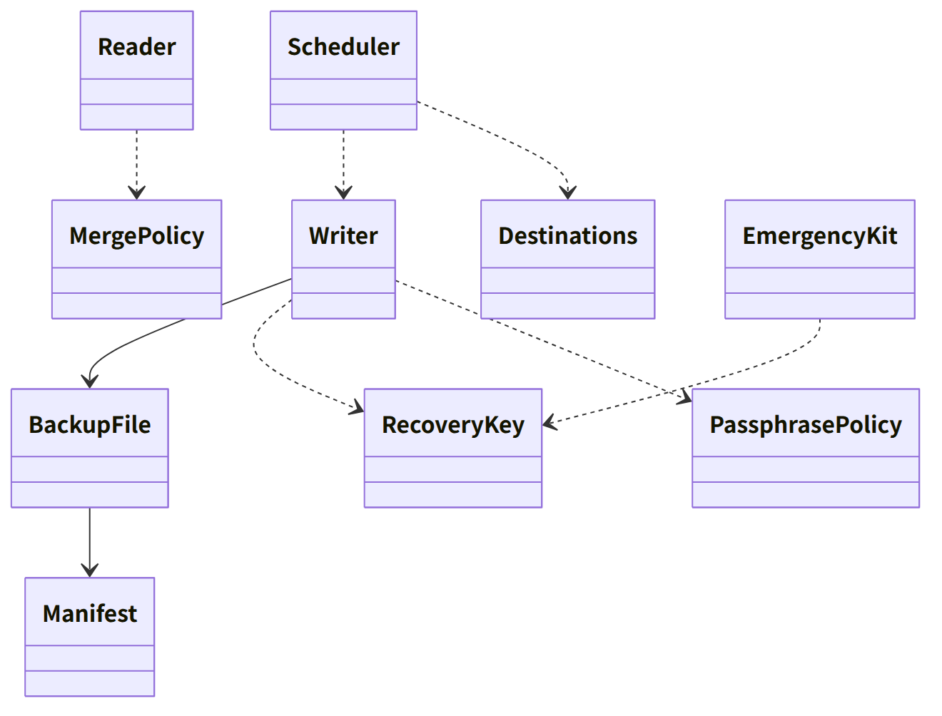
Figure：Class relationships（Class diagram）

Bridges (operations owned by this block)
No. | Operation (in the diagram above) | Used by | Origin
B-240 | Writer::create, Scheduler::schedule, run_due | app-client | Chapter 8, 5.2 and 5.5
B-241 | Reader::restore | app-client | Chapter 8, 5.3
B-242 | Reader::open_as_successor | app-client | Chapter 8, 5.3; Chapter 1, 13
B-243 | EmergencyKit::emergency_kit | app-client | Chapter 8, 5.1
B-244 | Destinations (detect, add, remove, list. The first add calls RecoveryKey::generate) | app-client | Chapter 8, 5.5 and 5.1
B-245 | PassphrasePolicy::check | app-client | Chapter 8, 5.2
B-246 | Scheduler::verify_monthly, consolidate | app-client | Chapter 8, 5.5 and 5.6

Algorithms (behind traits)
Trait | Implementation | Switching | Origin
PassphrasePolicy | The zxcvbn method, the bundled list (100,000 entries), length (15 characters; 8 for those who printed the emergency kit) | Constants of the initial values | Chapter 8, 5.2
Backup encryption | age (scrypt 2^18, encryption to the recovery key's X25519, and an attachment of the secret key wrapped with the passphrase) | Fixed | Chapter 8, 5.1
Choosing the diff | New chain rows and new evidence and Originals since the previous manifest.json. Cloud locations exclude Originals | Dest.kind | Chapter 8, 5.5

Data design
Record or output | Form | Fields | Origin
backup-<date/time>-<seq>.nrsdbak | age (outer) + ZIP (manifest.json, keys/, data/) + an attachment of the recovery key's secret key wrapped with the passphrase | The fields of Manifest | Chapter 8, 5.1 and 5.6
Emergency kit | PDF/A-2u + PDF/UA-1, one page, three languages | The content of the emergency kit in Chapter 8, 5.1 | Chapter 8, 5.1
Settings (placed in core-store's Settings; device-independent) | — | The recovery key's public key, the list of locations, the date/time of the last backup, the date/time verification last passed (per location) | Chapter 8, 5.5; Chapter 10, 10
state/backup-progress.json (nrsd.backup_progress/1) | JSON | The temporary name during creation, the temporary place during restoring (used for cleaning up after interruption) | Chapter 8, 8; Chapter 1, 7.8

