Anti-Repost Tool for Cosplay Photos
core-case (business; registering reposts, evidence preservation, case records and status, the evidence set)
Edition 1 (Draft) 2026-09-29 · Ishikawa Sou
Nagareyama Software Development Co., Ltd. (NRSD)
© 2026 Nagareyama Software Development Co., Ltd. (NRSD), Lead Developer: Ishikawa Sou (石川宗). Copyright in this document belongs to Nagareyama Software Development Co., Ltd. (NRSD). Rights in the third-party standards, software, commentaries on laws, and other materials referred to in this document belong to their respective holders. This is a translation of the Japanese original; where they differ, the Japanese original prevails.
Contents
Sections taken
Dependencies
Class diagram
Bridges (operations owned by this block)
Algorithms (behind traits)
Data design (records and outputs whose form this block holds)

Sections taken
- Chapter 2: 4.3 Takeover of the Notice account, 4.4 Clues when someone posing as the rights holder appears
- Chapter 6: 2.1 Procedure, 2.2 Fetching without running scripts (2.2.1 WARC and WACZ, 2.2.2 screen images and the extension's entry point), 2.3 Input fields for evidence to keep, 2.4 Items of registration data, 2.5 Collection record, 2.6 Entry point from the second stage, 3.1 Correspondence with what must be shown later, 3.2 Timestamps, 3.3 Fetch failures, 3.4 Export, 4.1 How the degree of match is shown, 4.2 What is infringed, 5 Who and where (4), 6.1 Status record, 6.2 Checking the current state, 7 Corrections, 8 Lists and means
- Chapter 7, 6.2 Joint response and priority (how the “priority” mark is given)
- The form of the output of the extension P-14 (extension/) is Chapter 6, 2.2.1 and 2.2.2. This block is its importing side.

Dependencies
- Below: core-common (URL normalization, identification numbers, Clock, error numbers), core-store (Chain, AtomicFile, ZIP checks, trash, Space), core-net (Http::fetch (Target::RepostPage, Target::Rdap; each hop of the redirects is Response.exchanges), Dns::resolve / reverse (B-045; raw responses), Scheduler), core-hash (SHA-256, PDQ, ISCC), core-image (loading fetched images, the date/time of screen images), core-identity (with_signing_key, notice codes), core-mark (reading the watermark), core-render (the report's PDF/A-3u, inserting the wording of the verification procedure), core-rights (checking against the Permitted Scope: the rules of Chapter 5, 2.3), core-sign (Inspector::inspect, Timestamps::timestamp, verify_tsr, ers_for, Works).
- Reference information (the list of contact points, the platform detection table, the RDAP bootstrap, tsa.json) is taken from core-ref by the caller and passed in (this block does not depend on core-ref; the row type and detection are core-common's B-007).
- Above: core-guidance (case, list, append_status, whois, deadlines), app-client, core-backup (enumerating cases/).
- Boundaries with the outside: repost pages (B-334), RDAP and DNS (B-333), TSA (B-332; via core-sign), the OS trash (B-338), the extension (P-14; the deep-link and the watching of the save folder are received by app-client and passed to import_capture).

Class diagram
- Case
  - +CaseId id
  - +Source source Manual | Auto
  - +Urls urls input, normalized, final
  - +Platform platform
  - +[WorkRef] work_refs
  - +[Evidence] evidence
  - +Option<Whois> whois
  - +UserNotes user_notes
  - +Option<RightsRef> rights_ref
  - +[Violation] violations
  - +Signer signer
  - +Rfc3339 created_at
  - +ClockStamp clock
  - +ChainLink chain
  - +Collection collection the form of 2.5
  - +bool page_capture_declined
- Evidence
  - +String original_name only in the list
  - +EvidenceKind kind Warc | Wacz | Screenshot | Image | RdapWarc
  - +Hash sha256
  - +u64 size
  - +Provenance provenance UserProvided | AppFetched | Extension
  - +Rfc3339 taken_at
  - +Option<DateSource> date_source Exif | FileMtime | None. Asks for confirmation if it differs from the registration date/time by 24 hours or more (2.2.2)
  - +bool truncated cut off at 50 MB (3.3)
- Input
  - +String url
  - +Option<ImageInput> image File(path) | Url (fetched in step 6)
  - +Option<Path> screenshot
  - +Option<Path> wacz
  - +bool capture_page default true
  - +UserNotes notes
  - +TsaChoice tsa Free | Paid(id)
  - +Rfc3339 screen_opened_at start of collection (2.5)
- UserNotes
  - +Option<String> account the reposter's account name or display name
  - +Option<String> posted_at_shown
  - +Option<String> counts views, likes, and so on
  - +[CommercialKind] commercial PaidDistribution | Advertising | Merchandise | AiTraining | NoneOrUnknown
  - +[Url] other_posts
  - +Option<String> free_text
- Collection
  - +String collector_handle
  - +NoticeCode collector_code
  - +Rfc3339 started_at
  - +Rfc3339 finished_at
  - +[Url] target_urls
  - +[IpAddr] server_ips
  - +[(String, Hash)] evidence_hashes
  - +Hash evidence_hashes_sha256 the target of the timestamp
  - +String app_version
  - +String tool_version
  - +Option<Duration> clock_skew
  - +Option<ExtensionInfo> extension version, browser name and version, date/time recorded
- FetchOutcome（enumeration）
  - Ok Gone LoginRedirect Unreachable TooLarge the table in Chapter 6, 3.3
- StatusRow
  - +StatusKind kind registered filed response removed reposted checked timestamped withdrawn
  - +Rfc3339 at
  - +Option<Filing> filing contact point, method, receipt number, standing, SHA-256 of the copy
  - +Option<CheckResult> check HTTP status, body hash, presence of the image, SHA-256 of the WARC
  - +Option<[TsResponse]> timestamps
  - +Option<WithdrawReason> reason
  - +ChainLink chain
- Registrar
  - +register(input: Input, refs: CaseRefs) Result<Case, Event> step 6. A mark in state/ per step. evidence_size is checked before fetching (estimate) and after (measured); refused if over 1 GB
  - +CaseRefs refs platforms, rdap_bootstrap, tsa (does not know core-ref's types)
  - +normalize_and_hint(url, platforms) Hint
  - +resume_pending() [Case]
  - +accept_auto(registration) Result<Case>
  - +search_urls(work) [Url]
- Capture
  - +fetch_page(url) (WarcFile, FetchOutcome) 2.2: GET, og:image and img (largest of srcset) top 5 via html5ever, each hop of the redirects into request/response
  - +import_capture(path) Captured checks of the .wacz, compat.yaml, hashes, signature and timeSignature
  - +screenshot_date(path) (Rfc3339, DateSource)
- WarcWriter
  - +begin(path) WarcWriter
  - +warcinfo(software)
  - +request(req)
  - +response(resp)
  - +metadata(fields)
  - +resource(uri, bytes)
  - +finish() Hash
- Wacz
  - +pack(warcs, pages, screenshots) WaczFile
  - +unpack(path, limits) Unpacked
  - +sign(datapackage_digest, signer, ts)
  - +verify(path) Verified
- Matcher
  - +match_image(path, works) MatchResult watermark, then PDQ, then ISCC. The 6 levels of 4.1
  - +clues(path) Clues the five of Chapter 2, 4.4
  - +violations(work, notes, rights) [Violation]
- Whois
  - +lookup(final_url, bootstrap) WhoisResult DNS, RDAP (IP and domain), reverse lookup, ICP
- Status
  - +append_status(id, row: StatusRow, filing_copy: Option<String>)
  - +check_now(id) StatusRow 6.2
  - +withdraw(id, reason) RetentionNotice
  - +deadlines(id, rules) [VTodo]
  - +ics(id) Bytes
- Bundle
  - +export_bundle(id, user_fields, include_clues) Path BagIt, ZIP, the report as TXT and PDF/A-3u, the procedure document, ERS
- Cases
  - +case(id) Case
  - +list(filter) [DomainSummary] per domain, count, first and last, status, priority mark
  - +verify_evidence_files() [Missing]
  - +evidence_size(id) u64 the 1 GB limit
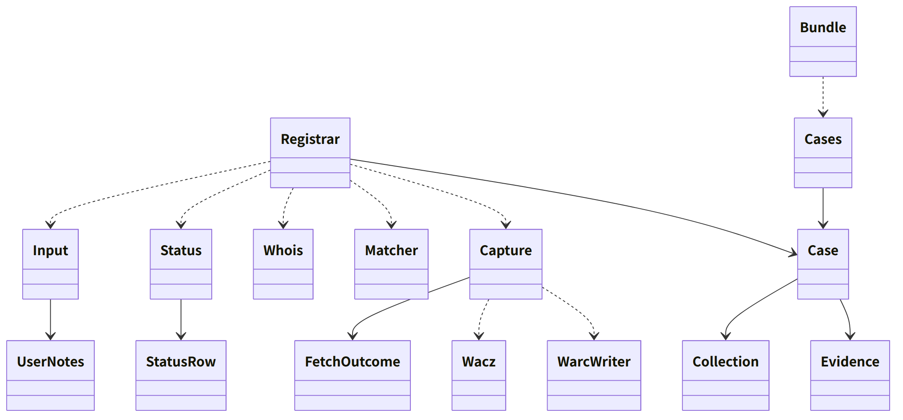
Figure：Class relationships（Class diagram）

Bridges (operations owned by this block)
No. | Operation (in the diagram above) | Used by | Origin
B-180 | Registrar::register | app-client | Chapter 6, 2.1 and 2.4
B-181 | Registrar::normalize_and_hint | app-client | Chapter 6, 2.1; Chapter 2, 2.3
B-182 | Capture::import_capture | app-client | Chapter 6, 2.2.2; Chapter 1, 4.1
B-183 | Matcher::match_image | app-client | Chapter 6, 4.1
B-184 | Cases::case, list | app-client, guidance | Chapter 6, 8; Chapter 10, G-15
B-185 | Status::check_now | app-client | Chapter 6, 6.2
B-186 | Status::append_status | app-client, guidance | Chapter 6, 6.1; Chapter 7, 6.1
B-187 | Status::withdraw (ui shows the returned RetentionNotice) | app-client | Chapter 6, 7
B-188 | Bundle::export_bundle | app-client | Chapter 6, 3.4
B-189 | Matcher::clues | app-client | Chapter 2, 4.4
B-190 | Status::deadlines, ics | app-client | Chapter 6, 6.1; Chapter 7, 6.3
B-191 | Registrar::accept_auto | app-client | Chapter 6, 2.6
B-192 | Registrar::search_urls | app-client | Chapter 6, 2.1; Chapter 10, G-12
B-193 | Whois::lookup | guidance | Chapter 6, 5; Chapter 7, 5
B-194 | Registrar::resume_pending | app-client | Chapter 1, 7.8; Chapter 6, 2.1
B-195 | Cases::verify_evidence_files | app-client | Chapter 8, 4; Chapter 6, 7

Algorithms (behind traits)
Trait | Implementation | Switching | Origin
MatchLevel (levels of match) | Watermark, then PDQ 0–15, then 16–31, then ISCC, then someone else's number, then cannot be confirmed | The thresholds are constants of the initial values | Chapter 6, 4.1
ImagePicker (how fetched images are chosen) | og:image and <img> (largest of srcset), 5 in order of size | Constants | Chapter 6, 2.2
WorkRefOrder | Watermark match, then PDQ distance, then newest first; grouped by the Original's SHA-256 | Fixed | Chapter 6, 4.1

Data design (records and outputs whose form this block holds)
Record | Form | Fields | Origin
cases/<case number>/case.json + .sig (nrsd.case/1; chain) | JSON | The table in Chapter 6, 2.4 (Case), the collection record of 2.5 | Chapter 6, 2.4 and 2.5
cases/<case number>/status/<device number>.jsonl + .sig (nrsd.status/1; chain) | JSON Lines | Chapter 6, 6.1 (StatusRow; the timestamp responses are also here) | Chapter 6, 6.1 and 3.2
cases/<case number>/evidence/<SHA-256>.<extension> | Files | WARC (capture-<serial>.warc.gz), WACZ, screen images, fetched images | Chapter 6, 2.4 and 2.2.1
cases/<case number>/filings/<UUID v7>.txt | TXT | Copy of the complaint (already [REDACTED]) | Chapter 6, 6.1
state/case-<case number>.json (nrsd.case_progress/1) | JSON | Marks for the completed steps of step 6 (preservation, record, save, timestamp) | Chapter 6, 2.1; Chapter 1, 7.8
Output: evidence set | evidence-<case number>-<date/time>.zip (BagIt: data/, manifest-sha256.txt, bag-info.txt, tagmanifest-sha256.txt) | The content of Chapter 6, 3.4 | Chapter 6, 3.4
Output: .ics | VTODO | Deadlines (Chapter 7, 6.3) | Chapter 6, 6.1

- Whois goes into the whois field of case.json; the raw request and response are placed in evidence/ as the WARC RdapWarc (Chapter 6, 5).

