Anti-Repost Tool for Cosplay Photos
core-guidance (business; candidate contact points, complaint drafts, deadlines, references to each country's laws, procedure for identifying the operator)
Edition 1 (Draft) 2026-09-29 · Ishikawa Sou
Nagareyama Software Development Co., Ltd. (NRSD)
© 2026 Nagareyama Software Development Co., Ltd. (NRSD), Lead Developer: Ishikawa Sou (石川宗). Copyright in this document belongs to Nagareyama Software Development Co., Ltd. (NRSD). Rights in the third-party standards, software, commentaries on laws, and other materials referred to in this document belong to their respective holders. This is a translation of the Japanese original; where they differ, the Japanese original prevails.
Contents
Sections taken
Dependencies
Class diagram
Bridges (operations owned by this block)
Algorithms (behind traits)
Data design

Sections taken
- Chapter 7: 3.1 Kinds of model texts, 3.2 Guidance that personal information reaches the other party, 3.3 Content of the model texts (3.3.4 portrait and privacy, 3.3.5 hosting and CDN), 3.4 Standing of the person filing, 5 Identifying the operator, 6.3 Display of procedural deadlines
- Chapter 12, 3.2 At the User's discretion (the System only guides)
- Read-only sections (owned by the reference information P-7): Chapter 7, 2.1 “Initial list of contact points”, 3.3.1–3.3.3 (the body of the model texts), 4 “References to each country's laws”. The forms are platforms.json, templates/, laws.json, deadlines.json, and holidays.json of Chapter 8, 3.4.

Dependencies
- Below: core-common (the insertion rules {field}, Clock, language), core-ref (each file above from Reference::current()), core-case (Cases::case, Status::append_status, the result of Whois::lookup).
- Above: app-client. The screens are G-16 (case details), G-17 (response guidance), G-24 (clue comparison; options when there is no case).
- The fields the User enters (name, address, phone, e-mail, URL of the original post, signature) only pass through this block and are written to no record (Chapter 7, 3.1). The only thing saved is core-case's copy of the complaint (already [REDACTED]; Chapter 6, 6.1).

Class diagram
- Venue
  - +VenueId id
  - +String name
  - +VenueKind kind Platform | Cdn | Hosting | Generic
  - +NoticeType notice Copyright | Portrait
  - +Country country
  - +Method method WebForm(url) | Email(addr)
  - +bool jp_article22 contact point by the method of Article 22
  - +String note
  - +[Url] sources
- Venues
  - +options(case: Option<Case>, platforms, whois) [Venue] general means if none
- Standing（enumeration）
  - CopyrightHolder
  - Subject
  - Authorized
- Drafter
  - +templates(kind, lang) Template front matter (kind, standing, venue_kinds, version, reviewed_*)
  - +draft(case, venue, standing, user_fields) Draft
  - +consent_texts(venue, standing) [String] the personal information guidance of 3.2 and the per-standing confirmation texts of 3.2.1
- Field
  - +String name
  - +FieldKind kind Text | Choice(options) (the "right claimed to be infringed" of Form A is a choice; the default is the right of public transmission)
  - +bool required
- Draft
  - +String text in the language of the contact point's country
  - +String translation reference translation in the screen language
  - +[Warning] warnings weak match (the three results of 4.1), mismatch of standing and kind, materials for representation
  - +[String] consent_texts
  - +[Field] user_fields fields left blank
  - +[AttachmentHint] attachments evidence to attach (from the content of Chapter 6, 3.4) and materials confirming that one is the copyright holder or similar (the table in 3.3.3)
  - +String redacted_copy a copy with the User's fields set to [REDACTED] (for core-case's filings/)
- DeadlineCalendar（trait）
  - +due(trigger_at, rule, holidays) Date
- Deadlines
  - +deadlines(case, filing, rules, holidays) [Deadline]
  - +ics(case) Bytes
  - +alarms_due(now, cases) [Deadline] 3 days before and on the day
- Deadline
  - +DeadlineId id
  - +Date due
  - +String basis
  - +Text text
  - +Trigger trigger
  - +Text overdue_advice what to do when past (asking the provider, consulting an expert; 6.3)
- LawRefs
  - +references(country, laws) [LawRef]
  - +further_steps(country) [Registration] the table in Chapter 12, 3.2
- OperatorSteps
  - +operator_steps(whois) [Step] the table in Chapter 7, 5: CDN, ICP, giving up
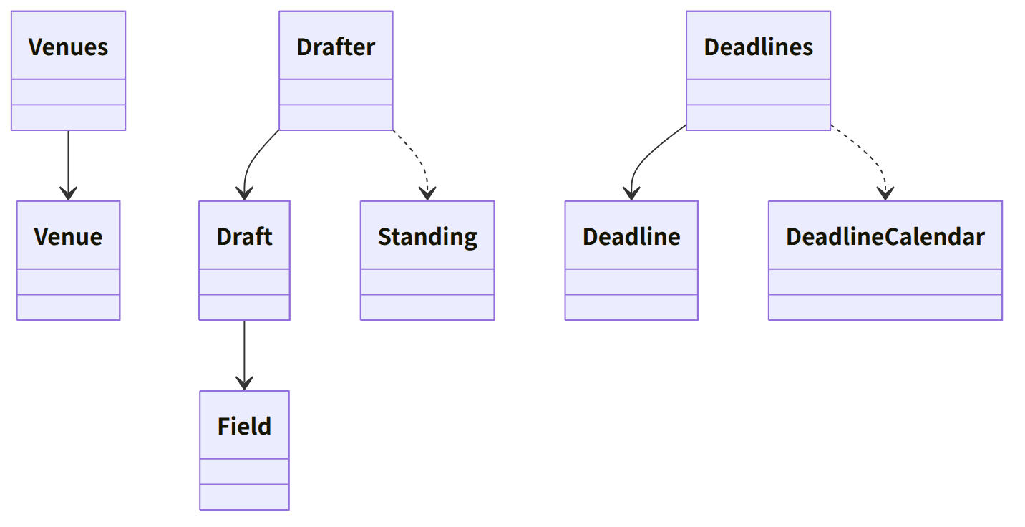
Figure：Class relationships（Class diagram）

Bridges (operations owned by this block)
No. | Operation (in the diagram above) | Used by | Origin
B-200 | Venues::options | app-client | Chapter 7, 2 and 5
B-201 | Drafter::draft (a Draft including consent_texts) | app-client | Chapter 7, 3
B-202 | Deadlines::deadlines, ics, alarms_due | app-client | Chapter 7, 6.3
B-203 | LawRefs::references, further_steps | app-client | Chapter 7, 4; Chapter 12, 3.2
B-204 | OperatorSteps::operator_steps | app-client | Chapter 7, 5

Algorithms (behind traits)
Trait | Implementation | Switching | Origin
DeadlineCalendar | Calendar days add the number of days. Business days are counted excluding weekends and the country's holidays in holidays.json | The unit of deadlines.json | Chapter 7, 6.3
Choosing the model text | Standing × kind of contact point × country → templates/<kind>.<language>.md (the depicted person is portrait, CDN and hosting are hosting, an Article 22 contact point is jp_form_a) | The front matter standing and venue_kinds of the reference information | Chapter 7, 3.1 and 3.4

Data design
- This block holds no records on the device. What it reads is the reference information (Chapter 8, 3.4); the only thing it writes is core-case's status append (B-186).
Output | Form | Fields | Origin
Complaint text | TXT (original and reference translation) | The model text with its fields filled in. Not saved in the app | Chapter 7, 3.3
.ics | iCalendar (RFC 5545) | The VTODO and VALARM of Chapter 7, 6.3 | Chapter 7, 6.3

