Anti-Repost Tool for Cosplay Photos
core-hash (business)
Edition 1 (Draft) 2026-09-29 · Ishikawa Sou
Nagareyama Software Development Co., Ltd. (NRSD)
© 2026 Nagareyama Software Development Co., Ltd. (NRSD), Lead Developer: Ishikawa Sou (石川宗). Copyright in this document belongs to Nagareyama Software Development Co., Ltd. (NRSD). Rights in the third-party standards, software, commentaries on laws, and other materials referred to in this document belong to their respective holders. This is a translation of the Japanese original; where they differ, the Japanese original prevails.
Contents
Sections taken
Dependencies
Class diagram
Bridges (operations owned by this block)
Algorithms (behind traits)
Data design

Sections taken
- Chapter 3, 6 Matching hashes (PDQ, ISCC, guide distances, 8 orientations, quality score)
- Roles and external components: Chapter 11, 7.1

Dependencies
- Below: core-common.

Class diagram
- Sha256（module）
  - +sha256_file(path) Hash
  - +sha256_bytes(bytes) Hash
- Pdq
  - +hash(pixels: &Pixels) PdqHash original orientation
  - +hash_all_orientations(pixels) [PdqHash; 8]
  - +distance(a, b) u32 Hamming
  - +quality(pixels) u8 0 to 100
- PdqHash
  - +[u8; 32] bits
  - +u8 quality
- Iscc
  - +compute(pixels, bytes) IsccCode
  - +content_match(a, b) bool exact match of the Content-Code
- IsccCode
  - +String content
  - +String data
  - +String instance
- PerceptualHash（trait）
  - +fingerprint(pixels) Fingerprint
  - +similarity(a, b) Similarity
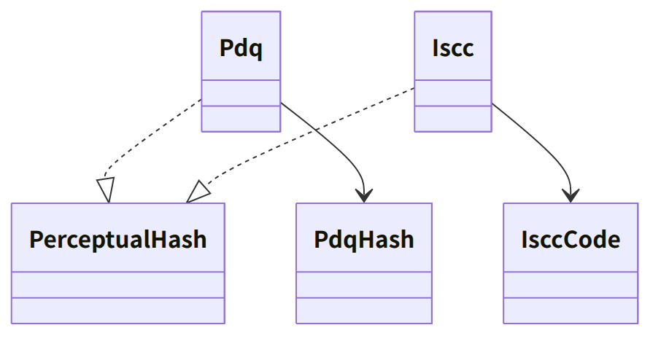
Figure：Class relationships（Class diagram）

Bridges (operations owned by this block)
No. | Operation (in the diagram above) | Used by | Origin
B-050 | Sha256 | sign, case, work, backup, rights, image, app-client (SHA256SUMS) | Chapter 3, 2
B-051 | Pdq | sign, case | Chapter 3, 6; Chapter 6, 4
B-052 | Iscc | sign, case | Chapter 3, 6

- The thresholds (distances 15 and 31, quality 50) are not held by this block. The judgment is core-case's MatchPolicy.
- Pixels is core-common's Pixels8 (B-014). It is made from core-image's Image and passed by the caller (core-hash does not depend on core-image).

Algorithms (behind traits)
Trait | Implementation | Switching | Origin
PerceptualHash | PDQ (pdqhash; pdq-rs if it does not match the upstream test values), ISCC (iscc-lib) | Both are always computed | Chapter 3, 6; Chapter 11, DD-11-4

Data design
- This block writes no records. Form of values: PDQ is 256 bits (64 hexadecimal characters) plus the quality score; ISCC is the three strings of ISO 24138. They are recorded in work data (Chapter 3, 7.2; core-sign's page) and case records (Chapter 6, 2.4; core-case's page).

