Anti-Repost Tool for Cosplay Photos
core-image (business)
Edition 1 (Draft) 2026-09-29 · Ishikawa Sou
Nagareyama Software Development Co., Ltd. (NRSD)
© 2026 Nagareyama Software Development Co., Ltd. (NRSD), Lead Developer: Ishikawa Sou (石川宗). Copyright in this document belongs to Nagareyama Software Development Co., Ltd. (NRSD). Rights in the third-party standards, software, commentaries on laws, and other materials referred to in this document belong to their respective holders. This is a translation of the Japanese original; where they differ, the Japanese original prevails.
Contents
Sections taken
Dependencies
Class diagram
Bridges (operations owned by this block)
Algorithms (behind traits)
Data design

Sections taken
- Chapter 1, 10.6 Checking what comes in from outside
- Chapter 3, 2 Input, 3.6.1 Writing per format, 8.4 Removing capture information, 8.5 Quality of delivery exports
- Chapter 4, 14.3 Resizing, color conversion, and JPEG export
- Roles and external components: Chapter 11, 7.1

Dependencies
- Below: core-common, core-hash (SHA-256 in thumbnail names).
- Handling of images that already carry a C2PA signature (the rows of the table in Chapter 3, 2) is core-sign (manifest verification is c2pa). This block handles only pixels, ICC, orientation, and segments.

Class diagram
- Format（enumeration）
  - Jpeg Png Tiff WebP
- Header
  - +InputKind kind Decodable (JPEG, PNG, TIFF, WebP) | FingerprintOnly (RAW, HEIC, CMYK TIFF, others)
  - +Format format
  - +u32 width
  - +u32 height
  - +u64 bytes
  - +u8 bit_depth
  - +ColorModel color_model Rgb | Gray | Cmyk
  - +bool has_alpha
  - +Option<Rfc3339> taken_at EXIF DateTimeOriginal
  - +memory_estimate() u64 height x width x bytes per pixel (4 for RGBA8, 8 for RGBA16). Used as the load limit of decode
- Image
  - +Pixels pixels RGB(A), 8 or 16 bits. Gray is expanded to RGB
  - +Option<Icc> icc
  - +IccSource icc_source Embedded | InferredAdobeRgb (EXIF Uncalibrated + InteropIndex R03) | AssumedSrgb
  - +u8 bit_depth
  - +u32 width
  - +u32 height
  - +CaptureFields capture
  - +bool orientation_applied pixels rotated; output Orientation is 1
  - +Option<ColorSpace> color_converted
  - +to_pixels8() Pixels8 core-common B-014. The plane passed to the watermark, PDQ, and ISCC
- Decoder
  - +probe(path) Result<Header, Event> header only. The limits of Chapter 3, 2 (100 million pixels, 200 MB) are here (IMG numbers)
  - +decode(path) Result<Image, Event> the load limit is memory_estimate. Broken means Event
  - +validate_image(path, formats, max_bytes, max_px) Result image layers, QR images, and other things whose limits are in the caller's section
- Resampler（trait）
  - +resize(image, target: Size) Image
- ColorEngine（trait）
  - +to_srgb(image) Image
  - +convert_to(image, icc) Image
  - +to_8bit(image) Image
- Encoder
  - +encode(image, format, settings: EncodeSettings, tiff_tags: Option<RightsFields>) Bytes for TIFF, XMP (700), Artist (315), and Copyright (33432) are written at encoding (Chapter 3, 3.6.1)
- EncodeSettings
  - +u8 jpeg_quality
  - +bool chroma_subsampling 4:4:4 for both delivery and social media
  - +bool progressive
  - +Option<Icc> embed_icc the original ICC for delivery, sRGB for social media
  - +TiffCompression tiff Deflate, bit depth kept
  - +bool webp_lossless VP8L
  - +for_delivery(format) EncodeSettings the table in Chapter 3, 8.5 (JPEG 95, PNG, TIFF Deflate, WebP lossless)
- StripReport
  - +[Removed] removed Gps | PlaceNames | Serials | OwnerName | MakerNote ("Location information removed" in the processing list)
- Metadata
  - +strip_capture_metadata(bytes, keep: KeepFields) (Bytes, StripReport) keep is the capture date/time and camera model (Chapter 3, 8.4). Orientation is set to 1
  - +write_rights_metadata(bytes, fields: RightsFields) Bytes JPEG APP1, PNG iTXt/eXIf, WebP RIFF (img-parts, little_exif). This block composes the XMP RDF/XML
  - +read_rights_metadata(bytes) RightsFields
- RightsFields
  - +[String] dc_creator both if there is a joint rights holder
  - +String photoshop_credit "{handle name} ({Notice account})"
  - +String dc_rights
  - +String xmpRights_WebStatement
  - +[(Lang, String)] xmpRights_UsageTerms per language (xml:lang). English plus the screen language (Chapter 3, 3.3)
  - +[Url] plus_Licensor the sequence of LicensorURL
  - +String dc_title
  - +String exif_artist UTF-8 of Exif 3.0
  - +String exif_copyright
- Thumbs
  - +thumbnail(path, short_side, cache_dir) Image
  - +preview_jpeg(path, long_side, cache_dir, display_icc: Option<Icc>) Path
- DisplayIcc（module）
  - +display_icc() Option<Icc> Linux: wp_color_management_v1, then X11 _ICC_PROFILE, then colord, otherwise None (sRGB)
- InputKind（enumeration）
  - Decodable FingerprintOnly
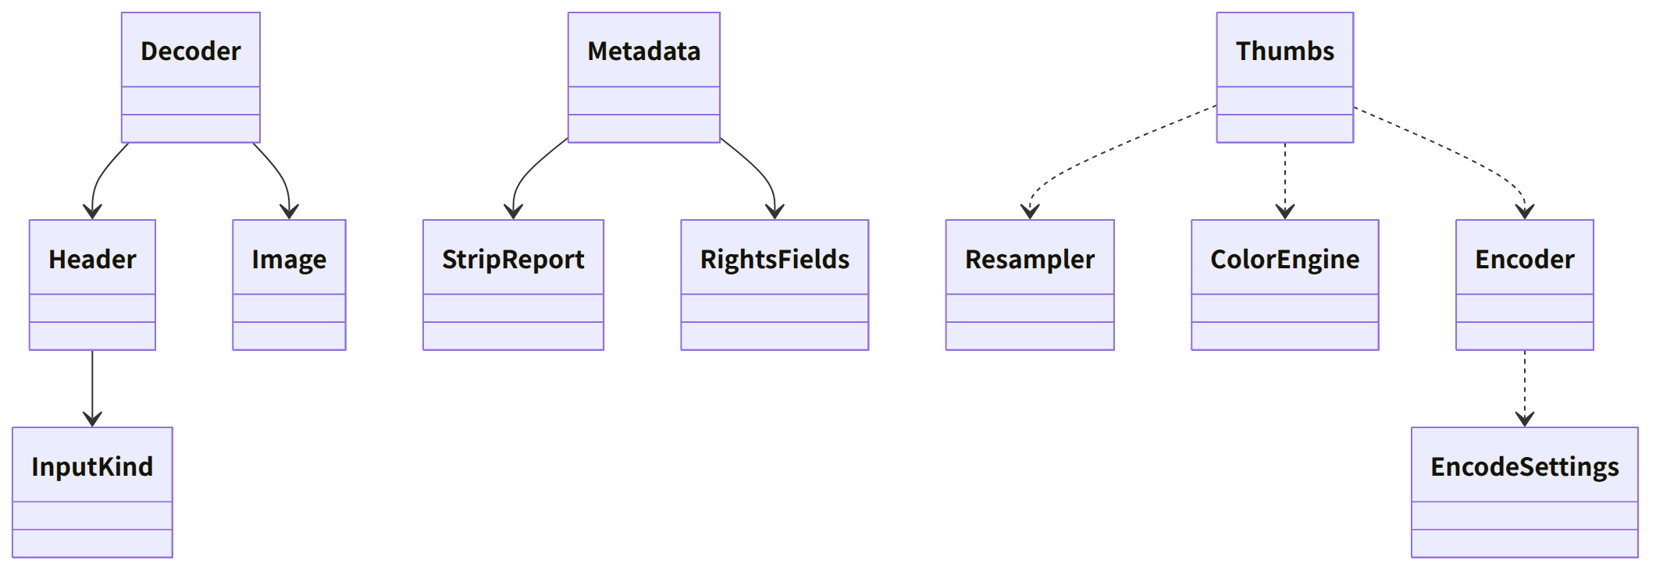
Figure：Class relationships（Class diagram）

Bridges (operations owned by this block)
No. | Operation (in the diagram above) | Used by | Origin
B-060 | Image | sign, work, render, mark, case | Chapter 3, 2
B-061 | Decoder::probe | work, sign, case | Chapter 1, 10.6; Chapter 3, 2
B-062 | Decoder::decode | sign, work, case | Chapter 3, 2
B-063 | Resampler::resize | work, sign | Chapter 4, 14.3
B-064 | ColorEngine | sign, work | Chapter 4, 14.3 and DD-4-12
B-065 | Encoder::encode | sign | Chapter 4, 14.3; Chapter 3, 8.5
B-066 | Metadata::strip_capture_metadata (the caller passes the items to keep from the settings) | sign | Chapter 3, 8.4
B-067 | Metadata::write_rights_metadata (the values are made by core-rights' B-124) | sign | Chapter 3, 3.6.1
B-068 | Metadata::read_rights_metadata (read-back verification) | sign | Chapter 3, 3.6.1
B-069 | Thumbs (the cache location is the caller's) | work | Chapter 4, 14.3
B-070 | Decoder::validate_image (the limits are in the caller's section) | work, app-client (QR images) | Chapter 4, 5; Chapter 1, 10.6
B-071 | DisplayIcc::display_icc | work | Chapter 4, 14.3

Algorithms (behind traits)
Trait | Implementation | Switching | Origin
Resampler | Lanczos3 of fast_image_resize. Transparency is premultiplied, resized, then unpremultiplied | Fixed | Chapter 4, 14.3
ColorEngine | moxcms. lcms2 if it does not meet the criteria of Chapter 4, 14.3 | Decided by measurement, a build feature | Chapter 4, 14.3

Data design
- Files this block writes: thumbnails (thumbs/<SHA-256 of the photo>.jpg) and previews (JPEG). Size and quality are Chapter 4, 14.3; the location is the caller's (Chapter 4, 11.8; the cache of Chapter 8, 2.1). They can be regenerated, so they are not records.
- The source of each value of RightsFields is Chapter 3, 3.6 (core-rights' page). This block only writes to and reads from the segments.
- Input limits and memory estimates are Chapter 3, 2.

