Anti-Repost Tool for Cosplay Photos
core-mark (business; invisible watermark, shared ONNX runtime)
Edition 1 (Draft) 2026-09-29 · Ishikawa Sou
Nagareyama Software Development Co., Ltd. (NRSD)
© 2026 Nagareyama Software Development Co., Ltd. (NRSD), Lead Developer: Ishikawa Sou (石川宗). Copyright in this document belongs to Nagareyama Software Development Co., Ltd. (NRSD). Rights in the third-party standards, software, commentaries on laws, and other materials referred to in this document belong to their respective holders. This is a translation of the Japanese original; where they differ, the Japanese original prevails.
Contents
Sections taken
Dependencies
Class diagram
Bridges (operations owned by this block)
Algorithms (behind traits)
Data design

Sections taken
- Chapter 3, 5 Invisible watermark (method, reading in 8 orientations, inference limits, bundled hash check, 16-bit, processing time)
- Roles and external components: Chapter 11, 7.1, DD-11-14

Dependencies
- Below: core-common (WorkId, Fault, Pixels8), core-image (Image, ColorEngine::to_8bit: handling of the 16-bit residual).
- Loading and sharing the ONNX runtime belongs to this block; core-work's auto-placement (u2netp) also uses Onnx::session (only the model in use is loaded; Chapter 3, 5).

Class diagram
- Watermark（trait）
  - +embed(pixels: Pixels8, id: WorkId) Result<(Pixels8, SoftBindingValue), Event>
  - +extract(pixels: Pixels8) Option<WorkId>
  - +model_info() ModelInfo
- TrustMark
  - +Variant variant Q / P / C
  - +String model_version
- ModelInfo
  - +Variant variant
  - +String model_version
  - +Hash encoder_sha256
  - +Hash decoder_sha256
- SoftBindingValue
  - +Bytes bits the value of c2pa.soft-binding
- Embedder
  - +embed_image(image: Image, id: WorkId) (Image, SoftBindingValue) 16-bit is residual x 257
  - +extract_image(image: Image, all_orientations: bool) Option<WorkId>
- Onnx
  - +session(model: ModelName) Session shared loading, memory limit, released after 5 minutes
  - +verify_runtime() Result<(), Fault> check against the bundled SHA-256
  - +usage() Usage
- Session
  - +run(inputs) outputs at most 2 concurrent inferences, intra-op min(4, cores)
- ModelName（enumeration）
  - TrustMarkEncoder TrustMarkDecoder U2netp
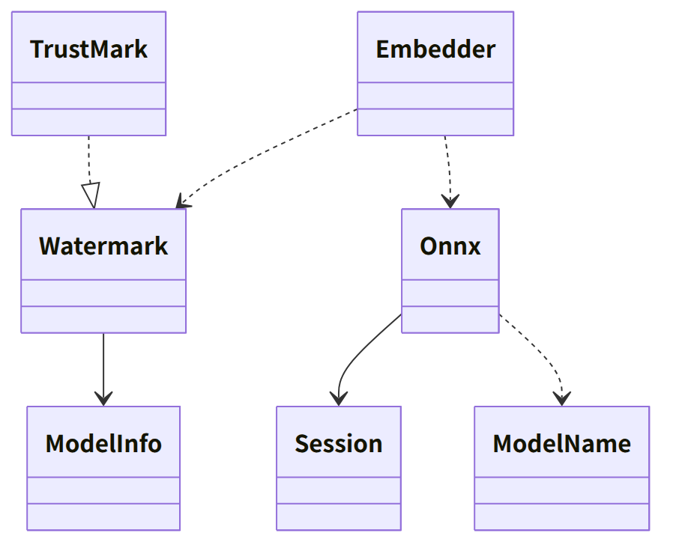
Figure：Class relationships（Class diagram）

Bridges (operations owned by this block)
No. | Operation (in the diagram above) | Used by | Origin
B-100 | Embedder::embed_image, Watermark::model_info | sign | Chapter 3, 5
B-101 | Embedder::extract_image (matching reads 8 orientations; read-back only the original orientation) | sign, case | Chapter 3, 5; Chapter 6, 4
B-102 | Onnx::session | work, app-client (lazy loading at start) | Chapter 3, 5
B-103 | Onnx::verify_runtime | app-client | Chapter 3, 5 and DD-11-14

- The watermark variant and model version are recorded in the app of the output's work data and case records (core-sign and core-case copy them from model_info()).
- Onnx::session(model) does not hold the watermark and auto-placement models at the same time (loads the one in use and releases the other; Chapter 4, 14.4). The ONNX runtime is loaded dynamically (ort's load-dynamic). If verify_runtime does not match, it is a Fault (anomaly detection) and no output without a watermark is produced (Chapter 3, 5).

Algorithms (behind traits)
Trait | Implementation | Switching | Origin
Watermark | TrustMark Q (default), P, C | Decided by measurement, fixed per version (recorded in the output) | Chapter 3, DD-3-2 and 5

Data design
- This block writes no records. Bundled assets (P-8): assets/models/encoder_Q.onnx and decoder_Q.onnx (Chapter 11, 4.3), the shared ONNX runtime component. The expected SHA-256 values are embedded at build time from assets/manifest.json (Chapter 11, 6).
- Form of values: SoftBindingValue is the embedded bit string (the 61 data bits of TrustMark BCH_5). Recording in the manifest is core-sign (Chapter 3, 3.1).

