Anti-Repost Tool for Cosplay Photos
core-ref (business; fetching the reference information package and update manifest, TUF verification)
Edition 1 (Draft) 2026-09-29 · Ishikawa Sou
Nagareyama Software Development Co., Ltd. (NRSD)
© 2026 Nagareyama Software Development Co., Ltd. (NRSD), Lead Developer: Ishikawa Sou (石川宗). Copyright in this document belongs to Nagareyama Software Development Co., Ltd. (NRSD). Rights in the third-party standards, software, commentaries on laws, and other materials referred to in this document belong to their respective holders. This is a translation of the Japanese original; where they differ, the Japanese original prevails.
Contents
Sections taken
Dependencies
Class diagram
Bridges (operations owned by this block)
Algorithms (behind traits)
Data design (records whose form this block holds)

Sections taken
- Chapter 8, 3.4 Reference information package (list of files, the five verification steps, the five sources, the bundled package, correction marks)
- Chapter 9, 4.2 Users of old versions (forced updates), 4.3 Form of the update manifest (static JSON) (TUF roles, expiry, locations)
- Chapter 12, 3.1 What is required to use NRSD's service (consent record)
- Roles and external components: Chapter 11, 7.1

Dependencies
- Below: core-common, core-store (Schema, AtomicFile, Paths), core-net (Http::fetch, Sources, Scheduler).
- Dependency inversions: this block defines BundleSource, implemented by core-sync (packages from another device or a contact). This block defines BundleSigner, implemented by app-operator (signing with the hardware token).
- Boundary with the outside B-330 (HTTPS GET from the public page and mirror; via core-net).

Class diagram
- RefBundle
  - +u32 version
  - +Rfc3339 issued_at
  - +[FileEntry] files
  - +[Correction] corrections
  - +[PlatformRule] platforms the row type is core-common (B-007)
  - +Templates templates
  - +Laws laws
  - +Texts texts
  - +[Notice] notices
  - +Terms terms
  - +TrackingRules clearurls
  - +RdapBootstrap rdap
  - +[TsaEntry] tsa
  - +[Relay] relays
  - +Holidays holidays
  - +Deadlines deadlines
  - +MinimumVersion minimum_version
  - +Vex vex
- FileEntry
  - +String path
  - +u64 size_raw
  - +u64 size_zstd
  - +u64 budget
- Correction
  - +String file
  - +u32 since
  - +Text3 reason
- Fetcher
  - +refresh() Outcome the latest from the five sources. Only the changed files
  - +import_bundle(bytes) Outcome
  - +export_bundle() Bytes
  - +verify_update_manifest(bytes, platform) Verified
- Outcome（enumeration）
  - Updated(version) UpToDate Stale(last_checked) Rejected(Event)
- Verified
  - +Url url
  - +String signature
  - +SemVer version
- BundleVerifier（trait）
  - +verify(root: RootJson, meta: TufSet, files) Result<Verdict, Event>
- TufSet
  - +Bytes timestamp
  - +Bytes snapshot
  - +Bytes targets
  - +Bytes reference delegation reference.json
  - +Bytes release delegation release.json
- Verdict
  - +bool timestamp_expired if expired, treated as a fetch failure
  - +u32 bundle_version
  - +Rfc3339 reference_expiry 120 days. Expiry is only a mark
- Store
  - +current() RefBundle
  - +pinned(version) RefBundle
  - +corrections_since(version) [Correction]
  - +minimum_version() SemVer
  - +bundled_version() u32 the bundled package of P-8
- Consent
  - +consent(state: ConsentState)
  - +consent_state() ConsentState
  - +terms_current() Terms
  - +terms_changed_since(version) Option<Change>
- ConsentState
  - +Option<String> version
  - +Option<Rfc3339> at
  - +bool declined
- BundleSource（trait）
  - +latest() Option<(u32, Bytes)>
- BundleSigner（trait）
  - +sign(bytes) (Sig, Attestation)
- Writer
  - +write_bundle(files, version, expiry, signer: BundleSigner) BundleOut used by app-operator
  - +diff_bundle(old: RefBundle, new: RefBundle) Diff difference from the previous version (M-01)
  - +iana_bootstrap_diff(fetched, current) Diff
  - +budget_check(bundle) [Warning] each file's budget and 80% of the 16 MB total
  - +mark_errata(bundle, items: [Correction]) RefBundle correction marks (Chapter 5, 2.4)
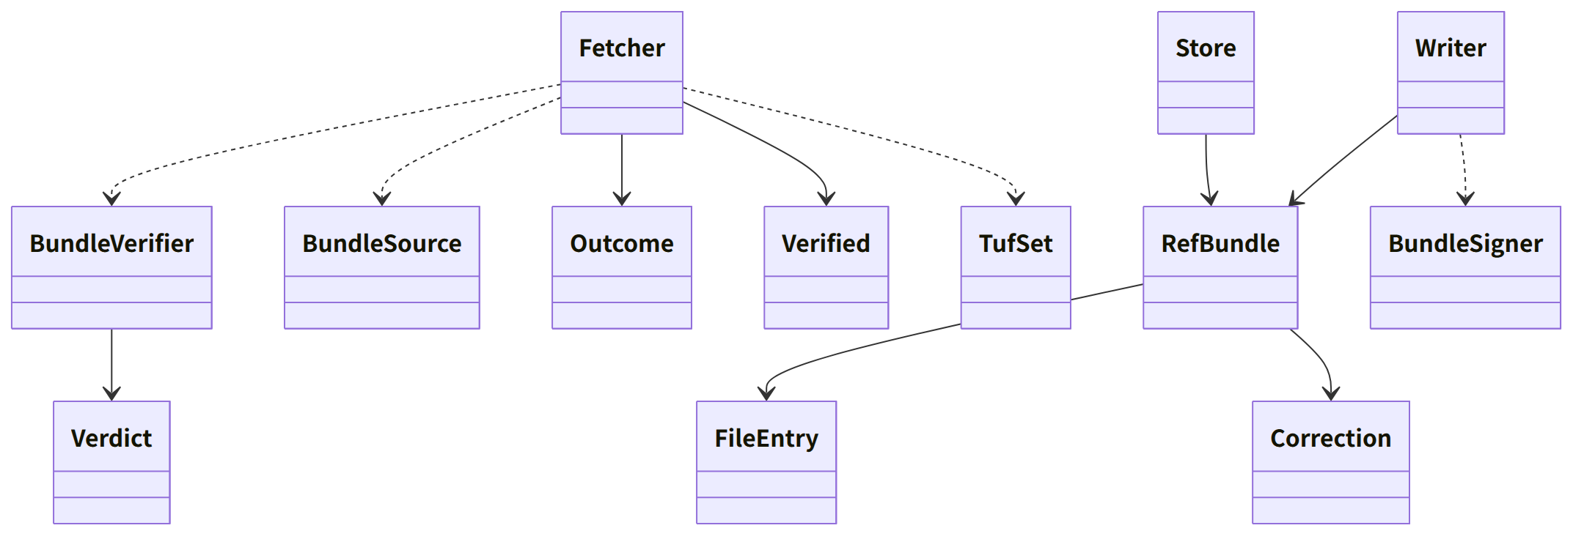
Figure：Class relationships（Class diagram）

Bridges (operations owned by this block)
No. | Operation (in the diagram above) | Used by | Origin
B-220 | Fetcher::refresh | app-client | Chapter 8, 3.4
B-221 | Store::current (each table) | rights, guidance, work, app-client (app-client passes it on to case and identity) | Chapter 8, 3.4; Chapters 7, 5, and 12
B-222 | Fetcher::verify_update_manifest | app-client | Chapter 9, 4.3
B-223 | Consent (only refresh follows consent; verification of the update manifest does not depend on consent) | app-client | Chapter 12, 3.1 and 4.3
B-224 | Store::minimum_version | app-client | Chapter 9, 4.2
B-225 | Store::pinned | work | Chapter 5, 4
B-226 | Fetcher::import_bundle, export_bundle (file, sync, portable kit. The first start imports the bundled package with this) | app-client, sync | Chapter 8, 3.4
B-227 | Store::corrections_since | app-client, rights | Chapter 8, 3.4
B-228 | BundleSource (definition; implemented by core-sync) | sync | Chapter 8, 3.4
B-229 | The form of RefBundle and Writer::write_bundle | app-operator | Chapter 8, 3.4
Part of B-310 | BundleSigner (definition; implemented by app-operator) | app-operator | Chapter 8, 3.4

- Posting site detection is done by core-common's Platforms::detect (B-007); this block only reads platforms.json into core-common's [PlatformRule]. The users (core-identity B-081, core-case B-181) pass the table (the same detection is not held in two places).

Algorithms (behind traits)
Trait | Implementation | Switching | Origin
BundleVerifier | tough (the TUF 1.0 order: root, then timestamp, then snapshot, then targets, then delegations). The root is updated from the bundled initial version through the sequence of versions | Fixed | Chapter 8, 3.4; Chapter 9, 4.3

Data design (records whose form this block holds)
Record | Form | Fields | Origin
reference/<version>/index.json (nrsd.reference/1) | JSON | schema, version, issued_at, files[] (FileEntry), corrections[] (Correction) | Chapter 8, 3.4
Each file in reference/<version>/ (nrsd.ref.<name>/1) | JSON (fetched as zstd, stored decompressed), Markdown | platforms (one row: id, name (three languages), hosts[], paths[], profile_limit, c2pa_survives, windows{copyright, portrait} (url, method, jp_art22, notes), sources, checked_at; Chapter 7, 2.1), laws (Chapter 7, 4), deadlines and holidays (Chapter 7, 6.3), tsa (id, name, url, roots (PEM), kind (free, paid), auth (none, basic), order; Chapter 3, 4), relays (url, region, operator), notices (number, date, kind, title and body in three languages, deadline), terms (version, effective date), minimum_version (app, reason, date), clearurls, rdap-bootstrap/, vex (CSAF 2.0), templates/<kind>.<language>.md (Chapter 7, 3.3), texts/ (Chapter 5, 3.7) | Chapter 8, 3.4; Chapter 7, 2.1, 3.3, 4, and 6.3; Chapter 9, 4.2; Chapter 11, 5.3
reference/latest.json | JSON | version, index_sha256 (not used as a basis of trust) | Chapter 8, 3.4
tuf/ (copies of the fetched TUF metadata: the sequence of root.json versions, timestamp, snapshot, targets, reference, release) | JSON | The form of the TUF specification 1.0 | Chapter 9, 4.3
consent.json (nrsd.consent/1) | JSON | The three fields of ConsentState | Chapter 12, 3.1
Bundled package (P-8) | The initial version of reference/ and the initial root.json | Same as above | Chapter 8, 3.4

- Store::minimum_version reads both the reference information's minimum-version.json and the TUF of the update manifest (the custom field of the release delegation's targets) and returns the larger (Chapter 9, 4.2; it also reaches Users who did not consent and do not fetch reference information).
- Writer::write_bundle makes each file (zstd), index.json, latest.json, and the targets.json of the reference delegation (signed with BundleSigner). snapshot.json and timestamp.json are re-signed by CI's tuf-online (Chapter 11, DD-11-13; P-10).
- The date/time of the last check (last_ref_check and last_update_check in fetch-state.json) is written with core-net's Sources::mark_checked.
- The fields of the update manifest (update/latest.json; nrsd.update_manifest/1) are the table in Chapter 9, 4.3. This block only verifies and returns Verified; fetching and swapping in the distributables is app-client (Tauri's update component).
- Marks: Verdict.timestamp_expired is a fetch failure (the local copy is used); exceeding reference_expiry is the notice “reference information is old” (row 5 of the table in Chapter 8, 3.4); a package that arrived by sync or from a file carries the mark stale_check: date (Chapter 8, 3.4).

