Anti-Repost Tool for Cosplay Photos
core-render (business; fonts, text composition, drawing, layout, compositing, PDF)
Edition 1 (Draft) 2026-09-29 · Ishikawa Sou
Nagareyama Software Development Co., Ltd. (NRSD)
© 2026 Nagareyama Software Development Co., Ltd. (NRSD), Lead Developer: Ishikawa Sou (石川宗). Copyright in this document belongs to Nagareyama Software Development Co., Ltd. (NRSD). Rights in the third-party standards, software, commentaries on laws, and other materials referred to in this document belong to their respective holders. This is a translation of the Japanese original; where they differ, the Japanese original prevails.
Contents
Sections taken
Dependencies
Class diagram
Bridges (operations owned by this block)
Algorithms (behind traits)
Data design

Sections taken
- Chapter 1, 10.11 PDF documents
- Chapter 4, 3.2 Formatting, 3.3 Vertical writing, 3.4 Missing glyphs, 3.5 Drawing, 6.2 Order of fallback fonts, 6.4 Fonts brought in, 7.1 Position and size, 7.3 When it does not fit, 7.4 Tiling
- Roles and external components: Chapter 11, 7.1

Dependencies
- Below: core-common, core-image (Image, ColorEngine: matching the drawn transparent image to the photo's color space and bit depth).
- The structure of templates and work sessions (layers, blocks, insertions) belongs to core-work; this block only receives a TemplateSnapshot (the copy needed for composition).

Class diagram
- Fonts
  - +load(path) Result<FontId, Event> TTF and OTF, up to 50 MB. Referenced by family name and SHA-256
  - +bundled() [FontId]
  - +fallback_chain(direction, lang) [FontId] the defaults of 6.2 (LXGW WenKai first for Chinese)
  - +missing_glyphs(text, chain: [FontId]) [char]
  - +supports_vertical(font) bool a font without vert (Caveat) cannot be chosen as the main font for vertical writing (3.3)
  - +resolve(family, sha256) Option<FontId> None if absent, then Layout's Issue::FontMissing
- Color
  - +opposite() Color white and black swap; others become white or black by opposite lightness (3.2 "opposite of the text color")
- Tiling
  - +Pattern pattern Grid | Diagonal (default)
  - +f32 angle -45 to 45, default -30
  - +(f32, f32) spacing 10 to 60% of the short side, default 25%
  - +f32 opacity 10 to 100%, default 20%
- Issue（enumeration）
  - TooSmall text under 1.5% (7.3)
  - LowContrast under 3:1. Marked after adding an outline automatically (3.2)
  - MissingGlyph a character in no font (3.4)
  - UndrawableGlyph a COLRv1 fill that cannot be drawn (6.3)
  - FontMissing a device without the brought-in font (6.4)
- TextStyle
  - +[FontId] fonts
  - +Weight weight
  - +f32 size_ratio ratio to the short side
  - +ColorSpec color fixed | Auto
  - +Align align
  - +f32 line_height
  - +f32 letter_spacing
  - +Option<Outline> outline
  - +Option<Shadow> shadow
  - +Option<Plate> plate
  - +Direction direction horizontal | vertical
  - +bool tcy tate-chu-yoko (numbers up to 2 digits; in vertical writing)
  - +f32 rotation
  - +f32 opacity
- Shaper（trait）
  - +shape(text, style: TextStyle) ShapedLines per-grapheme fallback, UAX #9, vertical writing is own implementation
- Layout
  - +[PlacedBlock] blocks
  - +[Issue] issues needs fixing (under 1.5%), hard to read
- PlacedBlock
  - +BlockId block
  - +Anchor anchor 9 points
  - +Margin margin
  - +Rect bounds_px
  - +f32 scale shrinking when over 40%
  - +Tiling tiling single | tiled
- Layouter
  - +layout(snapshot: TemplateSnapshot, overrides, photo: Size, inserts: Inserts) Layout
- Renderer
  - +render_block(layout: Layout, block: BlockId) RgbaImage plate, then shadow (Gaussian, sigma = blur/2), then outline (round join and cap), then fill. Emoji are COLRv1. 1/4 pixel. An outline is added automatically on low contrast
  - +render_tile(layout, block) RgbaImage one repeat of the tiling (7.4)
  - +composite(photo: Image, layers: [(RgbaImage, Pos)]) Image converts sRGB 8-bit transparency to the photo's color space and bit depth and overlays (core-image's ColorEngine). Tiling is laid out
- ContrastRule（trait）
  - +auto_color(bg: Pixels) Color boundary at relative luminance 0.179
  - +contrast_ratio(a: Color, b: Color) f32
- PdfWriter（trait）
  - +pdf_a(doc: PdfDocument) Result<Bytes, Fault> PDF/A-2u and 3u, PDF/UA-1; anomaly detection if it fails validation
- PdfDocument
  - +[Section] sections headings, paragraphs, tables, figures (with alternative text)
  - +[EmbeddedFile] embedded AssociationKind
  - +Archival level
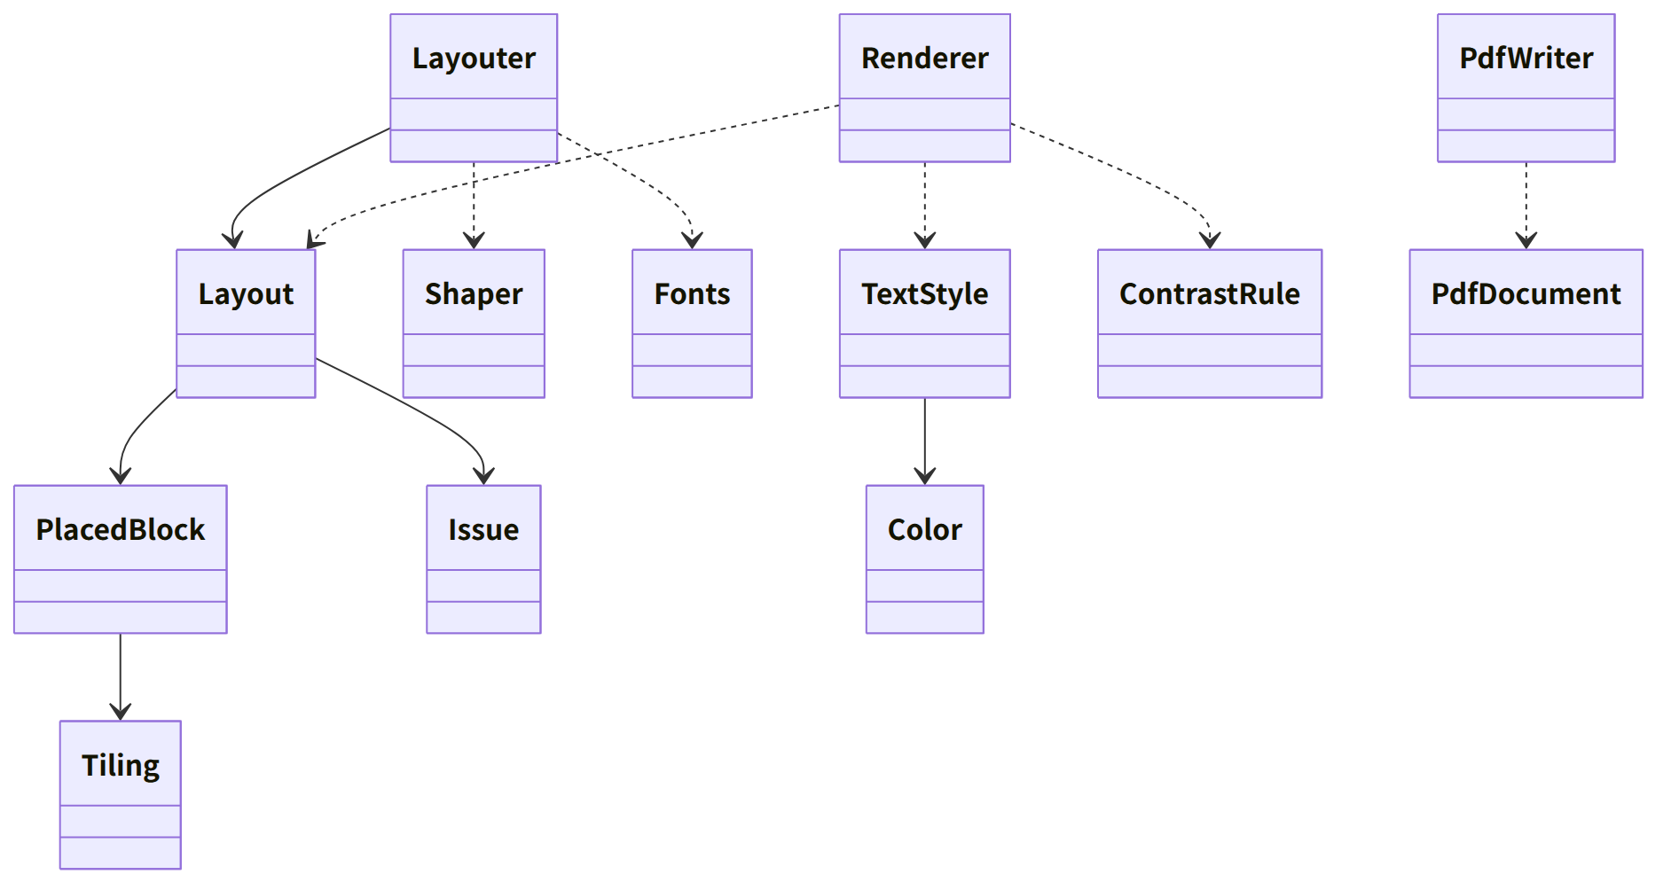
Figure：Class relationships（Class diagram）

Bridges (operations owned by this block)
No. | Operation (in the diagram above) | Used by | Origin
B-110 | Fonts | work | Chapter 4, 6 and 3.4
B-111 | Layouter::layout | work | Chapter 4, 7.1, 7.3, and 7.4
B-112 | Renderer::render_block | work | Chapter 4, 3.5 and 6.3
B-113 | Renderer::composite | sign | Chapter 4, 3.5
B-114 | ContrastRule | work | Chapter 4, 3.2
B-115 | PdfWriter::pdf_a | backup, case, app-client (exporting clues) | Chapter 1, 10.11

- Tiling draws one repeat once and lays it out (Chapter 4, 7.4). The center of rotation is the center of the block (Chapter 4, 3.5).

Algorithms (behind traits)
Trait | Implementation | Switching | Origin
Shaper | HarfRust. Vertical writing (vert, vhea and vmtx, rotation of Latin characters and digits, tate-chu-yoko) is own implementation | Fixed | Chapter 4, 3.3
ContrastRule | WCAG relative luminance and contrast ratio | Constants of the initial values (outline automatically at 3:1) | Chapter 4, 3.2
PdfWriter | krilla (also validated with veraPDF in CI). The alternative is printpdf | Fixed | Chapter 1, 10.11; Chapter 11, 12

Data design
- This block writes no records. Files of brought-in fonts are placed by core-work in assets/ (named by SHA-256; Chapter 8, 2.1), and this block receives the path and reads them.
- The fields, ranges, and defaults of TextStyle are the table in Chapter 4, 3.2; the anchors, margins, and shrinking of PlacedBlock are 7.1 and 7.3; the tiling fields are the table in 7.4. Holding these inside the template record (nrsd.template/2) is core-work (Chapter 4, 15.1).

