Anti-Repost Tool for Cosplay Photos
core-rights (business; Permitted Scope, Enclosed Document, rights metadata, example notice texts)
Edition 1 (Draft) 2026-09-29 · Ishikawa Sou
Nagareyama Software Development Co., Ltd. (NRSD)
© 2026 Nagareyama Software Development Co., Ltd. (NRSD), Lead Developer: Ishikawa Sou (石川宗). Copyright in this document belongs to Nagareyama Software Development Co., Ltd. (NRSD). Rights in the third-party standards, software, commentaries on laws, and other materials referred to in this document belong to their respective holders. This is a translation of the Japanese original; where they differ, the Japanese original prevails.
Contents
Sections taken
Dependencies
Class diagram
Bridges (operations owned by this block)
Algorithms (behind traits)
Data design (what this block gives form to; outputs, not device records)

Sections taken
- Chapter 2, 2.2 Limits of where the notice code is displayed
- Chapter 3, 3.3 Language of rights notices, 3.6 Rights metadata in files
- Chapter 5, 2.1 Options, 2.3 Linking to images, 2.4 Changes after sale, 3.1 Structure, 3.2 Outline of the common part, 3.4 Detecting rewriting, 3.6 Machine-readable Permitted Scope (ODRL), 3.8 Country and language codes, 5 Countries, 6.1 Levels of example texts
- Roles and external components: Chapter 11, 7.1

Dependencies
- Below: core-common (Text::text, NoticeCode, WorkId), core-store (Chain::sign_embedded: signing corrected versions), core-hash (SHA-256 of the Enclosed Document), core-ref (texts texts/, example texts, the posting site table, the pinned version).
- Does not depend on settings: the countries and languages to enclose are read from the settings and passed by the caller (core-sign, app-client).
- Corrected versions: listing the affected works is app-client (from core-sign's work data and core-ref's corrections_since), generation is this block, signing is core-store's sign_embedded (the RecordSigner is core-identity).

Class diagram
- PermittedScope
  - +Base base P1 | P2
  - +[Addon] addons A1 A2 A3
  - +short() String P2+A1+A2
  - +always_included() [Condition]
  - +sns_default() PermittedScope the social media default "P1 equivalent: viewing only, no reposting" (Chapter 5, 2.1; Chapter 3, 8.2)
- Enclosure
  - +[EnclosureFile] files 00_RIGHTS_README.txt, 00_RIGHTS_<country>.txt, 00_RIGHTS.json
  - +[(String, Hash)] hashes
- EnclosureBuilder
  - +build(scope, countries: [Country], holder: Holder, batch_id: Uuid, work_ids: [WorkId], ref_pinned: RefBundle) Enclosure
  - +regenerate(work: WorkData) Enclosure
  - +errata(work_ids, correction: Correction) (ErrataFile, Jws)
- Holder
  - +String handle
  - +NoticeCode notice_code
  - +[Url] accounts
  - +Option<Party> grantor output of an authorized person
  - +Option<Party> co_rights_holder
- Odrl（module）
  - +offer(scope, batch_id, holder, work_ids) JsonLd the correspondence of Chapter 5, 3.6
- EnclosureVerifier
  - +verify(folder: Path, manifest_hashes: [(String, Hash)]) VerifyReport match, mismatch, missing, extra; legitimacy of ERRATA
- Deed（module）
  - +deed(scope, lang) DeedTable can, conditions, cannot
- RightsText（module）
  - +rights_fields(stream, scope, lang, holder, title) RightsFields values of XMP, EXIF, cawg.metadata, cawg.training-mining
  - +notice_texts(level, lang, handle, code, platform, profile_limit: Option<u32>, registration: Option) String short, medium, long (Chapter 5, 6.1). The caller passes the limit from the platforms column (Chapter 2, 2.2)
  - +license_short(scope) String
- ViolationRules（trait）
  - +violations(scope, facts: RepostFacts) [ViolationCandidate]
- RepostFacts
  - +bool paid
  - +bool public
  - +bool c2pa_missing
  - +bool pixels_identical_to_delivery
  - +PlatformC2paSurvival survival
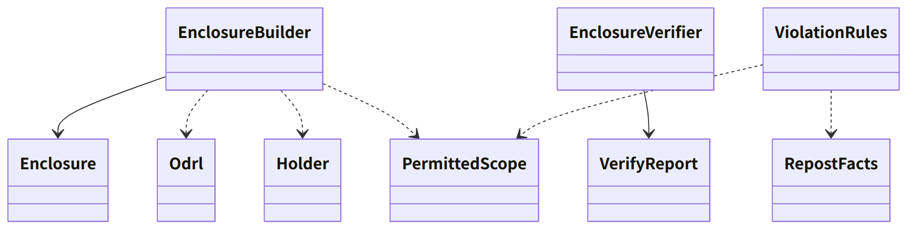
Figure：Class relationships（Class diagram）

Bridges (operations owned by this block)
No. | Operation (in the diagram above) | Used by | Origin
B-120 | PermittedScope | work, sign, case, app-client | Chapter 5, 2.1
B-121 | EnclosureBuilder::build | sign | Chapter 5, 3, 4, and 3.1
B-122 | EnclosureVerifier::verify | sign, app-client | Chapter 5, 3.4
B-123 | RightsText::notice_texts (the posting site limit comes from the table column) | app-client | Chapter 5, 6
B-124 | RightsText::rights_fields | sign | Chapter 3, 3.3 and 3.6
B-125 | Deed::deed | app-client, P-6 (the same table) | Chapter 5, 3.1
B-126 | EnclosureBuilder::regenerate, errata | app-client | Chapter 5, 2.4 and 4
B-127 | RightsText::license_short | work | Chapter 5, 2.1
B-128 | ViolationRules::violations | case | Chapter 5, 2.3

Algorithms (behind traits)
Trait | Implementation | Switching | Origin
ViolationRules | The candidate rules of Chapter 5, 2.3 (publication outside the Permitted Scope, commercial use, the condition of removed matching data) | Fixed | Chapter 5, 2.3

Data design (what this block gives form to; outputs, not device records)
Output | Form | Fields | Origin
00_RIGHTS_README.txt | TXT (UTF-8, no BOM, CRLF). Japanese, Chinese, English | The 10 items of Chapter 5, 3.2 | Chapter 5, 3.1 and 3.2
00_RIGHTS_<country>.txt | TXT | The per-country part (the texts are the reference information's texts/; P-7) | Chapter 5, 3.1 and 3.3
00_RIGHTS.json | ODRL 2.2 JSON-LD (Offer) | The table and example of Chapter 5, 3.6. The URIs of uid, assigner, and target are https://c2pa4cosplayer.nrsd.jp/id/… | Chapter 5, 3.6
00_RIGHTS_ERRATA.txt + .sig | TXT, JWS detached | The SHA-256 of the original and the corrected version at the head, the difference, the signature | Chapter 5, 2.4 and 3.4
RightsFields (XMP and EXIF values) | core-image's type | The fields of the table in Chapter 3, 3.6 | Chapter 3, 3.6

- The Permitted Scope is recorded in the work data's rights (core-sign's page) and in the manifest's jp.nrsd.rights, cawg.metadata, and cawg.training-mining (Chapter 3, 3.1).
- The body of the Enclosed Document is made by filling the insertions {handle}, {account}, {scope}, and {url} in the reference information's texts/common.<language>.md and texts/country.<country>.<language>.md (Chapter 5, 4) (the rules are the same as Chapter 4, 3.1; this block does not use core-work's insertion rules but places the same rules on core-common's Text side).

