Anti-Repost Tool for Cosplay Photos
core-sync (business; linking and syncing devices, confirmed contacts and direct handover of documents)
Edition 1 (Draft) 2026-09-29 · Ishikawa Sou
Nagareyama Software Development Co., Ltd. (NRSD)
© 2026 Nagareyama Software Development Co., Ltd. (NRSD), Lead Developer: Ishikawa Sou (石川宗). Copyright in this document belongs to Nagareyama Software Development Co., Ltd. (NRSD). Rights in the third-party standards, software, commentaries on laws, and other materials referred to in this document belong to their respective holders. This is a translation of the Japanese original; where they differ, the Japanese original prevails.
Contents
Sections taken
Dependencies
Class diagram
Bridges (operations owned by this block)
Algorithms (behind traits)
Data design

Sections taken
- Chapter 2, 5.5 Adding a contact (handing over documents)
- Chapter 8, 5.4 Syncing between devices
- Read-only: Chapter 1, 10.10 (the QR link and contact; the form is core-common), Chapter 1, 12 (the relay list relays.json; the form is core-ref), Chapter 8, 5.5 (a device as a backup location).

Dependencies
- Below: core-common (Qr, AppUrl::Link, AppUrl::Contact, Clock), core-store (Chain: exchanging heads and appending and verifying missing rows. Settings::merge_remote: device-independent items), core-net (Reachability, Scheduler, Limits::for_target (Direct, Dht), reading the no-relay setting), core-identity (current (the chain of the personal root and signing certificate), Keystore (the device key; signing nonces with with_signing_key; handing over keys at linking with export_keys / import_keys), Grants (importing documents), os_user_verify), core-ref (relays.json, the implementation of BundleSource), core-work (Merge::merge_remote).
- Above: app-client (G-18 contacts, G-20 devices, sync_now at start, notifications of arrived documents and templates). The location of core-backup's Device is wired by app-client via backup_folder.
- Boundary with the outside B-335 (direct connection: iroh's QUIC, public relays, the pkarr DHT). HTTP does not pass through it, so core-net's Http is not used.

Class diagram
- Endpoint
  - +NodeId node the device's public key
  - +start(relays, relay_mode) Endpoint iroh. ALPN c2pa4cosplayer/sync/1
  - +connect(peer: NodeId) Conn
  - +accept() Conn
- Link
  - +link_qr() Qr shown to the new device
  - +link_from(src: Qr ｜ CodePhrase) Result<Device> after the check, hands over the keys (export_keys) over the wire
  - +devices() [Device] at most 5 devices
  - +remove_device(id)
  - +announce_removed() the "this device was removed" row (before erasing records; Chapter 9, 2.3)
  - +challenge(conn) Result mutual check of the certificate chain and signatures over nonces
- Device
  - +DeviceId id
  - +NodeId node
  - +String name
  - +Option<Rfc3339> last_synced
- CodePhrase
  - +String phrase one number and two words from the PGP word list
  - +new() CodePhrase
  - +publish(node, ttl: 10min) Argon2id, then Ed25519, then pkarr
  - +resolve(phrase) NodeId
- Pake（trait）
  - +agree(conn, phrase) SessionKey SPAKE2 (RFC 9382)
- Contacts
  - +contact_qr() Qr
  - +contact_passphrase() CodePhrase
  - +add_contact(src: Qr ｜ CodePhrase) Pending
  - +safety_number(peer) String 60 digits as 5 digits x 12
  - +confirm(peer)
  - +peers() [Peer]
  - +remove(peer)
- Peer
  - +PeerId id
  - +NodeId node
  - +NoticeCode notice_code
  - +PeerState state Pending | Confirmed
- SafetyNumber（trait）
  - +compute(mine, theirs) String SHA-512 x 5200, first 30 bytes
- Transfer
  - +send_document(peer, doc: Document) Result queued until it arrives
  - +send_template(peer, tpl: Path) Result
  - +receive(conn) Inbound documents go to Grants::import, templates to "received templates"
  - +outbox() [Queued]
- Sync
  - +sync_now() SyncReport exchange heads, then missing rows, then blobs, then Merge
  - +backup_folder() Path receives the counterpart device's backups
  - +exchange_heads(conn) [(Stream, DeviceId, u64)]
- SyncReport
  - +[(DeviceId, u32)] rows_received
  - +u32 blobs_received
  - +[Conflict] conflicts rows with the same device and seq but different content (Chapter 1, 8.3)
  - +Option<u32> bundle_version_offered the counterpart's reference information version (BundleSource)
- Blobs
  - +fetch(conn, hash: Blake3) Path iroh-blobs. Resumes midway
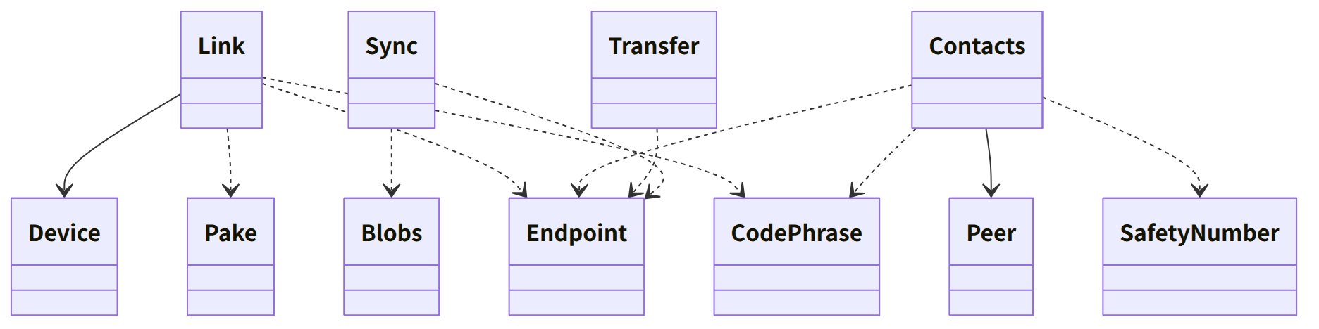
Figure：Class relationships（Class diagram）

Bridges (operations owned by this block)
No. | Operation (in the diagram above) | Used by | Origin
B-260 | Link (link_qr, link_from, devices, remove_device) | app-client | Chapter 8, 5.4; Chapter 10, G-20
B-261 | Contacts (QR, passphrase, add, safety number, confirm, list, remove) | app-client | Chapter 2, 5.5
B-262 | Transfer::send_document (what arrives goes to Grants::import) | app-client | Chapter 2, 5.5
B-263 | Transfer::send_template | app-client | Chapter 8, 5.4
B-264 | Sync::sync_now, backup_folder | app-client | Chapter 8, 5.4

Algorithms (behind traits)
Trait | Implementation | Switching | Origin
SafetyNumber | The Signal method (version 0, the personal root's SPKI, the notice code, then SHA-512 x 5200, then 30 digits x 2, then 60 digits) | Fixed | Chapter 2, 5.5
CodePhrase | The form of Magic Wormhole. An Ed25519 seed by Argon2id, a 10-minute record on pkarr (BEP 44) | Fixed | Chapter 8, 5.4
Pake | SPAKE2 (RFC 9382) | Fixed | Chapter 8, 5.4
Transfer | Direct QUIC connection (iroh); relays only for NAT hole punching; large things via iroh-blobs (BLAKE3) | The no-relay setting (G-20) | Chapter 8, 5.4

Data design
Record | Form | Fields | Origin
peers.json (nrsd.peers/1; top level; included in backups, not synced) | JSON | Devices: the fields of Device (device number, public key, name, date/time linked, date/time last synced, backup location). Contacts: the fields of Peer (notice code, SHA-256 of the root, name, date/time confirmed, known device numbers) | Chapter 8, 2.1 and 5.4; Chapter 2, 5.5
state/outbox/ (nrsd.outbox/1) | Queue of documents and templates (per contact) | Recipient, SHA-256 of the file, date/time created | Chapter 2, 5.5
Device key (keystore; core-identity) | — | The secret key of iroh's NodeId is derived from the device key (Chapter 2, 7.1) | Chapter 2, 7.1; Chapter 8, 5.4
Wire form | CBOR (ALPN c2pa4cosplayer/sync/1) | Hello (certificate chain, nonce), Prove (signature), Heads, Rows, Blob (BLAKE3), Doc, Tpl | Chapter 8, 5.4

