Anti-Repost Tool for Cosplay Photos
ui (screens P-3; the WebView's HTML, CSS, and TypeScript. Display and input only)
Edition 1 (Draft) 2026-09-29 · Ishikawa Sou
Nagareyama Software Development Co., Ltd. (NRSD)
© 2026 Nagareyama Software Development Co., Ltd. (NRSD), Lead Developer: Ishikawa Sou (石川宗). Copyright in this document belongs to Nagareyama Software Development Co., Ltd. (NRSD). Rights in the third-party standards, software, commentaries on laws, and other materials referred to in this document belong to their respective holders. This is a translation of the Japanese original; where they differ, the Japanese original prevails.
Contents
Sections taken
Dependencies
Class diagram (the structure on the screen side; TypeScript modules)
How the screens are accommodated (screen × commands called × notifications received × states in which it can be opened)
Bridges
Algorithms (what remains on the screen side)
Data design (what is placed on the screen side)

Sections taken
- Chapter 10: 2.1 Direction, 2.2 Fonts, 2.3 Colors, 2.5 Steps of text size and spacing, 2.6 List of components, 2.7 Definition of readability, 3.1 List of screens, 3.2 Transitions, 3.3 Layout of the main screens, 3.4 Displaying large lists, 3.5 Specification per screen (G-01 to G-25), 3.6 List of confirmation dialogs, 3.7 List of notifications, 5 Language, 6.1 First-run guidance, 6.2 Legal guidance, 6.3 Errors and help, 7 Display considerations, 9 Feedback channel
- Chapter 4: 9.1 Selecting and moving, 9.2 Display, 9.3 List of key bindings, 10.5 History list, 13.1 The two states of the image editing screen
- Chapter 3, 10.3 Survival on posting sites and Cloud (the one line in G-11), Chapter 5, 2.2 Explanation for non-technical people, 6.2 Relation to matching of rights (the guidance in G-04), Chapter 7, 6.1 Flow, 7 Where the line is drawn (the permanent text in G-17), Chapter 12, 6 What is returned to the screen
- Sections taken as screen text: Chapter 2, 3.3 How it appears in verifiers (the guidance in G-13), 4.5 Photos from before adoption (the text in G-01 and G-22).
- Read-only: Chapter 10, 4 (correspondence of requirements and screens), 10 (setting items; the values are app-client's get_settings), Chapter 1, 6.2 (CSP, permissions, handling of external text).

Dependencies
- Below: app-client only (calls the Tauri commands B-280 to B-293, subscribes to the notifications B-294, passes B-295 at start). It does not touch the Rust core directly. It holds no file, communication, key, or drawing processing (Chapter 1, 6.1).
- Processing done inside the screen: display and input checks (checking the form of fields; business checks are the core), virtualization of lists, dragging of elements on the editing screen (drawing overlays the result of the core's composite; Chapter 4, 9.4), display of dates and numbers by Intl, applying the texts.
- Outside: message files (P-4; ICU MessageFormat JSON; B-323), the generated command types and permission list (P-13; B-324), bundled fonts and guide images (P-8).
- Dependency inversion: the type of notifications (Event) is defined by app-client and subscribed to by ui.

Class diagram (the structure on the screen side; TypeScript modules)
- App
  - +boot(webview_info) B-295, then get_startup_state, then the first screen by state
  - +route(screen: ScreenId, params)
- Router
  - +go(screen, params)
  - +back()
  - +can_open(screen, app_state) bool the conditions of Chapter 10, 3.2, the eight states of Chapter 1, 7
- ScreenId（enumeration）
  - G01_Welcome
  - G02_Consent
  - G03_Identity
  - G04_Notice
  - G05_BackupSetup
  - G06_Restore
  - G07_Home
  - G08_ExportSelect
  - G09_BulkApply
  - G10_Scope
  - G11_ExportRun
  - G12_Works
  - G13_Verify
  - G14_Register
  - G15_Cases
  - G16_CaseDetail
  - G17_Guidance
  - G18_GrantsContacts
  - G19_KeysNotice
  - G20_Settings
  - G21_Notices
  - G22_Help
  - G23_About
  - G24_Clues
  - G25_Editor
- Api（generated）
  - +invoke(cmd, args) Promise generated from P-13. The types of B-280 to B-293
- EventBus
  - +on(kind: Event, handler) progress, notice, save_state, update_ready, startup_prompt, dropped_files, peer_event
- Store
  - +AppState app_state
  - +Settings settings
  - +[Notice] notices
  - +Map<ScreenId,ScreenState> screens values of input in progress
- I18n
  - +t(key, args) string intl-messageformat, <screen>.<component>.<role>, err.<number>.*
  - +set_language(lang)
  - +lang_attr(lang) string ja / zh-Hans / en
  - +format_date(utc, tz) string always with the time zone offset
- Theme
  - +tokens the names of Chapter 10, 2.3. Values are not hard-coded into components
  - +mode: Light ｜ Dark ｜ System
  - +scale: 0.9..2.0 Tauri's zoomHotkeysEnabled is not used (Chapter 10, 2.5)
  - +reduce_motion bool
  - +privacy_mask bool hides Notice accounts and case URLs (Chapter 10, 7)
  - +min_window 1024x700 in a smaller window the left navigation becomes icons only (Chapter 10, 3.3)
- Components
  - PrimaryButton
  - SecondaryButton
  - DangerButton
  - Field
  - Choice
  - Stepper
  - Grid
  - Table
  - Banner
  - ConfirmDialog
  - Progress
  - Mascot
- VirtualList
  - +render(visible_range) Chapter 10, 3.4
- EditorMode（enumeration）
  - EditTemplate "Edit template"
  - EditSession "Edit work session" (switch between all photos of this work session / this photo only)
- HistoryPanel
  - +list() newest first; pressing a step goes back to it (Chapter 4, 10.5)
- ScopeCard
  - +render(scope) a one-sentence explanation and illustrated examples of what can and cannot be done (Chapter 5, 2.2)
- EditorCanvas
  - +EditorMode mode
  - +select(ids, additive)
  - +drag(delta)
  - +resize(handle, delta)
  - +rotate(delta, snap15)
  - +snap(guides)
  - +zoom(level) 100% requests a redraw from full size
  - +compare_before_after(held)
  - +numeric_inputs(pos, size, rot) Chapter 4, 9.1
  - +keymap Chapter 4, 9.3
- Dialogs
  - +confirm(kind) Promise<Choice> the list of Chapter 10, 3.6. The default is never the irreversible side
- Notices
  - +banner(notice) not dismissed automatically
  - +list()
- A11y
  - +focus_order(screen)
  - +lang_attrs()
  - +contrast_check() CI. Chapter 10, 2.7
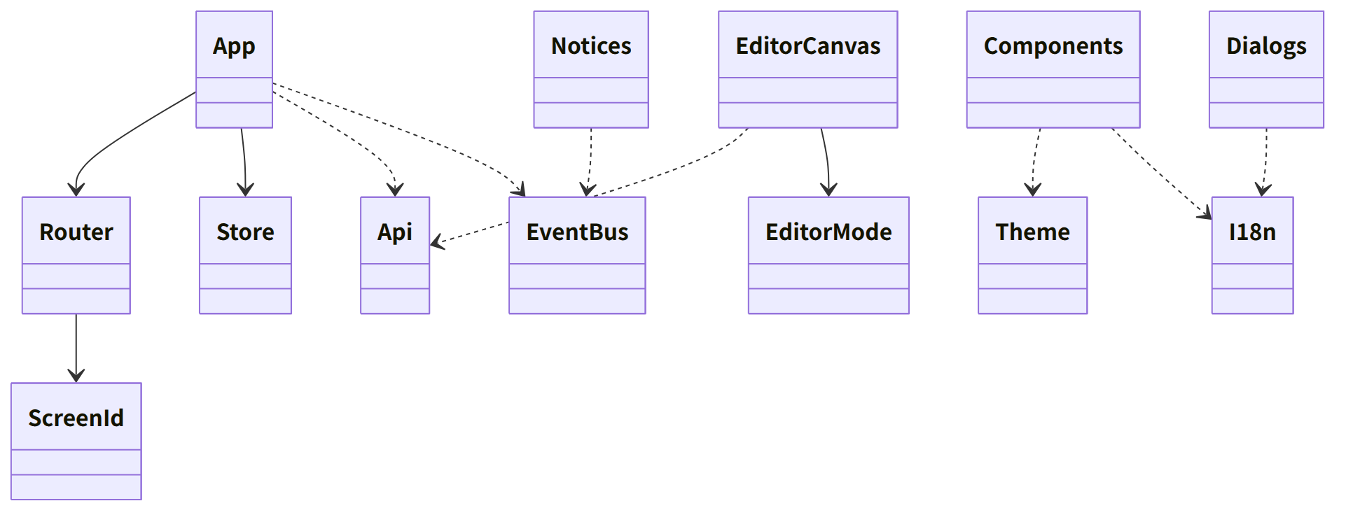
Figure：Class relationships（Class diagram (the structure on the screen side; TypeScript modules)）

How the screens are accommodated (screen × commands called × notifications received × states in which it can be opened)
- Where the core-side sequences (S-01 to S-12) reach the screen is accommodated here. The states are the eight of Chapter 1, 7 (before first run, verify only, no consent, normal, over 20 years, below the minimum version, migration failed, successor). The conditions for opening are Chapter 10, 3.2; what can be used in the read-only states is Chapter 8, 5.3 and Chapter 9, 4.2 and 4.4.
Screen | Commands called (app-client's table) | Notifications received | States in which it can be opened
G-01 to G-02 | B-280 | — | Before first run (G-01 is also the entrance for verify only)
G-03 to G-04 | B-281 | — | Before first run, normal (when correcting from G-19)
G-05 to G-06 | B-282 | progress, dropped_files (G-06) | Before first run (G-06 from G-01), normal, below the minimum version (creating backups only), successor (G-05 not allowed)
G-07 | B-283 | notice (the top banner), update_ready, dropped_files | Normal, no consent, over 20 years (the export and registration entrances cannot be pressed), below the minimum version (same), migration failed and successor (read only)
G-08 to G-11 | B-284, B-292 (touch-ups in G-09) | progress, save_state, notice (needs fixing, free space) | Normal, no consent
G-12 | B-285 | notice (linking Originals, corrected versions) | Normal, no consent, over 20 years, below the minimum version, migration failed and successor (read only; regenerating the Enclosed Document is allowed)
G-13 | B-285, B-293 | dropped_files | All states (leaves no records)
G-14 to G-16 | B-286, B-293 | progress (fetching, timestamp), dropped_files (G-14), notice (deadlines) | Normal, no consent (G-14 to G-16). Over 20 years and below the minimum version: G-14 not allowed, exporting the evidence set from G-16 allowed. Migration failed and successor: G-15 and G-16 read only (export allowed)
G-17 | B-287, B-293 | — | Normal, no consent (the reference information is the local version; a notice at the top if old)
G-18 | B-288 | peer_event (a document or template arrived) | Normal, no consent
G-19 | B-289 | notice (key expiry) | Normal, no consent, over 20 years (the entrance for remaking)
G-20 | B-290 | peer_event (connection from a counterpart device), notice | Normal, no consent, over 20 years, below the minimum version (portable kit, update from a file). Migration failed and successor: read only
G-21 to G-23 | B-291, B-293 | notice | All states (G-21 before first run only when the Terms changed)
G-24 | B-285 | — | Same as G-13
G-25 | B-292, B-293 | save_state, notice (save failure) | Normal, no consent
Start-up dialog (before the screen) | — | startup_prompt (passphrase), OS dialog (CPU) | —

- When a request to add to a screen comes, first add the row of this table (command, notification, state), then app-client's table (B-28x), then go down in the order of the core pages' bridges.

Bridges
- This block owns no bridges (it is the caller). The commands it calls and the notifications it subscribes to are the table of app-client (B-280 to B-295).
- External forms: message files (B-323; the key assignment is Chapter 10, 5), the generated command types and permission list (B-324; P-13).

Algorithms (what remains on the screen side)
Matter | Implementation | Origin
Color contrast | In CI, all combinations of Chapter 10, 2.3 are computed by the WCAG formula and 7:1 and 3:1 are checked | Chapter 10, 2.7
List virtualization | Only the visible rows are drawn. Thumbnails are URLs of the core's cache (asset://) | Chapter 10, 3.4
Snapping, aligning, numeric entry | As in the table of Chapter 4, 9.1 (0.1%, 1%, 0.5%, 15 degrees) | Chapter 4, 9.1
Display zoom | Chapter 4, 9.2. Beyond the thumbnail's magnification, a full-size crop is requested from the core | Chapter 4, 9.2 and 9.4

Data design (what is placed on the screen side)
Data | Location | Content | Origin
Values of input in progress | Memory (Store.screens). Only the draft of G-03 is saved in the core by a command | Field values | Chapter 2, 2.1
Read notices, window size | The core (settings.json, tauri-plugin-window-state) | — | Chapter 10, 10
Texts | i18n/<lang>.json (P-4) | ICU MessageFormat | Chapter 10, 5
Theme values | CSS variables (the names of Chapter 10, 2.3) | Colors, spacing (steps of 4 pixels), text steps | Chapter 10, 2.3 and 2.5

- The screen holds no records. localStorage and the like are not used (all records are in the core; Chapter 1, 6.1).

