Anti-Repost Tool for Cosplay Photos
S-01 Start-up
Edition 1 (Draft) 2026-09-29 · Ishikawa Sou
Nagareyama Software Development Co., Ltd. (NRSD)
© 2026 Nagareyama Software Development Co., Ltd. (NRSD), Lead Developer: Ishikawa Sou (石川宗). Copyright in this document belongs to Nagareyama Software Development Co., Ltd. (NRSD). Rights in the third-party standards, software, commentaries on laws, and other materials referred to in this document belong to their respective holders. This is a translation of the Japanese original; where they differ, the Japanese original prevails.
Contents
S-01a Normal start-up (until the screen is shown; serial)
S-01b Background after the screen is shown (a single queue; Chapter 1, 7)
S-01c Second launch, dropped files, deep-link
S-01d Closing and OS shutdown (Chapter 9, 4.1)
Gaps (found later and fixed)

Origin: Chapter 1, 7 (start-up order, the eight states), 7.8, 9.3; Chapter 8, 4; Chapter 9, 4.1 and 4.4; Chapter 11, 3.1; Chapter 12, 4.3.

S-01a Normal start-up (until the screen is shown; serial)
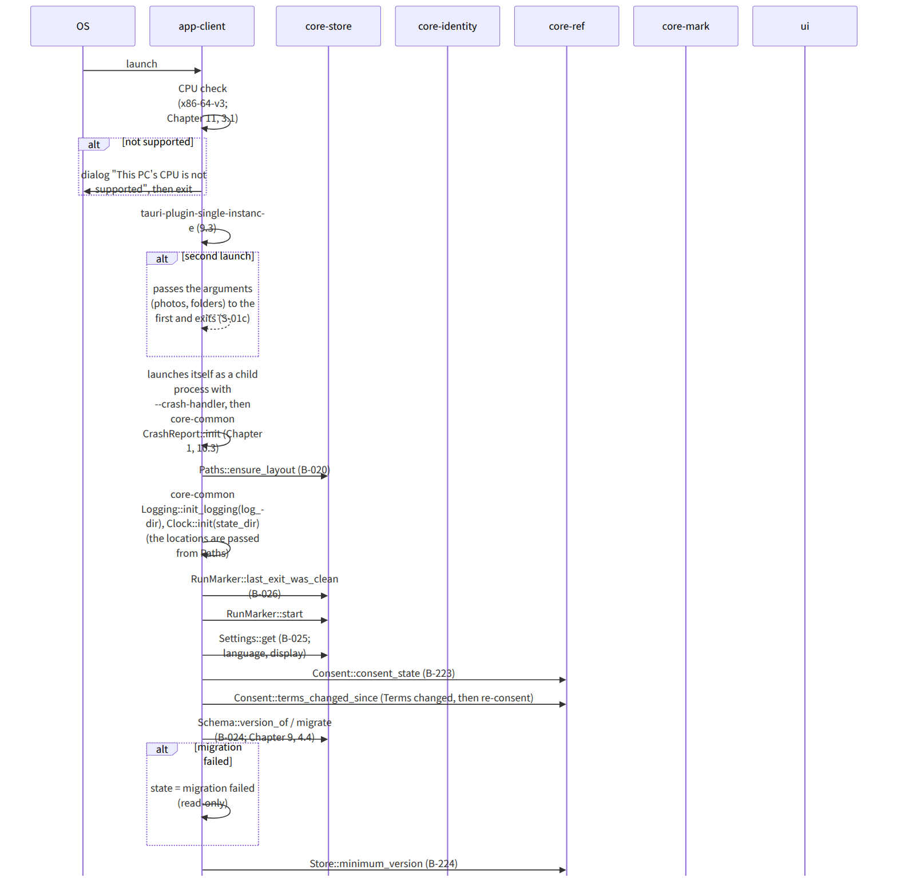
Figure：S-01a Normal start-up (until the screen is shown; serial)
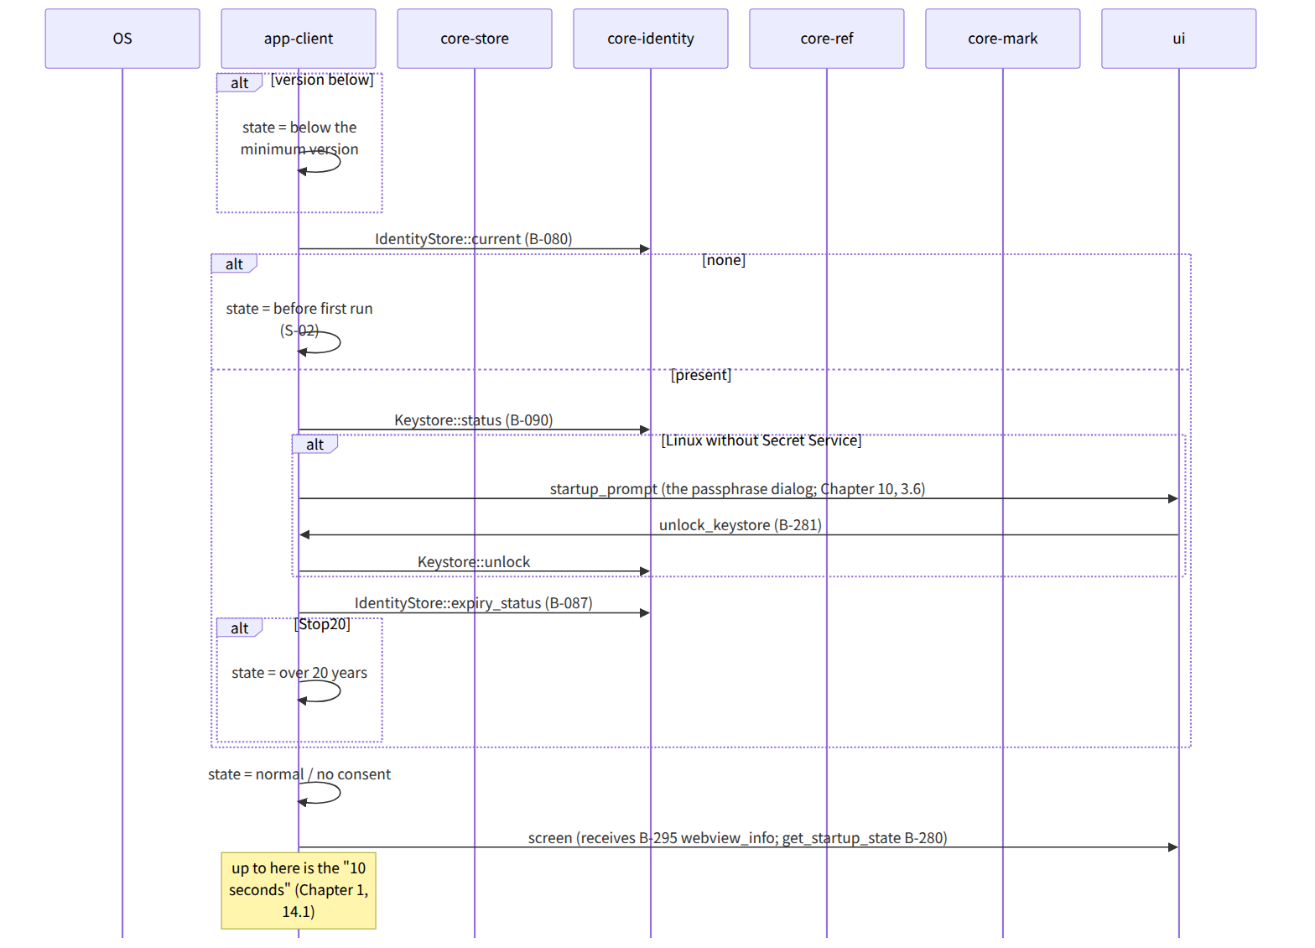
Figure：S-01a Normal start-up (until the screen is shown; serial)（continued 1）

S-01b Background after the screen is shown (a single queue; Chapter 1, 7)
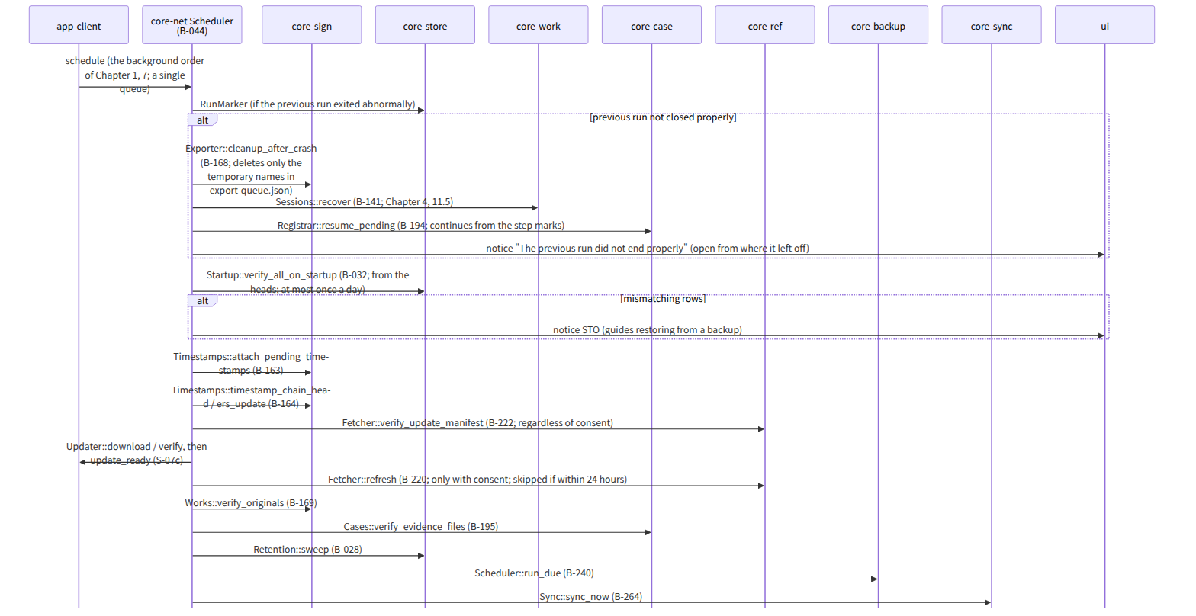
Figure：S-01b Background after the screen is shown (a single queue; Chapter 1, 7)
Figure：S-01b Background after the screen is shown (a single queue; Chapter 1, 7)（continued 1）

S-01c Second launch, dropped files, deep-link
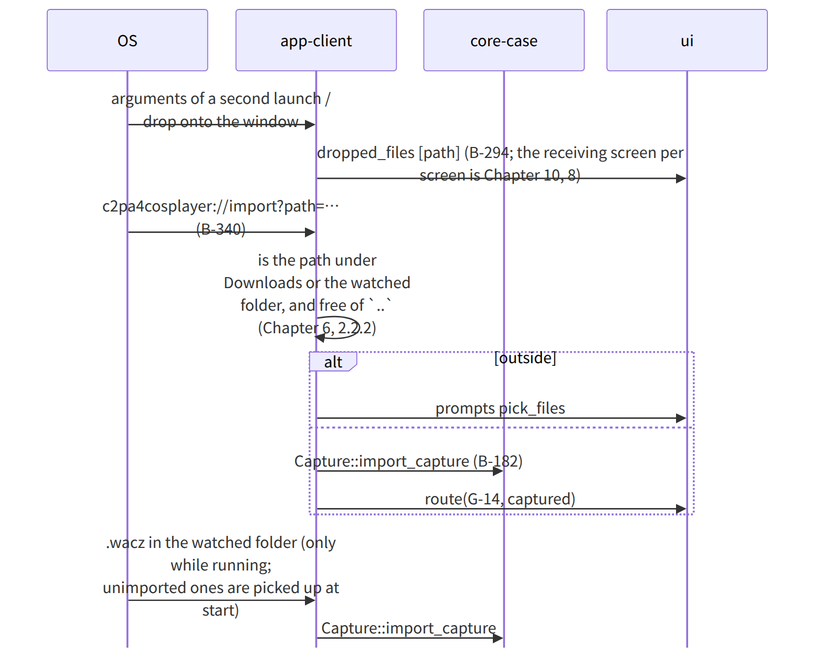
Figure：S-01c Second launch, dropped files, deep-link

S-01d Closing and OS shutdown (Chapter 9, 4.1)
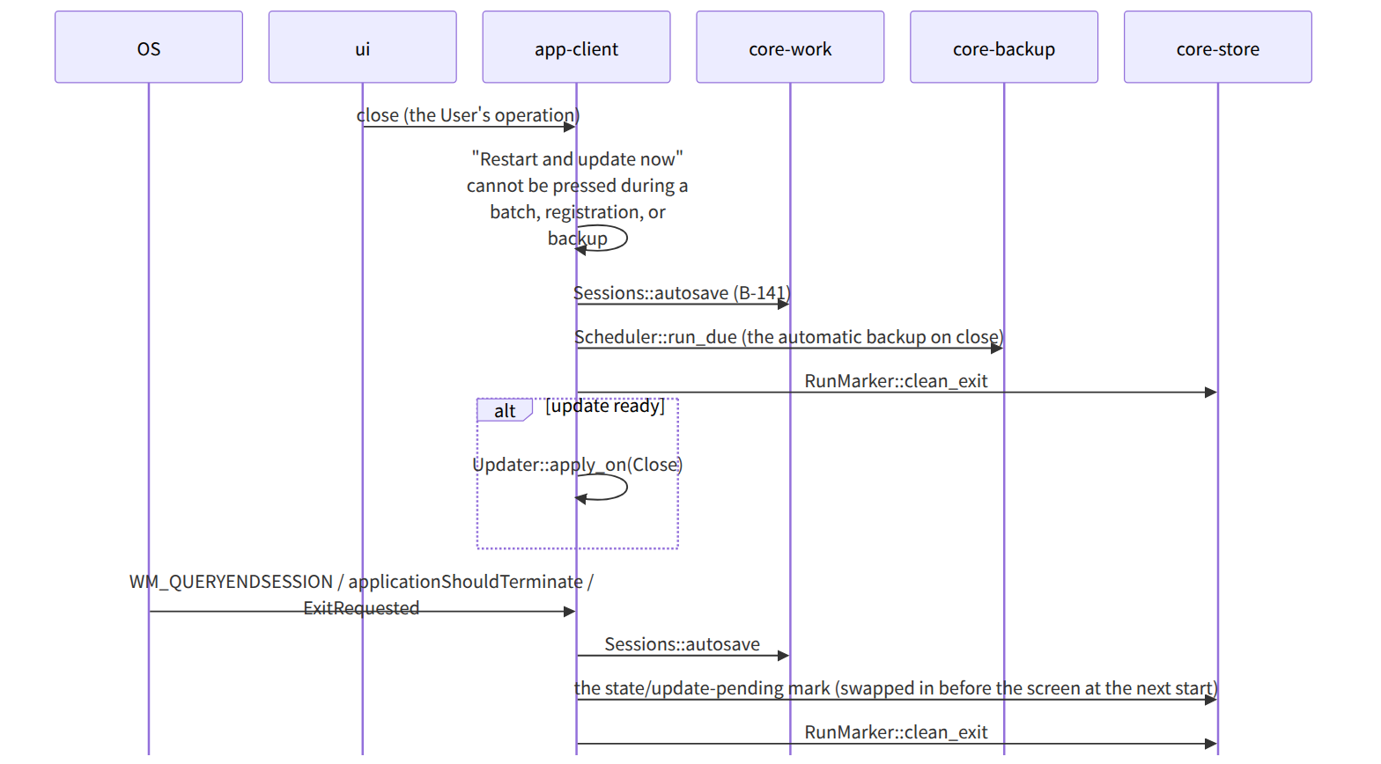
Figure：S-01d Closing and OS shutdown (Chapter 9, 4.1)

Gaps (found later and fixed)
- The serial start-up step “check for Terms changes” (Chapter 12, 4.3) was not in the note of Startup::run on app-client's page, so terms_changed_since was added to Startup in app-client.md (in line with S-01a of this file).
- When state/update-pending is placed and read existed only in app-client's data design, and the serial start-up (Chapter 1, 7) had no position for “swap in before showing the screen”, so, since the OS shutdown item of Chapter 9, 4.1 says “at the next start, before showing the screen”, “if state/update-pending exists, swap in the verified distributable (Chapter 9, 4.1)” was added at the head of the start-up order in Chapter 1, 7.
- The last item of the background queue, “deadline notices” (those missed while not running, Chapter 7, 6.3), was not in the background order of Chapter 1, 7, so it was added at the end of the background order in Chapter 1, 7.

