Anti-Repost Tool for Cosplay Photos
S-03 Export (G-08 → G-09 → G-10 → G-11)
Edition 1 (Draft) 2026-09-29 · Ishikawa Sou
Nagareyama Software Development Co., Ltd. (NRSD)
© 2026 Nagareyama Software Development Co., Ltd. (NRSD), Lead Developer: Ishikawa Sou (石川宗). Copyright in this document belongs to Nagareyama Software Development Co., Ltd. (NRSD). Rights in the third-party standards, software, commentaries on laws, and other materials referred to in this document belong to their respective holders. This is a translation of the Japanese original; where they differ, the Japanese original prevails.
Contents
S-03a Photos and purpose (G-08), then a work session
S-03b Batch application (G-09)
S-03c Permitted Scope (G-10; delivery only)
S-03d Execution (G-11; the 14 steps of Chapter 3, 8.1)
S-03e Cancel, interruption, resume
Gaps (found later and fixed)
Added to the specification

Origin: Chapter 1, 7.2; Chapter 3, 2, 8.1 (14 steps), 9, 10, and 11; Chapter 4, 7.2, 11, 12, and 14; Chapter 5, 3 and 4; Chapter 2, 4.6 and 5.4.

S-03a Photos and purpose (G-08), then a work session
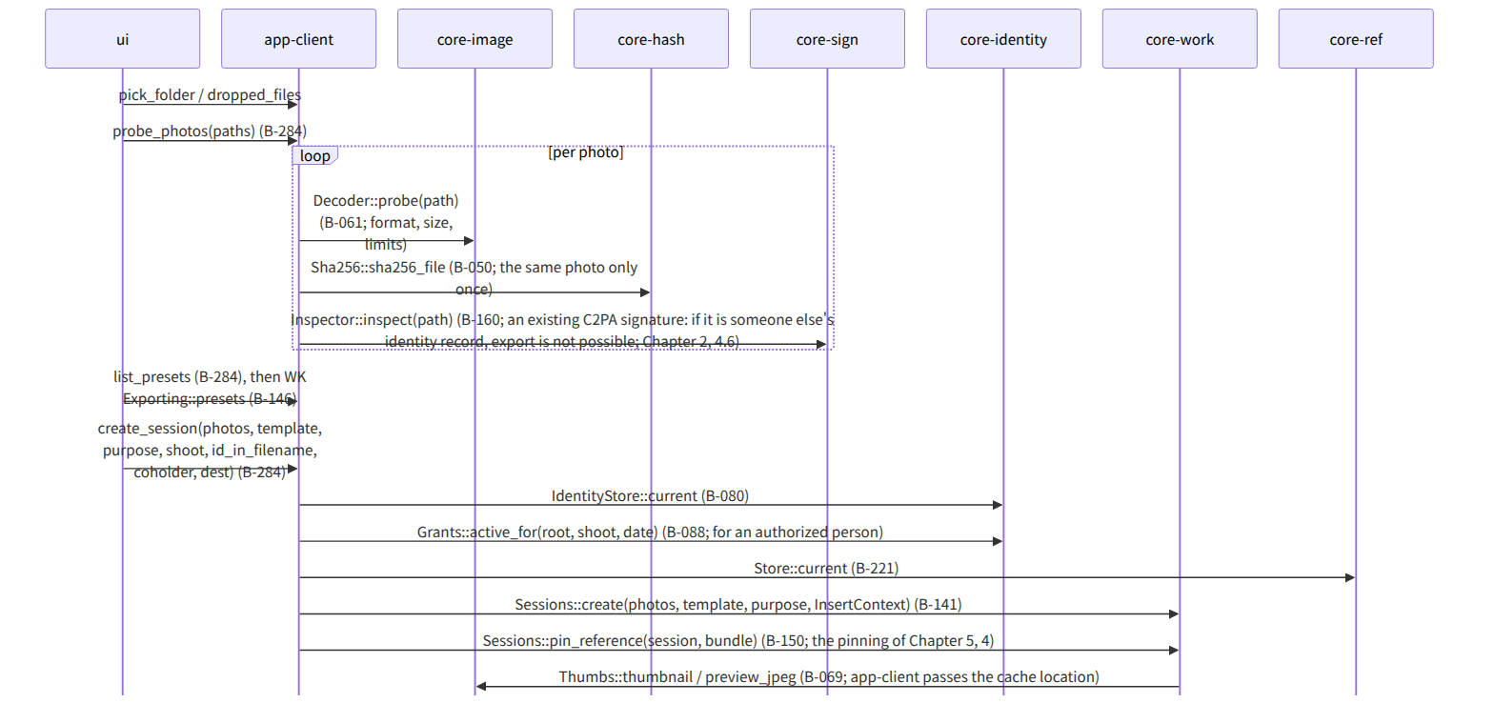
Figure：S-03a Photos and purpose (G-08), then a work session

S-03b Batch application (G-09)
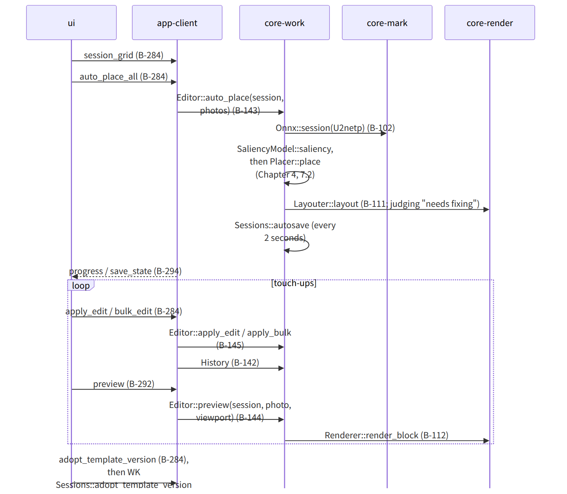
Figure：S-03b Batch application (G-09)

S-03c Permitted Scope (G-10; delivery only)
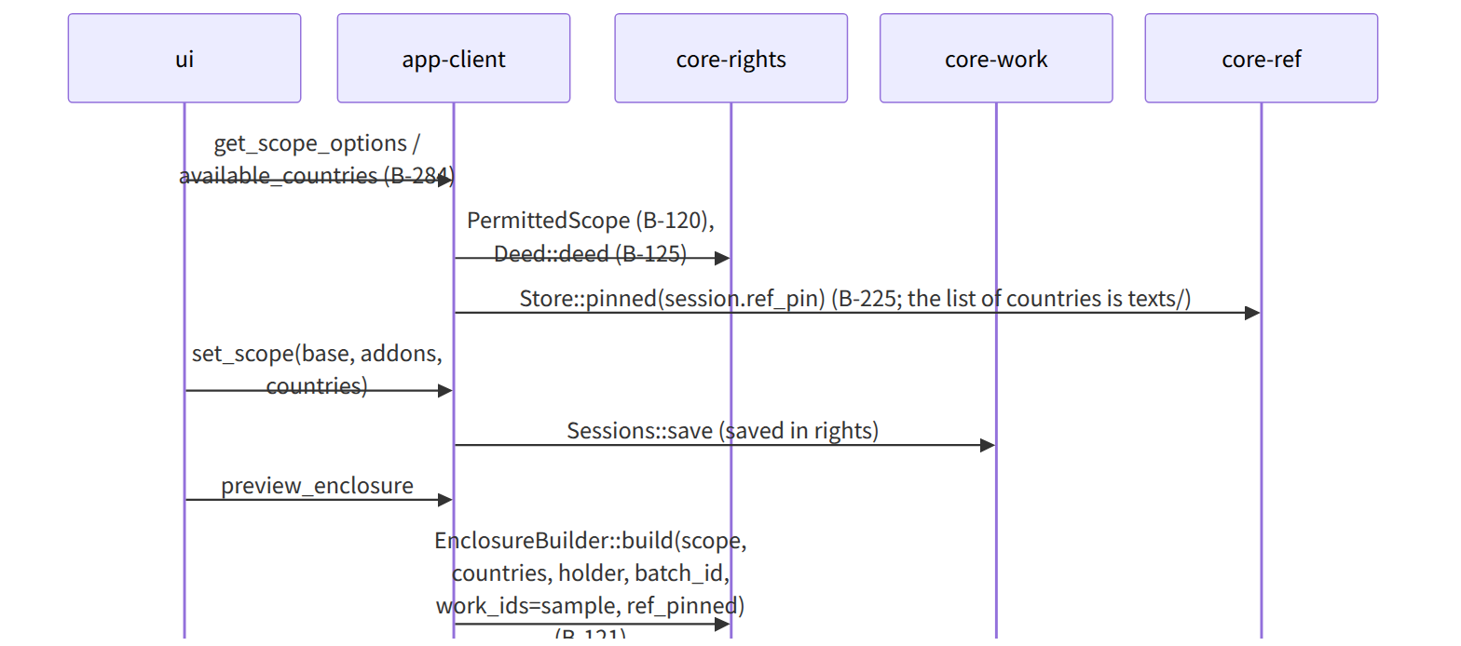
Figure：S-03c Permitted Scope (G-10; delivery only)

S-03d Execution (G-11; the 14 steps of Chapter 3, 8.1)
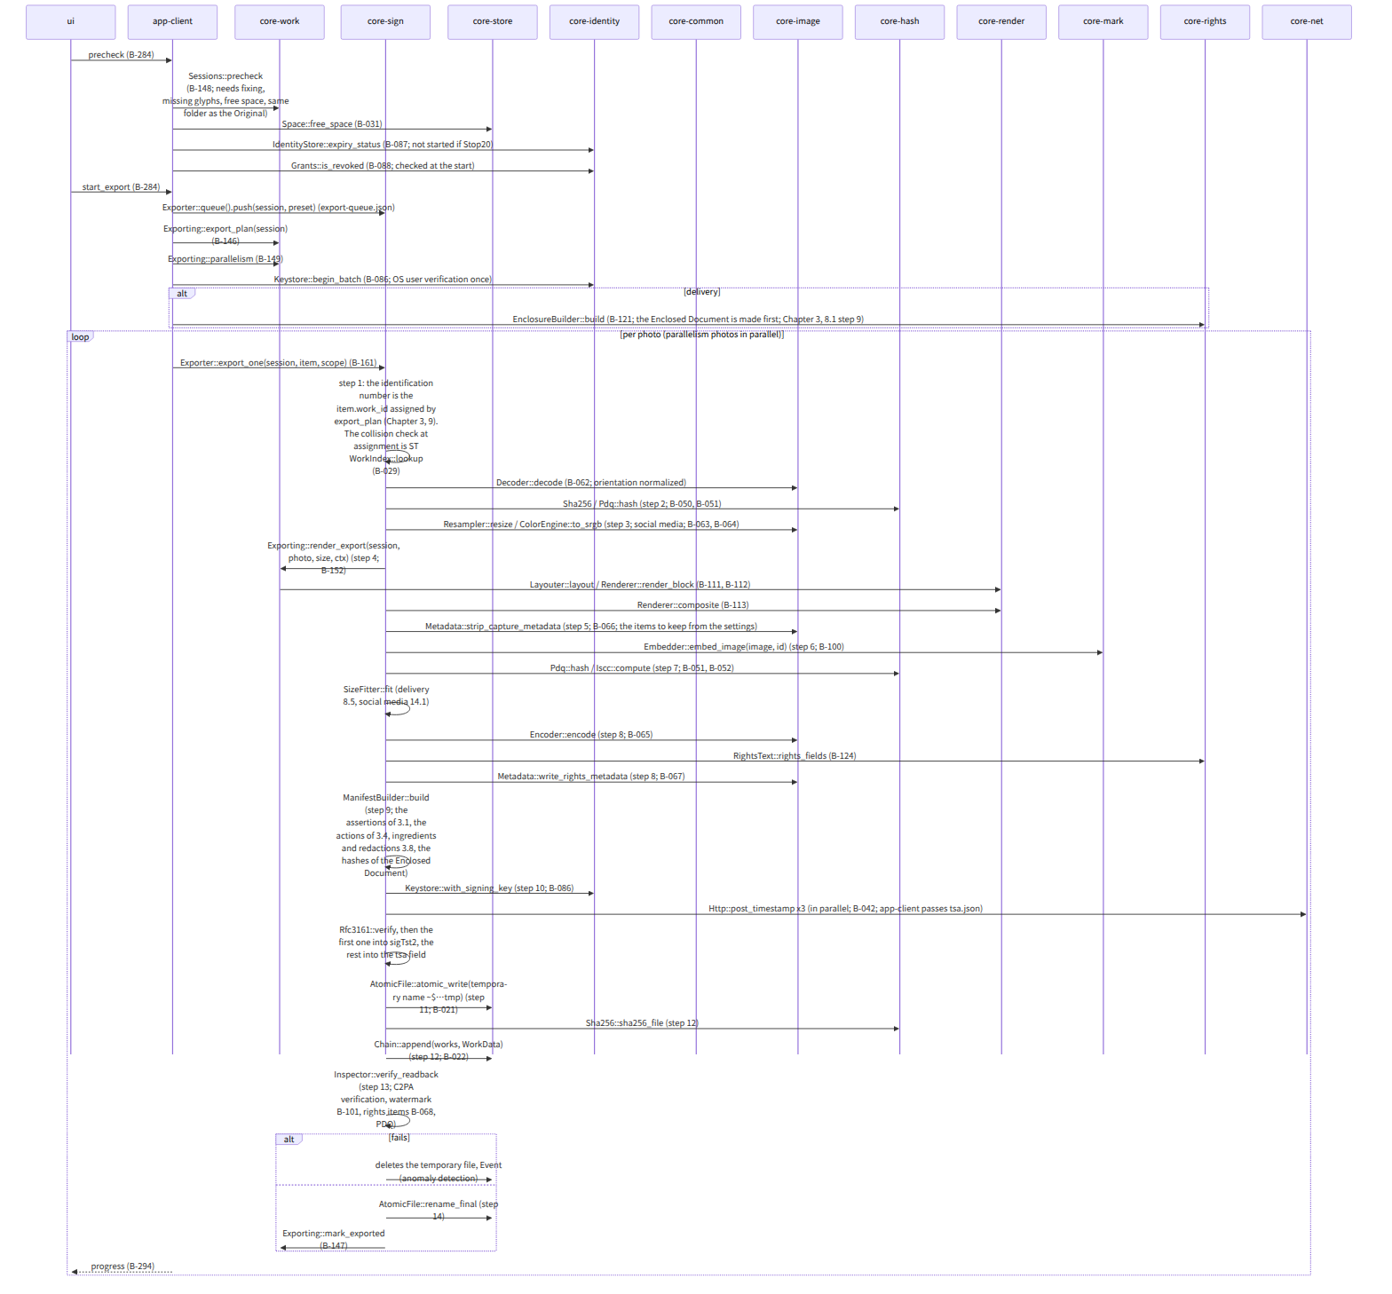
Figure：S-03d Execution (G-11; the 14 steps of Chapter 3, 8.1)
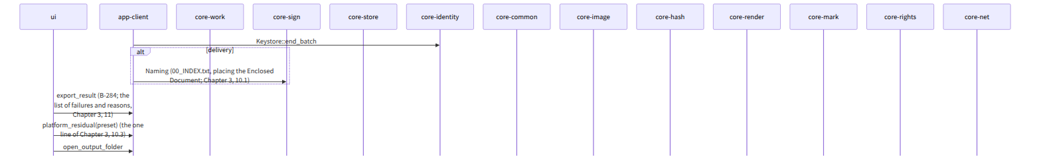
Figure：S-03d Execution (G-11; the 14 steps of Chapter 3, 8.1)（continued 1）

S-03e Cancel, interruption, resume
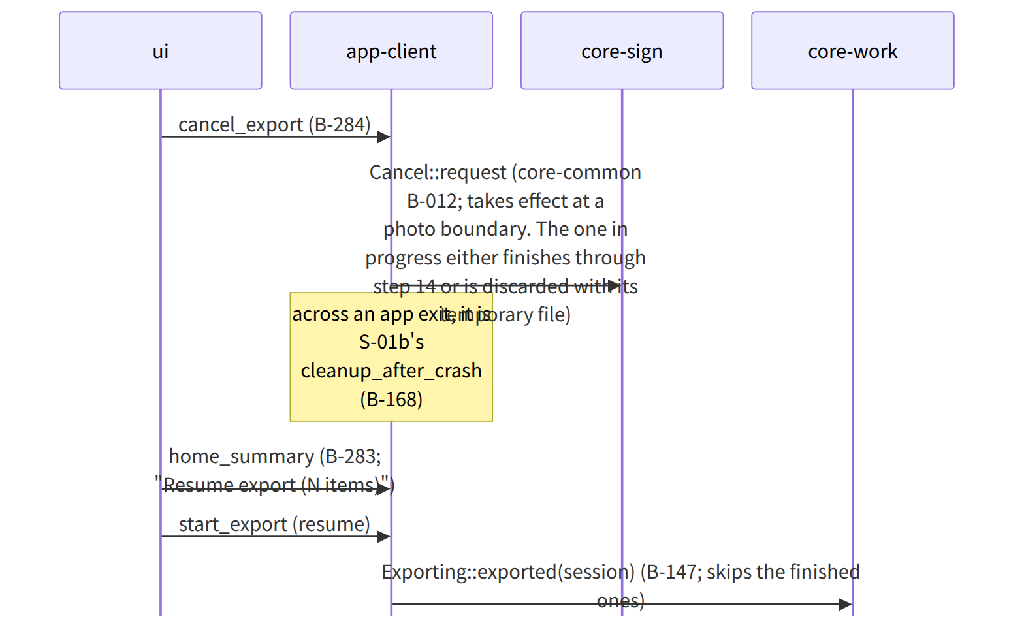
Figure：S-03e Cancel, interruption, resume

Gaps (found later and fixed)
- The “check of revoked authorizations” at the start (Chapter 2, 5.4) was not in app-client's precheck flow, so this file places Grants::is_revoked after precheck, and one line was added to the dependencies of core-sign.md that app-client calls the Grants::is_revoked of core-sign.md's dependencies at the start, not per photo.
- Where tsa.json is passed: because core-sign does not depend on core-ref (core-sign.md), export_one needs a tsa_set argument, so tsa_set was added to the arguments of Exporter::export_one in core-sign.md.
- Making the Enclosed Document “first” (Chapter 3, 8.1 step 9) happens once at the beginning of the batch, but 00_RIGHTS.json holds the list of all photos' identification numbers (Chapter 5, 3.1), and identification numbers are assigned per photo in step 1, so the list is not fixed at step 9 of the first photo. It was decided in Chapter 3, 9 that identification numbers for all photos are assigned at the start of the batch (Exporting::export_plan holds a WorkId per ExportItem; noted in B-146 of core-work.md).
- The position of Keystore::begin_batch (OS user verification once per batch) is in Chapter 2, 7.4 but was not in the flow diagram, so it was placed in this file (the page already has it).

Added to the specification
- Chapter 3, 9: identification numbers for all photos are assigned at the start of the batch, and the Enclosed Document is made once at the beginning with those numbers.

