Anti-Repost Tool for Cosplay Photos
S-04 Verify (G-13) and clue comparison (G-24)
Edition 1 (Draft) 2026-09-29 · Ishikawa Sou
Nagareyama Software Development Co., Ltd. (NRSD)
© 2026 Nagareyama Software Development Co., Ltd. (NRSD), Lead Developer: Ishikawa Sou (石川宗). Copyright in this document belongs to Nagareyama Software Development Co., Ltd. (NRSD). Rights in the third-party standards, software, commentaries on laws, and other materials referred to in this document belong to their respective holders. This is a translation of the Japanese original; where they differ, the Japanese original prevails.
Contents
S-04a Checking an image
S-04b Checking an Enclosed Document folder (Chapter 5, 3.4)
S-04c Clue comparison (G-24)
Gaps (found later and fixed)

Origin: Chapter 3, 10.2; Chapter 2, 4.1, 4.4, and 5.1; Chapter 5, 3.4; Chapter 6, 4.1; Chapter 10, G-13 and G-24. Leaves no records (Chapter 10, G-13).

S-04a Checking an image
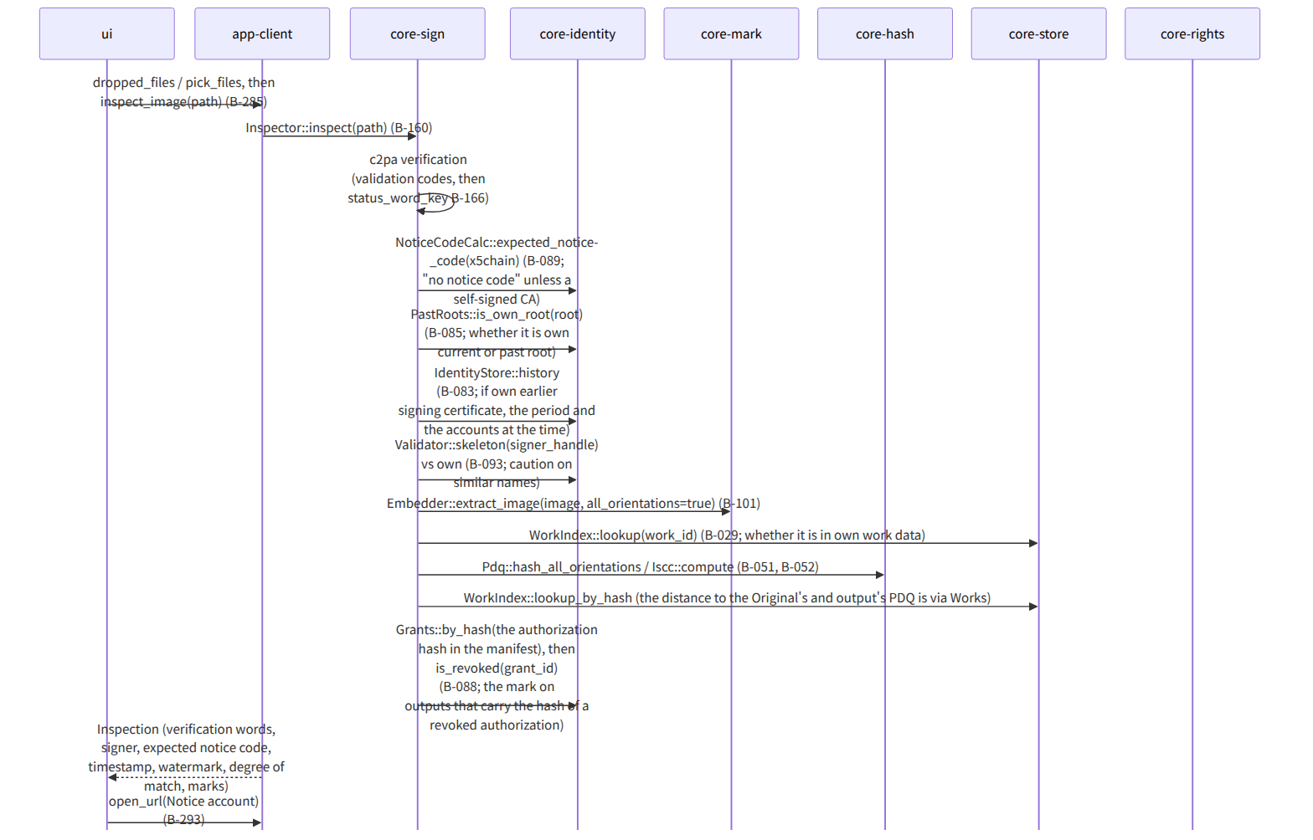
Figure：S-04a Checking an image

S-04b Checking an Enclosed Document folder (Chapter 5, 3.4)
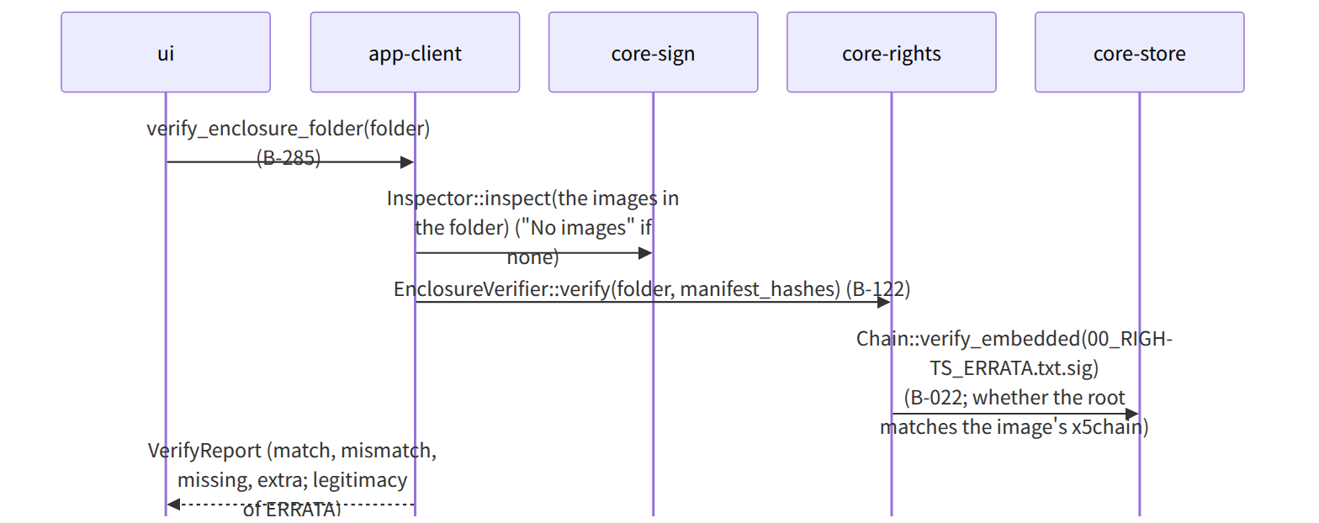
Figure：S-04b Checking an Enclosed Document folder (Chapter 5, 3.4)

S-04c Clue comparison (G-24)
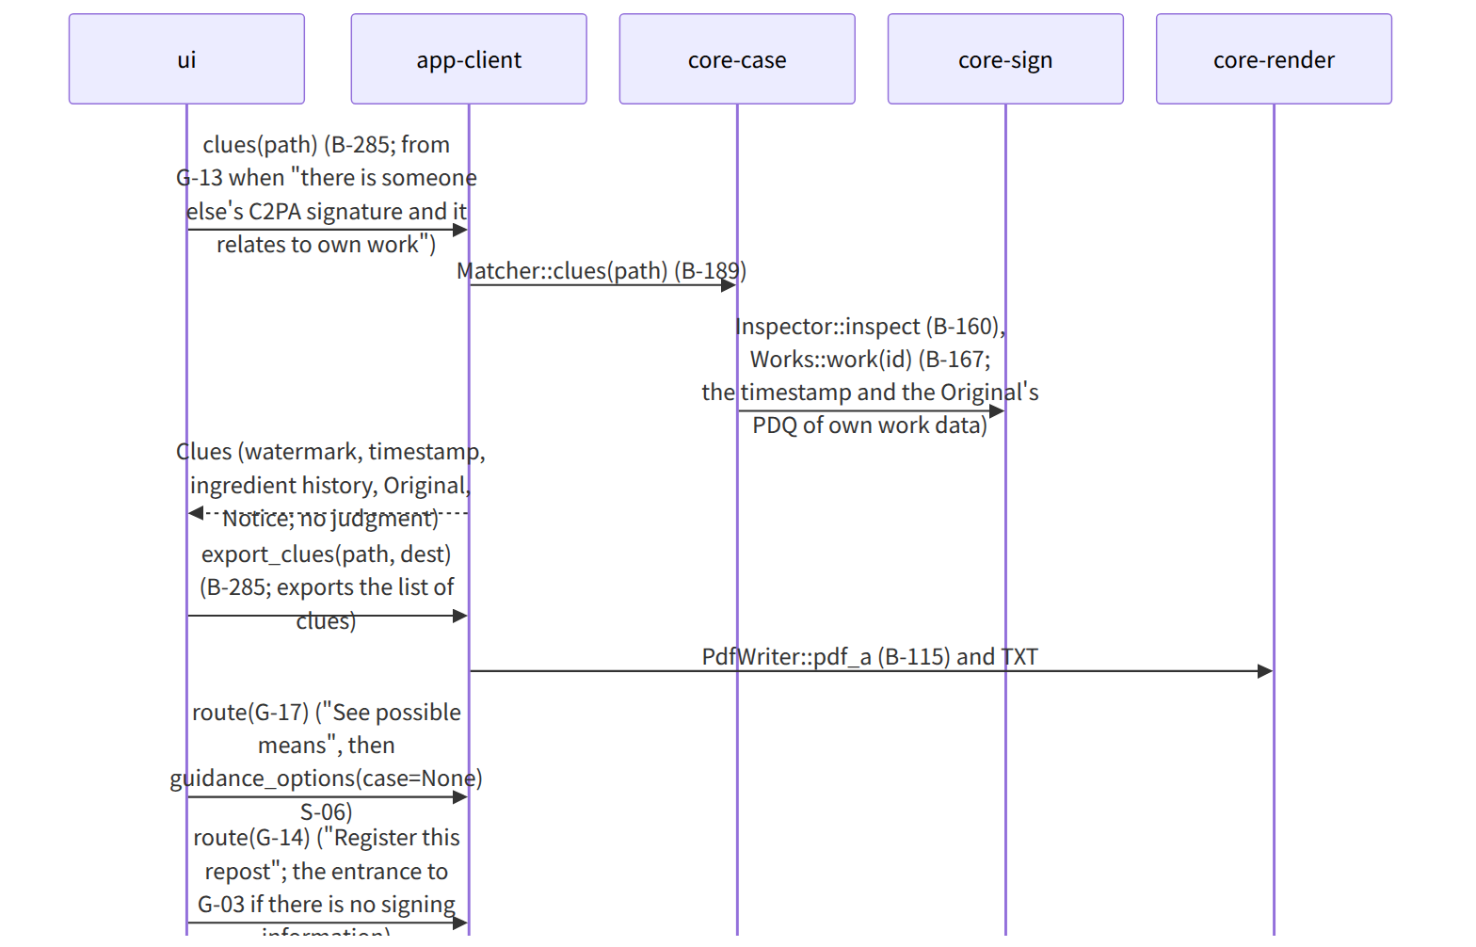
Figure：S-04c Clue comparison (G-24)

Gaps (found later and fixed)
- The form (TXT or PDF) of Chapter 2, 4.4 “the list of clues can be exported in addition to the evidence set” was not in the specification, so it was made the same as the report of Chapter 6, 3.4 (TXT and PDF/A-3u), taken by Bundle::export_bundle(include_clues) in core-case.md. The standalone “extracting clues” of G-24 is written in the same form by app-client's export_clues (this file). “The form is the same as the report of Chapter 6, 3.4” was added to Chapter 2, 4.4.
- The lookup “authorization hash in the manifest → authorization number” needed for G-13's “mark on outputs that carry the hash of a revoked authorization” (Chapter 2, 5.1) was not in core-identity's Grants, so by_hash(sha256) Option<Document> was added to Grants in core-identity.md.

