Anti-Repost Tool for Cosplay Photos
S-05 Registering a repost (G-14), cases (G-15 and G-16)
Edition 1 (Draft) 2026-09-29 · Ishikawa Sou
Nagareyama Software Development Co., Ltd. (NRSD)
© 2026 Nagareyama Software Development Co., Ltd. (NRSD), Lead Developer: Ishikawa Sou (石川宗). Copyright in this document belongs to Nagareyama Software Development Co., Ltd. (NRSD). Rights in the third-party standards, software, commentaries on laws, and other materials referred to in this document belong to their respective holders. This is a translation of the Japanese original; where they differ, the Japanese original prevails.
Contents
S-05a The registration screen (steps 1 to 5)
S-05b Registering (step 6; a mark in state/ per step)
S-05c Case list, details, current state, withdrawal, evidence set
Gaps (found later and fixed)

Origin: Chapter 1, 7.3; Chapter 6, 2.1 (steps 1 to 6), 2.2, 2.2.1, 2.2.2, 2.4, 2.5, 3.2, 3.3, 3.4, 4, 5, 6, and 7; Chapter 10, G-14 to G-16.

S-05a The registration screen (steps 1 to 5)
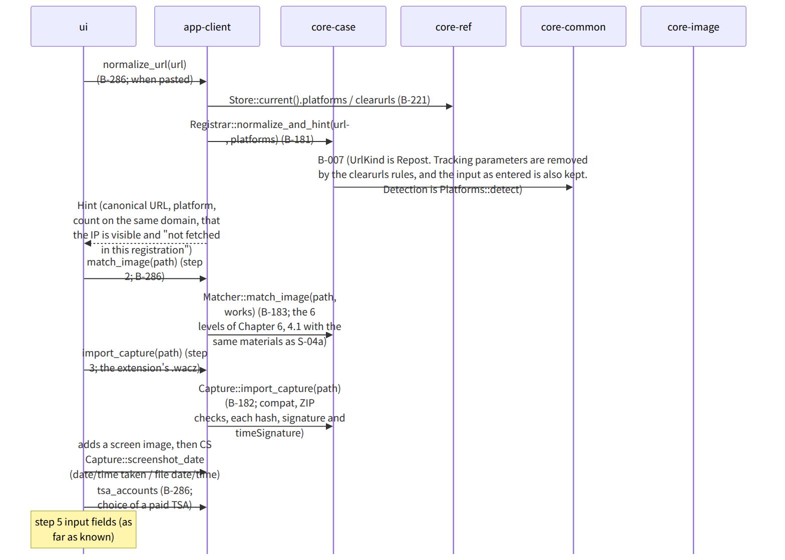
Figure：S-05a The registration screen (steps 1 to 5)

S-05b Registering (step 6; a mark in state/ per step)
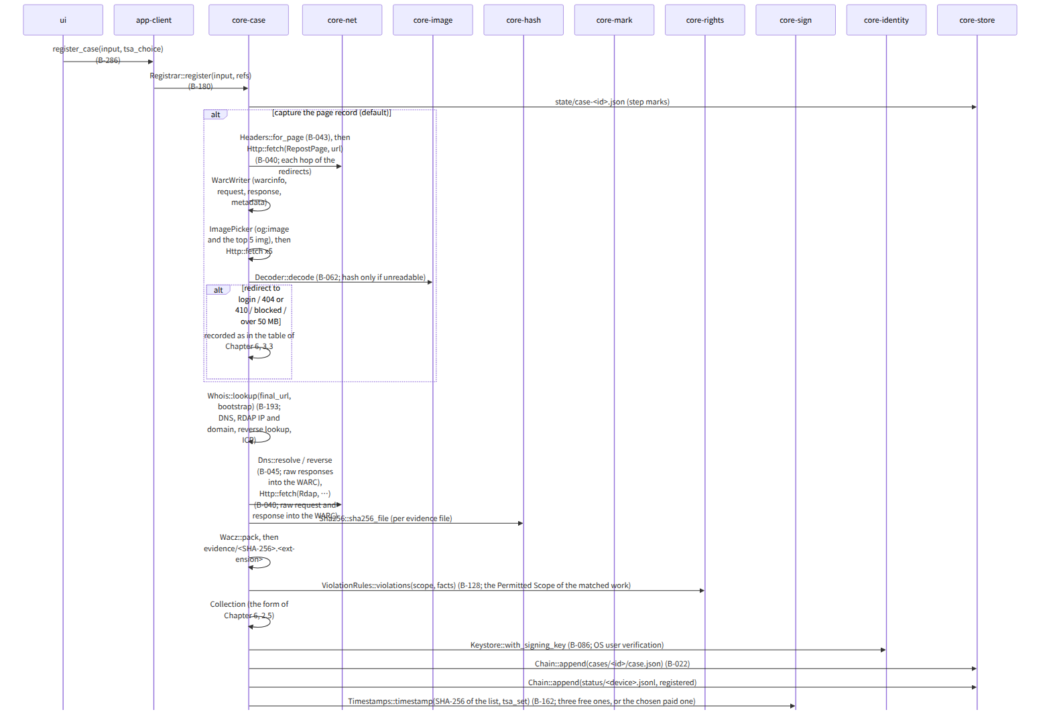
Figure：S-05b Registering (step 6; a mark in state/ per step)
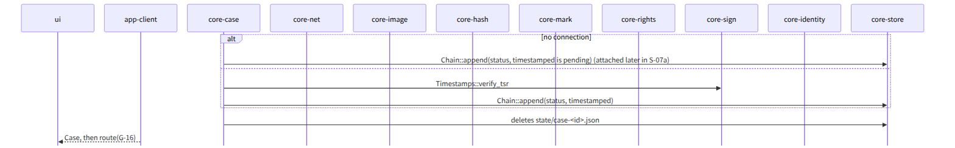
Figure：S-05b Registering (step 6; a mark in state/ per step)（continued 1）

S-05c Case list, details, current state, withdrawal, evidence set
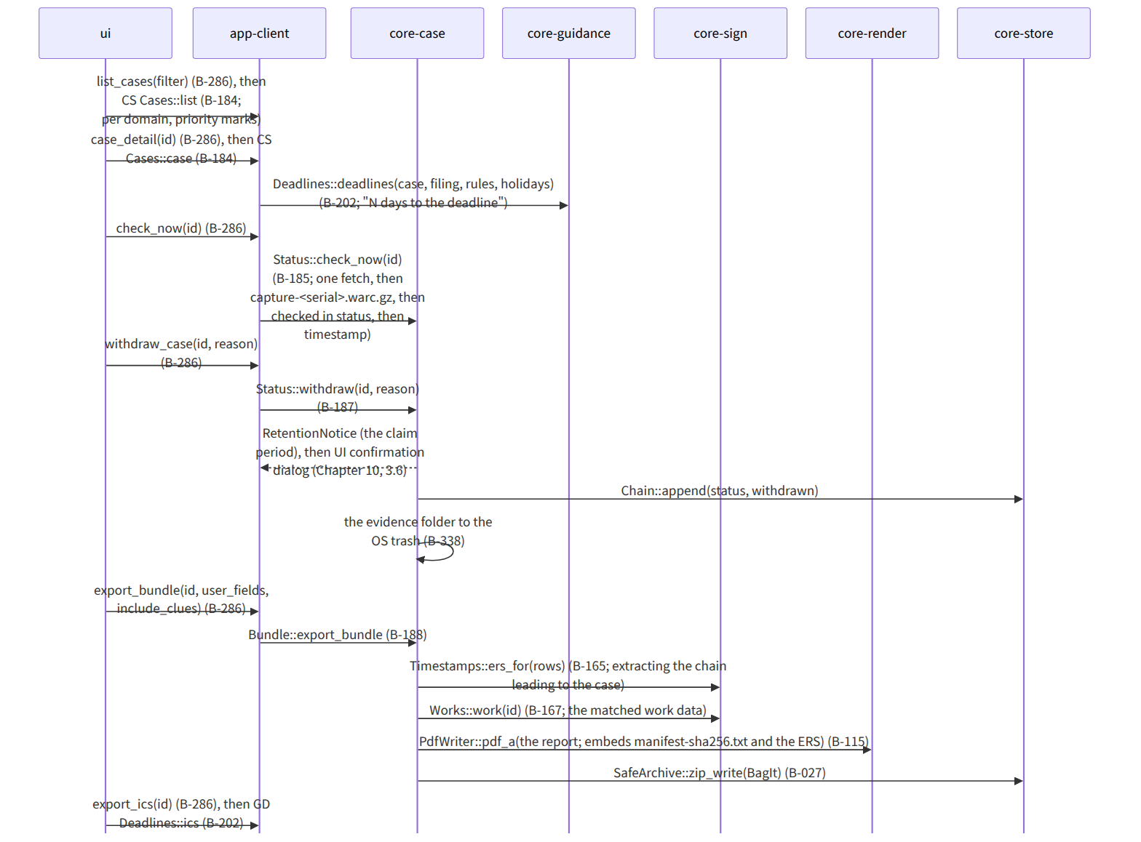
Figure：S-05c Case list, details, current state, withdrawal, evidence set

Gaps (found later and fixed)
- The form in which app-client passes the refs of register (the reference information's contact point list, detection table, RDAP bootstrap, tsa.json) is in the dependencies of core-case.md, but the argument name of Registrar::register was refs: RefBundle, pointing to core-ref's type, so, because core-case does not depend on core-ref, it was changed to a type holding only the needed tables, CaseRefs { platforms, rdap_bootstrap, tsa } (the diagram of core-case.md).
- Where the check of the 1 GB evidence total (Chapter 6, 2.4) stops within the flow of step 6 was unclear, so Cases::evidence_size is called twice, before fetching (the estimate from the page record limit and the total of screen images) and after (measured), and if exceeded the import is refused and “as a separate case” is shown (added to the note of Registrar::register in core-case.md).
- The route for attaching a case's “pending timestamp” (the state of G-14) at the next connection existed only in core-sign's attach_pending_timestamps (pending ones of work data), so attach_pending_timestamps also covers pending case status appends (noted in B-163 of core-sign.md; the enumeration of targets is received from core-case's Cases).

