Anti-Repost Tool for Cosplay Photos
S-06 Response guidance (G-17)
Edition 1 (Draft) 2026-09-29 · Ishikawa Sou
Nagareyama Software Development Co., Ltd. (NRSD)
© 2026 Nagareyama Software Development Co., Ltd. (NRSD), Lead Developer: Ishikawa Sou (石川宗). Copyright in this document belongs to Nagareyama Software Development Co., Ltd. (NRSD). Rights in the third-party standards, software, commentaries on laws, and other materials referred to in this document belong to their respective holders. This is a translation of the Japanese original; where they differ, the Japanese original prevails.
Contents
Gaps (found later and fixed)

Origin: Chapter 7, 3.1–3.4, 5, 6.1, 6.3, and 7; Chapter 6, 6.1; Chapter 12, 3.2; Chapter 10, G-17.
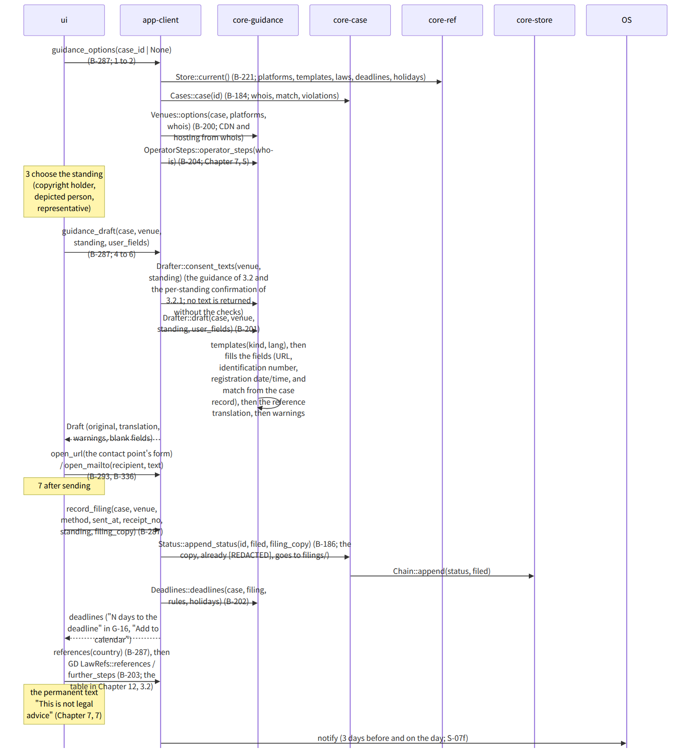
Figure：S-06 Response guidance (G-17)

Gaps (found later and fixed)
- Who does the [REDACTED] processing of the copy of the complaint (Chapter 6, 6.1): the one that knows the User's fields is core-guidance (Draft.user_fields), and saving is core-case, so Drafter::draft also returns a “text for the copy” (a version with the User's fields replaced by [REDACTED]), and app-client passes it to append_status as filing_copy. redacted_copy: String was added to Draft in core-guidance.md.
- Recording the provider's response (response), removal, and reposting calls append_status directly from G-16 (not through G-17). The commands of B-286 in app-client.md lacked record_status(id, kind, fields), so it was added (record_filing is for G-17, record_status for G-16).

