Anti-Repost Tool for Cosplay Photos
S-07 Background queue (what runs without screen operation)
Edition 1 (Draft) 2026-09-29 · Ishikawa Sou
Nagareyama Software Development Co., Ltd. (NRSD)
© 2026 Nagareyama Software Development Co., Ltd. (NRSD), Lead Developer: Ishikawa Sou (石川宗). Copyright in this document belongs to Nagareyama Software Development Co., Ltd. (NRSD). Rights in the third-party standards, software, commentaries on laws, and other materials referred to in this document belong to their respective holders. This is a translation of the Japanese original; where they differ, the Japanese original prevails.
Contents
S-07a Attaching timestamps later (on connection)
S-07b Bundled timestamp and ERS (once a day and on every connection)
S-07c Update manifest and reference information (at start and every 24 hours)
S-07d Checking Originals, retention sweep, free space
S-07e Automatic backup (hourly and on close), then S-08a
S-07f Deadline notices (at start and daily)
Gaps (found later and fixed)

Origin: Chapter 1, 7 (the background order), 7.5, 7.9; Chapter 3, 4 (pending and attaching later, bundled timestamps, ERS); Chapter 8, 3.4, 4, and 5.5; Chapter 9, 4.1–4.4; Chapter 2, 4.2; Chapter 1, 8.4; Chapter 7, 6.3; Chapter 11, 5.3. Triggers are S-01b (start-up), the Scheduler (core-net B-044; every 24 hours, hourly, line recovery), and closing.

S-07a Attaching timestamps later (on connection)
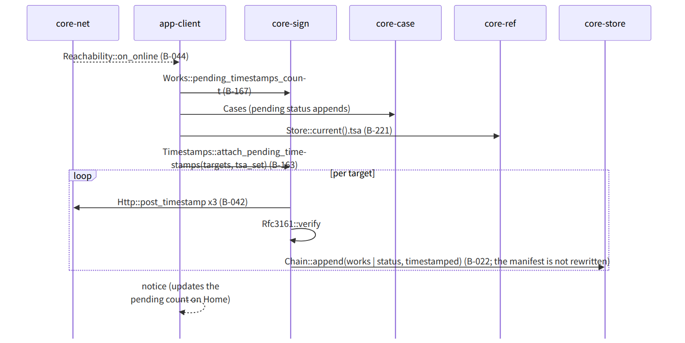
Figure：S-07a Attaching timestamps later (on connection)

S-07b Bundled timestamp and ERS (once a day and on every connection)
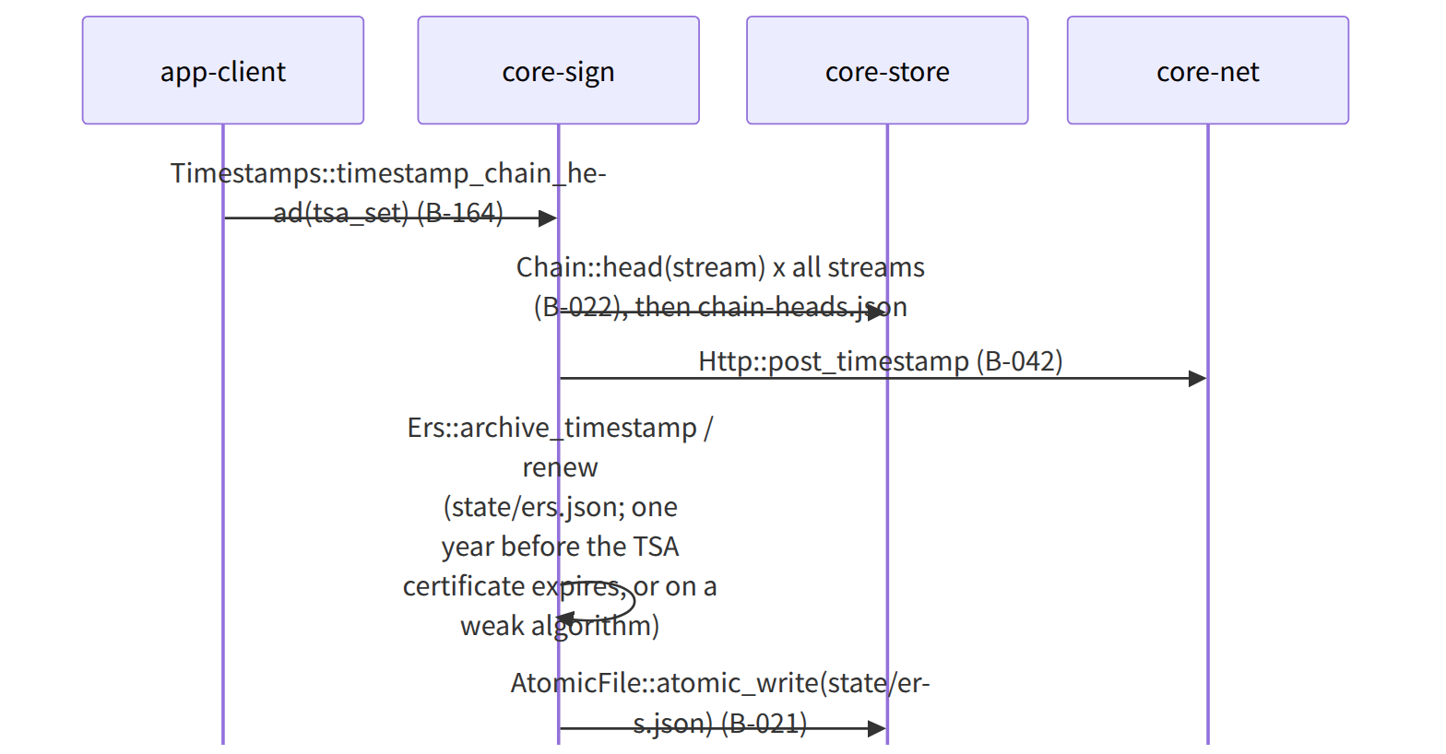
Figure：S-07b Bundled timestamp and ERS (once a day and on every connection)

S-07c Update manifest and reference information (at start and every 24 hours)
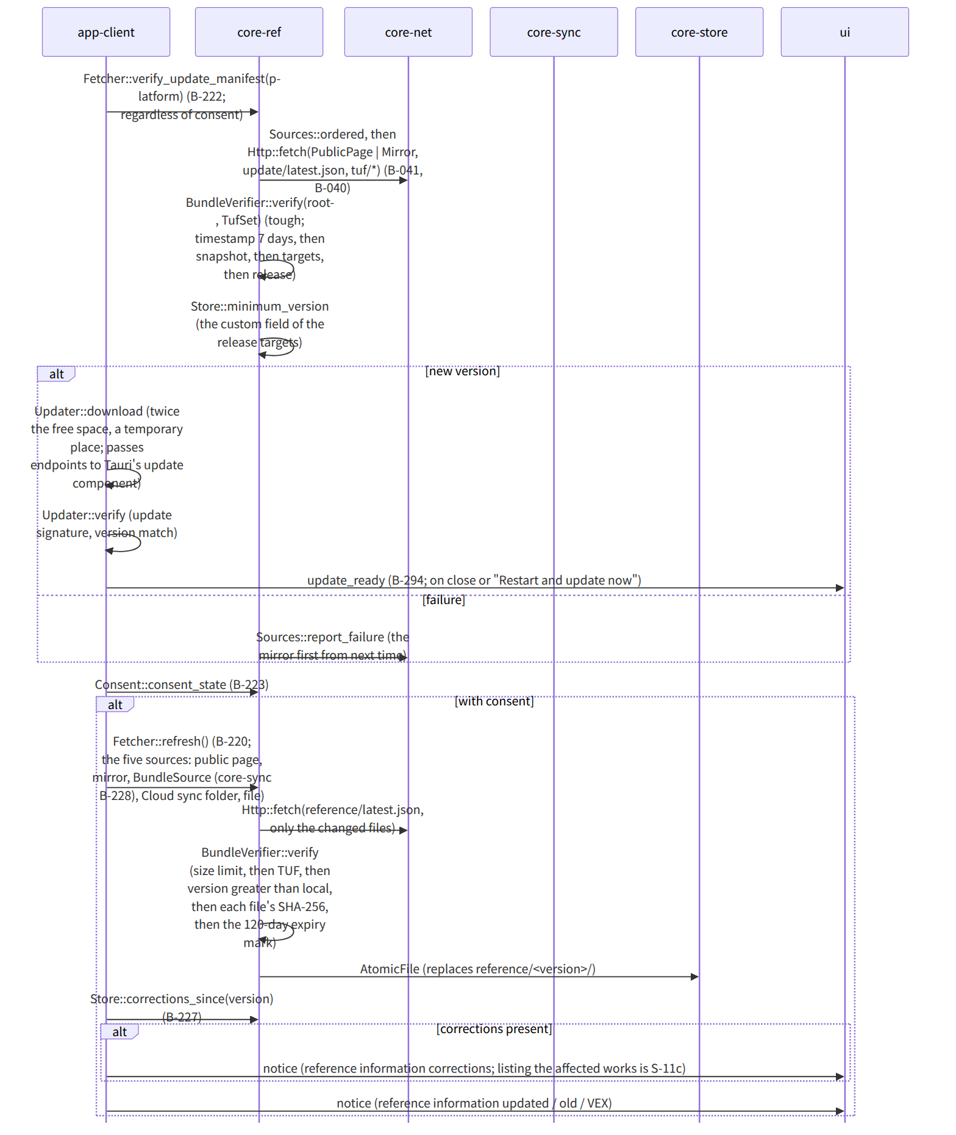
Figure：S-07c Update manifest and reference information (at start and every 24 hours)

S-07d Checking Originals, retention sweep, free space
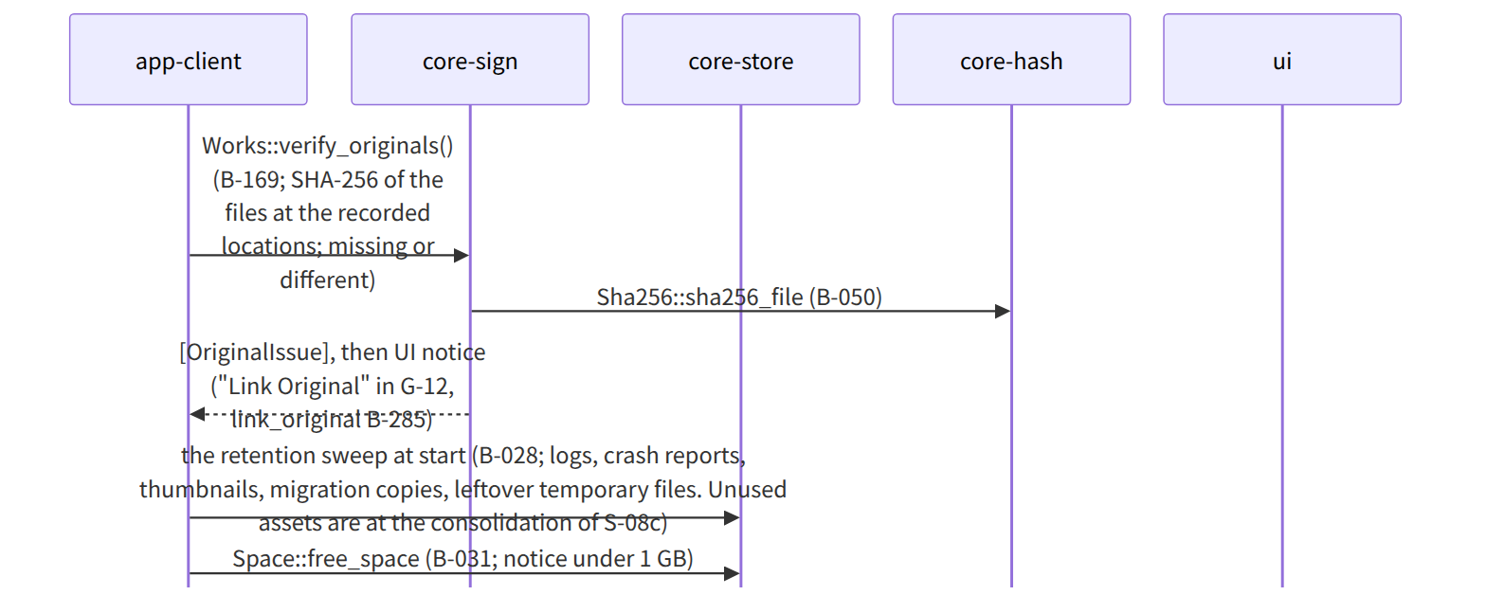
Figure：S-07d Checking Originals, retention sweep, free space

S-07e Automatic backup (hourly and on close), then S-08a

S-07f Deadline notices (at start and daily)
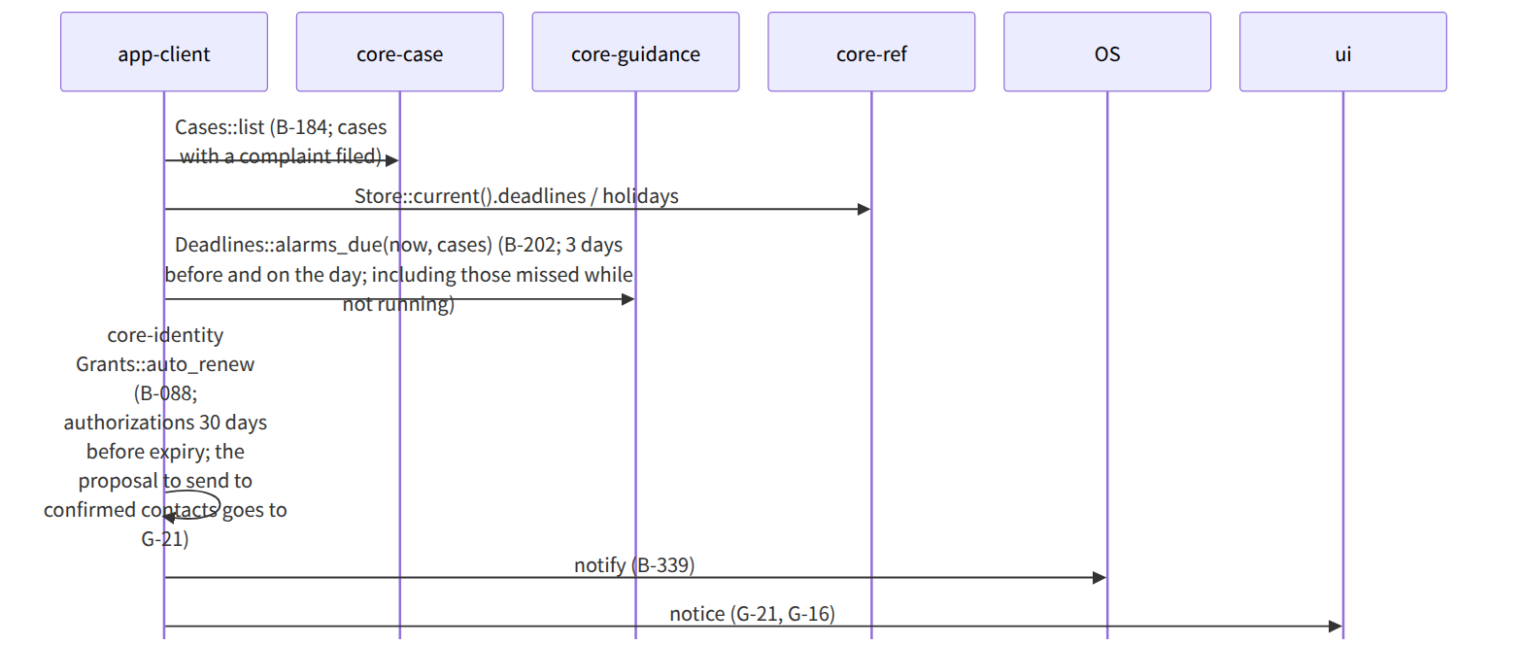
Figure：S-07f Deadline notices (at start and daily)

Gaps (found later and fixed)
- Attaching timestamps later needs tsa_set, but it was not among the arguments of attach_pending_timestamps, so tsa_set was added to the arguments of B-163 in core-sign.md (alongside the targets added in S-05).
- The “daily trigger of deadline notices” was not in the specification (Chapter 7, 6.3 has only the VALARM time and “those missed while not running, at the next start”), so while running, alarms_due is run on the 24-hour tick of core-net's Scheduler (“daily” was added at the end of the background order in Chapter 1, 7).
- Passing the order of Sources::ordered to the update component (the endpoints of Chapter 9, 4.3) is app-client, so “passes Sources::ordered to endpoints” was added to the note of Updater::download in app-client.md.

