Anti-Repost Tool for Cosplay Photos
S-08 Backup (create, restore, open as a successor, monthly check)
Edition 1 (Draft) 2026-09-29 · Ishikawa Sou
Nagareyama Software Development Co., Ltd. (NRSD)
© 2026 Nagareyama Software Development Co., Ltd. (NRSD), Lead Developer: Ishikawa Sou (石川宗). Copyright in this document belongs to Nagareyama Software Development Co., Ltd. (NRSD). Rights in the third-party standards, software, commentaries on laws, and other materials referred to in this document belong to their respective holders. This is a translation of the Japanese original; where they differ, the Japanese original prevails.
Contents
S-08a Create (manual B-240 create, automatic run_due, on close)
S-08b Restore (G-06)
S-08c Open as a successor, monthly check, consolidation
Gaps (found later and fixed)

Origin: Chapter 8, 5.1–5.3, 5.5, 5.6, and 8; Chapter 1, 7.7; Chapter 10, G-05 and G-06.

S-08a Create (manual B-240 create, automatic run_due, on close)
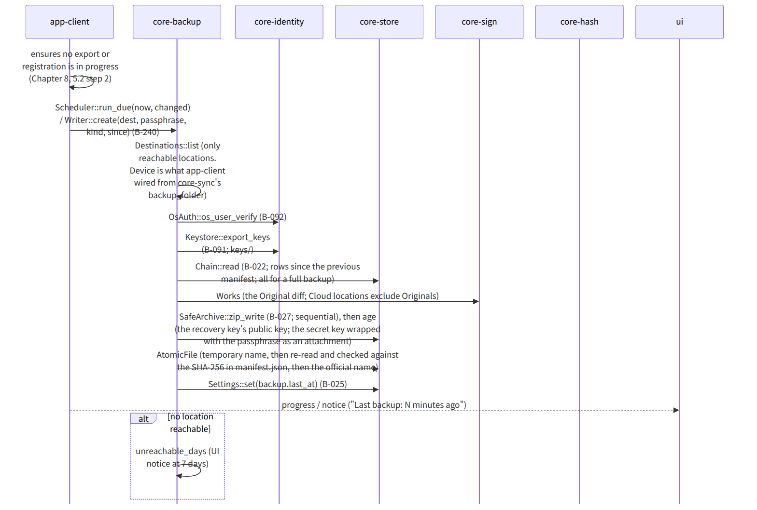
Figure：S-08a Create (manual B-240 create, automatic run_due, on close)

S-08b Restore (G-06)
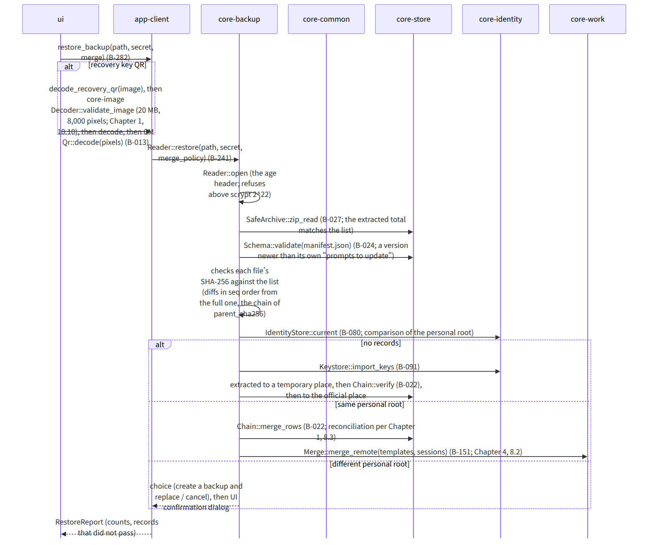
Figure：S-08b Restore (G-06)

S-08c Open as a successor, monthly check, consolidation
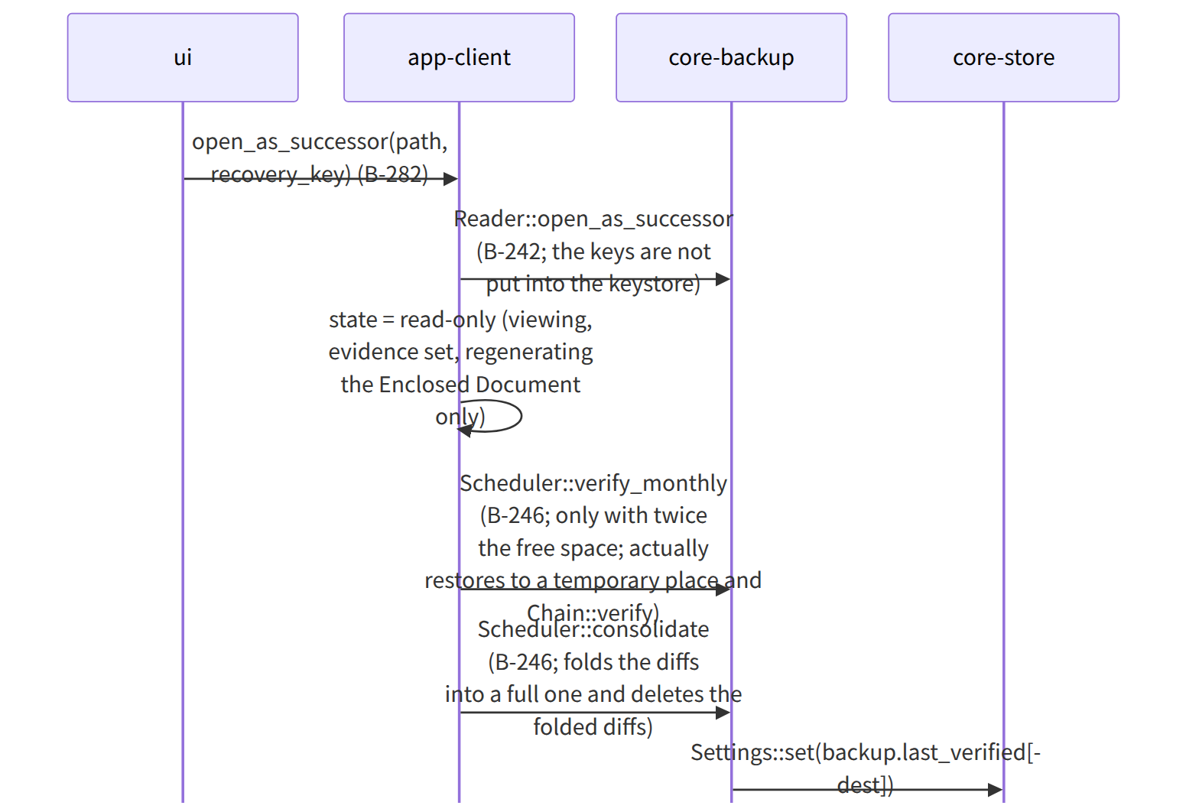
Figure：S-08c Open as a successor, monthly check, consolidation

Gaps (found later and fixed)
- The state “opened as a successor” was not among the seven states of Chapter 1, 7 (it is in Chapter 1, 13 and Chapter 8, 5.3), so “successor (read-only; Chapter 8, 5.3)” was added to the states of Chapter 1, 7, making eight. Successor was added to AppState in app-client.md.
- The judgment of “a backup made by a newer app than its own” when restoring uses the record_versions and app_version of manifest.json, so it is compared by core-backup, not by core-store's Schema::validate (as in the diagram). Added to the note of Reader::open in core-backup.md.

