Anti-Repost Tool for Cosplay Photos
S-09 Linking devices, adding contacts, sending documents, reconciliation, receiving
Edition 1 (Draft) 2026-09-29 · Ishikawa Sou
Nagareyama Software Development Co., Ltd. (NRSD)
© 2026 Nagareyama Software Development Co., Ltd. (NRSD), Lead Developer: Ishikawa Sou (石川宗). Copyright in this document belongs to Nagareyama Software Development Co., Ltd. (NRSD). Rights in the third-party standards, software, commentaries on laws, and other materials referred to in this document belong to their respective holders. This is a translation of the Japanese original; where they differ, the Japanese original prevails.
Contents
S-09a Linking a device (G-20 “Devices”)
S-09b Adding a contact (G-18)
S-09c Sending and receiving documents and templates
S-09d Reconciliation (sync_now; at start, on connection, on a connection from a counterpart device)
Gaps (found later and fixed)

Origin: Chapter 8, 5.4; Chapter 2, 5.5 and 5.4; Chapter 4, 8.3; Chapter 10, G-18 and G-20.

S-09a Linking a device (G-20 “Devices”)
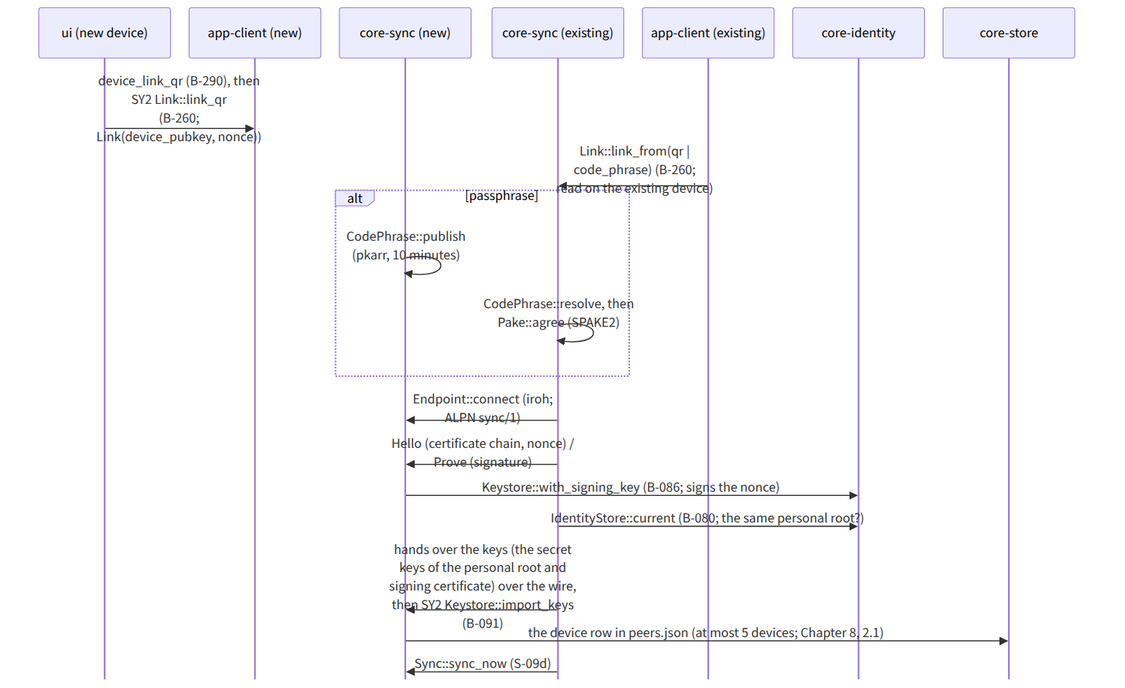
Figure：S-09a Linking a device (G-20 “Devices”)

S-09b Adding a contact (G-18)
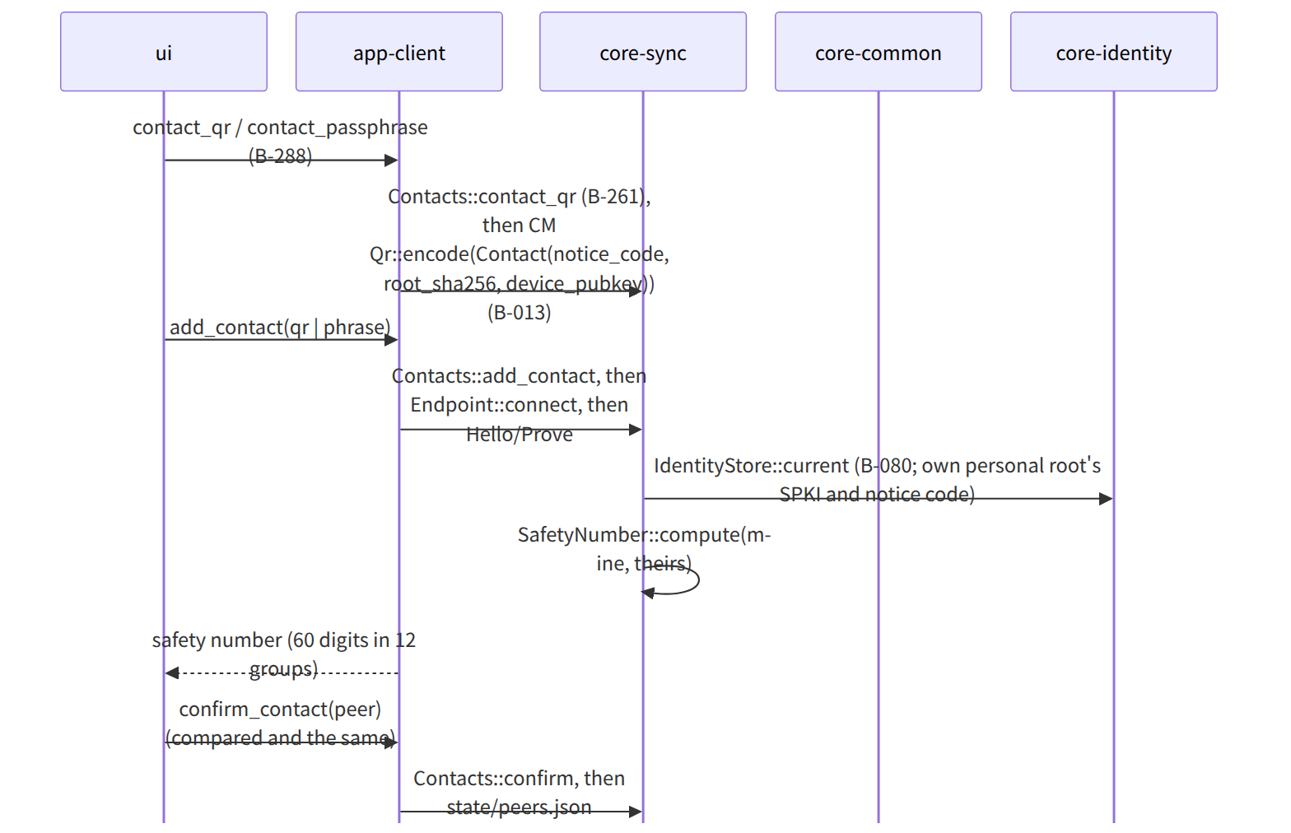
Figure：S-09b Adding a contact (G-18)

S-09c Sending and receiving documents and templates
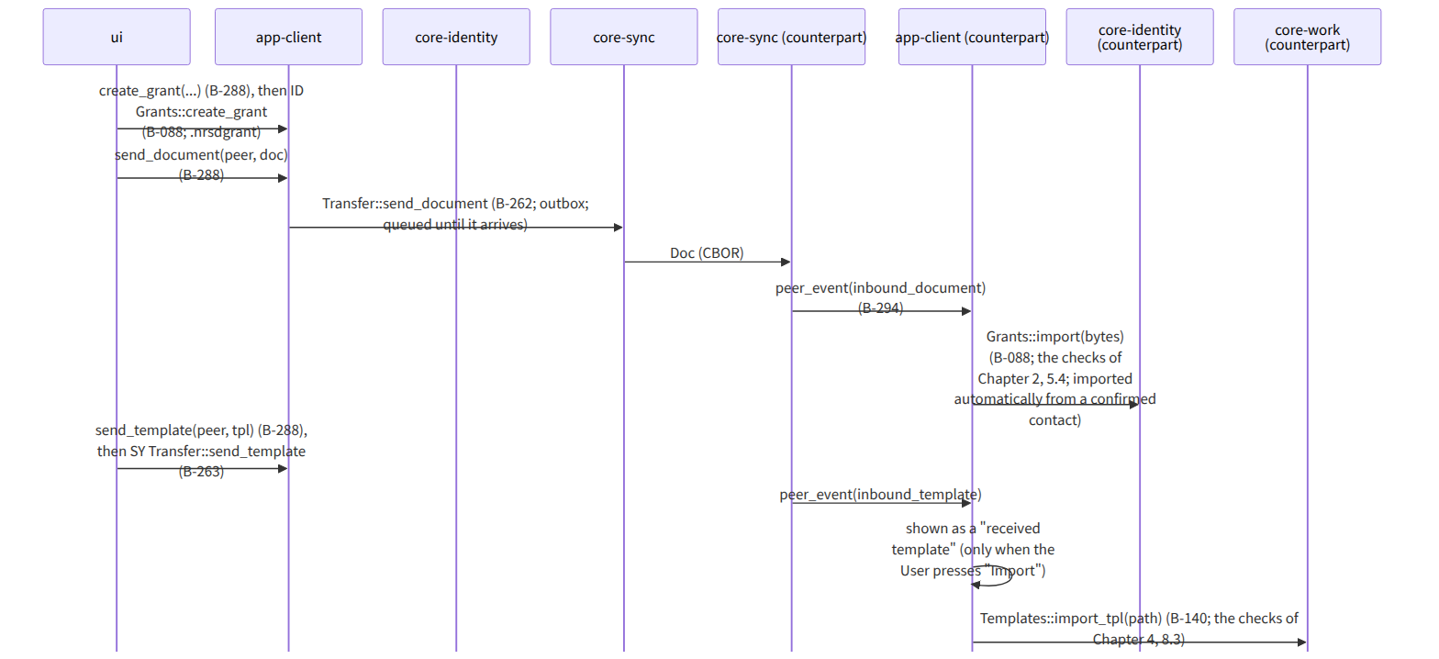
Figure：S-09c Sending and receiving documents and templates

S-09d Reconciliation (sync_now; at start, on connection, on a connection from a counterpart device)
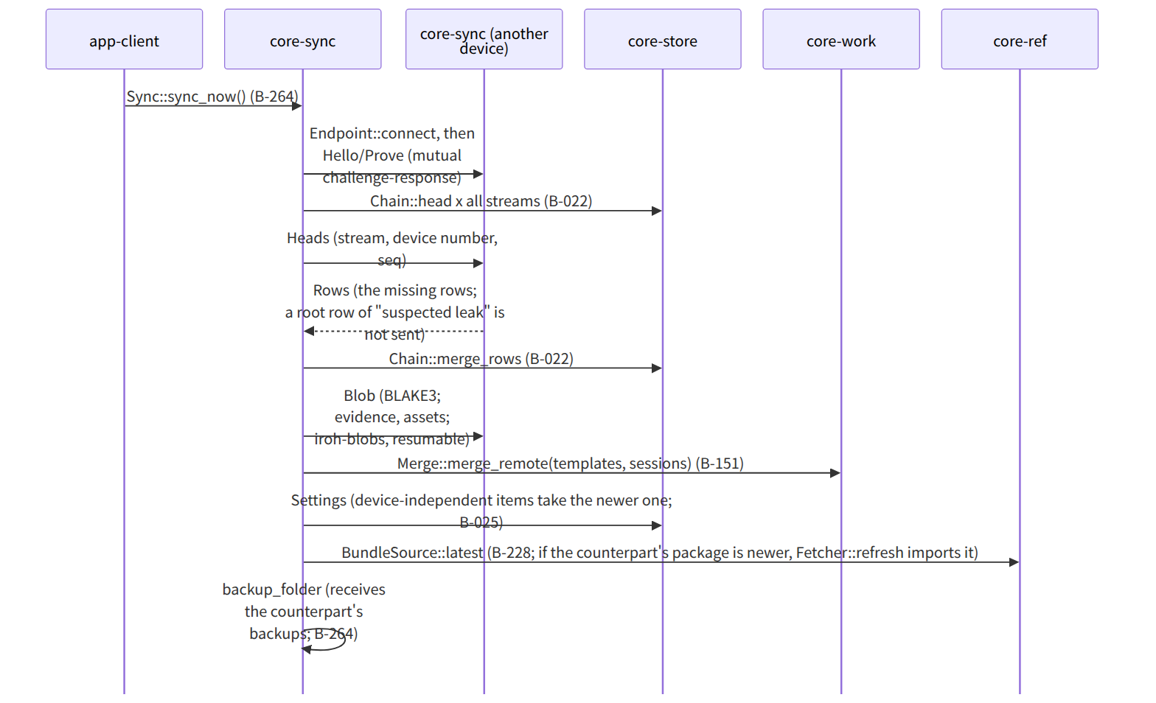
Figure：S-09d Reconciliation (sync_now; at start, on connection, on a connection from a counterpart device)

Gaps (found later and fixed)
- “How the keys are handed to the new device” when linking was not in Chapter 8, 5.4 (Signal's linking hands over keys; “use the same personal root and signing certificate” is Chapter 1, 13 and Chapter 2, 7.3), so “after the link check, the existing device hands over the keys of the personal root and signing certificate over the wire (end-to-end encrypted), and the new device puts them in its keystore (the same result as restoring from a backup)” was added to the procedure between devices in Chapter 8, 5.4. A note was added to Link::link_from in core-sync.md, and sync was added to the users of core-identity's Keystore::import_keys.
- The trigger for a connection from a counterpart device (when one is the receiving side) was not on app-client's page, so Endpoint::accept is always waiting in core-sync while running, and received events are passed to app-client by peer_event. “inbound_document, inbound_template, sync_request” was added to the note of B-294 peer_event in app-client.md.

