Anti-Repost Tool for Cosplay Photos
S-10 Image editing (G-25) and templates
Edition 1 (Draft) 2026-09-29 · Ishikawa Sou
Nagareyama Software Development Co., Ltd. (NRSD)
© 2026 Nagareyama Software Development Co., Ltd. (NRSD), Lead Developer: Ishikawa Sou (石川宗). Copyright in this document belongs to Nagareyama Software Development Co., Ltd. (NRSD). Rights in the third-party standards, software, commentaries on laws, and other materials referred to in this document belong to their respective holders. This is a translation of the Japanese original; where they differ, the Japanese original prevails.
Contents
S-10a Editing a template
S-10b Editing a work session (G-09's “Edit Visible Signature”, “Open photo”)
S-10c Handover (.nrsdtpl)
Gaps (found later and fixed)

Origin: Chapter 4, 4, 8, 9, 10, 11, and 13; Chapter 10, G-25; Chapter 4, 6.4 (fonts), 5 (image layers).

S-10a Editing a template
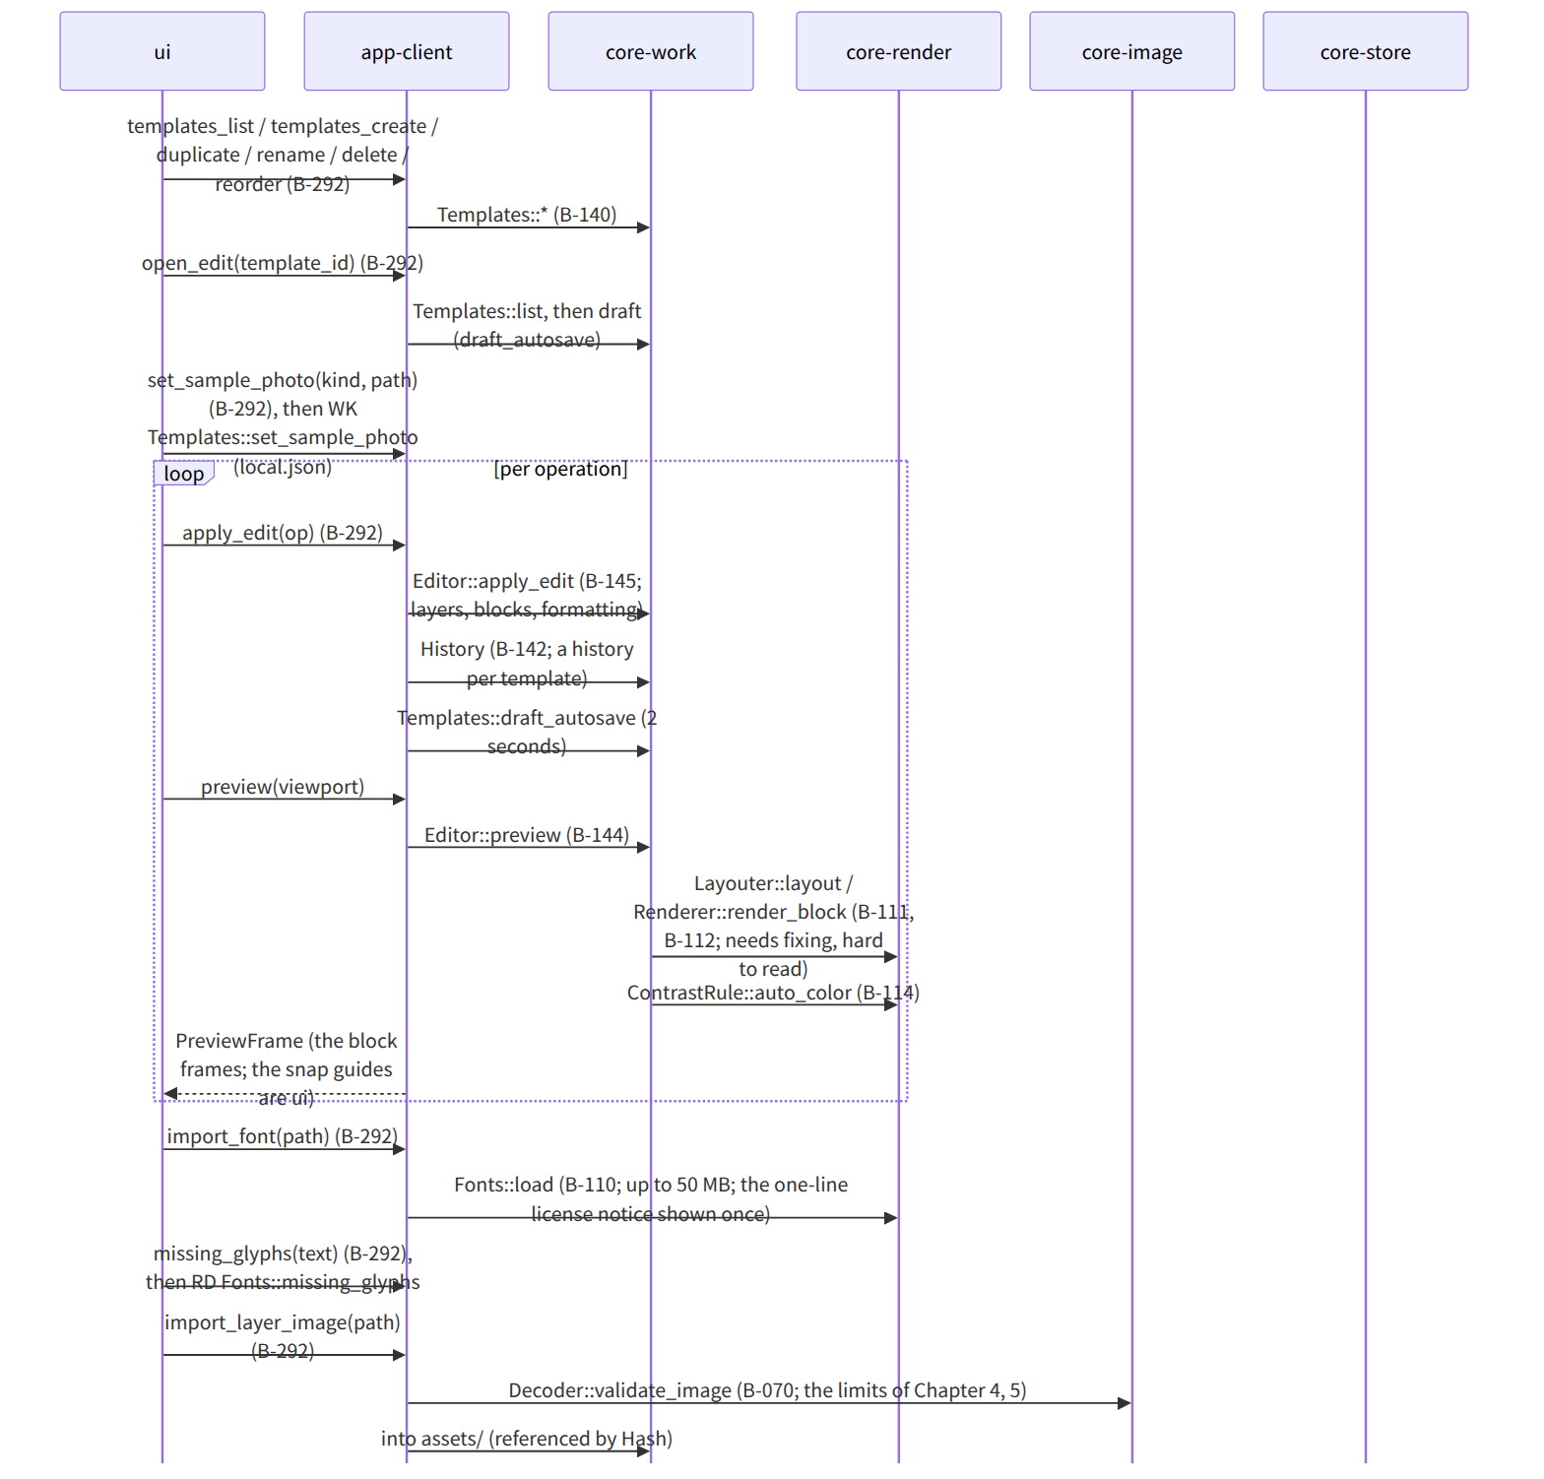
Figure：S-10a Editing a template
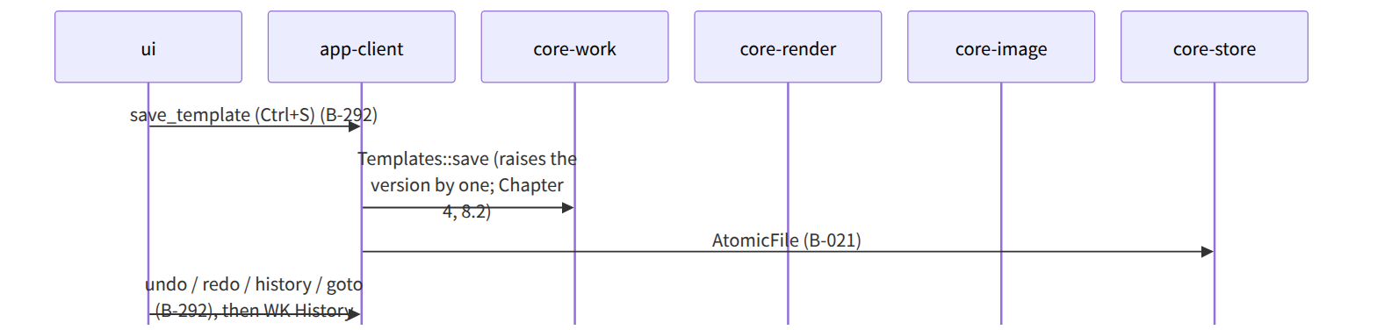
Figure：S-10a Editing a template（continued 1）

S-10b Editing a work session (G-09's “Edit Visible Signature”, “Open photo”)
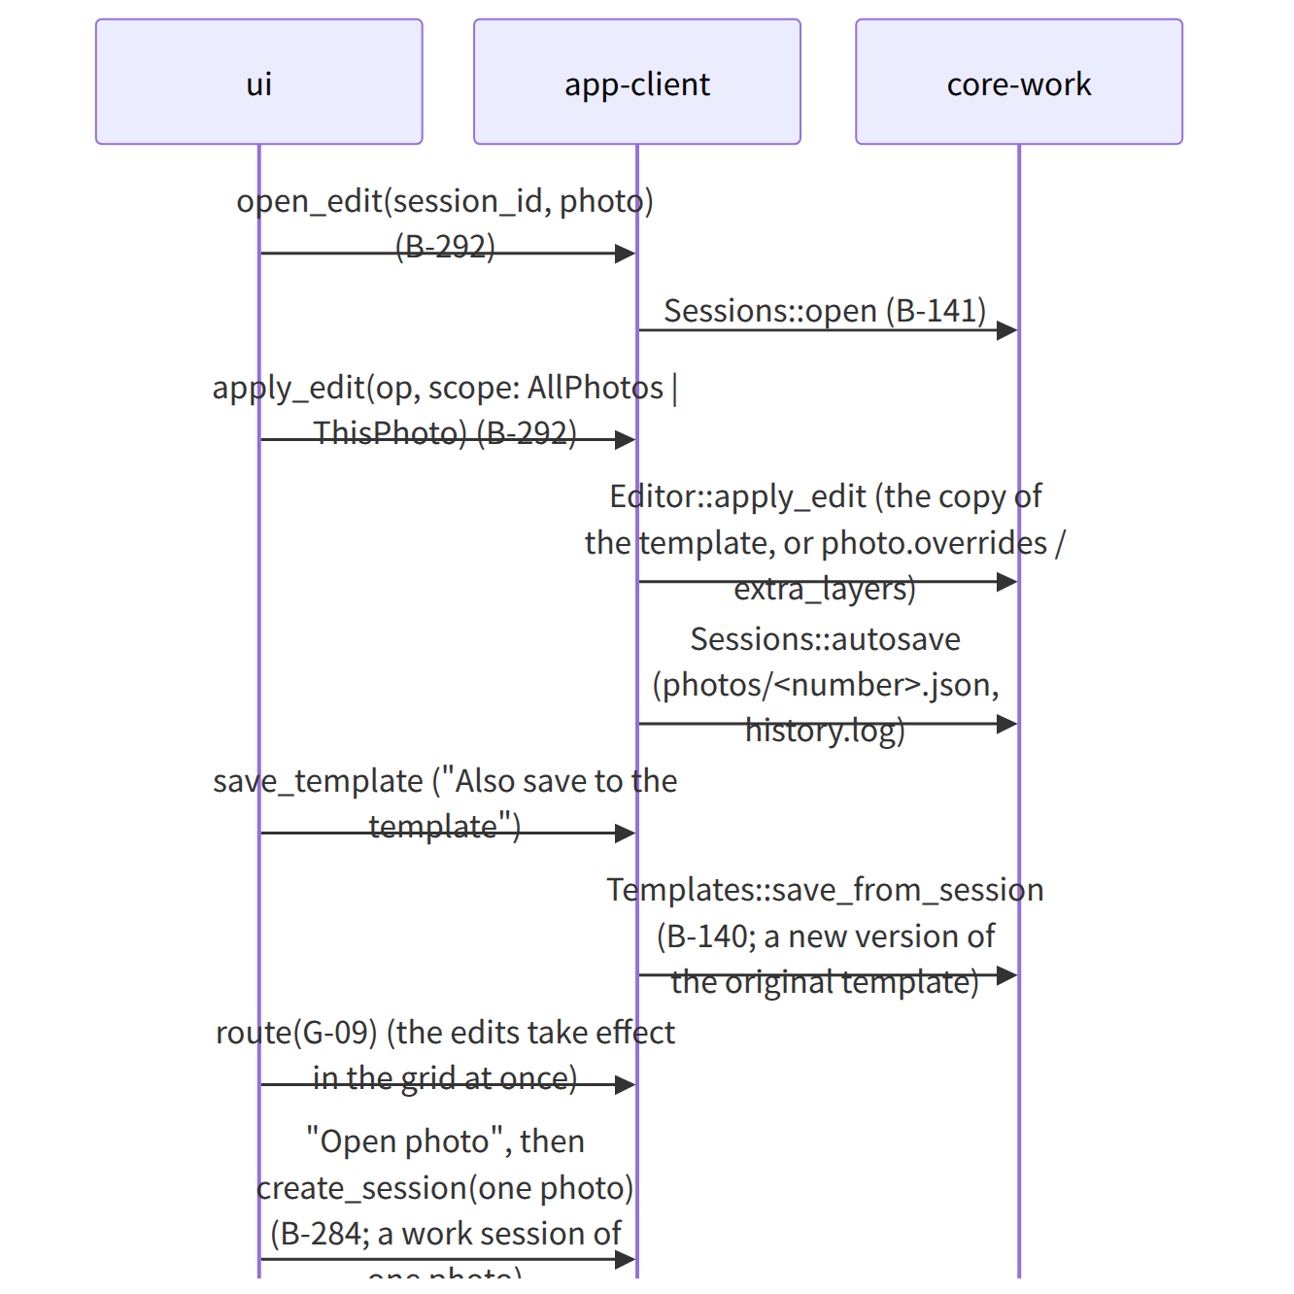
Figure：S-10b Editing a work session (G-09's “Edit Visible Signature”, “Open photo”)

S-10c Handover (.nrsdtpl)
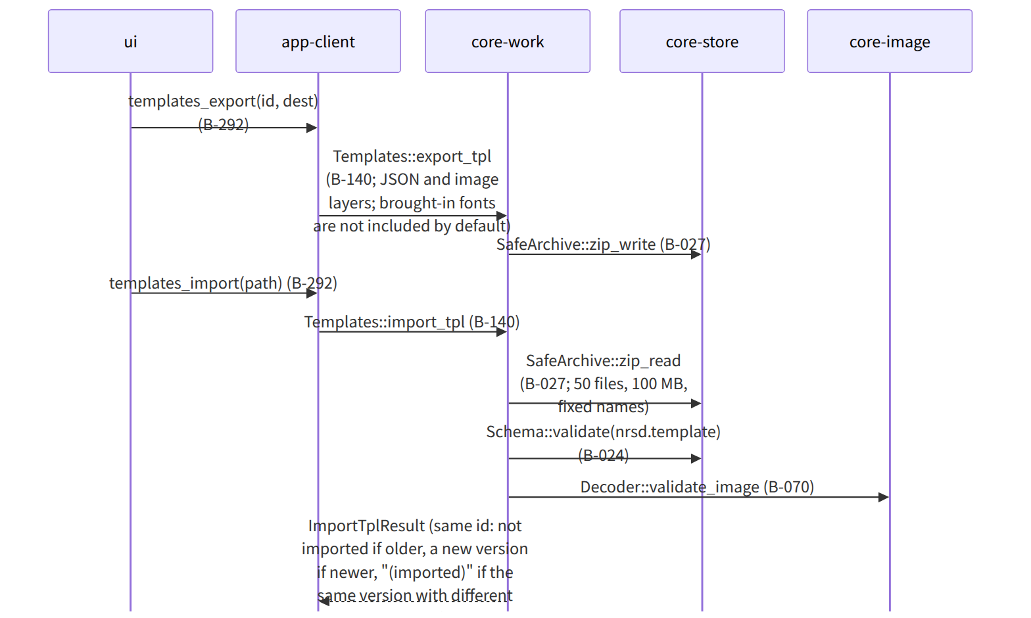
Figure：S-10c Handover (.nrsdtpl)

Gaps (found later and fixed)
- Saving image layer assets to assets/ and counting references (Chapter 1, 8.4 “assets brought in that are no longer used”) were not on core-work's page, so assets_gc_candidates() [Hash] was added to Templates in core-work.md. The time of deletion is, as in Chapter 1, 8.4, at backup consolidation; core-backup's consolidate collects the candidates and passes them to core-store's Retention::sweep_assets (B-028 of core-store.md).
- Who changes the “needs fixing” status (the state transitions of Chapter 4, 12.2): after Editor::apply_edit, core-work updates PhotoStatus from the issues of Layouter::layout (the note of Editor::apply_edit in core-work.md).

