Anti-Repost Tool for Cosplay Photos
S-12 Settings, erasing records, portable kit, importing reference information and updates from files, reports, about this app
Edition 1 (Draft) 2026-09-29 · Ishikawa Sou
Nagareyama Software Development Co., Ltd. (NRSD)
© 2026 Nagareyama Software Development Co., Ltd. (NRSD), Lead Developer: Ishikawa Sou (石川宗). Copyright in this document belongs to Nagareyama Software Development Co., Ltd. (NRSD). Rights in the third-party standards, software, commentaries on laws, and other materials referred to in this document belong to their respective holders. This is a translation of the Japanese original; where they differ, the Japanese original prevails.
Contents
S-12a Settings (G-20)
S-12b Erase this device's records (Chapter 9, 2.3)
S-12c Portable kit and importing from files (Chapter 9, 5 and 4.5)
S-12d Notices, help, reports, about this app (G-21 to G-23)
Gaps (found later and fixed)

Origin: Chapter 10, 10, 9, and G-20 to G-23; Chapter 9, 2.3, 4.5, and 5; Chapter 1, 10.3; Chapter 12, 5 and 6.

S-12a Settings (G-20)
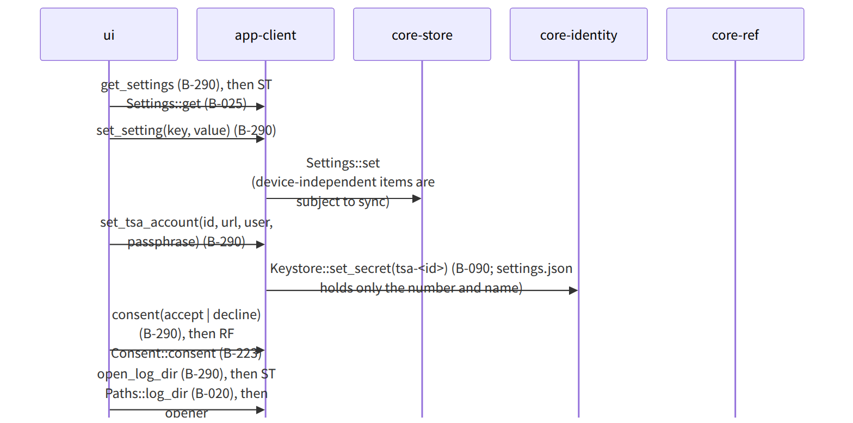
Figure：S-12a Settings (G-20)

S-12b Erase this device's records (Chapter 9, 2.3)
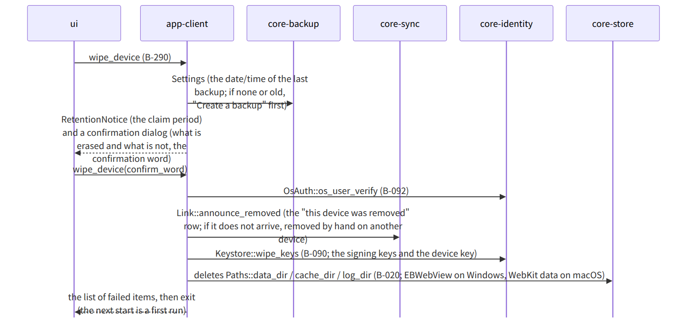
Figure：S-12b Erase this device's records (Chapter 9, 2.3)

S-12c Portable kit and importing from files (Chapter 9, 5 and 4.5)
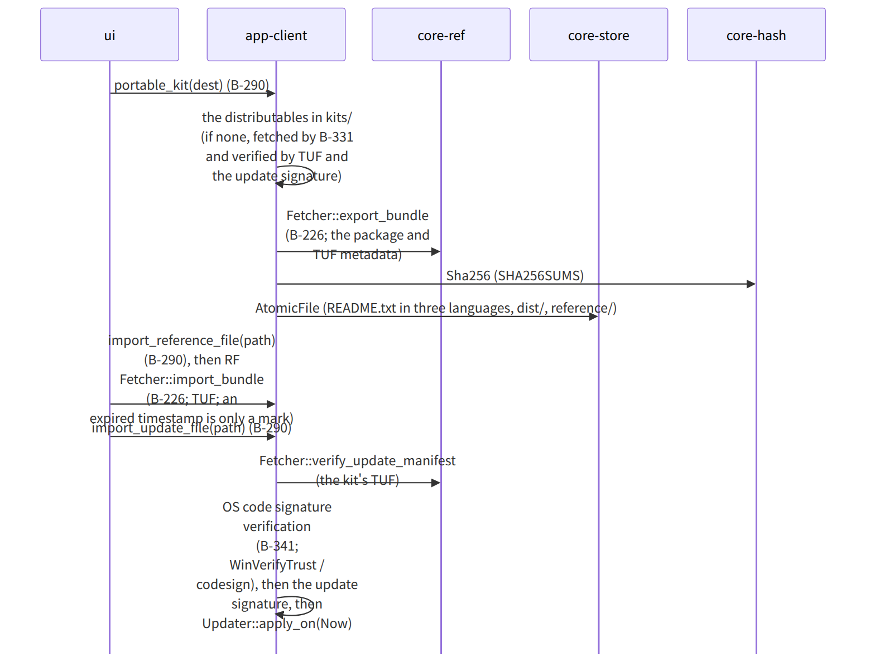
Figure：S-12c Portable kit and importing from files (Chapter 9, 5 and 4.5)

S-12d Notices, help, reports, about this app (G-21 to G-23)
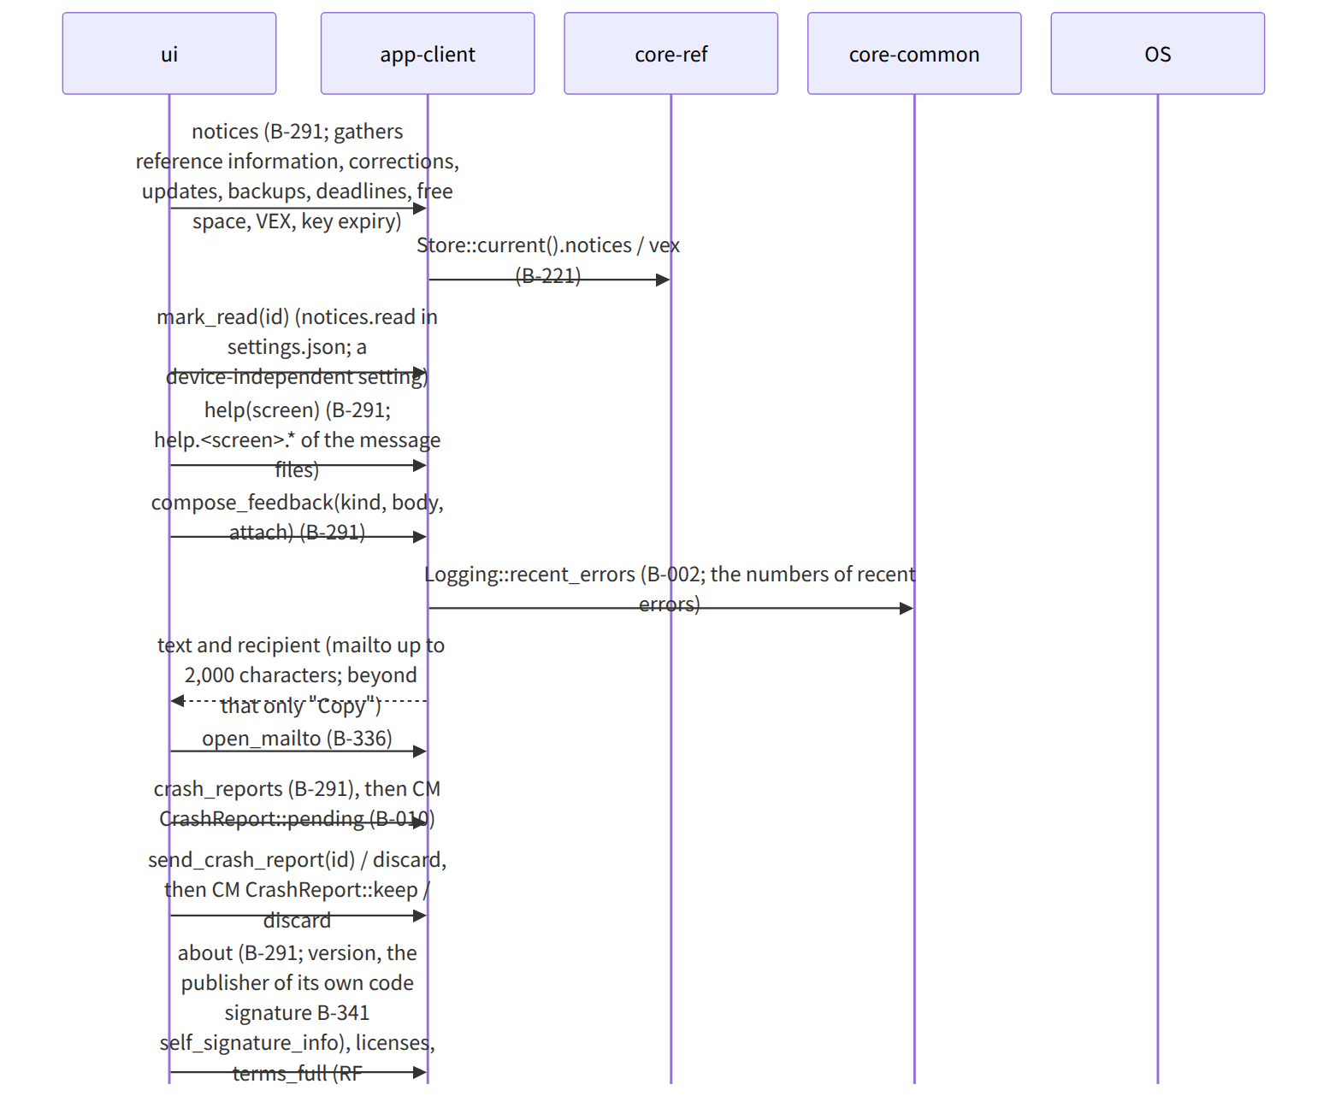
Figure：S-12d Notices, help, reports, about this app (G-21 to G-23)

Gaps (found later and fixed)
- Read notices are a “device-independent setting” (the saving item of Chapter 10, 10), yet app-client's data design had them in state/read-notices.json (per device), so it was changed to notices.read in settings.json (device-independent) and the row in app-client.md's data design was corrected.
- The destination of the “this device was removed” row (the operation name in core-sync) was not on core-sync's page, so announce_removed() (sent as a row of the devices chain) was added to Link in core-sync.md.

