Researchers, professionals, consumers, and students alike regularly interpret information from graphically presented data. Graphs (e.g., scatter plots) have become ubiquitous in the last century for representing quantitative relations. Such visual representations are useful for these purposes because they allow one to make sense of patterns in large amounts of data. This use of graphs—to communicate material empirical information—is, however, a very recent phenomenon; the utility of visual mathematical figures as abstract tools for thinking was realized far earlier in history. The earliest mathematics consisted of tallies and characters used for arithmetic, but when the Greeks needed a way to measure their land, which required considering two spatial dimensions, they invented geometry, a diagrammatic rather than notational representation (Burton, 2011). The progenitor to modern graphical figures had a similar origin: algebra could be used to solve for fixed unknowns, but not until Descartes’ proto-coordinate grid were these variables conceived of as arbitrarily varying continua with intelligible relations, the principles which laid the foundation for modern mathematics.
Such figures—whether geometric or graphical—are evidently crucial for mathematical thinking. One reason is that their features are basic, being built from elementary perceptual non-symbolic magnitudes such as lengths and areas (Cleveland and McGill, 1984). This information can be perceived without the need for discrete recognition of symbols, thus reducing cognitive load and requiring little knowledge. Indeed, 2-dimensional figures allow young children to represent complex patterns they might otherwise not appreciate in a discrete format (Ciccione et al., 2026), and people without formal mathematics education, as well as non-human primates, can judge trends in noisy scatter plots (Ciccione et al., 2023; 2025). The fact that graphical figures are intuitive, because they convey information spatially, yet they also facilitate complex mathematical thinking, seems paradoxical, but theories in cognitive psychology can offer an explanation.
Many theories of cognition propose that even complex concepts are embodied in space and based in sensorimotor experience (Barsalou, 2008; Lakoff & Johnson, 1980; Lakoff & Núñez, 2000), and that the higher cognition needed to conceive of these complex ideas is based on “core knowledge” that is present very early in development (Spelke & Kinzler, 2006; Carey & Spelke, 1994). The goal of this study is to investigate how the basic ability to judge spatial relations in simple 2-dimensional figures could be a core building block on which more complicated reasoning about quantitative relations is based.
The ANS as a Perceptual Building Block for Mathematics
Much research has aimed to advance a similar hypothesis in numerical cognition, specifically the idea that humans have a primitive approximate number system that allows us to roughly ascertain quantities in the world and on which we base counting, arithmetic, and other mathematical capacities (Dehaene, 1997; Feigenson et al., 2004). Humans from a very early age and non-human primates display consistent sensitivity to the numerosity of a set of objects, a capacity based on what is called the approximate number system (ANS; Xu and Spelke, 2000; Neider & Miller, 2004). Some even argue that number is uniquely salient and might have an evolutionary basis in primates and other animals (Neider, 2025).
Despite the simplicity of this ability, many argue that it underpins humans' symbolic number system, which allows us to precisely quantify and manipulate numerical magnitudes and to engage in more complex mathematics. Much research has found a correlation between the ability to approximate non-symbolic numerical magnitudes and achievement in formal mathematics education while controlling for other indicators of general intelligence (Halberda et al., 2008; Starr et al., 2013; Schneider et al., 2016). Moreover, there is evidence that non-symbolic numbers—that which is the subject of study in such tasks—and symbolic numbers share a neural representation (Piazza et al., 2007).
Beyond symbolic numbers, the ANS can also support more complex operations, such as basic arithmetic (Wynn, 1992) and the representation of ordinal relationships (Brannon, 2002; de Hevia et al., 2017). In addition, the same brain area that supports non-symbolic number (the intra-parietal sulcus) is activated in expert mathematicians evaluating the veracity of mathematical propositions (Amalric & Dehaene, 2016). Evidently, the ANS is involved in higher-level mathematical thinking, but notably, this relation is bidirectional. Experience in math education improves the acuity of the ANS (Piazza et al., 2013) and increases the salience of non-symbolic numerical magnitude (Ferrigno et al., 2017). Thus, humans have a core ability to judge number, which serves as one basis for higher mathematical thinking.
Trend Judgment as A Perceptual Building Block
How does trend judgment compare as a possible basic building block for understanding mathematical relations? There has also been research, albeit less than for the ANS, seeking to answer this question. Ciccione and colleagues make a similar argument to that for the ANS and mathematics that the ability to judge trends in graphs is (1) built on a basic perceptual ability of primates and (2) supports Western humans’ perception and comprehension of graphs.
They cite as evidence for the first claim the fact that young children, adults with no formal mathematics education, and non-human primates are proficient at a trend judgment task (Ciccione et al., 2023; 2025). This task, which is very similar to those discussed hereafter, required participants to view a noisy set of data points in a scatter plot and, using key presses, report whether the dataset's trend was increasing or decreasing (Ciccione et al., 2021). The researchers argued that this ability to judge relations in data presented in a 2-dimensional format relies on a more basic capacity to judge the orientation of objects. They provided further support for this claim with a neuroimaging study in which this trend judgment task activated areas localized in an object orientation judgment task (Ciccione & Dehaene, 2026). Based on these findings, they argued that this ability to perceive quantitative or spatial relations in 2-dimensional figures is very basic, akin to the ANS.
On the second claim, that this ability is a building block for more advanced reasoning with graphs, they cite as evidence the fact that participants’ performance on the trend judgment task (as measured by their sensitivity to the t-test of the data in the stimulus) correlated with their discipline of study (Ciccione et al., 2023). This evidence is less definitive than that for their first claim. This is because general spatial intelligence could explain correlations between performance on trend judgment and discipline of study, as people with more math experience tend to have stronger visuospatial skills. Indeed, among the limited literature investigating the relationship between graphical and mathematical abilities, Ludewig et al. (2019) found that general cognitive ability, rather than components of mathematical ability, best predicted performance on graphical tasks. In addition, Ciccione and colleagues’ findings already indicate that the task can be performed without engaging any quantitative knowledge; therefore, the presumption that participants with more of such knowledge are using it and, as a result, performing better on the task requires scrutiny.
Evidence is thus lacking for the claim that judgment of spatial relations in figures can serve as a foundation for more complex thinking about graphs or quantitative relations. Another sort of evidence that can indicate underlying representations that are not obvious at face value is behavioral biases. For example, that people's judgments of the font size of numerical digits is influenced by the numerical magnitude of those digits indicates that numerical magnitude is perceived and mentally represented in the task, and that the representations of physical and numerical size are in some way related (Henik & Tzelgov, 1982). If the judgment of trend in graphical representations was indeed affected by the knowledge of the higher concepts the figures are meant to instantiate, this would provide valuable evidence for the claim that such perception serves as a basis for that knowledge, analogous to that which shows that formal mathematics education influences the ANS (Piazza et al., 2013; Ferrigno et al., 2017).
Parrott et al. (2014) and a replication of that study by the authors (Tarantino & Alibali, in progress) lend evidence to the possibility that trend judgment evokes abstract associations of the relations being judged. Both studies found that, when participants searched for graphs with particular trend directions that appeared in different portions of the screen, they were faster to detect trends in congruent locations: increasing trends in the upper and right parts of the screen and decreasing trends in the lower and left. The latter study found that the extent to which participants exhibited these biases depended on their level of math education, indicating the bias might have a conceptual basis. This congruency reflects abstract associations with trend directions and space, like those with numbers and space in the numerical Stroop task, evincing a representation of the abstract concept in the task.
Despite this, there are limitations to this evidence as it regards the argument put forth here. First of all, the task utilized graphs that contained semantic information indicating their graphical nature, including axes and language describing them as graphs. Thus, it is not possible to ascertain if the effect arises from the act of merely perceiving these spatial relations or if the semantic information of increasing and decreasing graphs gives rise to the effect. Second, unlike Arabic numerals in the classic SNARC study by Dehaene et al. (1993) or those in the numerical Stroop task (Henik & Tzelgov, 1986), which have no iconicity, graphs are iconic and have spatial features confounded with the judgment being made; thus, spatial biases are less clearly caused by irrelevant features and therefore constrain interpretations about the processing they reveal. In addition, these studies suggest that the spatial biases, which are reminiscent of SNAs, might be caused by associations between trends and numbers and, in turn, numbers and space.
To solve those two issues and to provide evidence for that possible explanation of the bias, we will investigate the presence of trend-number associations in simple quasi-graphical stimuli. Trend judgment might implicate numerical magnitude because people appear to take into account the number of data points when judging whether a noisy scatter plot is increasing or decreasing, as their performance is well described by a t-test of the data, which depends in part on the number of points (Ciccione et al., 2023). Moreover, Ciccione and Dehaene (2026) found that judging trends in graphs largely activated the intraparietal sulcus, an area commonly implicated in numerical judgments and other mathematical tasks, suggesting that numerical representations may be implicated in trend judgment.
If participants automatically judge a scatterplot's numerosity before judging its trend, then the magnitude representation of this numerosity might interact differently with increasing versus decreasing relations, just as different spatial locations appear to. That is, task-irrelevant magnitude information should interfere with judgments of numerical and non-numerical magnitudes, as well as spatial directions, as these magnitudes are argued to share overlapping representations (Walsh, 2003).
Moreover, regarding the other limitation of past literature, if this ability serves as a perceptual building block for quantitative relations, then it should be influenced by those abstract concepts even when it lacks semantic information pertaining to such concepts. We will therefore use very simple dot arrays that contain no semantic or conventional graphical information. To our knowledge, no study has investigated proto-graphical abilities in such simplistic stimuli. These data will therefore also allow us to understand the psychophysical basis of trend judgment with no semantic information implicated.
Study 1
The purpose of Study 1 is to investigate whether there exist abstract associations between trend directions in graphically presented data and the numerosity of that data set, and if these associations are implicated in the act of trend judgment with simplistic non-graphical stimuli. To test this question, we assessed participants on a trend judgment task in which they judged whether a simple non-graphical test array’s trend, depicted using variable numbers of points, was increasing or decreasing relative to a baseline reference array (with a trend of slope=0). Instead of investigating spatial biases, as increasing and decreasing graphs could elicit different viewing patterns that could appear as biases but not affirmatively indicate conceptual engagement with the mathematical relations, we investigate associations between non-symbolic numerical magnitude and trends. If there are associations between the numerosity of the data points in a graph and its trend and trend judgment per se elicits these abstract associations, then participants should have higher performance in judging putatively congruent arrays than incongruent arrays. More specifically, we predicted that participants' performance would increase as the number of points increased for positive trends and that it would decrease with the number of points for negative trends.
We also tested whether this effect would hold in the reverse of the task, that is, when judging the numerosity of the test array relative to the reference array, within each trend direction. Because judging numerosity does not require considering the trend of the dot cloud, observing a similar interference effect in this task would not be expected.
Study 1 Method
Participants
We recruited participants from the undergraduate participant pool at the University of Wisconsin–Madison to complete an online unmoderated survey on Qualtrics that contained either the trend judgment task or the numerosity judgement task and demographic questions. To ensure data quality, we excluded participants who did not report normal or corrected-to-normal vision and participants who missed more than 236 non-training trials. This error cutoff was based on a binomial test indicating that performance was not significantly above chance when participants were incorrect on more than 236 trials. We excluded one participant who did not have normal or corrected-to-normal vision and 9 who were not above chance accuracy.
Our final sample included 82 undergraduate students (mean age = 19.7 years, SD = 0.82; range =18–22), 62 of which were females, 10 were males and 10 chose not to respond. Of these participants, 48 were White, 6 were Hispanic or Latino, 5 were Asian, 12 were multiracial or other, and 11 did not answer. Participants' math backgrounds included 31 who had not taken calculus, 16 who had taken one semester of calculus, 20 who had taken two semesters of calculus, 6 who had taken math beyond two semesters of calculus, and 9 who did not respond. Participants completed the task on their laptops or computers with keyboards and received one extra credit point in applicable undergraduate courses for participating.
Stimuli
Stimuli were dot arrays of white dots on a dark grey background, which varied parametrically in the number of dots and the ordinary least squares (OLS) slope their coordinates produced, unlike Study 1 no axes were depicted. Arrays had 12, 14, 16, 18, 20, or 22 dots and they were generated with slopes of -0.3153, -0.2217, -0.1317, -0.0437, 0.0437, 0.1317, 0.2217, or 0.3152 which correspond to lines whose angle with the x-axis equal 17.5, 12.5, 7.5, and 2.5 degrees respectively on either side of the x-axis.
A given stimulus had any combination of these factors, making 64 unique stimulus types, for which we generated 8 exemplars each, for a total of 512 stimuli. A final neutral stimulus to which the others were compared in the task was generated with 15 points and a slope of 0.
The dot array stimuli were generated in an identical manner to Ciccione and Dehaene's (2021) scatter plot stimuli. A Python program generated each dot array using a linear equation with added Gaussian noise, yi = alpha(xi) + epsiloni, where yi are the vertical positions of the dots, and xi are points equally spaced from 0 to 1 depending on the desired number of points. The vertical position of a given point (yi) is determined by the product of the slope term alpha and that point's x value, plus an added noise term epsiloni. Epsiloni are random numbers drawn from a normal distribution with standard deviation sigma centered at 0, making the residual variance of the data equal to sigma^2. Similar to Ciccione and Dehaene (2021), if a y value was generated at too high or low a coordinate (y < -0.27 or y > 1.27), that would be outside of the frame, we redrew the array for that stimulus. Because of the noise term epsiloni the array can be displaced from the center of the screen. To keep the array centered in the frame, we shifted each dot's vertical position by the mean of the vertical positions of all the dots.
Moreover, because we wanted to increase the difficulty of the task we used very small slopes, thus, given the slopes exiguity with respect to the residual variance of the data, we had to iteratively resample stimuli until conditions for the slope and residual variance were met. The OLS slope was calculated for each stimulus and the bounds of the range in which a given slope had to fall were equal to the acrtan of plus or minus 1 degree of the slope’s prescribed angle rounded to the ten-thousandths place. The residual variance of the data was also calculated at each generation and had to fall within the range of 0.01 to 0.0035 for a residual standard error, or noise, of roughly 0.15.
The coordinates were drawn as white dots on 900x900-pixel images in an 860-pixel frame with 20-pixel borders on either side so that points falling near the vertical values at -0.27 or 1.27 were not cut off.
Procedure
After giving informed consent and completing a screener on their visual acuity, participants were randomly assigned to complete either the numerosity task or the trend judgement task. In each task, there were 512 trials consisting of the neutral stimulus and a novel stimulus randomly drawn from the 512-stimulus set without replacement. As such, both tasks contained the same stimuli, presented in a random order. The neutral stimulus was rendered above the novel stimulus with both stimuli having equal sizes, maintaining their original aspect ratios, not overlapping, and together spanning the entire vertical extent of the viewport, which depended on the display size of the participant’s computer. The two stimuli were also centered horizontally in the viewport. A white, two-pixel-thick line separated the two stimuli and spanned the entire horizontal extent of the viewport.
In the numerosity task, participants were instructed to use the “q” and “p” keys to indicate whether the dot array at the bottom of the screen was more or less numerous than the reference array at the top. In the trend judgment task, participants were instructed to use the same keys to indicate whether the dot array at the bottom of the screen was increasing or decreasing relative to the reference array at the top. In both tasks, response key assignments were counterbalanced across participants. Stimuli appeared on the screen for 1500 ms or until a “p” or “q” key press. After 1500 ms, after the stimulus disappeared, a prompt to press either the “p” or “q” key appeared. Trials proceeded only after a key press.
Study 1 Results
RQ1: The Influence of Number on Trend Judgement
To assess whether the number of points in a dot array influences judgments differently for arrays with increasing and decreasing slopes, we analyzed both reaction time and accuracy on (excluding trials faster than 250 ms and training trials) using mixed-effects models including the number of points, slope direction, and their interaction with a random intercept of slope direction. We hypothesized that participants would perform better on arrays with more points for increasing trends. as in Ciccione et al. (2021), but that this effect would be null or reversed for decreasing trends. Thus we expected an interaction between the slope direction and the number of points.
For reaction times, there was a significant main effect of slope direction, such that responses were faster for increasing slopes than decreasing slopes, b = −27.003, SE = 10.796, t = −2.501, p = .016. More importantly, there was a significant interaction between the number of points and slope direction, b = −3.264, SE = 1.212, t = −2.694, p = .007. Simple effects tests indicated that for increasing slopes, participants were faster to make trend judgments as the number of points increased, b = −2.07, SE = 0.857, z = −2.412, p = .016. For decreasing slopes, the effect of number was reversed, as predicted, but not significant, b = 1.20, SE = 0.856, z = 1.399, p = .162. These results indicate that increasing the number of points facilitates the speed with which participants judge trends differentially, depending on the direction of the trend (see Figure 1).
Figure 2.2
Reaction Time and Accuracy for Trend Task by Trend Sign and Number of Points
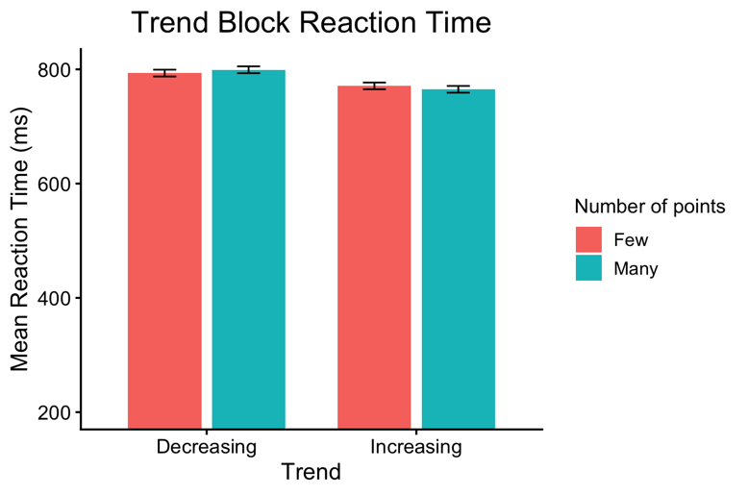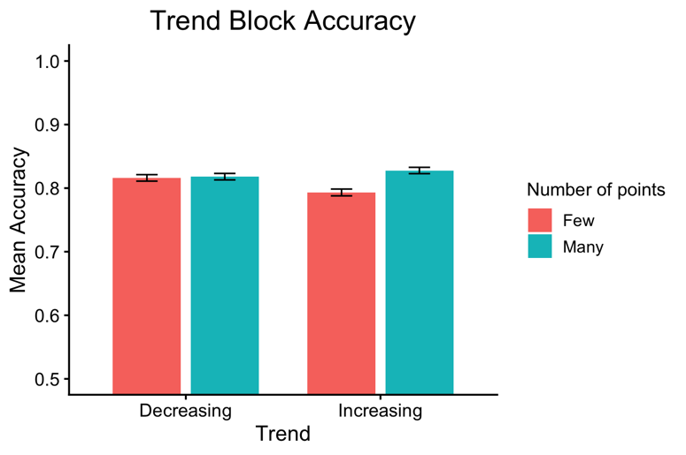
Note. The figures show the reaction time (left) and accuracy (right) for judging the trend direction of increasing and decreasing arrays with few (<15) and many (>15) points. Error bars represent ± 1 standard error.
The same pattern was observed for accuracy. There was a significant interaction between number of points and slope direction, b = 0.032, SE = 0.008, z = 4.184, p < .001. For increasing slopes, participants more accurately judged the trend of the array as the number of points increased, b = 0.036, SE = 0.005, z = 6.703, p < .001, whereas for decreasing slopes, the effect of number was not significant, b = 0.004, SE = 0.005, z = 0.790, p = .430. Thus, like reaction time, the number of points differentially facilitates participants' judgments of trend depending on its direction.
Two possible explanations obtain for these data. The first possibility is, as hypothesized, an interference/facilitation effect caused by the associations between the stimulus features of the trend and the number of points in each dot array, such that increasing trends are associated with more numerous arrays and decreasing trends with more sparse ones. The second possibility is that participants have a prior for decreasing trends and thus default to responding ‘decreasing’ when there is little evidence for the correct decision, such as when there are few points. This would explain the difference in accuracy for sparse and numerous increasing arrays because the task is a 2AFC. For sparse arrays (in which there is low evidence) participants may be more likely to rely on the prior and choose decreasing while they are less likely to do so when the array is numerous. This would also explain the reverse effect of accuracy as a function of the number of points for decreasing slopes, that is, that sparse decreasing arrays would be more accurate than numerous ones. Again, this is because relying on a prior for sparse arrays would lead to more accurate answers for decreasing arrays, and as the number of points increases one would expect fewer ‘decreasing’ responses. Despite the fact that we did not obtain this result (a reverse effect of number for decreasing slopes, this account might still be plausible and is worth investigating.
If participants relied on a decreasing-trend prior under conditions of low evidence, then increasing either the number of points or the steepness of the trend should reduce the proportion of decreasing responses (i.e., increase “increasing” choices). To distinguish between these accounts, we modeled the probability of choosing “increasing” as a function of the number of points and the absolute value of the slope (that is, its steepness) with random effects of the number of points and the absolute value of the slope and their interaction.
The analysis revealed no main effect of number, b = 0.010, SE = 0.007, z = 1.393, p = .164, and no main effect of steepness, b = 0.052, SE = 0.239, z = 0.219, p = .827. There was, however, a significant interaction between number and steepness, b = 0.116, SE = 0.029, z = 4.037, p < .001. To investigate this interaction we evaluated the effect of the number of points at plus and minus one standard deviation of the absolute value of slope (hereafter, low and high slope magnitude). When slope magnitude was low, the number of points did not influence the proportion of “increasing” responses, b = −0.002, SE = 0.008, z = −0.218, p = .828. In contrast, when slope magnitude was high, greater numbers of points increased the likelihood of choosing “increasing,” b = 0.022, SE = 0.008, z = 2.805, p = .005. In other words, only when the slope was steep did increasing the number of points lead to more “increasing” responses, and decreasing the number of points lead to more “decreasing” responses (see Figure 2).

Figure 2.3
Percent Responses Increasing by Slope Magnitude for Numerous and Sparse Arrays
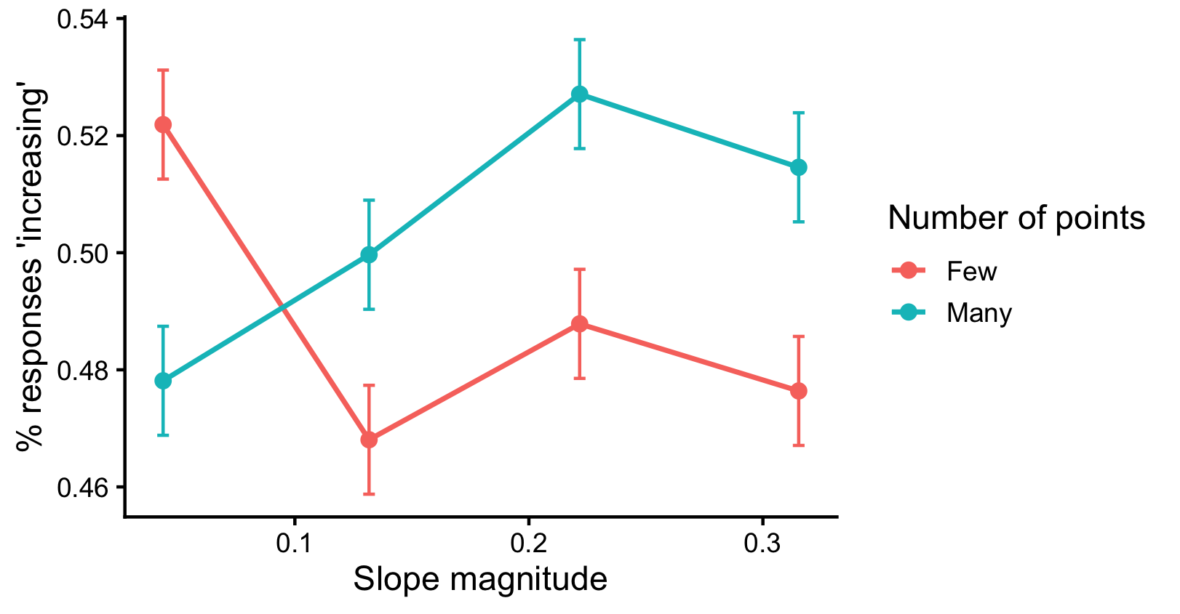
Note. The figure shows the proportion of ‘increasing’ responses as a function of the slope magnitude for arrays with few (<15) and many (>15) points. Error bars represent ± 1 standard error.
RQ2: The Influence of Trend on Numerosity Judgement
To assess whether the trend of the points in a dot array influences judgements of its numerosity, we analyzed both reaction time and accuracy (excluding trials faster than 250 ms and training trials) using mixed-effects models including a categorical variable for the number of points (n < 15 and n > 15), slope as a continuous variable, and their interaction, with random intercepts for slope and the number of points. We hypothesized that the slope of an array would have no influence on judgements of its numerosity.
For reaction time, there was no main effect of slope, b = 0.01557, SE = 0.01937, t = 0.80, p = .423, and no main effect of numerosity, b = 0.02124, SE = 0.01389, t = 1.53, p = .135. Critically, there was no interaction between slope and numerosity, b = −0.02113, SE = 0.02678, t = −0.79, p = .430.
Accuracy analyses yielded a similar pattern. There was a significant main effect of numerosity, indicating higher accuracy for more numerous arrays, b = −0.59445, SE = 0.19362, z = −3.07, p = .002, but no main effect of slope, b = 0.01660, SE = 0.16160, z = 0.10, p = .918. Importantly, there was no interaction between slope and numerosity, b = 0.06751, SE = 0.21489, z = 0.31, p = .753. Thus, as predicted, there was no evidence that the trend of an array influenced the speed or accuracy with which participants judged its numerosity.
Study 1 Discussion
In Study 1, we sought to answer whether graphical trends have associations with numerical magnitudes and whether simplistic quasi-graphical figures could elicit these associations. To this end, we administered participants online a trend judgment task or a numerosity judgment task with increasing and decreasing arrays that were either numerous or sparse.
We found that when judging the trend of an array, participants were faster and more accurate at judging increasing arrays as the number of points increased, while there was no effect of the number of points for decreasing arrays. Importantly, these two effects were significantly different, indicating that participants associated different numerosities selectively with different trend directions. When judging the numerosity of an array, on the other hand, the trend had no influence. Thus, the effect is not an association between an orientation of the stimulus and its numerosity per se.
A possible explanation (although insufficient for the reaction time data) is that participants exhibited a decreasing trend prior to which they chose decreasing more often when the trends were noisier and less obvious, thus explaining why sparse increasing arrays were less accurate and sparse decreasing arrays were somewhat more accurate. However, the follow-up analyses ruled out this explanation as participants were not overall less likely to choose decreasing as the decisions became more certain (i.e., when trends became steeper and when the number of points increased). They were only less likely to choose decreasing as the number of points increased when the trends were also steep.
This fact helps rule out a second possible explanation: participants might exhibit a semantic congruence effect, in which the words "increasing" and "decreasing" are associated with larger and smaller numerosities, respectively. This hypothesis also seems unlikely in light of the follow-up analyses, which indicate that the effect that the number of points has on judgments of trend depends largely on the magnitude of the trend, not merely its direction. We found that, for numerous arrays, the proportion of 'increasing' responses increased linearly with trend magnitude and for sparse arrays, the proportion of 'decreasing' responses did. Thus, when the magnitude of the slope is not salient, associations with numerosity are weak; when it is salient, associations are strong and opposite for decreasing and increasing trends. Such a linear effect is similar to that observed in the classic SNARC effect (Dehaene et al., 1993; the effect increases linearly as a number’s distance from 5, in both directions, increases) and would not be expected by a categorical semantic effect, especially because the effect appears to flip for very weak trends (see Figure 2.3).
Some features of Study 1 limit the interpretations we can draw from it. We did not observe that decreasing trends were facilitated by reducing the number of points in the stimulus, and our effects were overall quite small. This could be due to the fact that we used a very small range of points in our arrays. Our justification for doing so was to make the numerosity task similarly difficult to the trend judgment task. Indeed, it seems likely that the effect observed here might be more extreme when the numerosities of arrays are much more different. In addition, we cannot say whether this effect extends to graphical figures, as our study was interested in answering whether non-graphical stimuli could elicit abstract associations between numbers and the relations these stimuli represent. Moreover, our sample was also quite small, which could limit the observation of a decreasing trend effect if one exists, and it was also quite homogenous in terms of education and culture.
To address these issues and to extend and more rigorously test this effect, we will reanalyze a publicly available dataset on OSF from the study by Ciccione et al. (2023). These data were collected from a similar trend-judgment task of scatter plots, which contained conventional graphical information (i.e., axes), and we will therefore use them to answer the same question addressed in Study 1: whether the number of points of a scatter plot influences the judgment of its trend depending on its direction, and whether this effect extends to a larger educationally and culturally heterogeneous sample with more ecologically valid figures.
Study 2
Intro gotta go here
Method Study 2
Participants
Study 2 reanalyzed the adult online sample from Ciccione et al. (2023). The original adult sample included 3,943 participants who completed the online trend-judgment task. Participants were recruited through social networks, primarily Twitter, and completed the task on either a computer or a tactile device. Before beginning the experiment, participants provided written informed consent and declared that they were at least 18 years old. The sample included 2,409 women, 1,294 men, 82 non-binary participants, 20 participants who selected “other,” and 138 participants who preferred not to report their gender.
Trend Judgment Task
Very similar to the trend-judgment task in Study 1, participants completed a trend-judgment task in which they viewed a series of noisy scatterplots and judged whether each display showed an increasing or decreasing trend. On each trial, a scatterplot was presented briefly for 100 ms, unlike the task in study 1 in which arrays appeared for Blank, after which participants indicated their response by pressing one of two keys on a computer keyboard or, for smartphone and tablet users, by touching an upward- or downward-pointing arrow. The response mapping was randomly determined for each participant in the online experiment. Participants were instructed to respond as quickly and accurately as possible. Correct responses were rewarded with points in a game and were followed by a pleasant sound, while incorrect responses were followed by an unpleasant sound. The full task lasted approximately 6 min. For the original analyses, responses given more than 5 s after stimulus onset were excluded.
Stimuli
The stimuli in Ciccione et al. (2023) were noisy scatterplots generated in the same general manner as the dot arrays used in Study 1. Each display represented a set of points generated from a linear equation with added Gaussian noise, $y_{i}=αx_{i}+ε_{i}$, where $α$specified the prescribed slope and $ε_{i}$was sampled from a normal distribution centered at zero with standard deviation $σ$. As in Study 1, the x-coordinates were fixed and equally spaced, and displays varied parametrically in both trend direction and numerosity. However, Ciccione et al.’s stimuli differed from ours in several ways. First, their displays were presented as scatterplots with axes, whereas our Study 1 displays were axis-free dot arrays. Second, their stimuli varied over a wider range of numerosities: 6, 18, 38, or 66 points, compared with 12, 14, 16, 18, 20, or 22 points in Study 1. Third, Ciccione et al. manipulated noise level directly, using four values of $σ$: 0.05, 0.10, 0.15, and 0.20. Finally, their displays used seven prescribed slopes: −0.1875, −0.125, −0.0625, 0, 0.0625, 0.125, and 0.1875. Crossing these slope, noise, and numerosity values produced 112 scatterplots that they presented to participants. Despite these differences, the question of whether the numerosity influences judgments of trends differentially based on their sign is very possible.
Analyses
Using this dataset, we sought to answer the same question as Study 1: whether the number of points of a scatter plot influences the judgments of its trend, depending on the direction of the trend, such that increasing trends are faster and more accurate to judge as the number of points increases, and decreasing trends are faster and more accurate to judge as the number of points decreases. To do so, we had to modify some of the coding of the factors used in the original analyses.
First, because of the method of stimulus generation, which includes random noise, similar to an issue we encountered, graphs could be generated with the opposite trend direction from the intended one, especially for shallow trends. To ensure that the small effect we observed would not be obscured by such miscoding, we recoded the trend direction based on the observed slope, with negative slopes coded as decreasing and positive as increasing. In addition, to maintain consistency with our data, we excluded trials that were too fast to be processed (200 ms) and trials longer than 3000 ms.
Results Study 2
To assess whether the number of points in a dot array influences judgments differently for arrays with increasing and decreasing slopes, as in Study 1, we analyzed both reaction time and accuracy using mixed-effects models with fixed effects for the number of points as a linear predictor, slope direction, and their interaction and by-participant random effects for number of points, slope direction, and their interaction, with correlations among random effects omitted. We hypothesized that participants would perform better on arrays with more points for increasing trends and fewer points for decreasing trends. Thus, we expected an interaction between the slope direction and the number of points.
Just as in Study 1, reaction times showed a significant main effect of slope direction, such that participants responded faster to increasing slopes than decreasing slopes, b = −0.040, SE = 0.002, t = −26.969, p < .001. More importantly, there was a significant interaction between the number of points and slope direction, indicating that the effect of the number of points on response speed differed for increasing and decreasing trends, b = −8.10e−05, SE = 3.82e−05, t = −2.121, p = .034. Simple effects tests showed that, for increasing slopes, participants were faster to make trend judgments as the number of points increased, b = −7.85e−05, SE = 2.74e−05, z = −2.865, p = .004. For decreasing slopes, the number of points did not significantly predict reaction time, b = 2.43e−06, SE = 2.82e−05, z = 0.086, p = .931. Thus, replicating the pattern observed in Study 1, increasing the number of points facilitated response speed for increasing trends, whereas the number of points had no reliable effect on responses to decreasing trends.
The accuracy results were also similar to those of study 1. There was a significant main effect of slope direction, indicating participants were more accurate for increasing slopes than decreasing slopes, b = 0.318, SE = 0.012, z = 26.017, p < .001. There was also a significant main effect of number of points, indicating accuracy increased as the number of points increased, replicating the results obtained from the analyses of Ciccione et al. (2023), b = 0.001, SE = 0.0002, z = 3.966, p < .001. More importantly, there was a significant interaction between the number of points and slope direction, b = 0.003, SE = 0.0004, z = 9.330, p < .001. Simple effects tests showed that, for increasing slopes, participants more accurately judged the trend of the array as the number of points increased, b = 0.002, SE = 0.0003, z = 9.088, p < .001. For decreasing slopes, the effect of number was significant in the opposite direction, such that participants became more accurate as the number of points decreased, b = −0.001, SE = 0.0002, z = −4.362, p < .001. Thus, as in Study 1 and the reaction-time results, the number of points differentially affected trend judgments depending on slope direction.

