Data: data is collection of raw facts.
Information: Information is processed data.

What is database?
It is a collection of inter-related data and relationships among those data.

What is database management system?
A database-management system (DBMS) is a collection of inter-related data and a set of programs to access those data.

(or)
A Database Management System (DBMS) is software designed to store, retrieve, define, and manage data in a database.

Popular DBMS Software: Here, is the list of some popular DBMS systems:
    - Oracle
    - NCR Teradata
    - Microsoft SQL Server
    - MySQL
    - IBM DB2
    - Microsoft Access
    - SQLite
    - MariaDB, etc.

Disadvantages of File System
Generally, we store our data in a text file. Now think about if you want to develop a system software for banking system, then we need to create a lot of text file to store different information. By considering this example we understand disadvantages of conventional based file system.

Disadvantages of File System compare to DBMS
- Data Redundancy
  - Data redundancy means repetition of data.
  - There is possibility of data duplication of same information in different files. This situation leads towards data redundancy.
  - As a result of data redundancy leads to memory wastage.
  - Example: A customer having both kind of accounts- saving and current. In such a situation a customer’s detail like: name, address, e-mail, contact number, city, etc... stored in both the files, saving.txt - a file which store's details of saving account holder and current.txt- a file which store's details of current account holder. because of storing same information of customer in two separate files, it leads to Data Redundancy.

Data Inconsistency
  - Because of data redundancy, may be data is not in a consistent state.
  - Example: (Here we continue above example) Suppose a customer having both kind of accounts a saving and a current. so, in file system this customers address is stored in both the files saving.txt and current.txt. Now customer changed his/her address. There might be a possibility that address is changed in only one file (saving.txt) and other (current.txt) remain unchanged. So now for the same customer in two different file two different value/information is available for the same field/attribute address. This is called Data Inconsistency.

Difficulty in Accessing Data
  - In file processing system Accessing Data is not convenient and efficient.
  - Example: We have stored customers data like: name, address, e-mail, contact number, and city. Now we want a complete record of the customer who lives in a particular city (for example, Guntur), to achieve this we need to write a separate program OR we need to execute to separate program i) to select all the record from file ii) select only those record whose city is Guntur from the result of first (i) program. We cannot achieve convenient and efficient data accessing by using both ways.

Limited Data Sharing/ Data Isolation
  - Data are stored in various files.
  - File formats may be different (for example: .txt and .xml) and these files may be stored in different folders of computer system or may be in a different system.
  - Because of isolation of data, it is difficult to share data between various applications.

Integrity Problems
  - It means the data available in the database is must be correct and consistent.
  - To achieve this data stored in a file must satisfy the rules define by the DBA.
  - Example: Initially while developing s/w for any bank they have decided that account balance should not be less than zero, and they developed an application program according to this constraint/rule. Now after few years chairperson and committee member of bank have decided that minimum balance should not be less than 2000, to implement these constraints you need to change in application program and need to install in all systems using that application program, but this is not an easy task.

Atomicity Problems
  - It means, transaction/operation completes either all (100%) or none (0%).
  - In other words all (any) operations on database must be atomic.
  - Example: Suppose there are two bank accounts: A/c-1 and A/c-2 having balance Rs.4500 and Rs.2000 respectively. Now we have to transfer Rs.500 from A/c1 to A/c-2. To achieve this, entire transaction divide into two separate parts:
i) debit Rs.500 from A/c-1 and ii) credit Rs.500 to A/c-2, but after performing debit operation somehow system goes down or power failure happened and credit operation not complete, because of that we loss Rs.500. This leads database towards in-consistence state.
  - It is difficult to ensure atomicity in a file system, while in DBMS you do not need to worry about it.

Concurrent Access Anomalies
  - In any system, for better performance and faster response, multiple users are allowed to access data concurrently.
  - Assume that A/c-1 having balance Rs.5000, now consider concurrent access of A/c-1. A person access A/c-1 and debit Rs.1000 by reading A/c-1 data from database, but before writing change back to database, simultaneously someone performed debit operation on same account worth Rs.500. So, it will read Rs.5000 as balance and after debit Rs.500 remaining balance is Rs. 4500. But after two simultaneous transaction worth Rs.1000 and Rs.500 actual balance would be Rs.3500.
  - In file system, concurrent data access should be perform under some supervision, which is usually a some program.
  - Due to lack of coordination between different application program, it is difficult to achieve this in file system.

Security Problems
  - Database should be accessible in a limited way to different users.
  - Each user are allowed to access only those data, which is required for his/her application.
  - In file processing system, different programmers are add their application program, it is difficult to achieve security constraints.
  - Example: Only a customer can check his/her account detail, no one else have to rights to access his/her account.

Advantage of using DBMS over the traditional file system
    - Fast Data Access: The data response time increases in DBMS. Example: If we search for any train in IRCTC then we get results about that train only in a fraction of seconds. But the file system would have given us the entire file. Such a file size is large hence its access time will also be more.
    - Minimized Data Redundancy: DBMS has different constraints like primary key constraints which helps in ensuring that we store only unique data in our database i.e. same data can't be stored in more than one places.

    - Data Consistency: Since DBMS solves the problem of data redundancy, the problem of data consistency is automatically solved. All you need to do is just change the data at one place and you are good to go.
    - Security: We have role-based access control in DBMS. Each user has a different set of access thus the data is secured from problems like data leaks, misuse of data etc. Example: In a university system the access is restricted according to the user. The teachers, students, accounts manager etc. all have different access
i.e. the accounts manager will have the access to all the data related to the accounts and the teacher will not be allowed to view the accounts data.
    - No attributes for accessing the data: Here, we don't need to know the location of the file. The user makes a request from any web application or app and the server responds accordingly. Example: If we want to know the fastest train between two stations we make a request on IRCTC and we get the result and we don't need to know where the data is stored.
    - Concurrent Access: Multiple users can access the database at the same time when we are using the Database Management System.

Characteristics of Database Management System
    - Provides security and removes redundancy
    - Self-describing nature of a database system
    - Insulation between programs and data abstraction
    - Support of multiple views of the data
    - Sharing of data and multiuser transaction processing
    - DBMS allows entities and relations among them to form tables.
    - It follows the ACID concept (Atomicity, Consistency, Isolation, and Durability).
    - DBMS supports multi-user environment that allows users to access and manipulate data in parallel.

Applications of DBMS
    - Banking: all transactions.
    - Airlines: reservations, schedules.
    - Universities: registration, grades.
    - Sales: customers, products, purchases.
    - Manufacturing: production, inventory, orders, supply chain.
    - Human Resources: employee records, salaries, tax deductions.

View of Data / Data Abstraction
Data Abstraction refers to the process of hiding irrelevant details from the user. There are mainly three levels of data abstraction. They are:
- Physical Level
- Conceptual Level
- View Level
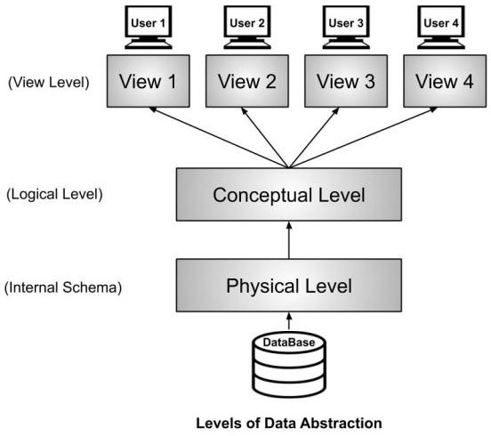

Physical Level:
    - Describes HOW data are actually stored.
    - It deals with the data structures used in physical level.
    - It is also called as Internal level.

Logical Level:
    - Describes WHAT data is stored in database and their relationships among data.
    - This level is usually designed by using ER diagrams.
    - It is otherwise called as Conceptual Level, Schema level.

External Level:
    - Only part of the database can be viewed at a time but not the entire database.
    - Database has many views.
    - It is otherwise called as Subschema level, View level.

Data Independence
Data independence refers to the property of DBMS through which we can modify the schema definition at one level without changing the schema definition at higher level.
We have two levels of data independence that are defined on the basis of three levels of abstraction.
- Physical Data Independence
- Logical Data Independence

Physical Data Independence
Physical Data Independence refers to the characteristic of changing the physical level without affecting the logical level or conceptual level. Using this property, we can easily change the storage device of the database without affecting the logical schema.

Example: Suppose you want to replace the storage device form hard disk to SSD or
magnetic tape then it should not affect the data stored at the logical level.

Logical Data Independence
It refers to the characteristics of changing the logical level without affecting the external or view level. If we do any changes in the logical level then the user view of the data remains unaffected. The changes in the logical level are required whenever there is a change in the logical structure of the database.

Due to Logical independence, any of the below change will not affect the external layer.
- Add/Modify/Delete a new attribute, entity or relationship is possible without a rewrite of existing application programs
- Merging two records into one
- Breaking an existing record into two or more records

Instances and Schemas in DBMS
Schema: The overall description of a database is called as schema
Instance: The collection of data stored in database at a particular moment or time is called Instance.

Data Models

- A data model-a collection of concepts that can be used to describe the structure of a database
- provides the necessary means to achieve this abstraction.
- structure of a database, we mean the data types, relationships, and constraints that should hold for the data.
- Most data models also include a set of basic operations for specifying retrievals and
- updates on the database.

Data Model gives us an idea that how the final system will look like after its complete implementation. It defines the data elements and the relationships between the data elements. Data Models are used to show how data is stored, connected, accessed and updated in the database management system.

The Relational model is the most widely used model. Apart from the Relational model.
    - Data models are classified into two categories. They are:
      - Object-based logical models.
      - Record-based logical models.

    - Data model is a collection of conceptual tools for describing data, data relationships, data semantics and consistency constraints.
    - Data Models are used to show how data is stored, connected, accessed and updated in the database management system
    - There are many data models being used nowadays but the relational model is the most widely used model.

Object Based Logical Models
    - There is no fixed format for representing data.
    - These models consist of conceptual tools.
    - These are used for designing the logical/ conceptual level of a database.
    - Otherwise called as semantic models.
    - For example: ER Model, ER diagrams are used for designing logical level of a database.

Entity-Relationship Model

Entity-Relationship Model or simply ER Model is a high-level data model diagram. In this model, we represent the real-world problem in the pictorial form to make it easy for the stakeholders to understand. It is also very easy for the developers to understand the system by just looking at the ER diagram. We use the ER diagram as a visual tool to represent an ER Model. ER diagram has the following three components:
- Entities: Entity is a real-world thing. It can be a person, place, or even a concept. Example: Teachers, Students, Course, Building, Department, etc are some of the entities of a School Management System.
- Attributes: An entity contains a real-world property called attribute. This is the characteristics of that attribute. Example: The entity teacher has the property like teacher id, salary, age, etc.
- Relationship: Relationship tells how two attributes are related. Example: Teacher works for a department.

Example:

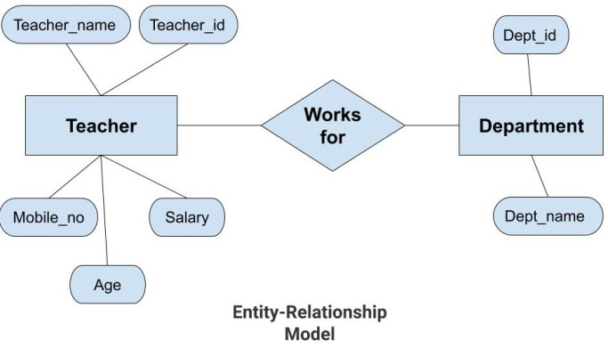

In the above diagram, the entities are Teacher and Department. The attributes of Teacher entity are Teacher_Name, Teacher_id, Age, Salary, Mobile_Number. The attributes of entity Department entity are Dept_id, Dept_name. The two entities are connected using the relationship. Here, each teacher works for a department.

Features of ER Model
- Graphical Representation for Better Understanding: It is very easy and simple to understand so it can be used by the developers to communicate with the stakeholders.
- ER Diagram: ER diagram is used as a visual tool for representing the model.
- Database Design: This model helps the database designers to build the database and is widely used in database design.

Advantages of ER Model
- Simple: Conceptually ER Model is very easy to build. If we know the relationship between the attributes and the entities we can easily build the ER Diagram for the model.
- Effective Communication Tool: This model is used widely by the database designers for communicating their ideas.
- Easy Conversion to any Model: This model maps well to the relational model and can be easily converted relational model by converting the ER model to the table. This model can also be converted to any other model like network model, hierarchical model etc.

Disadvatages of ER Model
- No industry standard for notation: There is no industry standard for developing an ER model. So one developer might use notations which are not understood by other developers.
- Hidden information: Some information might be lost or hidden in the ER model. As it is a high-level view so there are chances that some details of information might be hidden.

Record Based Logical Models:
    - There is fixed format for representing data
    - Data Models in this category are:
      - Network Model
      - Hierarchical Model
      - Relational Model
    - Network Model uses the data structure Graph for representing data
    - Hierarchical Model uses the data structure Tree for representing the data
    - Relational Model uses relation / table (set of rows & columns) for representing data

Hierarchical Model
Hierarchical Model was the first DBMS model. This model organizes the data in the hierarchical tree structure. The hierarchy starts from the root which has root data and then it expands in the form of a tree adding child node to the parent node. This model easily represents some of the real-world relationships like food recipes, sitemap of a website etc.

Example: We can represent the relationship between the shoes present on a shopping website in the following way:
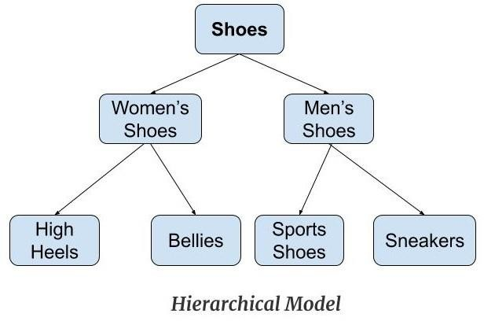

Features of a Hierarchical Model
- One-to-many relationship: The data here is organised in a tree-like structure where the one-to-many relationship is between the datatypes. Also, there can be only one path from parent to any node. Example: In the above example, if we want to go to the node sneakers we only have one path to reach there i.e through men's shoes node.
- Parent-Child Relationship: Each child node has a parent node but a parent node can have more than one child node. Multiple parents are not allowed.
- Deletion Problem: If a parent node is deleted then the child node is automatically deleted.
- Pointers: Pointers are used to link the parent node with the child node and are used to navigate between the stored data. Example: In the above example the 'shoes' node points to the two other nodes 'women shoes' node and 'men's shoes' node.

Advantages of Hierarchical Model
- It is very simple and fast to traverse through a tree-like structure.
- Any change in the parent node is automatically reflected in the child node so, the integrity of data is maintained.

Disadvantages of Hierarchical Model
- Complex relationships are not supported.
- As it does not support more than one parent of the child node so if we have some complex relationship where a child node needs to have two parent node then that can't be represented using this model.
- If a parent node is deleted then the child node is automatically deleted.

Network Model
This model is an extension of the hierarchical model. It was the most popular model before the relational model. This model is the same as the hierarchical model, the only difference is that a record can have more than one parent. It replaces the hierarchical tree with a graph.
Example: we can see that node student has two parents i.e., CSE Department and Library. This was earlier not possible in the hierarchical model.
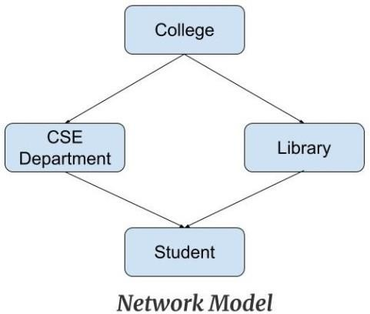
    - Both network and hierarchical models are involved with a greater number of pointers.
    - A single misplaced pointer corrupts the entire database.

Features of a Network Model
- Ability to Merge more Relationships: In this model, as there are more relationships so data is more related. This model has the ability to manage one-to-one relationships as well as many-to-many relationships.
- Many paths: As there are more relationships so there can be more than one path to the same record. This makes data access fast and simple.
- Circular Linked List: The operations on the network model are done with the help of the circular linked list. The current position is maintained with the help of a program and this position navigates through the records according to the relationship.

Advantages of Network Model
- The data can be accessed faster as compared to the hierarchical model. This is because the data is more related in the network model and there can be more than one path to reach a particular node. So the data can be accessed in many ways.
- As there is a parent-child relationship so data integrity is present. Any change in parent record is reflected in the child record.

Disadvantages of Network Model
- As more and more relationships need to be handled the system might get complex. So, a user must be having detailed knowledge of the model to work with the model.
- Any change like updation, deletion, insertion is very complex.

Relational Model
Relational Model is the most widely used model. In this model, the data is maintained in the form of a two-dimensional table. All the information is stored in the form of row and columns. The basic structure of a relational model is table. So, the tables are also called relations in the relational model.
For example: We have an Employee table.
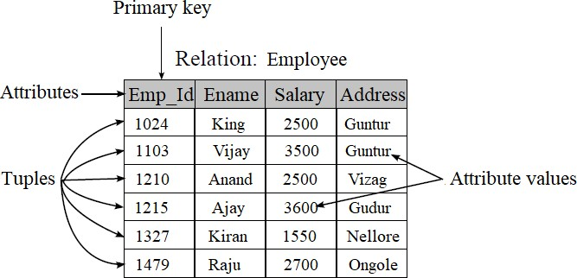
- A tuple/ row is a combination of different column values of one real world object.
- Number of columns represents degree of the table.
- Number of tuples represents cardinality of the table.
- Set of possible values for a column is domain.
- Tuple is identified uniquely by using primary key.

Properties of Relation:
  - All values in a table are atomic.
  - Rows are unordered from top to bottom.
  - Columns are unordered from left to right.
  - Relation must contain primary key for identifying rows uniquely.

Advantages of Relational Model
- Simple: This model is simpler as compared to the network and hierarchical model.
- Scalable: This model can be easily scaled as we can add as many rows and columns we want.
- Structural Independence: We can make changes in database structure without changing the way to access the data.

Database Users:
- Any person who uses the database and takes benefits from the database is considered as Database User.
- They can be programmers, scientists, engineers, business person or can be an employee.
- They are:
- Database Administrators.
- Database Designers.
- System Analysts.
- Application Programmers.
- Sophisticated Users.
- Naïve Users/Parametric Users.
- Casual/Temporary Users.

DBA stands for database administrator
He is responsible for managing the overall database management system like a superuser of the system.

DBA is responsible for:
    - Schema Definition: The DBA creates the original database schema by executing a set of data definition statements in the DDL.
    - Storage Structure and Access Method Definition: The storage structure and accessing methods of data at physical storage medium is modified by DBA only.
    - Schema and Physical Organization Modification: The DBA carries out changes to the schema and physical organization in-order to meet the requirement of organization when needed and to increase the performance of system.
    - Granting of Authorization for Data Access: DBA regulates the access of various parts of database. Users can access only limited parts of database. A user must take authorization from DBA in-order to access the parts which the user cannot access.
    - Routine Maintenance: The routine activities of DBA are:
      - Periodical backups of database.
      - Upgrading disk space in-order to provide space for normal operations.
      - Monitoring tasks running on the database and ensuring the performance of database without degrading.
    - New Software Installation.
    - Monitoring the database Server’s health and Tuning accordingly.

Database Designers
- Database designers design the appropriate structure for the database, where we share data.

System Analyst
- System analyst analyses the requirements of end-users, especially naïve and parametric end users.
- They are responsible for the design, structure, and properties of the database.

Application Programmers
- Application programmers are computer professionals, who write application programs.
- They develop application programs such as C, C++, Java, PHP, Python, etc. through which another user can interact with the database.

Sophisticated Users
- Sophisticated users can be engineers, scientists, business analysts, who are familiar with the database.
- These users interact with the database but they do not write programs

Naïve Users / Parametric Users
- Naïve Users are Unsophisticated users, who have no knowledge of the database.
- They are the end-users of the database who work through the menu-driven applications.
- For Example: Railway’s ticket booking users are naive users. Or Clerical staff in
any bank is a naïve user.

Casual Users / Temporary Users
- These types of users communicate with the database for a little period of time.

Structure of DBMS

The database system is partitioned into modules that deal with each of the responsibilities of the overall system. The functional components of a database system can be broadly divided into the storage manager and the query processor components.
The storage manager is important because databases typically require a large amount of storage space. Corporate databases range in size from hundreds of gigabytes to, for the largest databases, terabytes of data. A gigabyte is 1000 megabytes (1 billion bytes), and a terabyte is 1 million megabytes (1 trillion bytes). Since the main memory of computers cannot store this much information, the information is stored on disks. Data are moved between disk storage and main memory as needed. Since the movement of data to and from disk is slow relative to the speed of the central processing unit, it is imperative that the database system structure the data so as to minimize the need to move data between disk and main memory.

Storage Manager:
  - It is a program module which provides interface between the low-level data stored in the database and the application programs and queries submitted to the system.
  - It is responsible for interaction with the File Manager.
  - It translates DML commands into low level file system commands.
  - It is responsible for storing, retrieving and updating data in database.
  - It includes the following components:
- Authorization and Integrity Manager: Tests the integrity constraints and authorization of users.
- Transaction Manager: Ensures the consistency of database despite of system failures by non-conflicting schemes.
- File Manager: Manages the allocation of space on disk storage and data structures used to represent data on disk.
- Buffer Manager: It is responsible for fetching data from disk storage to main memory.
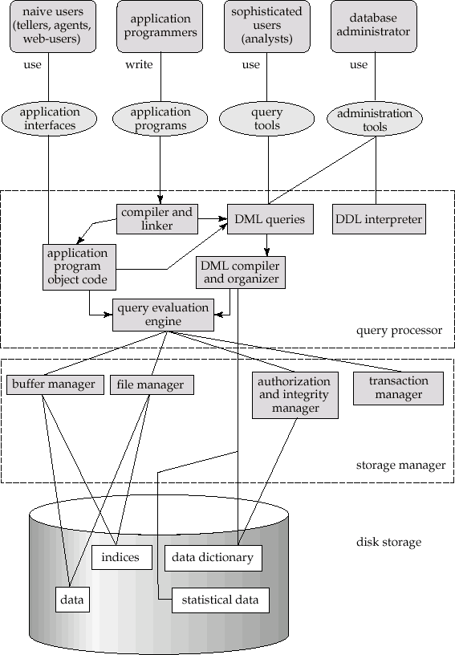

Disk Storage
The Storage Manager implements several data structures at physical level of database. They are:
  - Data Files: Stores database.
  - Data Dictionary: Store metadata of stored database.
  - Indices: Provides fast access to database. Hashing is alternative to indexing.

Query Processor
The Query Processor contains the following components:
  - DDL Interpreter: Interpreters DDL statements and records the definition into data dictionary.
  - DML Compiler: Translates DML statements into an evaluation plan consisting of low-level instructions that the query evaluation engine understands. It translates the query into a number of evaluation plans. DML Compiler performs query optimization i.e., selects the optimal evaluation plan for execution of query.
  - Query Evaluation Engine: Executes the low-level instructions generated by DML compiler.

*************End of Unit-1*************

