Functional Dependency in Normalization
Functional Dependency (FD) is a key concept in database normalization that describes the relationship between attributes in a relation (table). It helps in reducing data redundancy and ensuring data integrity.

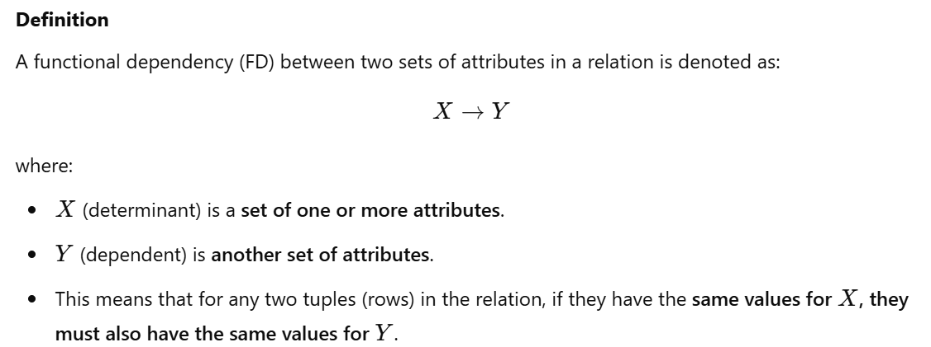

Example
Consider a relation Student (Student_ID, Name, Dept, Phone):
- FD: {Student_ID} {Name, Dept, Phone}
- This means that if two students have the same Student_ID, they must have the same Name, Dept, and Phone.

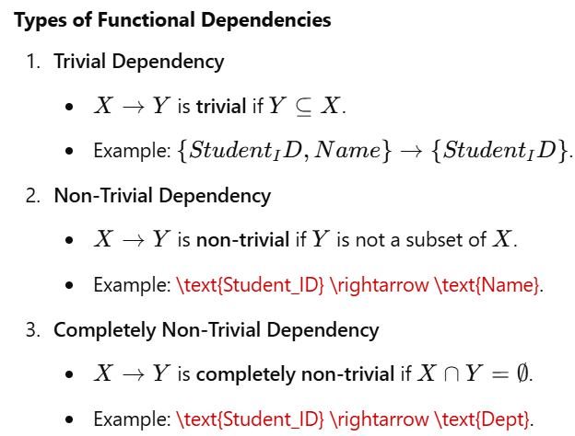

Role of Functional Dependency in Normalization
Functional dependencies help in identifying:
- Candidate Keys: The minimal set of attributes that can determine all other attributes.
- Normalization Forms:
  - 1NF: Eliminates duplicate attributes and ensures atomicity.
  - 2NF: Eliminates partial dependency (if any non-key attribute depends only on part of a composite key).
  - 3NF: Eliminates transitive dependency (if a non-key attribute depends on another non-key attribute).
  - BCNF: Ensures every determinant is a super key.

