J O I N S
Need of Joins

1. Data is stored in multiple related tables
- Normalization in databases separates data into multiple tables (for avoiding redundancy and ensuring data integrity).
- To combine meaningful data from these different tables, joins are needed.
Example:
- Employee details in employees table,
- Department names in departments table.
To find employee names along with department names — you must join both.

2. Real-world queries always require combining data
- Any business report or analytics dashboard needs combined data: sales with customers, orders with products, employees with departments.
- Joins enable writing complex queries to fetch interconnected information.

3. Support for complex analysis and reporting
- Joins allow users to write:
  - Aggregations by department or category
  - Manager-employee hierarchies (via self-joins)
  - Mismatch identification (via outer joins)

4. Required for handling data inconsistency checks
- Outer joins (LEFT/RIGHT/FULL) help in finding records that do not have matches.
- Useful for:
  - Finding orphan records
  - Data quality checks
  - Ensuring referential integrity
Joins are the foundation of relational queries, helping you intelligently combine data from multiple tables to answer real-world questions.

Sample Tables Setup

-- Create Departments Table

CREATE TABLE departments (
dept_id NUMBER PRIMARY KEY,
dept_name VARCHAR2(50)
);

-- Insert data into Departments

INSERT INTO departments VALUES (10, 'HR');
INSERT INTO departments VALUES (20, 'Finance');
INSERT INTO departments VALUES (30, 'IT');
INSERT INTO departments VALUES (40, 'Operations');

-- Create Employees Table

CREATE TABLE employees (
emp_id NUMBER PRIMARY KEY,
emp_name VARCHAR2(15),
dept_id NUMBER,
salary NUMBER,
FOREIGN KEY (dept_id) REFERENCES departments(dept_id)
);

-- Insert data into Employees

INSERT INTO employees VALUES (101, 'Alice', 10, 5000);
INSERT INTO employees VALUES (102, 'Bob', 20, 6000);
INSERT INTO employees VALUES (103, 'Charlie', NULL, 4000);
INSERT INTO employees VALUES (104, 'David', 30, 7000);

COMMIT;

Practice Queries for All Types of Joins

INNER JOIN
Returns only matching rows from both tables.
SELECT e.emp_id, e.emp_name, e.salary, d.dept_name
FROM employees e
INNER JOIN departments d
ON e.dept_id = d.dept_id;

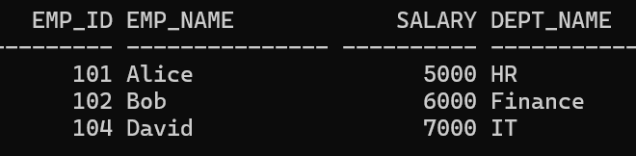

LEFT OUTER JOIN (LEFT JOIN)
Returns all rows from the left table and matching rows from the right; unmatched rows from right are NULL.
SELECT e.emp_id, e.emp_name, e.salary, d.dept_name
FROM employees e
LEFT JOIN departments d
ON e.dept_id = d.dept_id;

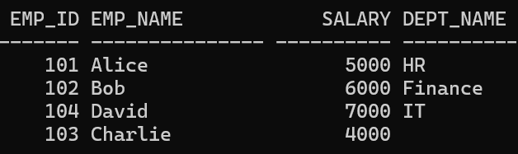

RIGHT OUTER JOIN (RIGHT JOIN)
Returns all rows from the right table and matching rows from the left; unmatched rows from left are NULL.
SELECT e.emp_id, e.emp_name, e.salary, d.dept_name
FROM employees e
RIGHT JOIN departments d
ON e.dept_id = d.dept_id;

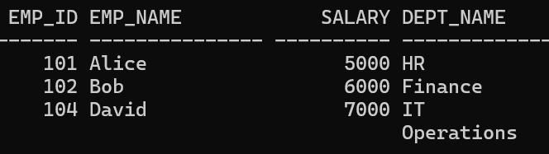

FULL OUTER JOIN
Returns all rows when there is a match in either table or no match in one of them.
SELECT e.emp_id, e.emp_name, e.salary, d.dept_name
FROM employees e
FULL OUTER JOIN departments d
ON e.dept_id = d.dept_id;

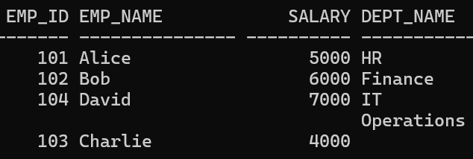

CROSS JOIN
Produces a Cartesian product (every combination of rows).
SELECT e.emp_name, d.dept_name
FROM employees e
CROSS JOIN departments d;

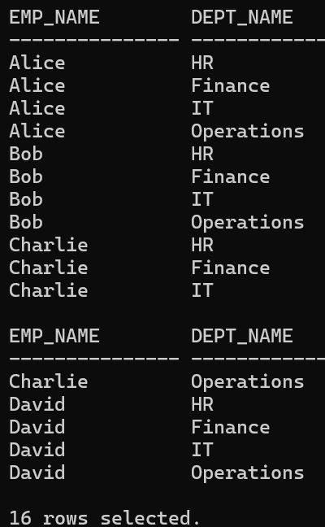

SELF JOIN
Join a table with itself (useful for hierarchy or reporting managers).
-- Add a manager_id column for demonstration

ALTER TABLE employees ADD (manager_id NUMBER);

-- Update manager_id for demonstration
UPDATE employees SET manager_id = 101 WHERE emp_id = 102;
UPDATE employees SET manager_id = 101 WHERE emp_id = 104;
COMMIT;

-- Self join to show employee-manager relationships

SELECT e.emp_name AS employee, m.emp_name AS manager
FROM employees e
LEFT JOIN employees m
ON e.manager_id = m.emp_id;

NATURAL JOIN
Automatically joins on columns with the same name in both tables.
-- Make sure dept_id has the same name in both tables

SELECT emp_id, emp_name, salary, dept_name
FROM employees
NATURAL JOIN departments;

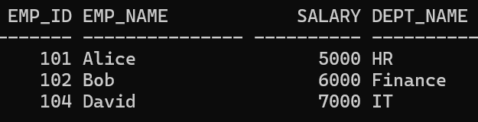

Queries for Practice

Inner Join Queries
1. List all employees along with their department names where the department is assigned.
SELECT e.emp_name, d.dept_name
FROM employees e
INNER JOIN departments d
ON e.dept_id = d.dept_id;
2. Show employee names, department names, and salaries for only those employees who belong to a valid department.
SELECT e.emp_name, e.salary, d.dept_name
FROM employees e
INNER JOIN departments d
ON e.dept_id = d.dept_id;

Left Outer Join Queries
3. List all employees along with their department names. If a department is not assigned, show NULL for department name.
SELECT e.emp_name, d.dept_name
FROM employees e
LEFT JOIN departments d
ON e.dept_id = d.dept_id;
4. Find employees who do not have any assigned department.
SELECT e.emp_name
FROM employees e
LEFT JOIN departments d
ON e.dept_id = d.dept_id
WHERE d.dept_id IS NULL;

Right Outer Join Queries
5. Display all departments along with the employees working in them. If no employee is working in that department, display NULL for employee names.
SELECT e.emp_name, d.dept_name
FROM employees e
RIGHT JOIN departments d
ON e.dept_id = d.dept_id;
6. Identify departments that do not have any employees.
SELECT d.dept_name
FROM employees e
RIGHT JOIN departments d
ON e.dept_id = d.dept_id
WHERE e.emp_id IS NULL;

Full Outer Join Queries
7. List all employees and all departments. For employees without departments and departments without employees, show NULL values accordingly.
SELECT e.emp_name, d.dept_name
FROM employees e
FULL OUTER JOIN departments d
ON e.dept_id = d.dept_id;
8. Find both employees who don’t belong to any department and departments without employees in one single query.
SELECT e.emp_name, d.dept_name
FROM employees e
FULL OUTER JOIN departments d
ON e.dept_id = d.dept_id
WHERE e.dept_id IS NULL OR d.dept_id IS NULL;

Cross Join Queries
9. Generate a report showing every possible pair of employee and department (Cartesian product).
SELECT e.emp_name, d.dept_name
FROM employees e
CROSS JOIN departments d;
10. How many total combinations of employees and departments are possible from the current data?
SELECT COUNT(*)
FROM employees e
CROSS JOIN departments d;

Self Join Queries
11. List each employee’s name along with their manager’s name.
SELECT e.emp_name AS employee, m.emp_name AS manager
FROM employees e
LEFT JOIN employees m
ON e.manager_id = m.emp_id;
12. Find employees who do not have managers assigned.
SELECT emp_name
FROM employees
WHERE manager_id IS NULL;
13. Identify employees who are managers themselves (their IDs appear as manager_id for other employees).
SELECT DISTINCT m.emp_name AS manager
FROM employees e
JOIN employees m
ON e.manager_id = m.emp_id;

Natural Join Queries
14. Display employee ID, employee name, department ID, and department name using a natural join.
SELECT emp_id, emp_name, dept_id, dept_name
FROM employees
NATURAL JOIN departments;
15. Write a query that automatically joins employees and departments on the common column (without specifying ON conditions).
SELECT emp_id, emp_name, salary, dept_name
FROM employees
NATURAL JOIN departments;

Challenge Queries
16. List employees and their department names, but include also departments that have no employees. Sort by department name.
SELECT e.emp_name, d.dept_name
FROM employees e
RIGHT JOIN departments d
ON e.dept_id = d.dept_id
ORDER BY d.dept_name;
17. Find employees whose salary is above the average salary of all employees in their department.
SELECT e.emp_name, e.salary, d.dept_name
FROM employees e
JOIN departments d ON e.dept_id = d.dept_id
WHERE e.salary > (
SELECT AVG(salary)
FROM employees
WHERE dept_id = e.dept_id
);
18. Identify mismatches: list employees whose dept_id does not exist in the departments table.
SELECT e.emp_name, e.dept_id
FROM employees e
LEFT JOIN departments d
ON e.dept_id = d.dept_id
WHERE d.dept_id IS NULL AND e.dept_id IS NOT NULL;

