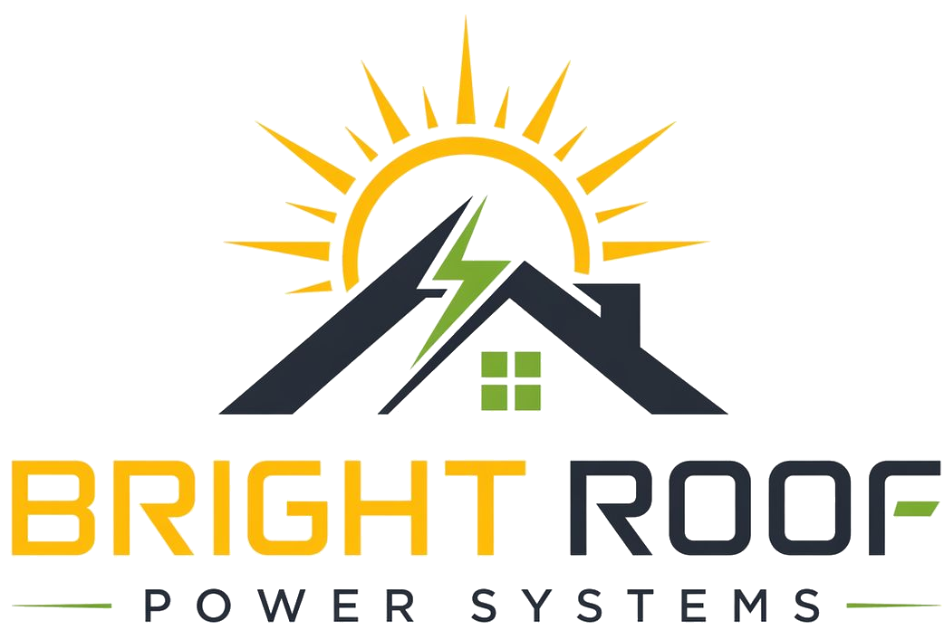

Rooftop solar for apartment societies
No upfront installation cost for the society.

Bright Roof installs, owns, operates, and maintains rooftop solar systems for apartment societies in Hyderabad. Your society pays only for solar electricity consumed or offset under the signed agreement, with a starting proposal of 10% saving against the agreed electricity-tariff benchmark.
Item | Bright Roof position
Upfront installation cost | Nil for the society
Ownership | Bright Roof owns the system
Maintenance | Bright Roof handles operation, cleaning, monitoring, and repairs
Monthly payment | Society pays for solar electricity under the agreement
Saving | Starting proposal of 10% against agreed electricity benchmark
Grid connection | Existing grid supply remains for balance electricity
Survey | Done only after society permission

Why societies consider this model
- No lakhs of rupees collected from residents for installation.
- No long-term maintenance burden on the committee.
- No automatic handover of operational risk after payback.
- Lower common-area electricity cost without changing normal grid supply.

First step
- Share the last 12 months of common-area electricity bills.
- Confirm consumer service number and sanctioned load details.
- Allow rooftop and electrical-room access for a technical survey.
- Share society registration and authorized signatory process.
Contact: support@brightroofpower.com | +91 93902 10407 | www.brightroofpower.com

