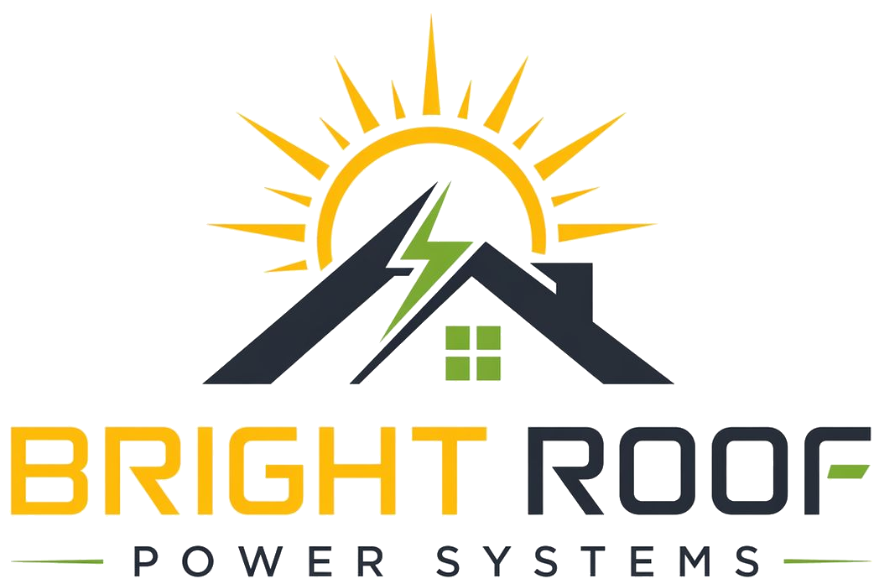

Bright Roof Power Systems
Short company profile for apartment society committees.

Field | Detail
Legal name | M/s. Bright Roof Power Systems
Short name | Bright Roof
Business model | Rooftop solar PPA / RESCO model
Location | Hyderabad, Telangana
Website | www.brightroofpower.com
Email | support@brightroofpower.com
Phone | +91 93902 10407
Address | 8-3-945/8/18&19 Pancom Business Centre, Ameerpet, Hyderabad, 500073, Telangana

What Bright Roof Does
Bright Roof Power Systems is a Hyderabad-based rooftop solar company focused on apartment societies. We install, own, operate, and maintain rooftop solar systems. The society does not pay the installation cost upfront.

Who We Serve
- Lifts
- Pumps
- Common lighting
- Clubhouse
- STP
- Security and maintenance loads
- Other shared facilities

How The Process Works
Step | What happens
1. Bill review | Bright Roof reviews 12 months of electricity bills and tariff details.
2. Site survey | Rooftop, electrical room, meter location, and cable route are inspected.
3. Proposal | Bright Roof prepares a society-specific commercial and technical proposal.
4. Agreement | Final terms are documented in a Power Purchase Agreement.
5. Installation | Bright Roof coordinates installation, safety, and approvals.
6. Operation | Bright Roof monitors, maintains, cleans, and supports the system.

