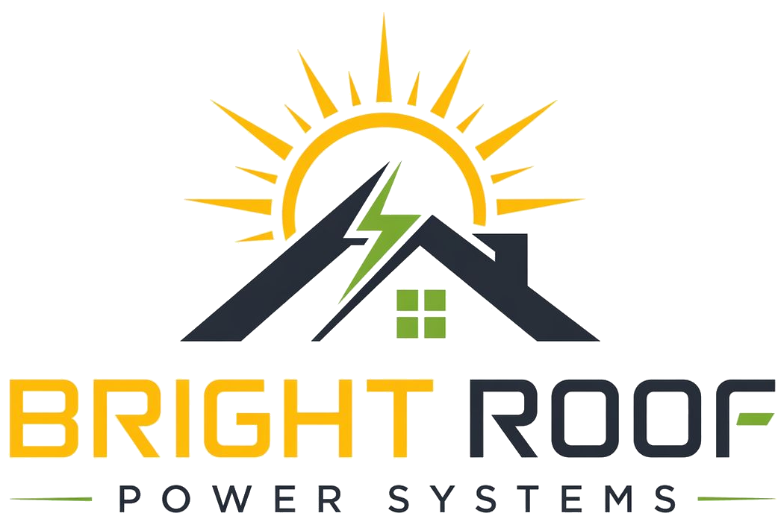

Document Request Checklist
For first-stage Bright Roof review.

Electricity Details
- [ ] Last 12 months of common-area electricity bills.
- [ ] Consumer service number(s).
- [ ] Sanctioned load details, if shown separately.
- [ ] Current tariff category, if known.
- [ ] Any existing net-metering or solar application history.

Society Details
- [ ] Exact registered name of the society.
- [ ] Society registration certificate.
- [ ] Society bye-laws, if available.
- [ ] Current committee office-bearer list.
- [ ] Authorized signatory details.

Site Access Details
- [ ] Rooftop access contact person.
- [ ] Electrical room access contact person.
- [ ] Meter location access contact person.
- [ ] Preferred day/time for inspection.
- [ ] Any known roof leakage, structural, or access concerns.

