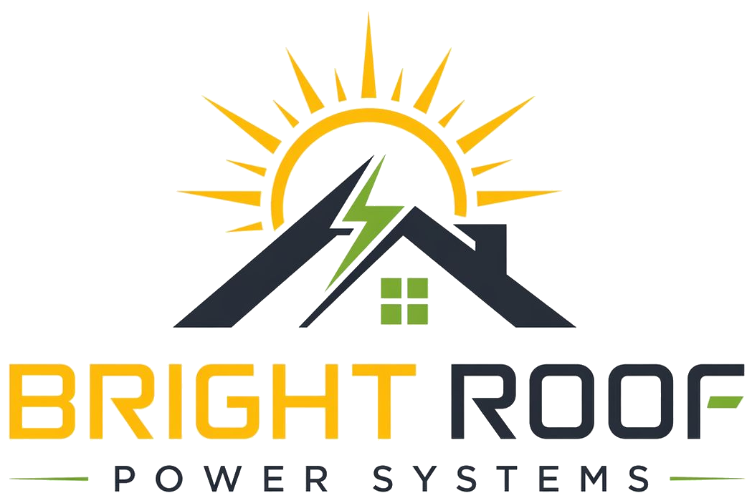

Permission For Bill Review And Rooftop/Electrical Survey
Preliminary review consent. Requires final legal review before formal use.

Date: ____________________
Field | Details
Society name
Society address
Contact person
Designation
Phone
Email

Permission Granted
- Review electricity bills and related consumption/tariff information shared by the society.
- Review society registration, office-bearer, and signatory information shared by the society.
- Visit and inspect the rooftop, electrical room, meter area, cable route, and related common areas by prior appointment.
- Take site photographs and notes required for technical and commercial feasibility review.
- Prepare a preliminary proposal or draft documentation for committee review.

Clarifications
- This permission is only for preliminary review and survey.
- This permission does not create an obligation for the society to sign a final agreement.
- Bright Roof will not begin installation work based only on this consent.
- Final terms will be governed by separately approved and signed documents.

Signatures
Society representative | Bright Roof representative
Name:  Designation:  Signature:  Phone:  Email: | Name:  Signature:  Phone:  Email: support@brightroofpower.com

