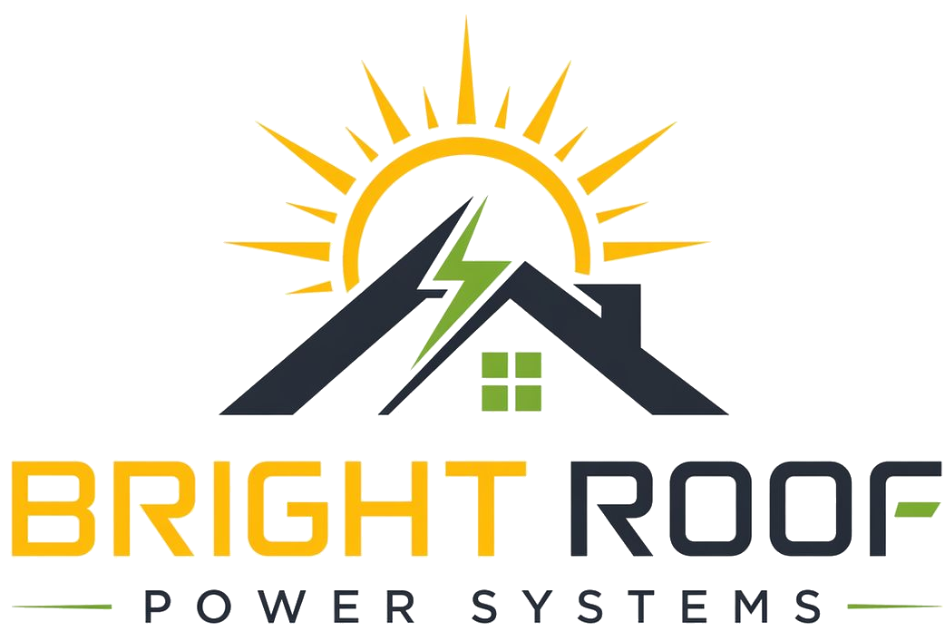

FAQ And Objection Replies
Internal field reference for Srinivas, Vijay, and Kalyan.

Is installation really free?
There is no upfront installation payment from the society. Bright Roof funds, owns, operates, and maintains the rooftop solar system. The society pays only for solar electricity under the signed agreement.

What saving do we get?
The starting proposal is 10% saving against the agreed electricity-tariff benchmark. Bright Roof confirms the exact benchmark and proposal after reviewing bills and site feasibility.

Can you give more than 10%?
Possibly, but do not commit before review. Bright Roof can check whether a higher saving is possible after seeing the bills, rooftop feasibility, and expected system size.

What is the installation cost?
Bright Roof funds the system. The society's decision is about the tariff saving and agreement terms, not paying the installation cost upfront.

Who owns the system?
Bright Roof owns the system during the agreement period.

Will you hand over the system after payback?
No automatic handover is part of the standard Bright Roof model. Bright Roof remains responsible for the system, so the society does not inherit operational risk.

What system size will be installed?
That depends on electricity consumption, sanctioned load, rooftop space, electrical connection, and survey results.

What if the roof is damaged?
The final agreement and installation method will address safe installation, access rules, roof protection, insurance, and responsibility for damage caused by Bright Roof or its installers.

Are we signing anything today?
No final PPA is required in the first meeting. The first step is permission for bill review and rooftop/electrical survey.

Escalate before answering in writing
- Exact tariff commitment.
- Discount above 10%.
- Final system capacity.
- Contract duration changes.
- Handover after payback.
- Roof damage liability wording.
- Payment default consequences.
- Net-metering guarantee.

