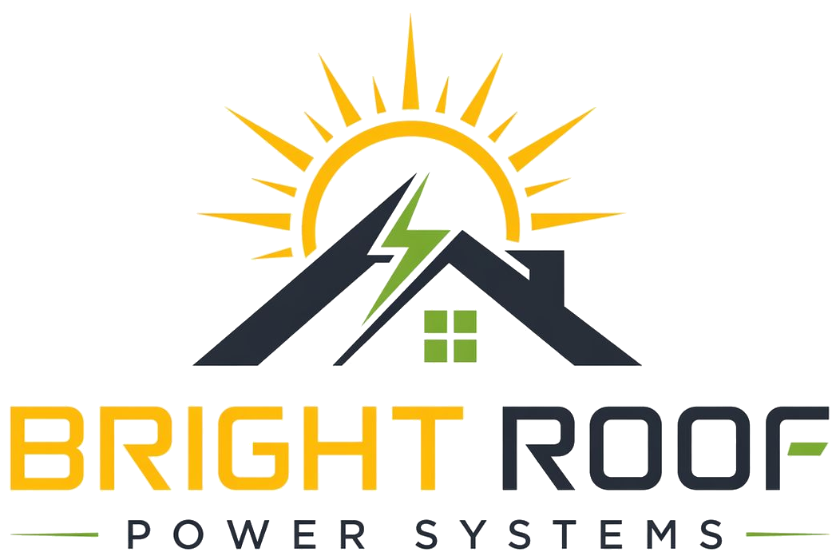

Bright Roof Vs Alternatives
Three ways an apartment society can go solar.

Option | Upfront cost | Ownership | Maintenance | Best for
Society buys the system | Paid by society/residents | Society | Society manages | Societies comfortable collecting capex and managing the system
Payback-and-handover model | Usually low or nil depending on model | May transfer later | May shift to society | Societies that want eventual ownership
Bright Roof model | Nil for society | Bright Roof | Bright Roof handles it | Societies that want savings without upfront collection or maintenance burden

Simple Decision
Choose society-owned solar if residents want to fund and manage the system. Choose Bright Roof if the society wants lower electricity cost without upfront installation payment and without taking over long-term system maintenance.

