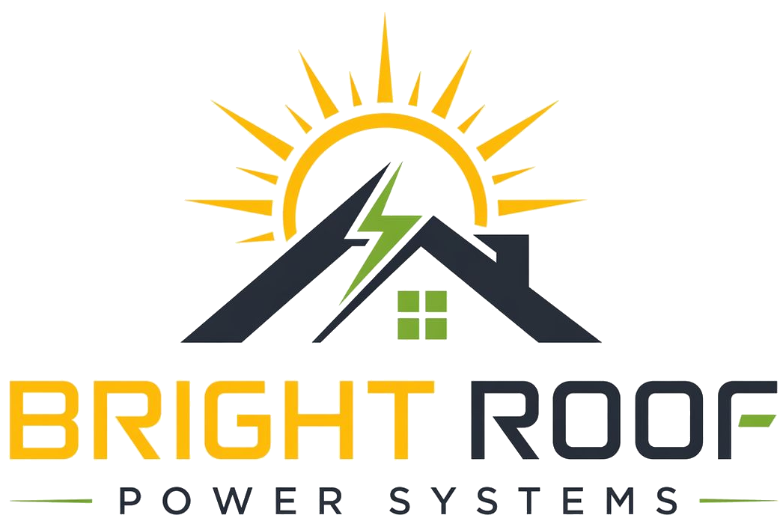

Committee Pitch Deck
Six-slide speaking outline.

1. Bright Roof Power Systems
Rooftop solar for apartment societies, without upfront installation cost.
- Bright Roof installs, owns, operates, and maintains rooftop solar systems.
- Starting proposal: 10% saving against the agreed electricity-tariff benchmark.

2. The Problem
Common-area electricity cost keeps rising.
- Lifts, pumps, lighting, clubhouse, STP, and other common loads add up every month.
- Many societies want solar but do not want to collect lakhs from residents.

3. The Bright Roof Model
We fund and maintain the system. The society gets lower power cost.
- No upfront installation cost to the society.
- Existing grid supply remains for balance electricity.
- Society pays for solar electricity under the agreement.

4. What The Society Provides
First we verify fit. Then we propose.
- 12 months common-area electricity bills.
- Consumer service number and sanctioned load details.
- Rooftop and electrical-room access for survey.

5. Process And Timeline
Clear steps before any final commitment.
- Bill and document review.
- Rooftop and electrical-room survey.
- Society-specific proposal.
- Committee/PPA review.
- Final approval and agreement.

6. Today's Ask
Permission for bill review and rooftop survey.
- Review 12 months of bills.
- Inspect rooftop and electrical room by appointment.
- Prepare a site-specific proposal for committee review.

