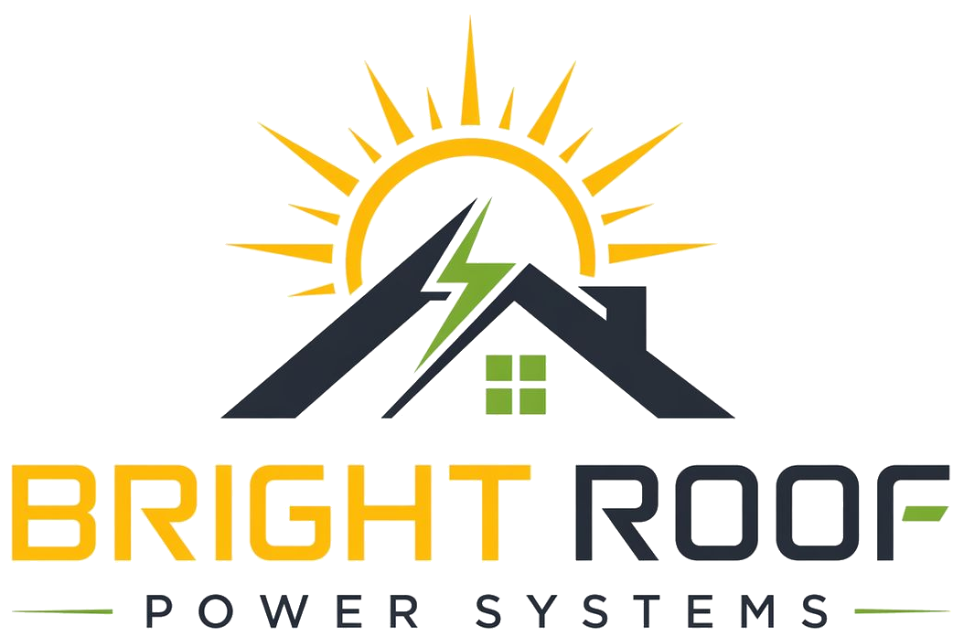

Srinivas Field Kit
Technical & Project Coordination

Primary Mission
Make Bright Roof feel technically credible without turning the first meeting into an engineering session.

WhatsApp Intro
Hi [Name], this is Srinivas from Bright Roof Power Systems. We help apartment societies reduce common-area electricity bills through rooftop solar with no upfront installation cost to the society. My role is to help with rooftop suitability, electrical access, survey requirements, and installer coordination.

Carry Pack
- Visiting card.
- One-page leaflet.
- Document request checklist.
- Consent form.
- Meeting notes template.

Escalate To Nrupal When
- A society asks for written proposal material.
- Bills are shared.
- A committee meeting is scheduled.
- Any number needs to go into writing.
- A stronger discount is requested.

