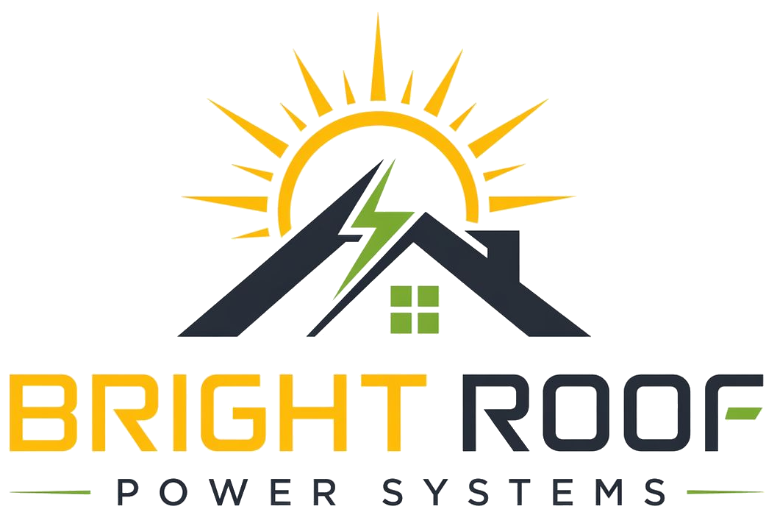

Vijay Field Kit
Society Relations

Primary Mission
Use local trust and apartment-network access to get serious committee conversations and document sharing.

WhatsApp Intro
Hi [Name], this is Vijay from Bright Roof Power Systems. We work with apartment societies in Hyderabad on rooftop solar where the society does not pay the installation cost upfront. The first step is only bill review and rooftop survey permission.

Carry Pack
- Visiting card.
- One-page leaflet.
- Document request checklist.
- Consent form.
- Meeting notes template.

Escalate To Nrupal When
- A society asks for written proposal material.
- Bills are shared.
- A committee meeting is scheduled.
- Any number needs to go into writing.
- A stronger discount is requested.

