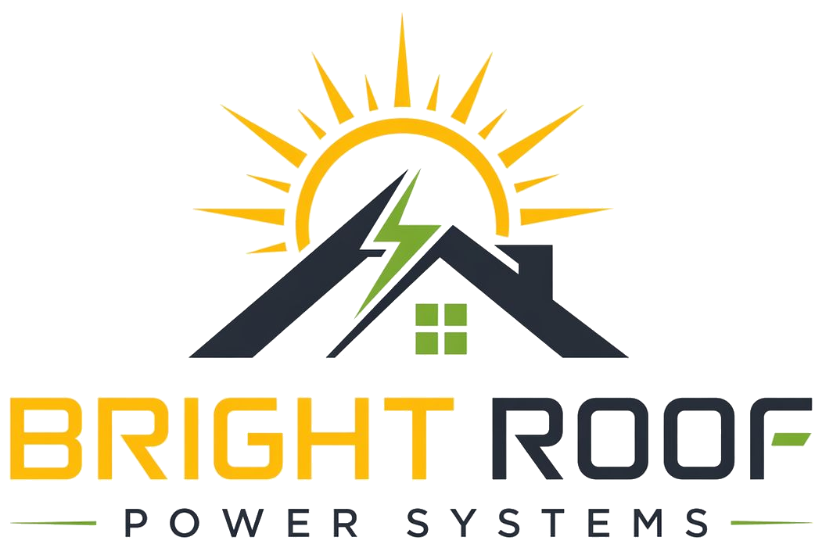

Kalyan Field Kit
Society Outreach

Primary Mission
Build and maintain a qualified pipeline of Hyderabad apartment-society leads.

WhatsApp Intro
Hi [Name], this is Kalyan from Bright Roof Power Systems. We help apartment societies reduce common-area electricity bills using rooftop solar, without the society paying upfront installation cost. Can I connect you with the Bright Roof team for a short discussion?

Carry Pack
- Visiting card.
- One-page leaflet.
- Document request checklist.
- Consent form.
- Meeting notes template.

Escalate To Nrupal When
- A society asks for written proposal material.
- Bills are shared.
- A committee meeting is scheduled.
- Any number needs to go into writing.
- A stronger discount is requested.

