# Introduction to TCL

Tcl is a general-purpose multi-paradigm system programming language. It is a scripting language that aims at providing the ability for applications to communicate with each other.

Day -1:

To check the usage of vsdsynth



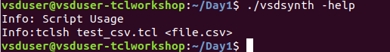

Incorrect CSV file

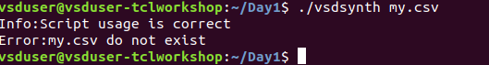

Usage of command and check to correct if csv file exist

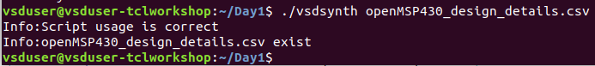

Test_csv.tcl

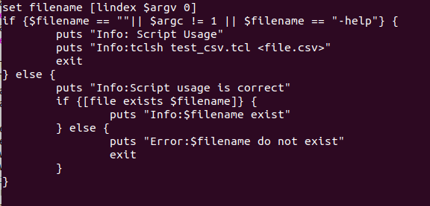

Day-2

Auto create variable using awk command

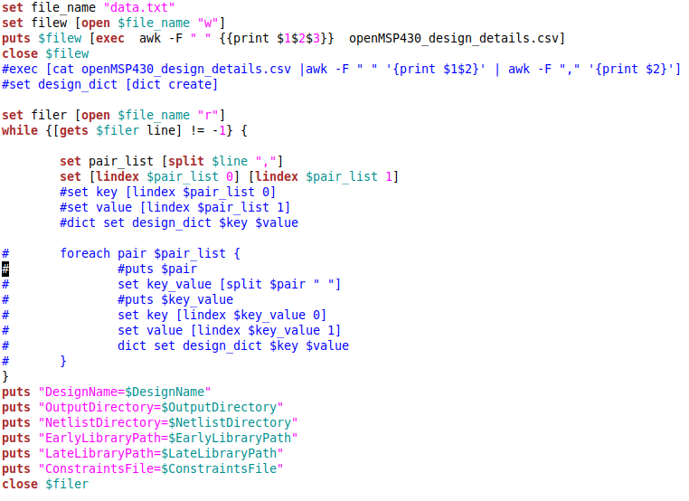

To check if files and folders exist

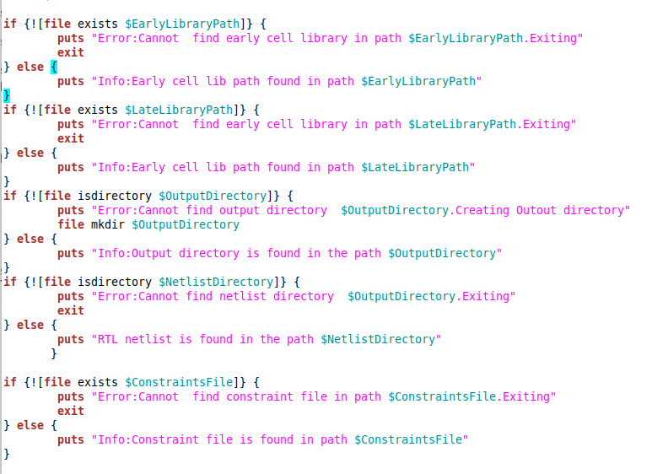

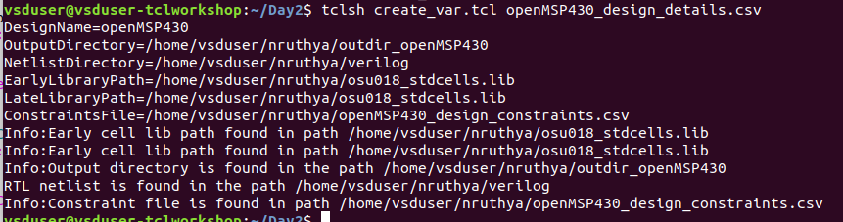

Day-3

Create clock constraints

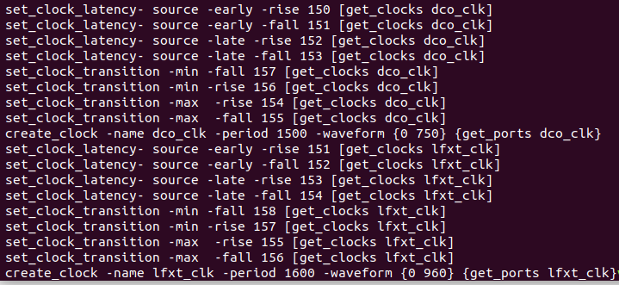

Categorize between busses and bits

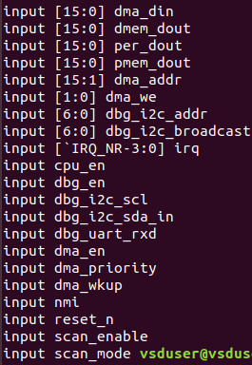

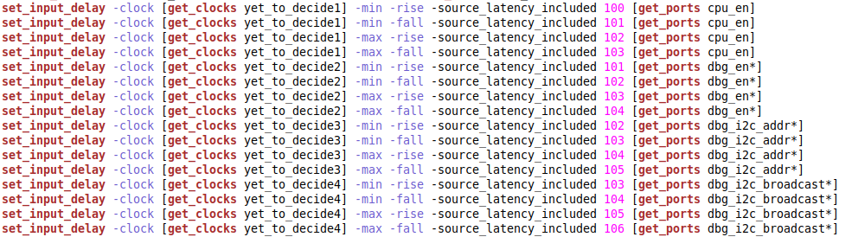

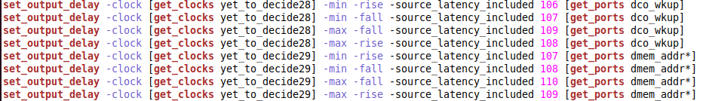



Day-4

Creating hierarchical check script for yosys open source tool.

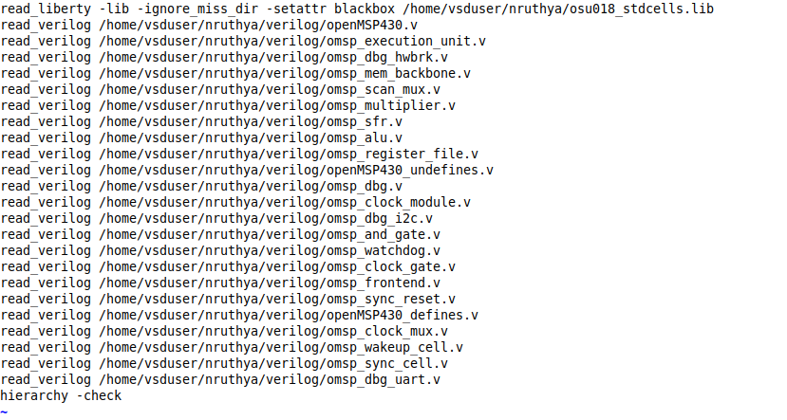

Error handling for hierarchy check

If all the modules in the top module.v file is defined then error_flag is 0.

hierarchy check PASS

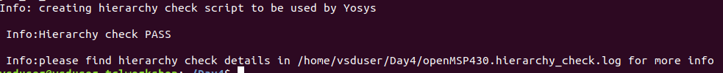

When module is not found=> hierarchy check FAIL

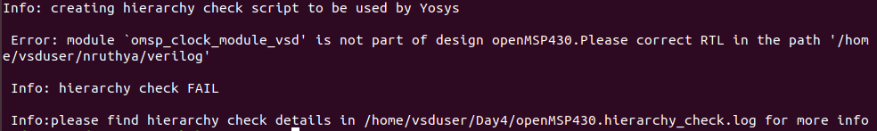



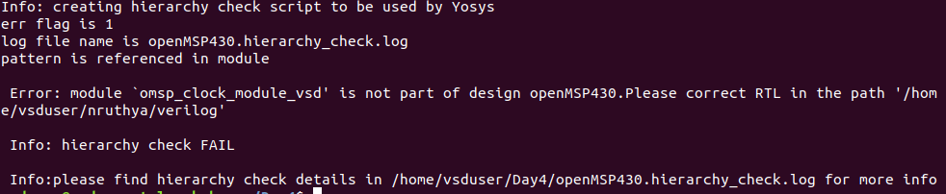

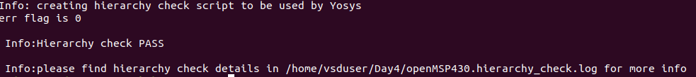

Day-5

Main synthesis script

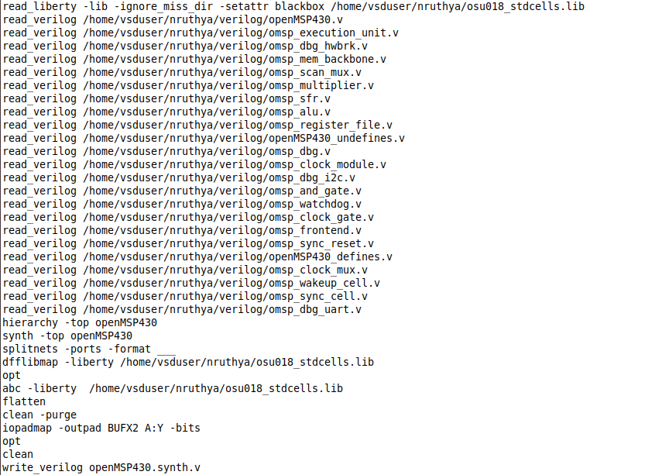

Running synthesis

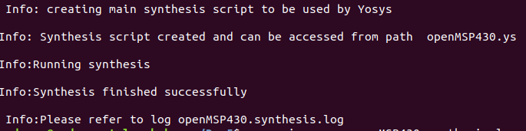

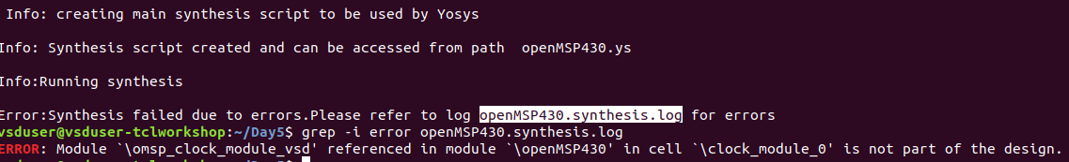

Editing the output netlist

1.removing the statements having stars

2.Removing slashes to make it compatible to Opentimer tool.

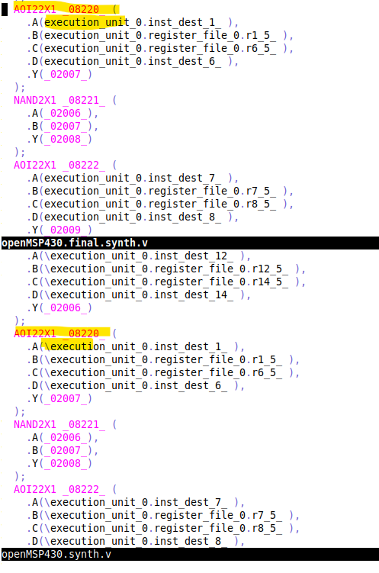

Procs

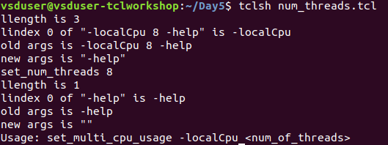

Preparing .conf file for openTimer

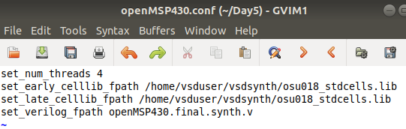

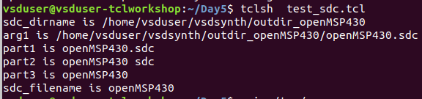

Clock period and duty cycle constraints

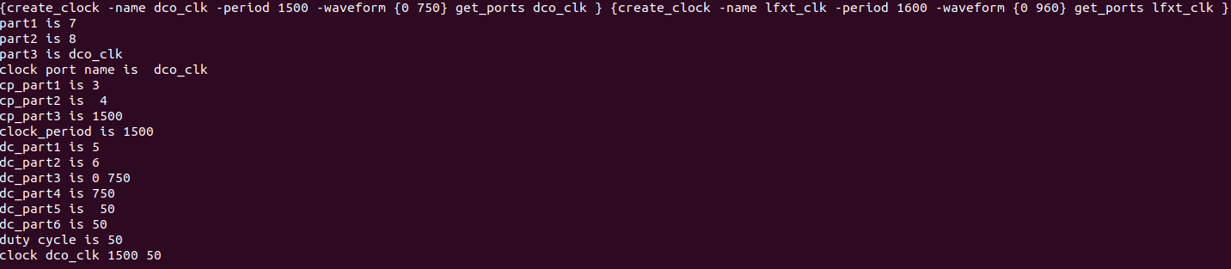



Clock latency constraints are added to the same file.

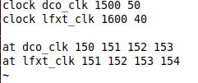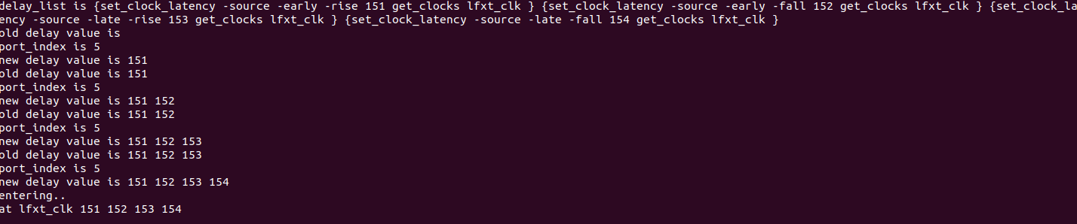

Clock transition Constraints

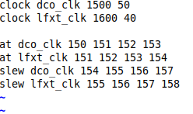

Input delay and transition constraints

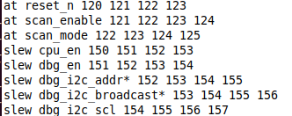

Output delay and load constraints

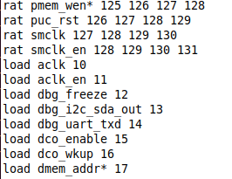

Expand the bussed ports and apply constraints to each and every bit of bussed port

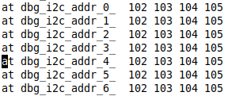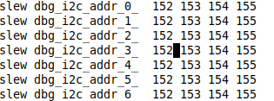

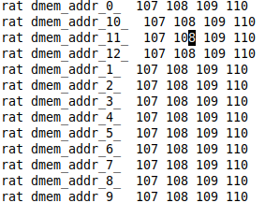

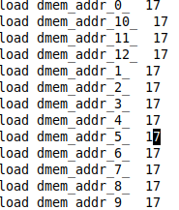

Configuration file for opentimer

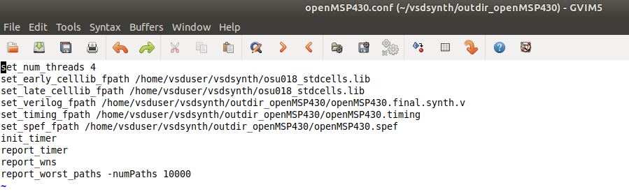

Runtime elapsed and Worst RAT slack

Number of Violations

