**Purchase Reward Points**

DB Script is Included.

Execute the DB Script in Database.

Change the DB Credentials in Code

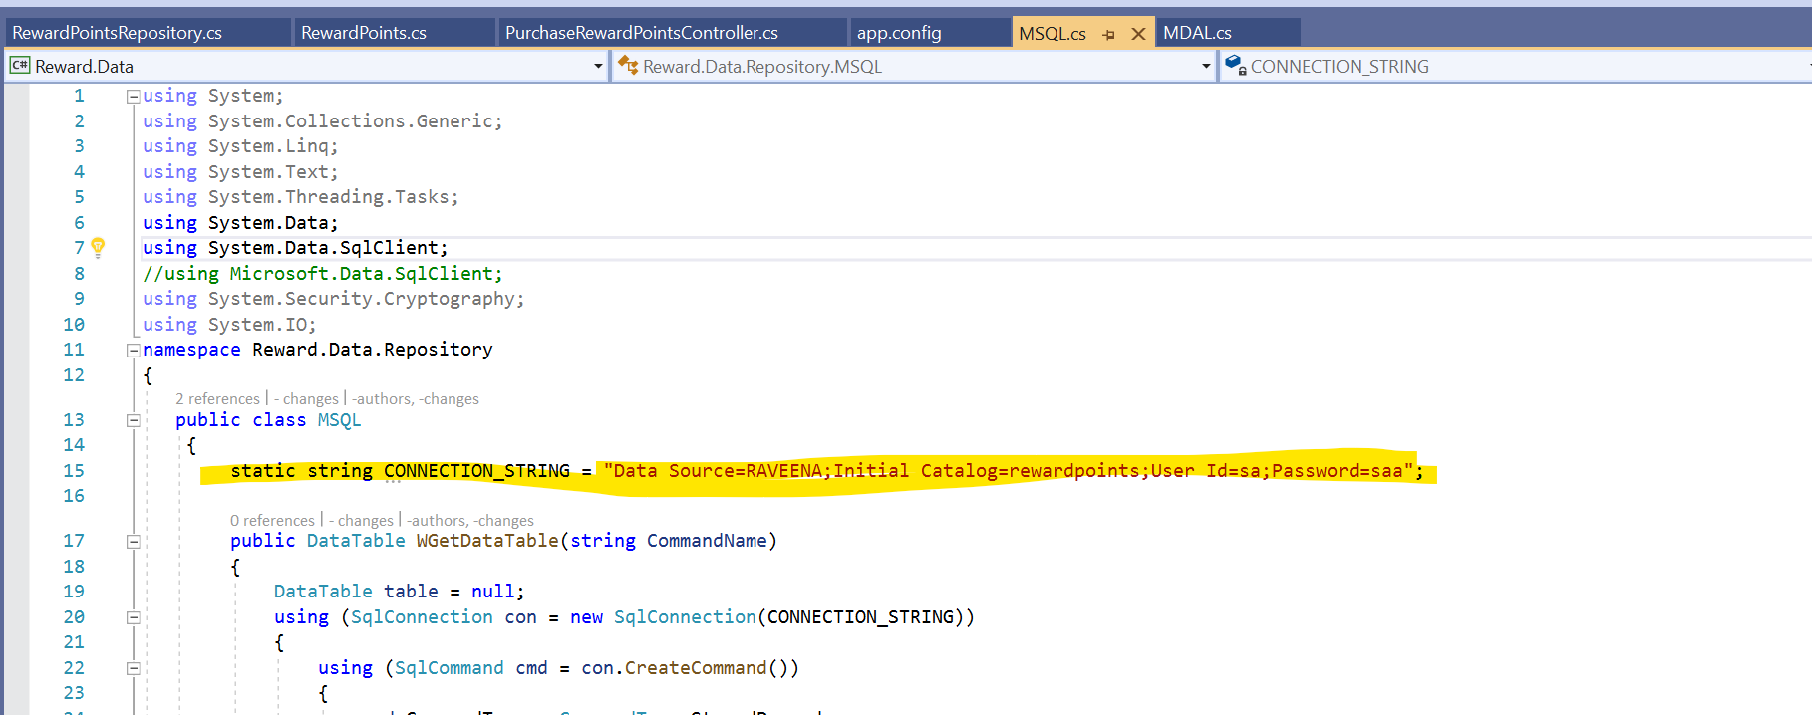

Run the application

1. Reward points calculation and Add to database using mobile no.

In Swagger, Enter the values in /api/PurchaseRewardPoints/api/PurchaseRewardPoints/AddUserRewardDetails

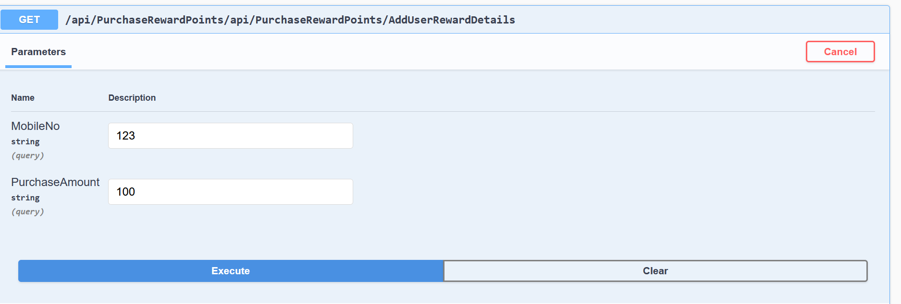

Input:

Mobile No. and Purchase Amount

Output:

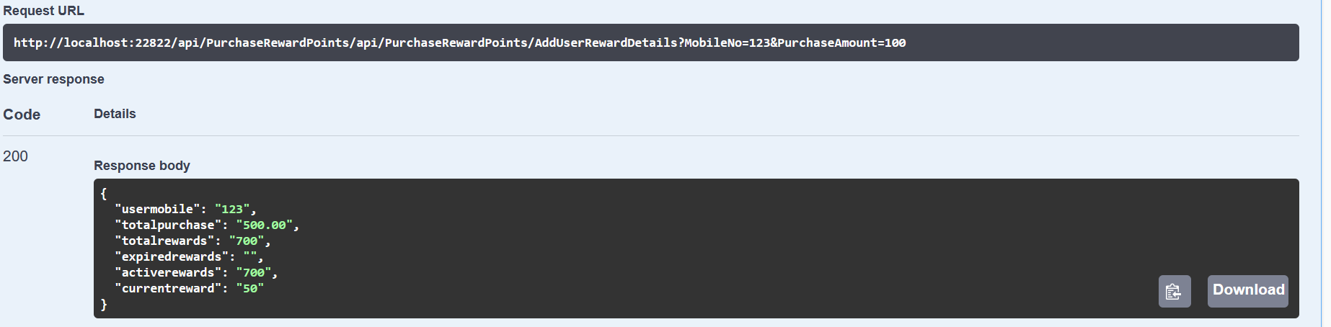

{

"usermobile": "123",

"totalpurchase": "500.00",

"totalrewards": "700",

"expiredrewards": "",

"activerewards": "700",

"currentreward": "50"

}

|  |  |
| --- | --- |
| Output | Meaning |
| usermobile | User Mobile |
| totalpurchase | Amount purchased till now |
| totalrewards | Reward points earned till now |
| expiredrewards | Reward points expired till now(default expiry date 360 days added in database) |
| activerewards | Available Reward points |
| currentreward | Reward points earned for current purchase |

API URL is

http://localhost:22822/api/PurchaseRewardPoints/api/PurchaseRewardPoints/AddUserRewardDetails?MobileNo=123&PurchaseAmount=100

1. Retrieve the User Details through Mobile

​/api​/PurchaseRewardPoints​/api​/PurchaseRewardPoints​/GetUserRewardDetails

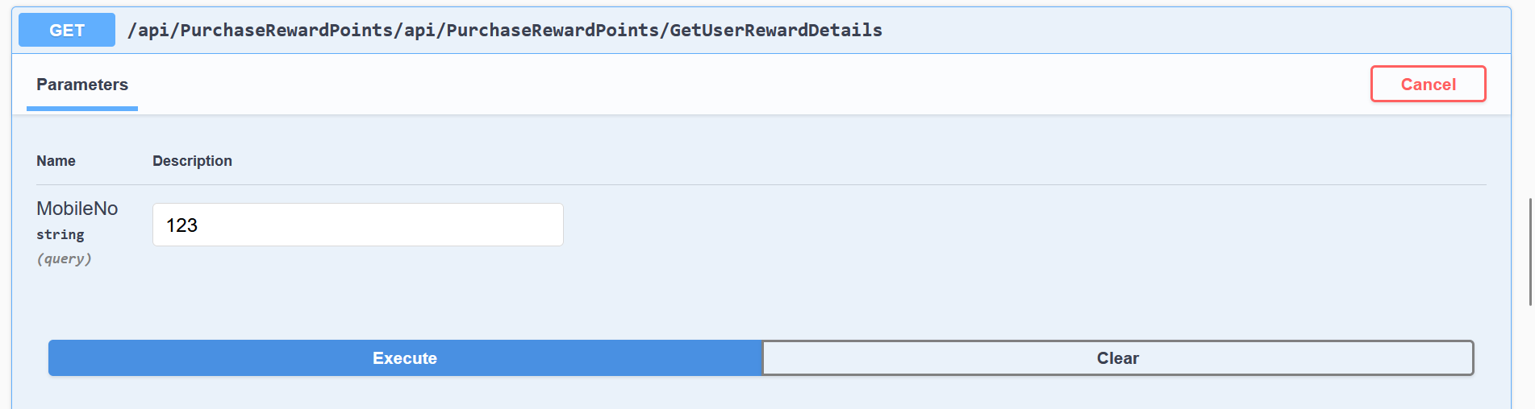

Input:

MobileNo

Output

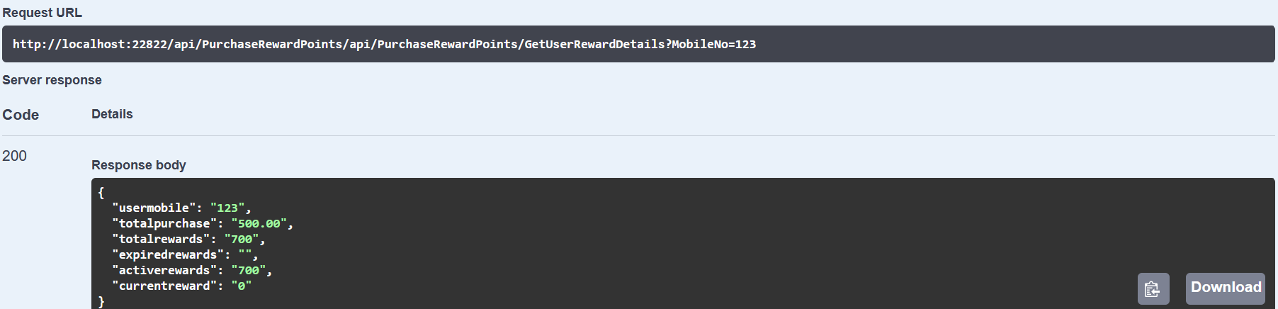

{

"usermobile": "123",

"totalpurchase": "500.00",

"totalrewards": "700",

"expiredrewards": "",

"activerewards": "700",

"currentreward": "0"

}

API URL:

<http://localhost:22822/api/PurchaseRewardPoints/api/PurchaseRewardPoints/GetUserRewardDetails?MobileNo=123>

1. Retrive Reward History through Mobile

/api/PurchaseRewardPoints/api/PurchaseRewardPoints/GetRewardPointsHistory

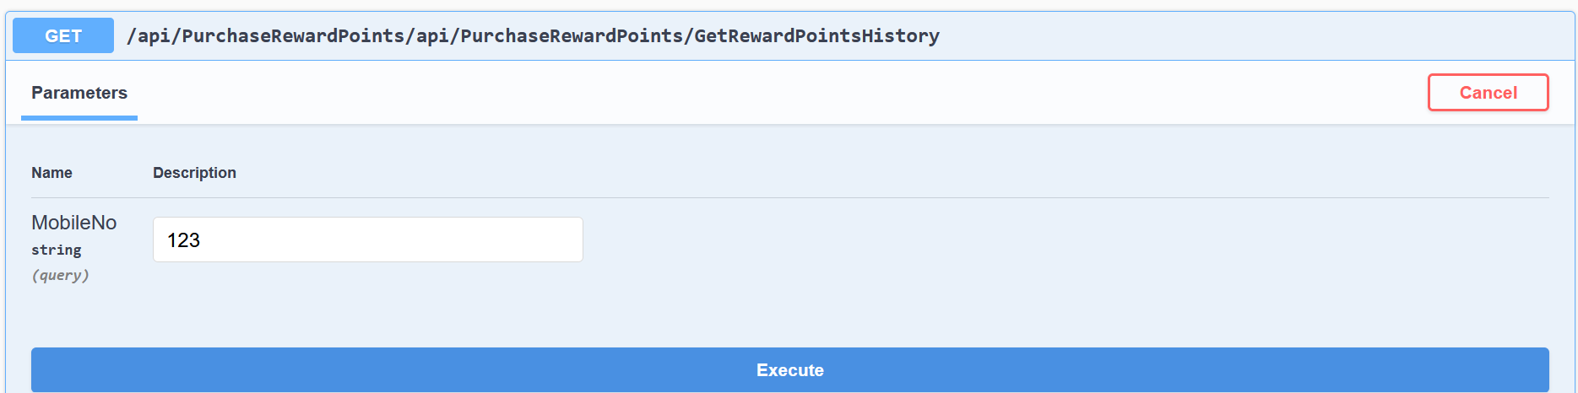

Input:

MobileNo

Output

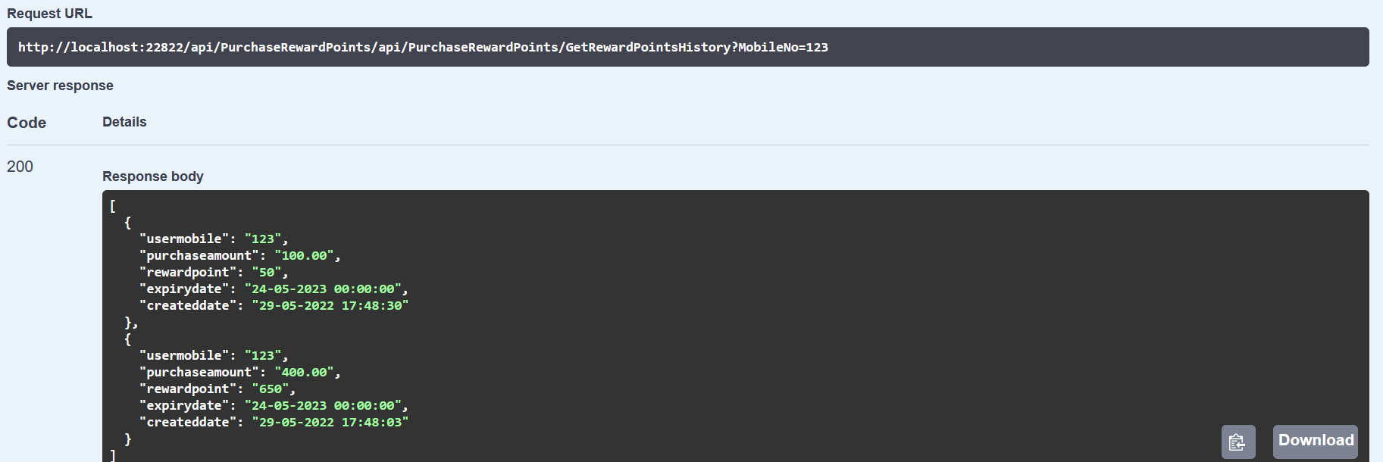

[

{

"usermobile": "123",

"purchaseamount": "100.00",

"rewardpoint": "50",

"expirydate": "24-05-2023 00:00:00",

"createddate": "29-05-2022 17:48:30"

},

{

"usermobile": "123",

"purchaseamount": "400.00",

"rewardpoint": "650",

"expirydate": "24-05-2023 00:00:00",

"createddate": "29-05-2022 17:48:03"

}

]

API URL:

http://localhost:22822/api/PurchaseRewardPoints/api/PurchaseRewardPoints/GetRewardPointsHistory?MobileNo=123