**Purchase Reward Points**

Run the API in visual studio 2019.

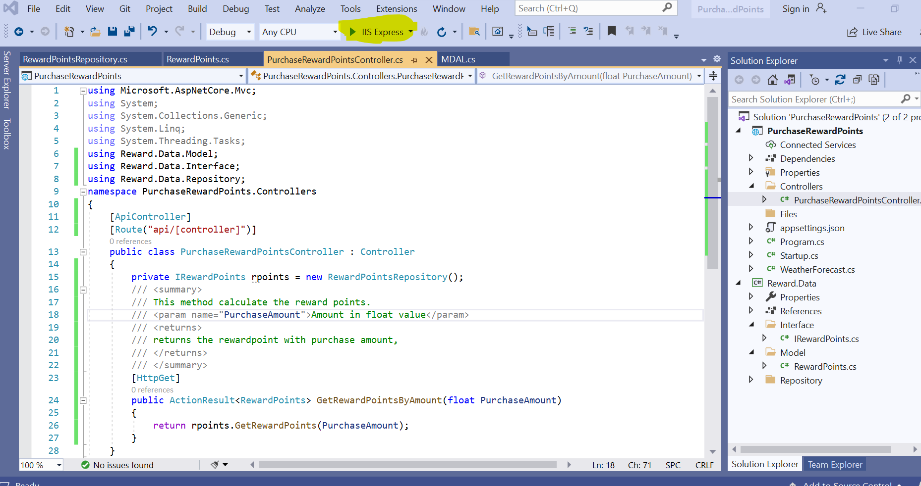

Expand the API method in Swagger

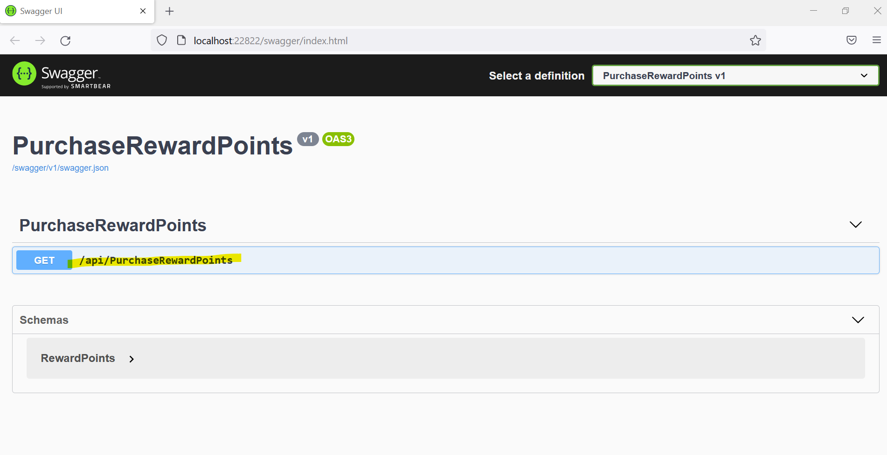

Click “Try it now” button

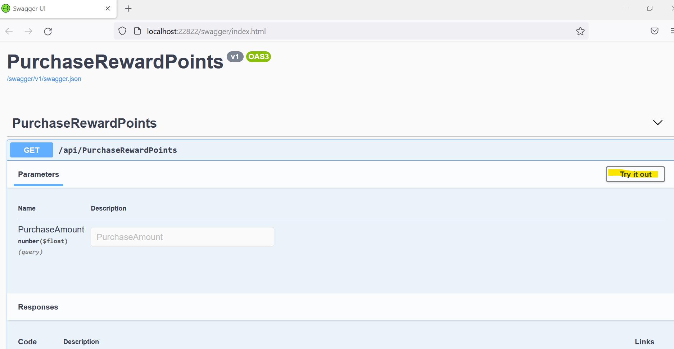

Enter the purchase Amount value in textbox then click Execute

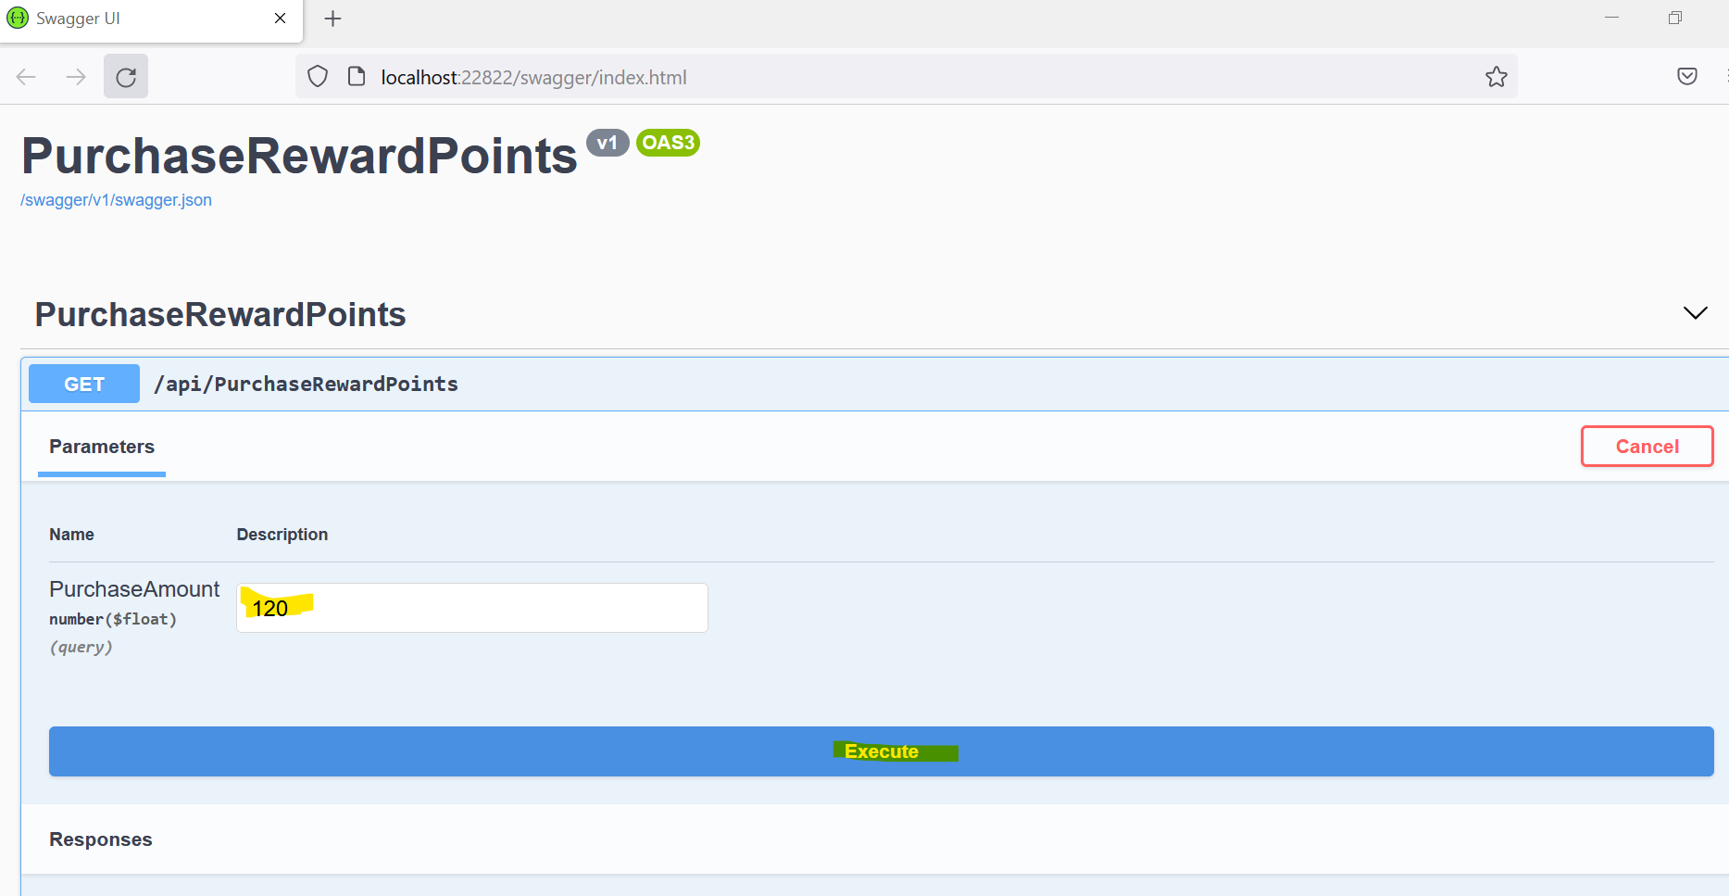

Response will display

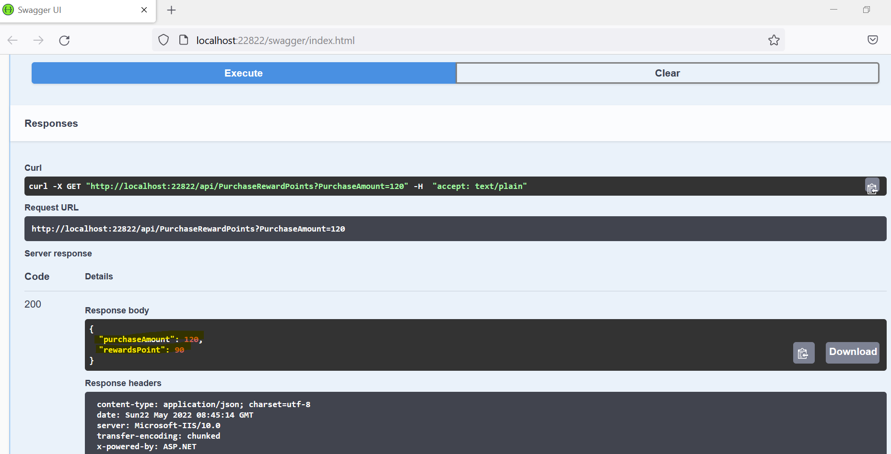

To invoke this API, use the following URL

<http://localhost:22822/api/PurchaseRewardPoints?PurchaseAmount=120>

