- Register band “The BLTs” (NEED TO CHANGE REGISTRATION ROUTE TO LOGIN PAGE)
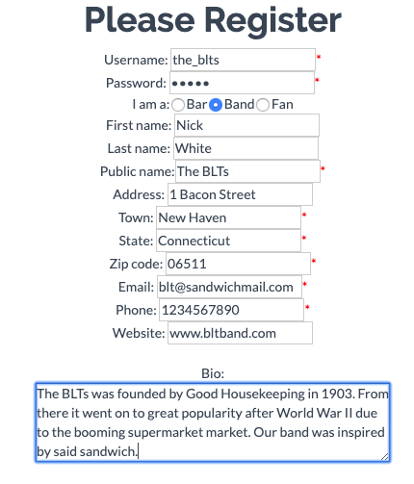
- Log in as High Bar (insert joke about “it's just a name, actually more of a tavern”)
  - Explain bar homepage
  - Host show “Lucky Seven”
  - Back to homepage → View profile of Bob Balaban
  - Back to homepage → Book Bob Balaban to Lucky Seven
  - Back to homepage → View show Lucky Seven
  - Edit the description of show and submit changes
  - Edit the start time of a booking and submit changes
  - Log out
- Log in as Bob Balaban
  - Explain changes in homepage
  - Visit profile of What a Dive!
  - Book gig to What a Dive!
  - Visit booking page and confirm High Bar's request
  - Log out
- Log in as Nicktest
  - View show Lucky Seven
  - Back to homepage → Search page → Search for “BLTs”

More Fixes:
-add edit booking for bands

