1. HomePageLoad  
     
   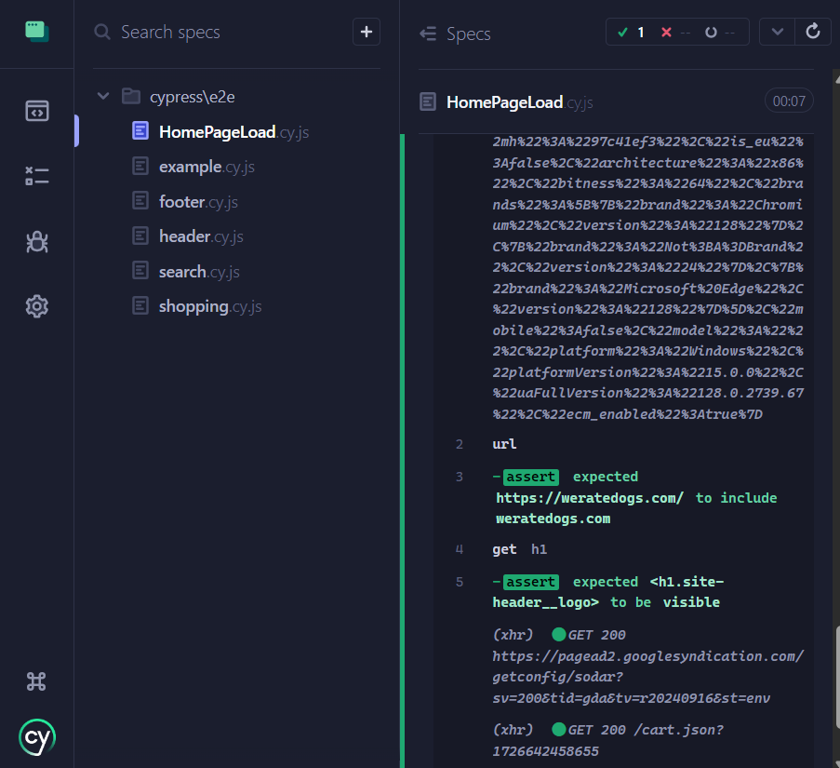

2- Header

3-Footer  
  
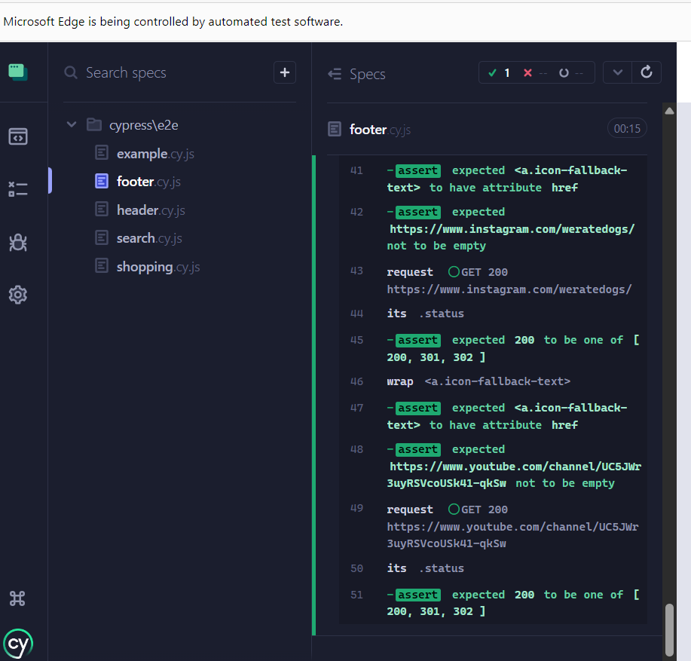

4-Shopping

5 -Search(1 fail and 1 pass)

Tests when ran from the CMD  
  
