Telegraf/InfluxDB/Grafana NPA Publisher Monitoring Solution v2
Whilst some capability is currently available via DEM to monitor the resource utilisation of our customers’ publishers – this solution aims to provide a more detailed look into the current health and function of one or many customer publishers from a central InfluxDB/Grafana platform.
This is a community solution and requires the deployment of an InfluxDB/Grafana virtual server to receive Telegraf metrics from one or many publishers deployed inside a customer’s environment. The attached InfluxGrafana_install.sh script can be used to turn a NEW UNUSED Ubuntu based NPA Publisher VM into the InfluxDB/Grafana server. The script will destroy the existing publisher configuration – so should not be used on a Publisher currently handling production traffic.
It is then possible to create an NPA Private Application definition to the Grafana server (Browser based NPA should also work) for customers to monitor the health of their NPA Publishers.
This currently utilises a PUSH methodology and thus requires each publisher to be able to create an outbound connection the Publisher Monitor (Grafana) Server on tcp/8086.
Updates to Telegraf on the the publishers should be handled by NPA’s Auto update feature (that basically runs apt-get update)
Updates to the InfluxDB/Grafana server can be handled via normal ubuntu apt update processes.

Prerequisites

Netskope Publisher Virtual Appliance
Each Publisher will require access to access to:
https://repos.influxdata.com/ - to download the Telegraf metric collecting agent as well as future updates
Firewall connectivity on tcp/8086 from each Publisher that is to be monitored to the monitoring Server (InfluxDB/Grafana)

Publisher Prometheus/Grafana server
We will repurpose a new Netskope Publisher OVA for this – however, the setup scripts can be modified to be used on any Linux instance.
Please modify the specifications of the Publisher OVA before booting to the following.
Recommended:
2vCPU
4GB RAM
20GB HDD (or more – depending on how many Publisher’s you will be monitoring)
This server will require access to:
https://repos.influxdata.com
https://packages.grafana.com
Inbound firewall rules from each Publisher on tcp/8086

Steps to deploy Telegraf to the Publishers that are to be monitored:
Warning – Ensure you have read and fulfilled the prerequisites – failure to do so will cause the script to fail and could cause unintended consequences including Publisher outages/issues
- Scp “telegraf_install.sh” to the home directory of the Publisher(s) that are to be monitored
example: scp telegraf_install.sh ubuntu@10.10.10.24:~/
- SSH to the Publisher
- Exit out of npa_wizard
- Ensure the file transferred successfully and has execute privileges.
example sudo +x telegraf_install.sh
- Execute the script with sudo
example: sudo ./telegraf_install.sh
- Enter the hostname of the Publisher – This will appear in the Grafana dashboards
- Enter the IP of the Publisher Monitoring Server (InfluxDB/Grafana) when prompted
- Done!

Steps to build a new InfluxDB/Grafana monitoring server from a NEW UNUSED Publisher:
- Provision a new Publisher virtual appliance as described in the prerequisites at the start of this document. More resources will give you a better experience when browsing Grafana
- Scp “InfluxGrafana_install.sh” to the home directory of the Publisher(s) that are to be monitored
example: scp InfluxGrafana_install.sh ubuntu@10.10.10.20:~/
- SSH to the Publisher
- Use the network settings wizard to configure the appliance with the static IP address you assigned when installing the Node_Exporter script in the previous section
- Exit out of npa_wizard
- Ensure the file transferred successfully and has execute privileges.
example sudo +x InfluxGrafana_install.sh
- Execute the script with sudo
example: sudo ./InfluxGrafana_install.sh
- After the installation is complete – Grafana is accessible by a web browser. Open a browser and navigate to the IP address you assigned to the Grafana server and port 3000
example; http://10.10.10.20:3000
Congratulations! You have an InfluxDB and Grafana server now
Log in with the default credentials of admin & admin and change the password to one of your preference

The install script configured a default data source for our InfluxDB metric receiver on http://localhost:8086

Now we need to import a dashboard and assign it to the correct data source.
From the left navigation bar – select the 4 squares (Dashboards) and select “Browse”
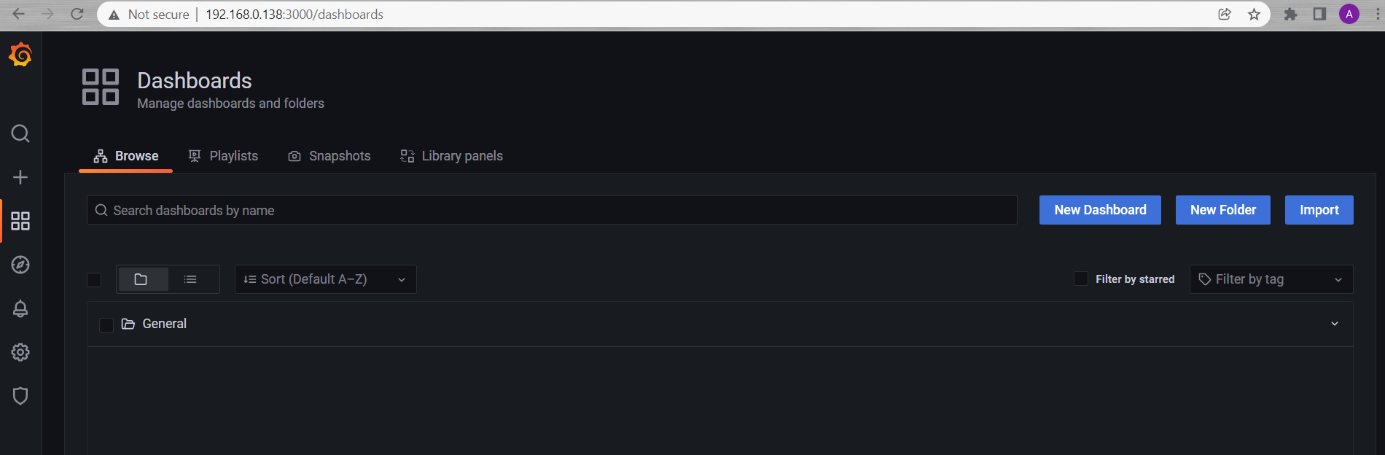
Press the “Import” Button
You can import any Grafana dashboard from their extensive library if you have a preference, or write your own. However for the purpose of this tutorial I will use Grafana Dashboard ID 928 (Templated dashboard for telegraf + influxdb.)
https://grafana.com/grafana/dashboards/928-telegraf-system-dashboard/

Enter 928 in the Load bar and hit Load
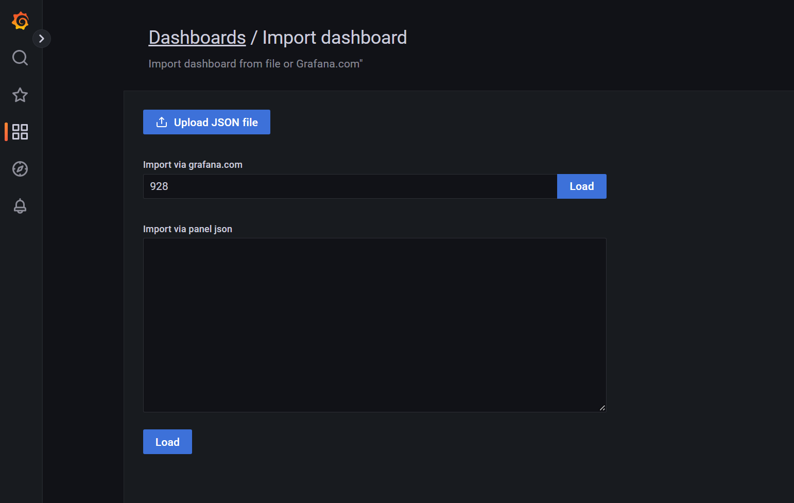

You should see the Node Exporter for Telegraf: system dashboard trying to be imported as below
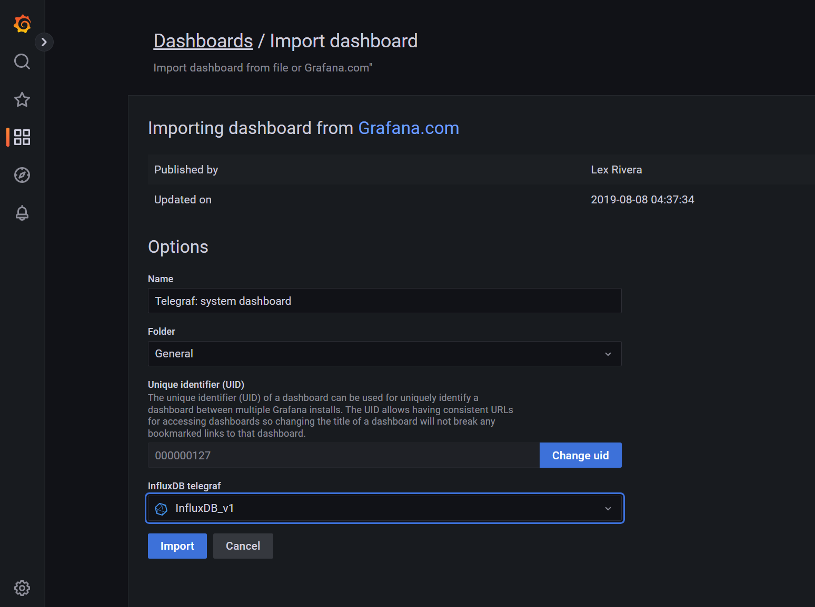

Select the correct InfluxDB data source by selecting the drop down box and “InfluxDB_v1”

Now hit Import
That’s it! Congratulations – you can now monitor your Publishers in greater detail

Bonus points if you want to set up an NPA Private Application (or NPA Browser Access App) to access your Grafana server from anywhere.

