Utilising Machine Learning to Optimise the Identification of Metal Organic Frameworks in Hydrogen Storage

BEng PROJECT FINAL DISSERTATION 2024-25

Author: Nina So
Student ID: 20475904
Date of report: 16th May 2025
Supervisor: Sanliang Lin

ADD ACCESS DATES FOR ALL REFS

Summary
This report introduces a bachelor's individual project that will aim to identify potential metal organic frameworks (MOFs) for use in hydrogen storage via the use of a neural network. By highlighting MOFs which still might be a theoretical concept for use in the hydrogen storage industry, this project can aid in the testing and development of MOFs to further industries such as in (commercial) transport into a more sustainable future.
The primary focus of this project is to write code for a neural network which will identify MOFs with desirable properties for the storage of hydrogen. In doing so, it will reduce the factor of trial and error in the testing of potential materials for hydrogen storage as well as the cost of money and time in manufacturing the materials.
Milestones expected to be reached within this project are: a successful working machine learning algorithm with optimised hyperparameters; optimised algorithms tuned to handle MOF datasets with limited data and missing key points; and successful highlighting new MOFs within recent datasets.
OUTCOME
FUTURE WORK
(this can be expanded, even doubled!!! – max 400 words ish)
CONTENTS
NOMENCLATURE 4
ACRONYM 4
1. INTRODUCTION 5
1.1. HYDROGEN STORAGE SOLUTIONS 5
1.2. MACHINE LEARNING 7
2. AIMS 7
2.1. PROGRAM SUCCESS CRITERIA 7
2.2. PROGRAM REQUIREMENTS 8
3. LITERATURE REVIEW 8
4. METHODOLOGY 11
4.1. PROGRAM REQUIREMENTS & PROPOSED SOLUTION – SOFTWARE DESCRIPTION. 11
4.2. DEVELOPMENT 11
5. RESULTS AND DATA ANALYSIS 12
5.1. LIMITING PROPERTIES 12
5.2. OPTIMISING HYPERPARAMETERS 12
5.3. TESTING NEW MOFS 12
6. DISCUSSION 12
7. CONCLUSIONS 12
8. FUTURE WORK 13
9. REFERENCES 14
10. APPENDIX 1 - Written Code 15
11. APPENDIX 2 – File directory 15

NOMENCLATURE
Symbol | definition | si Unit
$$ρ$$ | Density | $$gm^{3}$$
g | Grams | $1×{10}^{-3}$ kg
cm | Centimeters | $$1×{10}^{-}2 m$$
m | Meters | $1$ m
Å | Angstroms | $1×{10}^{-10}$ m

ACRONYMS
Acronym | Meaning
MOF | Metal organic framework
RES | Renewable energy sources
HES | Hydrogen energy storage
ERT | Extremely randomised trees
PS | Pressure swing
TPS | Temperature and pressure swing
UG | Usable gravimetric capacity (wt.%)
UV | Usable volumetric capacity (g H2/LMOF)
GSA | Gravimetric surface area (m2 g-1)
VSA | Volumetric surface area (m2 cm-3)
PV | Pore volume (cm3 g-1)
VF | Void fraction
LCD | Largest cavity diameter (Å)
PLD | Pore limiting diameter (Å)
ASA | Accessible surface area
NASA | Non-accessible surface area
MSE | Mean square error

INTRODUCTION
Global warming still currently proves to be a prominent issue in our lives. From threatening fragile ecosystems to intensifying the effects of natural disasters, its impact is witnessed by all. More countries are pushing for sustainable lifestyles to combat global warming. In doing so, the output of carbon dioxide (and other greenhouse gases that trap heat within the Earth's atmosphere) is reduced. The UK government aims to reach net-zero by 2050 by replacing "with cheaper, cleaner, domestic sources of energy" [2].
Some viable sustainable energy sources include renewables such as wind and hydro powered turbines, to longer lasting nuclear and hydrogen sources. In comparison, in the UK, coal and oil have been steadily decreasing over time [3] - the last coal power plant was shut down on 30th September 2024 signalling a new era for the UK's future in energy.
The UK government also aims to increase spending in industries to increase exports and innovation efforts in hydrogen and its related technologies and "consistently feature in the top 10 countries globally for hydrogen technology patent rates" [2].
Although hydrogen as a renewable energy carrier is incredibly rewarding: "the chemical energy per mass of hydrogen (142 MJ kg–1) is at least three times larger than that of other chemical fuels" [4] hydrogen fuel storage methods prove to be a major roadblock for using it as a widespread fuel within industries and personal use (for instance in cargo ships or in cars).

HYDROGEN STORAGE SOLUTIONS
Most vehicles store hydrogen fuel cells in large high pressure gas cylinders. The industries target for these cylinders is 110 kg at 70 MPa (700 bar) [4]. The cylinders must be built to withstand the internal pressure as well as not be a major risk in the catastrophic event of a car crash or any other incident since hydrogen is a highly flammable gas.
This requirement can raise the weight of the overall fuel system and can act negatively to the overall efficiency of the vehicle in terms of top speed vs power.
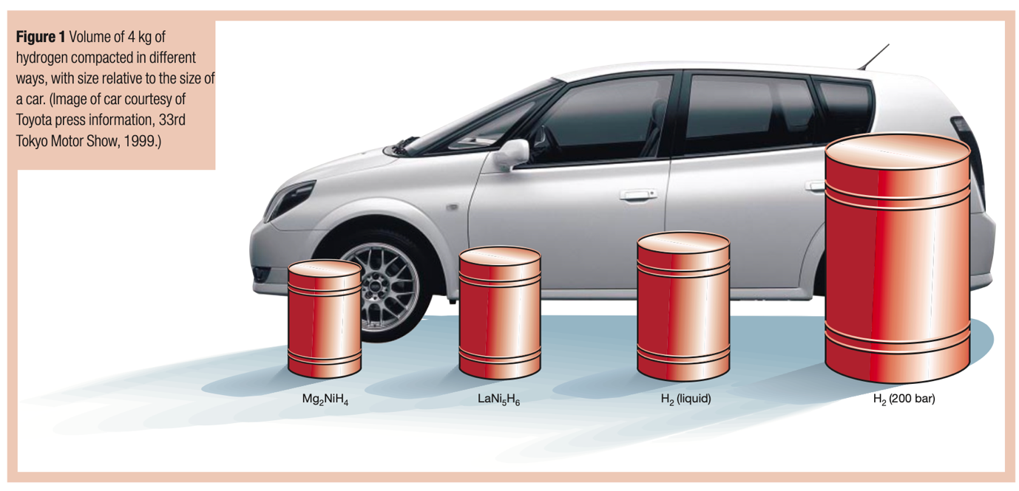
  - Figure 1: Comparison of hydrogen storage in comparison to a car. [4]
When considering other forms of hydrogen storage, it can be stored in its liquid form. This requires extremely low temperatures of 21.2 K and within a closed system pressures can reach high levels (10,000 bar) [4].
Hydrogen can also be stored as a hydride - chemically bonded to metals in a reversible reaction. This reaction can cause strain within the material and the volume of hydrogen absorbed is set by its enthalpy change of both the hydrogen and metal [4]. Therefore, maintaining a fixed temperature within the system during fuelling is extremely important.

Another alternative that will become the focus of this project is utilising metal organic frameworks (MOFs) to act as a sponge for hydrogen. MOFs are a nanoporous material consisting of metal ions and organic linking branches that utilise the fact that hydrogen adsorbs on solid surfaces via van der Waals-type weak physisorption [4]. MOFs are able to store a higher volume of hydrogen compared to a solid block of material due to its porous nature; leading to its high surface area to volume ratio.
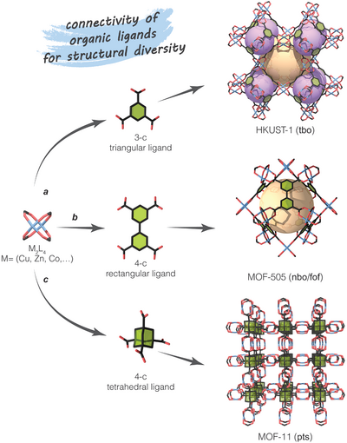
  - Figure 2: Examples of Cu‐based MOFs and the various structures possible [1]

The properties of metal organic frameworks differ depending on the metal used and the structures in which the ions are held resulting in a wide variety of topologies and structures; each with their own advantages and disadvantages.
It should be noted, at the present time MOFs operate best as a hydrogen storage system in temperatures below 90 K and under high pressures (even at 500 bar it was observed full saturation was not achieved) [5]. This is the main hurdle separating MOFs from being utilised as hydrogen storage in mass transport but MOFs can be used in many different industries outside solely just hydrogen storage: sensing, separations, drug delivery, and catalysis

MACHINE LEARNING
Neural networks model the human brain's way of recognizing patterns through interconnected layers. They handle complex relationships well and are versatile, capable of tasks like predicting continuous values (regression) and categorizing data (classification). However, they need lots of data and computing power, and can overfit without proper regulation. These machine learning algorithms have been used and well documented in the process of material optimisation, allowing for researchers to reduce the time and cost sunk into synthesising and testing materials still in a theoretical stage.
Decision trees split data based on feature values to make decisions, travelling along various nodes and decision functions in descending priority. They're easy to interpret and handle various data types, being useful in both regression and classification. However, decision trees and their variants like random forests and extremely randomised trees can be prone to overfitting.
Regression methods predict variables in a linear relationship – providing data that is easily interpretable since it can be plotted in a graph with clear spread of data points (and therefore error) against a line of best fit. This method can be altered for a more optimal output by using weights and biases.[6]
MORE???

AIMS
The overall aim of this project is to develop a program able to analyse preexisting data on metal-organic frameworks (MOFs) and predict the $H_{2}$ uptake based on known properties.
- The algorithm should be able to preprocess and featurise data into a format in which the neural network is easily able to process and utilise, to reduce the time spent manually processing multiple data sets.
- The code can identify potential metal organic frameworks (MOFs) for hydrogen storage via the use of machine learning such as neural network to reduce the cost of the experimental process of manufacturing and testing MOFs and to aid in the innovation of hydrogen fuel.
- Analysis using the values generated by the program can determine the optimal algorithm and set of properties in predicting potential MOFs for hydrogen storage to optimise the prediction process and therefore further reduce the cost of time and budget towards testing MOFs.

PROGRAM SUCCESS CRITERIA
The success of the project can be based on the following objectives:
- The trained model can identify key properties to help fine tune the featurisation process.
- The machine learning algorithms trained will provide results that support the same findings of the main paper studied: Predicting hydrogen storage in MOFs via machine learning by Alauddin Ahmed and Donald J. Siegel [7].
  - The optimal combination of features for predicting UG and UV $H_{2}$ storage capacities at a pressure swing condition are similar with a $R^{2}$ value of around 0.983 and 0.997 respectively.
- The machine learning algorithm was able to test MOFs with unknown hydrogen storage capacities and predict either their gravimetric and/or volumetric $H_{2}$ uptake.
  - The machine learning algorithm was able to test MOFs with key properties missing and still obtain a predicted $H_{2}$ storage capacity with similar error to a MOF with all properties available to be pared into the program.
- From these predicted values, suggest a list of MOFs that have potential for testing and potential synthesising.

LITERATURE REVIEW

CURRENT SOLUTIONS
The main paper studied in preparation was Predicting hydrogen storage in MOFs via machine learning by Alauddin Ahmed and Donald J. Siegel [7]. The paper covers different machine learning models used to predict the hydrogen storage capacity of various MOFs from extremely randomised trees, linear and ridge regressions, and other bagging algorithm variants.
The paper concludes that the extremely randomised trees (ERT) method is the most accurate method and also suits the context of the MOF structure extremely well since the models do not require large amounts of input data – suitable for theoretical MOF structures which have yet to undergo manufacturing. Boosted decision trees yield similar results as well as the random forest method. These methods are based on decision trees whilst linear and ridge regression methods had a poorer performance and support vector machines produced the worst results from the tested algorithms.
The accuracy and error levels of the ERT method produced R² values exceeding 0.997 for gravimetric capacities (the amount of H2 adsorbed per unit mass) and error levels of 0.14 wt % - volumetric capacities had slightly higher errors, ranging from 1.1 g-H₂ L⁻¹ on average.
In comparison, linear regression produced R² values ranging from 0.913 to 0.992 and error levels significantly higher than the tree-based methods.

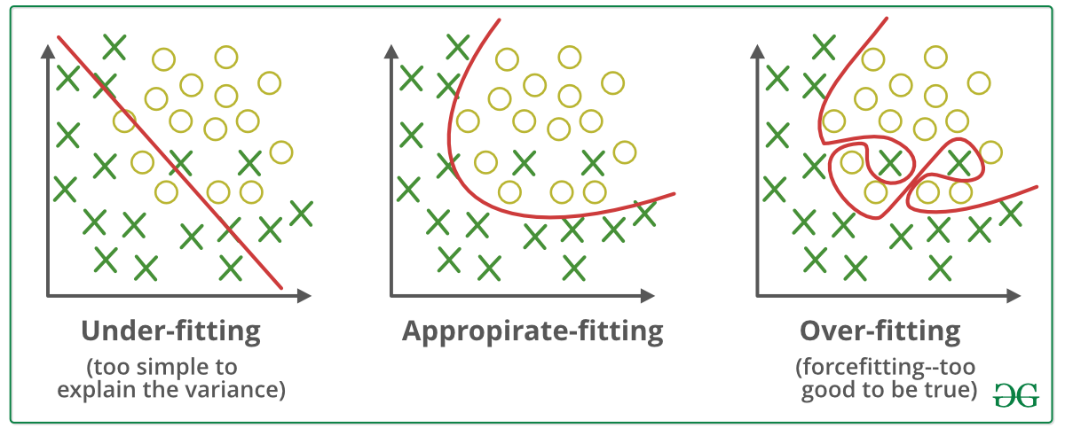
  - Figure 3: Underfitting and overfitting [8]
Underfitting and overfitting are two aspects generally responsible for unsatisfactory results of the neural network. Underfitting is usually due to the lack of data used to train the model or the oversimplification of the algorithm. On the other hand, overfitting occurs when the model is too complex and there is high variance (sensitivity to changes) and low bias (predictions follow the provided data closely). Underfitting can be avoided by providing more data although care must be taken to ensure that the data has been scaled and is appropriate for the algorithm – it has been featurised. Overfitting can be reduced by allowing the network to focus on more meaningful patterns in the overall data rather than placing a large bias on small changes within the training data. Reducing the complexity of the system is also a good method however it should be noted that in this project, underfitting is of a higher likelihood of occurring than overfitting. [9]
Other limitations on the neural network originate from the Chahine rule which suggests that increasing the specific surface area of a nanoporous material enhances its gravimetric hydrogen uptake. [10] The Chahine rule generally overpredicts hydrogen capacities for high-surface-area MOFs and so identifying other key features that influence hydrogen uptake such as the availability of electronegativity sites and other open metal sides of MOFs formed due to the topology and chemical features of the structure.
The paper also highlights the fact that synthesising high-capacity MOFs is quite difficult and sometimes not feasible to create in practice. In addition, even if the predicted hydrogen storage capacity for a certain MOF is high, during activation, the MOF may experience framework collapse which will reduce its available space for hydrogen.[7]

MATHEMATICAL CONCEPTS

MEAN SQUARE ERROR (MSE)
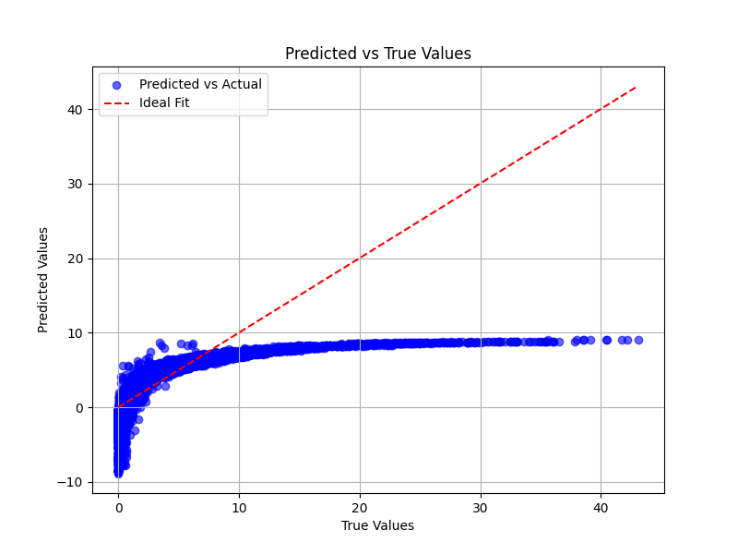
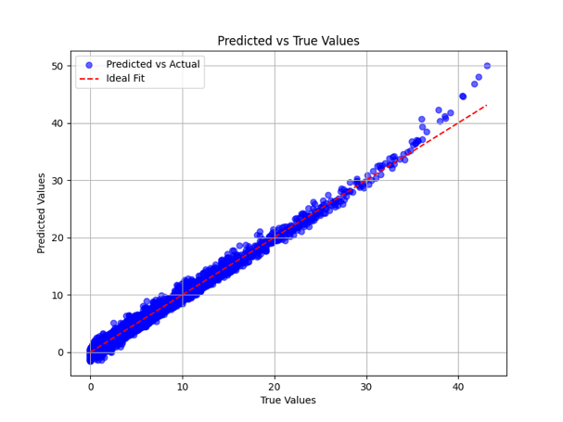
The program will utilise the mean squared error which is a risk metric relating to the error – it can be shown as the distance away from the line of best fit. In the graph below, the line of best fit is the projected is the optimum result in which the predicted theoretical values are the same as the values reflected in reality.
  - Figure 4: Two plots displaying the graphical results of a machine learning algorithm. The leftmost plot displays a high MSE whilst the right hand plot represents a low MSE.

The mean squared error can be calculated using the equation as follows:
If $\hat{y_{i}}$ is the predicted value of the $i^{th}$ sample, and $y_{i}$ is the corresponding true
value, then the mean squared error (MSE) estimated over $n_{samples}$ is defined as:
$$MSE\left(y,\hat{y}\right)=\frac{1}{n_{samples}}\sum_{i=0}^{n_{samples}-1}{{\left(y_{i}-\hat{y_{i}}\right)}^{2}}$$ | Equation 1: Mean square error  Source: [11]

R-SQUARED
R² is a number between 0 and 1 that shows how well the model’s predictions match the actual data. The closer to 1, the better the fit is.
If $\hat{y_{i}}$ is the predicted value of the $i^{th}$ sample, and $y_{i}$ is the corresponding true value, then the mean squared error (MSE) estimated over $n_{samples}$ is defined as:
$$R^{2}\left(y,\hat{y_{i}}\right)=1-\frac{\sum_{i=1}^{n}{{\left(y_{i}-\hat{y_{i}}\right)}^{2}}}{\sum_{i=1}^{n}{{\left(y_{i}-\overline{y}\right)}^{2}}}$$ | Equation 2: R-squared  Source: [11]
Where $both:$
$$\overline{y}=\frac{1}{n}\sum_{i=1}^{n}{y_{i}}$$ | Equation 3: Defining y-bar  Source: [11]

$$\sum_{i=1}^{n}{{\left(y_{i}-\hat{y_{i}}\right)}^{2}=\sum_{i=1}^{n}{ϵ_{i}^{2}}}$$ | Equation 4: Defining  Source: [11]

ACCURACY SCORE

$$MSE\left(y,\hat{y}\right)=\frac{1}{n_{samples}}\sum_{i=0}^{n_{samples}-1}{{\left(y_{i}-\hat{y_{i}}\right)}^{2}}$$ | Equation 1: Mean square error  Source: [11]

Make sure you check your references look okay well in advance of submission in case you need help with the referencing software.
If you have equations then they should be numbered sequentially. This borderless table allows you to lay out your equations properly. Use References>insert caption>Label>Equation to get the right format and sequential numbering. Copy the table each time you want a new equation and use the equation editor to make your equations.
$$Ex=\frac{amp}{le}E^{q}$$ | Equation 1
When you refer to your equations use References> cross-reference>Reference type>equation as this will keep your equation numbering correct even if you add or delete equations. You will need to use “update field” to update automatic numbering.
You may want to include figures in your literature review. If so make sure they are numbered and captioned. To insert a figure caption use References>insert caption>Label>Figure. This will give you the label and number and you then type in the caption text. You should always refer to figures you include (otherwise why are they there?). Use References> cross-reference>Reference type>figure to make sure you refer to the correct figure even if you add in additional ones. You will need to use “update field” to reset the numbers. In your report make sure you only include relevant figures such as are appropriate for a technical report.
Your literature review should be succinct and typically no longer than 1500 words – it may be far shorter.
Tables should also be numbered and captioned. It is usual practice for the caption for a table to go above the table whereas the caption for a figure goes below. When referring to a figure or table, you use a capital letter (because it is a specific figure/table). So when referring to the table that summarises the word count information in the template it is referred to as Table 1. If you use the automatic referencing in MS Word then this is done automatically for you. Go to References>Insert caption>Label>Table to get your caption numbering and References> cross-reference>Reference type>Table to refer to your table.
Table 1: Indicative word count for various sections of the report
Section heading | Indicative max word count
Introduction (including aims and objectives) | 1000
Aim and objectives | 200
Literature review | 1500
Technical content/body of report | 7500
Conclusions | 300
Total for dissertation | 10,000

The maximum word count for the dissertation for the sections indicated in Table 1 is 10,000 There is no need to have 10,000 words if you can cover your project properly in fewer. It is fine to have fewer words in the literature review and more in the technical content, those numbers are indicative only. The limit is on the total word count.
You need to choose headings appropriate to the work you are reporting. I would suggest you talk through your report structure with your supervisor. Typical headings might include the following. Pay attention to the marking rubric in choosing your section headings. Make it easy for the markers to find the necessary elements in your report.

METHODOLOGY

PROPOSED SOLUTION
Coding a program to train various machine learning algorithms and testing MOFs without a known volumetric uptake of $H_{2}$ requires both the understanding of machine learning methods and the ability to implement such methods into code. Machine learning algorithms are a well known method and solutions have been developed to ease the process of running such algorithms. Libraries in Python have been built to aid in the utilisation of such algorithms and for that reason, the code has been written purely in Python.
The program works on an average laptop able to run Python 3.10 or other suitable versions. The user

PROGRAM STRUCTURE
The program is works in a linear fashion

DEVELOPMENT
Although the basic hardware requirements do not require any dedicated GPU or graphics card as well as multiple cores for parallel processing; it should be noted that running the full optimisation for hyperparameters, instead of using the tuned hyperparameters already provided within the software files, will result in an incredibly long runtime of the program.

State where the data has come from - ref original paper

Discuss the distribution of the training data that you have collected and make some comment on this.
More discussions on pressure swing and combined temperature-pressure swing

Be clear on the differences between this work and the previous paper.

RESULTS AND DATA ANALYSIS

LIMITING PROPERTIES

OPTIMISING HYPERPARAMETERS

TESTING NEW MOFS

DISCUSSION

CONCLUSIONS
Briefly summarise the important points from the report. You should aim to cover all of:
a) Text briefly summarising the work that has been conducted including
b) the important outcomes.
c) The findings/contribution to knowledge
It is very important that you do not introduce new material or new discussion points into your conclusions. This is just summarising and concluding the important content of the report for someone who has read the report and just wants reminding of the “best bits”.
This should be typically 200-300 words

FUTURE WORK
Future work will involve further optimisation of the project code. A noted issue with the code was that the optimisation process for the hyperparameters was not efficient enough and had a long runtime. In addition, further investigation into how the topology of a MOF affects its $H_{2}$ intake will be looked into. This would require an implementation of the software package zeo++ used for the analysis of crystalline porous materials. This could either be done via an automated in-terminal process or the use of the pyzeo python interface for zeo++. Similarly, integrating the CoRE MOF Tools API into the program can help achieve a smoother pipeline workflow of the project.
Further analysis of MOF databases with a temperature and pressure swing would also be useful

REFERENCES
[1] V. Guillerm, H. Jiang, D. Alezi, N. Alsadun, and M. Eddaoudi, "From Elementary to Advanced Design of Functional Metal–Organic Frameworks: A User Guide to Deciphering the Reticular Chemistry Toolbox," Advanced materials (Weinheim), p. e2414153, 2024, doi: 10.1002/adma.202414153.
[2] (2023). Powering Up Britain: Net Zero Growth Plan.
[3] (2023). UK ENERGY IN BRIEF 2023.
[4] A. Züttel and L. Schlapbach, "Hydrogen-storage materials for mobile applications," Nature (London), vol. 414, no. 6861, pp. 353-358, 2001, doi: 10.1038/35104634.
[5] L. Zhang et al., "Fundamentals of hydrogen storage in nanoporous materials," Progress in energy, vol. 4, no. 4, p. 42013, 2022, doi: 10.1088/2516-1083/ac8d44.
[6] S. Henrard, N. Speybroeck, and C. Hermans, "Classification and regression tree analysis vs. multivariable linear and logistic regression methods as statistical tools for studying haemophilia," Haemophilia : the official journal of the World Federation of Hemophilia, vol. 21, no. 6, pp. 715-722, 2015, doi: 10.1111/hae.12778.
[7] A. Ahmed and D. J. Siegel, "Predicting hydrogen storage in MOFs via machine learning," Patterns (New York, N.Y.), vol. 2, no. 7, pp. 100291-100291, 2021, doi: 10.1016/j.patter.2021.100291.
[8] G. f. Geeks. "ML | Underfitting and Overfitting." https://www.geeksforgeeks.org/underfitting-and-overfitting-in-machine-learning/ (accessed 9 Jan 2025, 2024).
[9] G. f. Geeks. "ML | Underfitting and Overfitting." https://www.geeksforgeeks.org/underfitting-and-overfitting-in-machine-learning/ (accessed 2024).
[10] D. P. Broom, C. J. Webb, G. S. Fanourgakis, G. E. Froudakis, P. N. Trikalitis, and M. Hirscher, "Concepts for improving hydrogen storage in nanoporous materials," International journal of hydrogen energy, vol. 44, no. 15, pp. 7768-7779, 2019, doi: 10.1016/j.ijhydene.2019.01.224.
[11] SciKit-learn. "User Guide: 3.4. Metrics and scoring: quantifying the quality of predictions." https://scikit-learn.org/stable/modules/model_evaluation.html#mean-squared-error (accessed July 2025, 2025).
[12] G. B. Zhao, Logan M. Chheda, Saumil Huang, Ju Kim, Haewon Liu, Kunhuan Mochida, Kenji Pham, Thang D. Prerna Terrones, Gianmarco G. Yoon, Sunghyun Zoubritzky, Lionel Coudert, François-Xavier Haranczyk, Maciej Kulik, Heather J. Moosavi, Seyed Mohamad Sholl, David S. Siepmann, J. Ilja Snurr, Randall Chung, Yongchul G., "Computation-Ready Experimental Metal-Organic Framework (CoRE MOF) 2024 Dataset," ed. https://zenodo.org/records/15055758, 2025.
[13] A. Ahmed and D. J. Siegel. HyMarc Sorbent Machine Learning Model [Online] Available: https://sorbent-ml.hymarc.org/

APPENDIX 1 - Written Code
The code written for this project can be found on this GitHub page: https://github.com/egyns10/MOFNN

APPENDIX 2 – File directory
Included within the project GitHub page are a number of other files not necessary for running the program but useful for understanding decisions made for some programming choices as well as being referenced within this document. This appendix will give a brief overview for each file and act as a content page for the folder named “Project Files”.

- Databases
  - 12089-recommended-screening-list.csv
    - Source: [12]

  - ASR_data_SI_20250204.csv
    - Source: [12]

  - FSR_data_SI_20250204.csv
    - Source: [12]

  - h2_capacity_gcmc.csv
    - Source: [13]

  - training_data_UVUC-Peaked.csv
    - This csv file is an altered file from h2_capacity_gcmc.csv where the UG and UV have been sorted in terms of highest value to lowest, identifying the MOFs that define the threshold coded into the program. It defines that any MOF with a predicted UG above 34 or a predicted UV above 38 will be highlighted within MOFs_of_interest-ASR-UV.csv or MOFs_of_interest-FSR-UV.csv .

  - ASR_Altered.csv
    - This is an altered file of the original: ASR_data_SI_20250204.csv . It is the recommended file to parse into the program and was used as a database of new MOFs to test and predict UG and UV values from.

  - FSR_Altered.csv
    - This is an altered file of the original: FSR_data_SI_20250204.csv . It is the recommended file to parse into the program and was used as a database of new MOFs to test and predict UG and UV values from.
- Program Results
  - Linear Regression Graphs
    - This is a folder containing all graphs generated within the linear regression algorithm for all combinations of the given properties within h2_capacity_gcmc.csv .

  - MOFs_of_interest-ASR-UV.csv
    - This is a program generated database of any MOFs that have shown a predicted $H_{2}$ volumetric uptake of over 38 g H2/LMOF from the altered database ASR_Altered.csv and original file ASR_data_SI_20250204.csv .

  - MOFs_of_interest-FSR-UV.csv
    - This is a program generated database of any MOFs that have shown a predicted $H_{2}$ gravimetric uptake of over 38 wt.% from the altered database FSR_Altered.csv and original file FSR_data_SI_20250204.csv .

  - summary_results_bare.csv
    - This file holds the accuracy analysis for combinations of properties in the file h2_capacity_gcmc.csv ran in the program with default hyperparameters.

  - summary_results_optimised.csv
    - This file holds the accuracy analysis for all combinations of properties in the file h2_capacity_gcmc.csv ran in the program with optimised hyperparameters.
Below is a brief overview of all program files.
- Program Files
  - best_SK_BG_params.json
    - This file holds the optimised hyperparameters for combinations of properties in the file h2_capacity_gcmc.csv parsed into the machine learning algorithm: gradient boosted decision trees – from the scikit-learn Python library.

  - best_SK_RF_params.json
    - This file holds the optimised hyperparameters for combinations of properties in the file h2_capacity_gcmc.csv parsed into the machine learning algorithm: random forest – from the scikit-learn Python library.

  - best_XG_RF_params.json
    - This file holds the optimised hyperparameters for combinations of properties in the file h2_capacity_gcmc.csv parsed into the machine learning algorithm: XG Boosted random forest – from the xgboost Python library.

  - dataSetUp.py
  - getData.py
  - gradBoost.py
  - h2_capacity_gcmc.csv
  - hyperparameters.py
  - linearReg.py
  - main.py
  - preprocess.py
  - randomForest.py
  - README.md
  - validate.py

