**Task A**

1. **Use a program design language to produce the design for the validation routines. Perform all validation as required for the design. Any assumptions you make about the design must be documented.**

**Answer:**

**Membership Number validation**

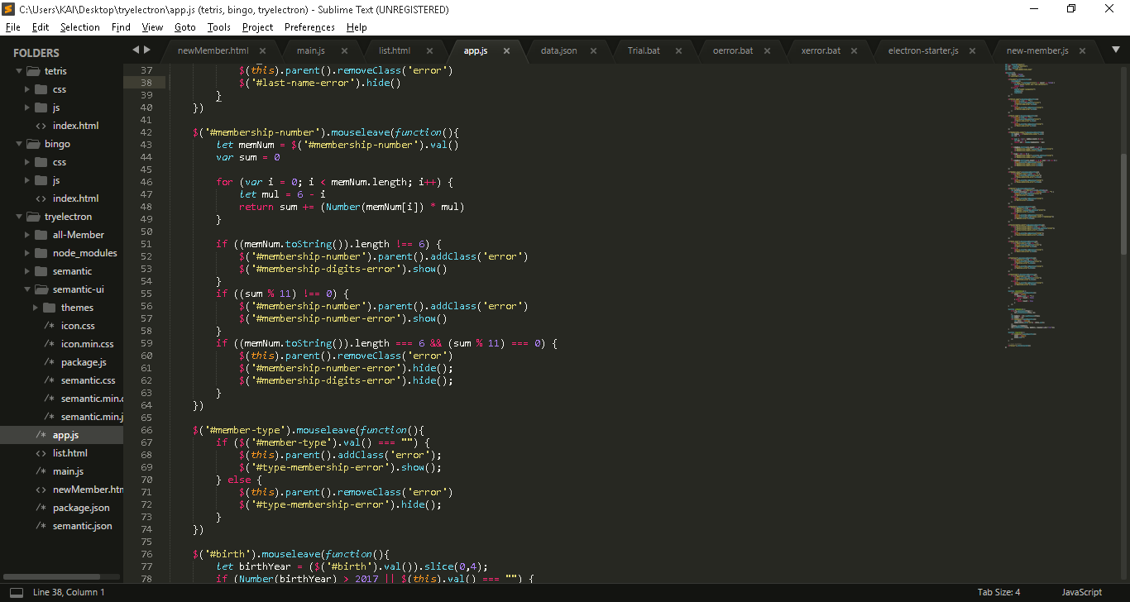

**Join Date validation**

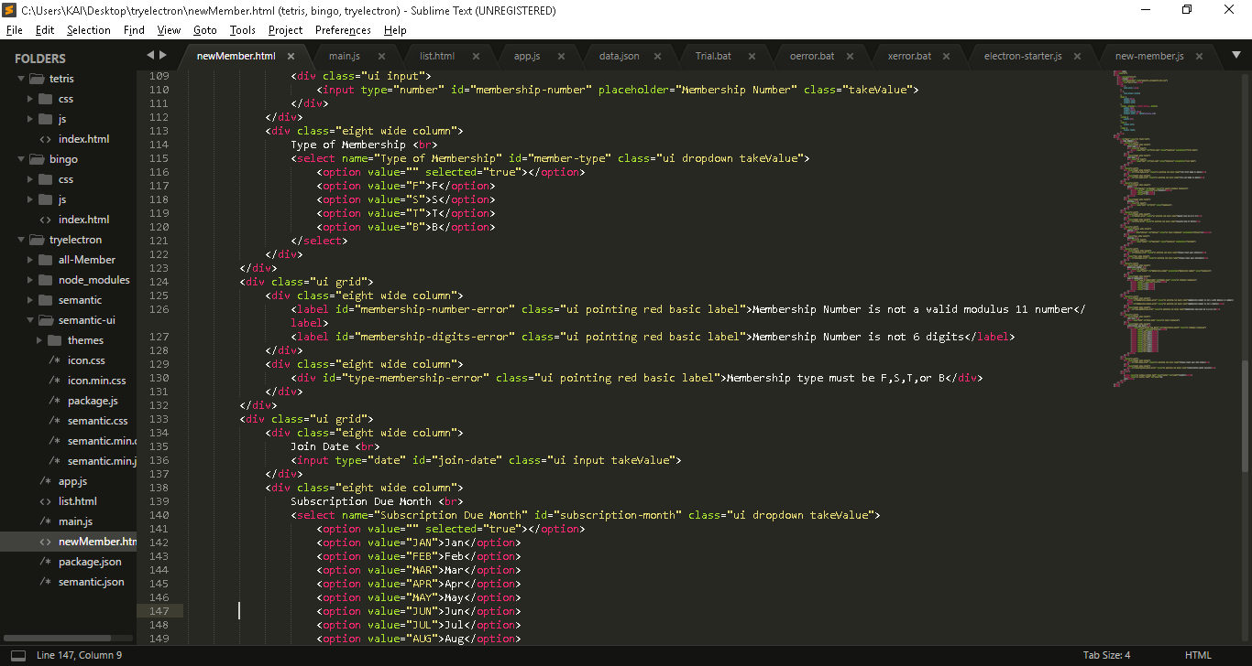

**Birth Date validation**

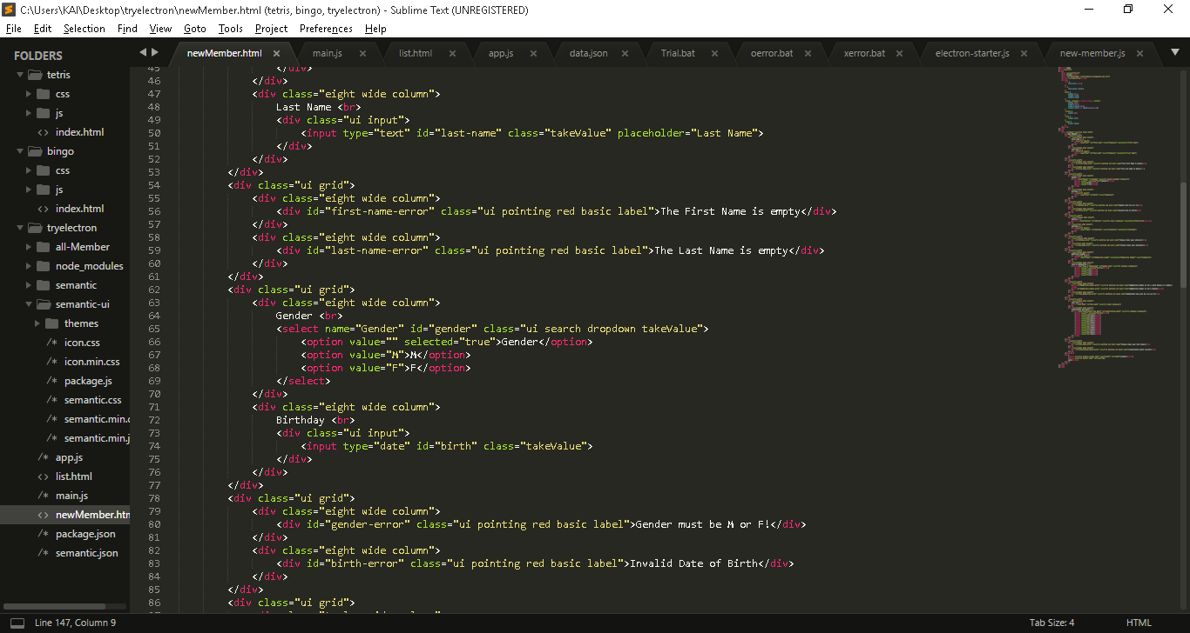

1. **Some error codes have already been defined for the software and are shown below with their associated message**

**Answer:**

|  |  |
| --- | --- |
| **ERROR NUMBER** | **ERROR MESSAGE** |
| **1** | 1: Membership Number is not numeric |
| **2** | 2 :Membership Number is not 6 digits |
| **3** | 3: Membership Number is no a valid modulus 11 number |
| **4** | 4: Sex must be F or M |
| **5** | 5: Membership type must be F,S, |
| **6** | 6: Invalid Date of Birth |
| **7** | 7: Invalid Join Date |
| **8** | 8: File not open |
| **9** | 9: Subscription month invalid |
| **10** | 10: Membership Number is empty |
| **11** | 11: The form is not complete |
| **12** | 12: The First Name is empty |
| **13** | 13: The Join Date is earlier than Birth Date |
| **14** | 14: The Birth Date is late than now year |

**Task B**

1. **The design conforms to the design specification**

**Answer:**

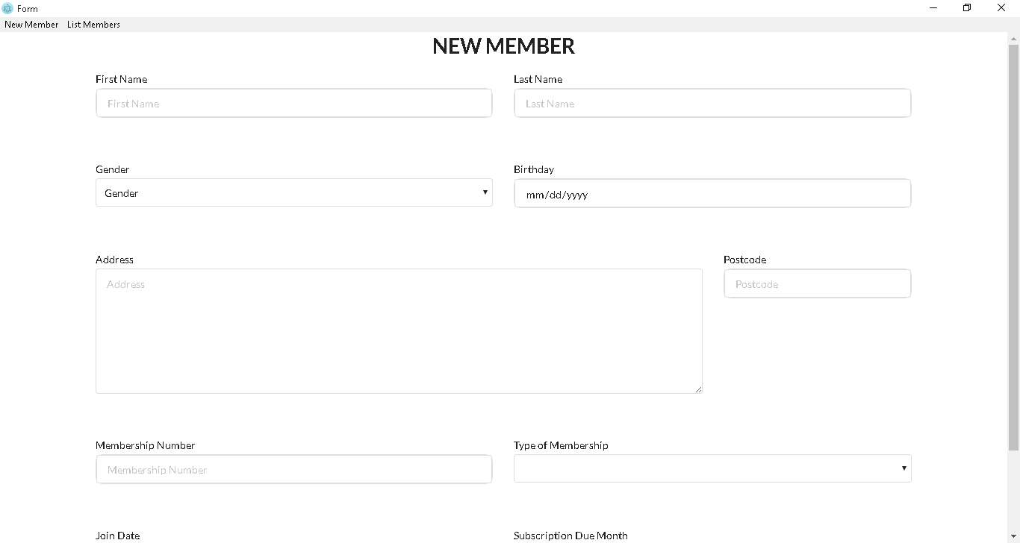

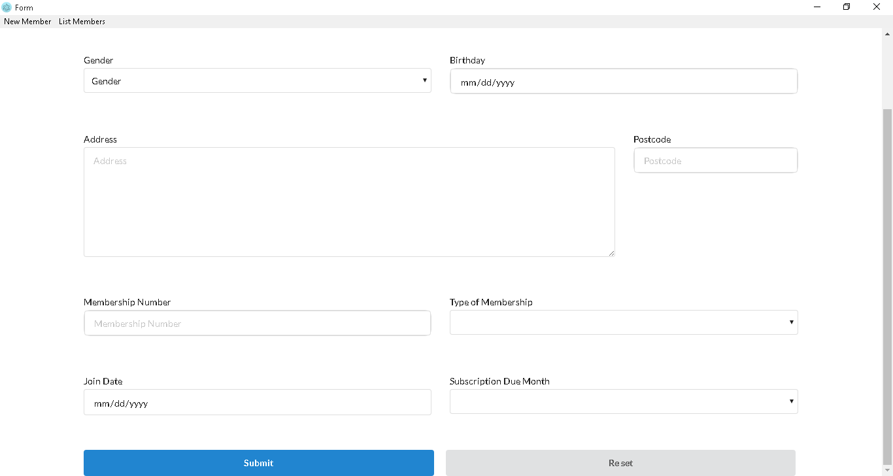

1. **The design uses the most appropriate data types(s)**

**Answer:**

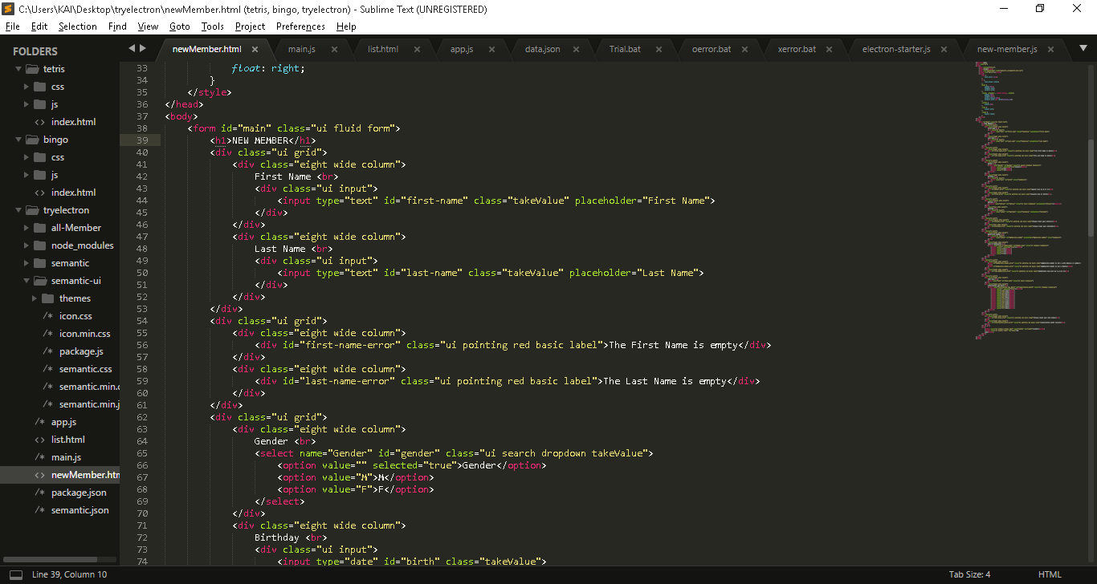



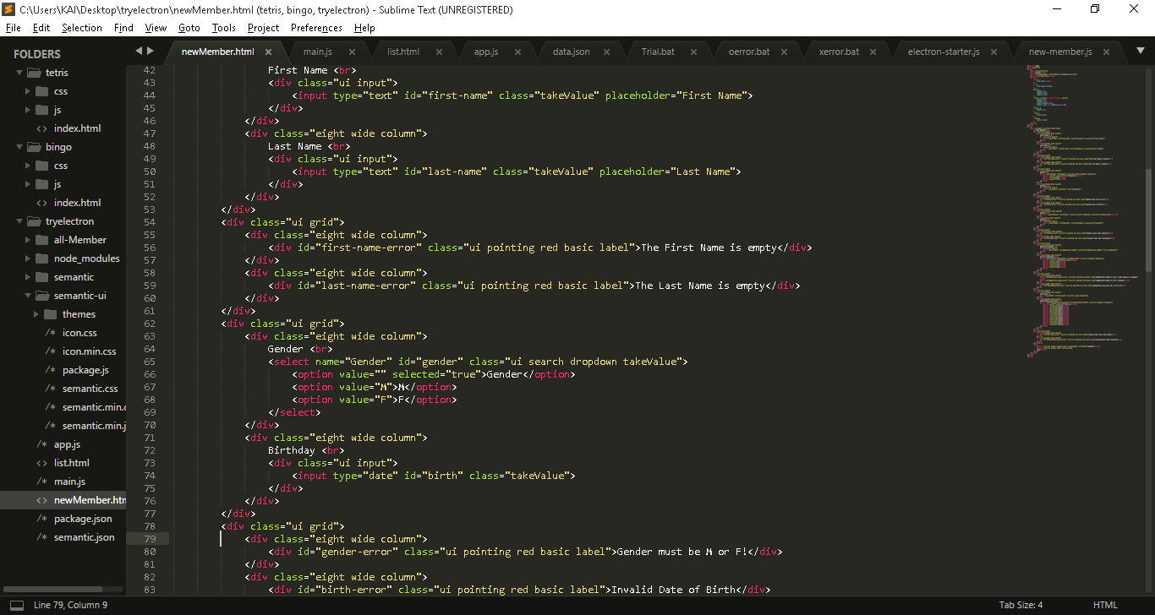



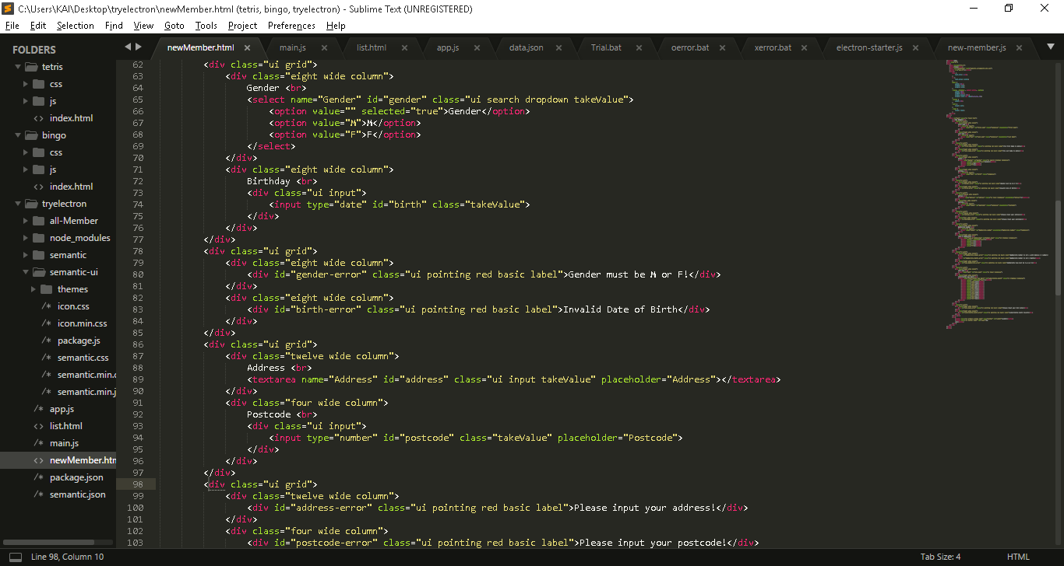



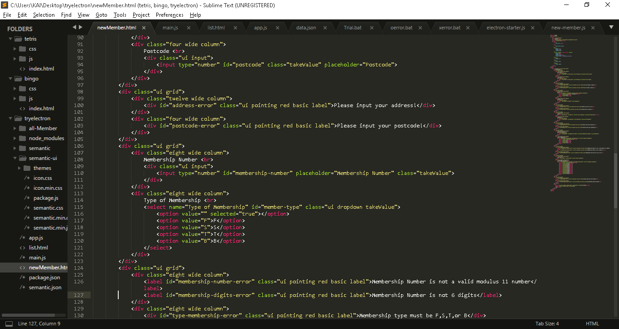



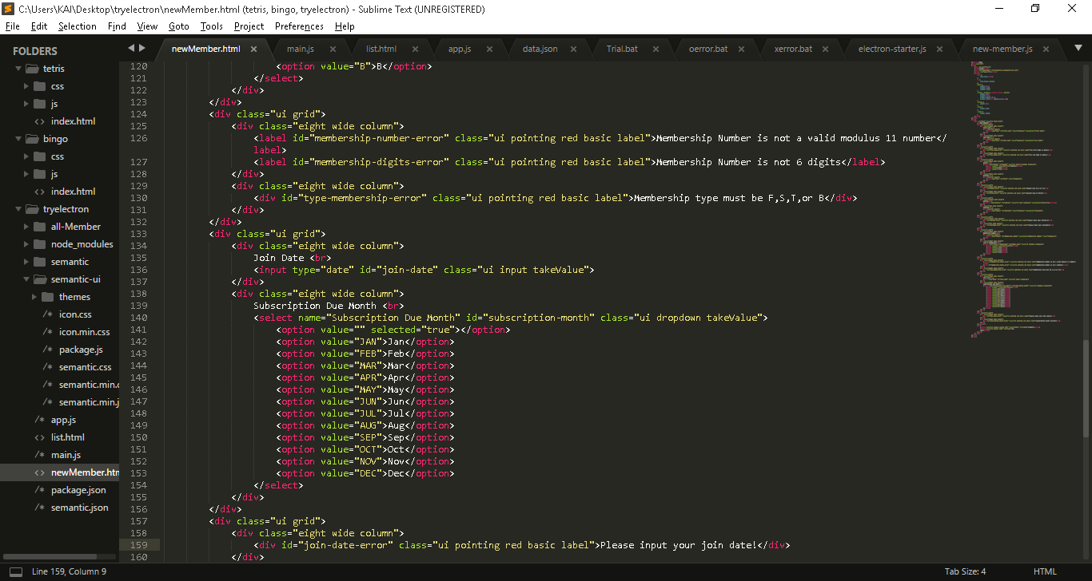



1. **The design is consistent and complete**

**Answer:**





1. **The program design language clearly shows variable names and data types, constants, argument names and data types, return value data types and any data structures used.**

**Answer:**





















1. **The program design language clearly shows the beginning and end of each iteration, selection and routine**

**Answer:**

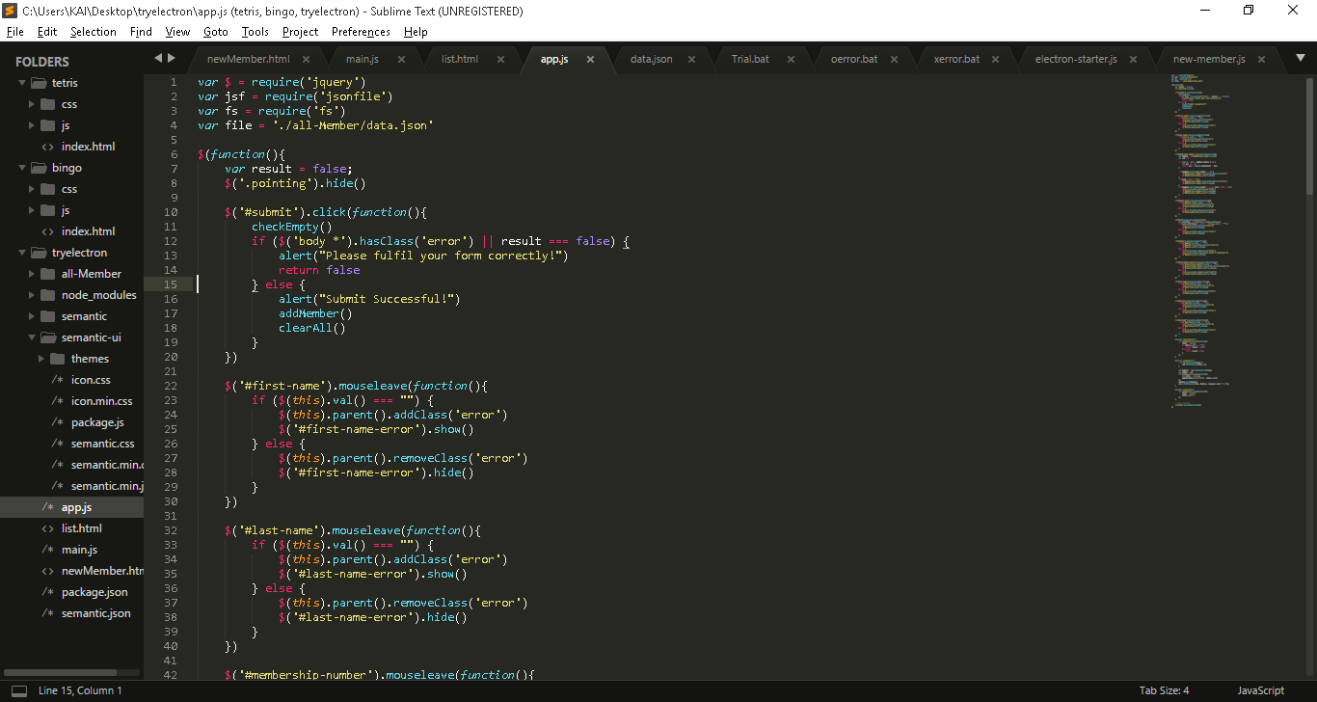

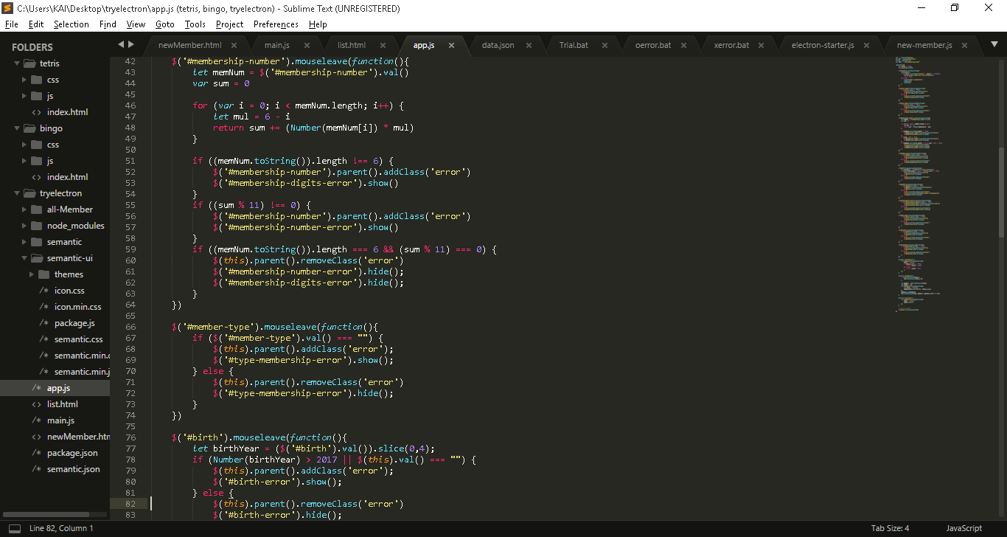

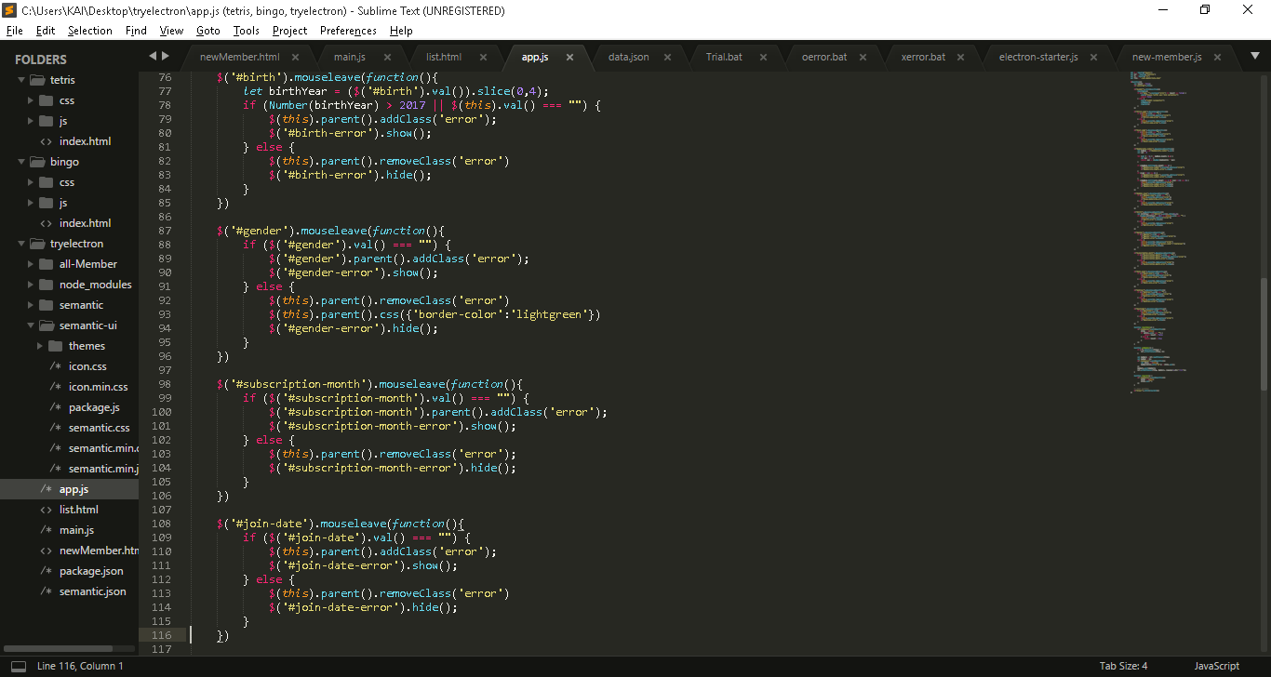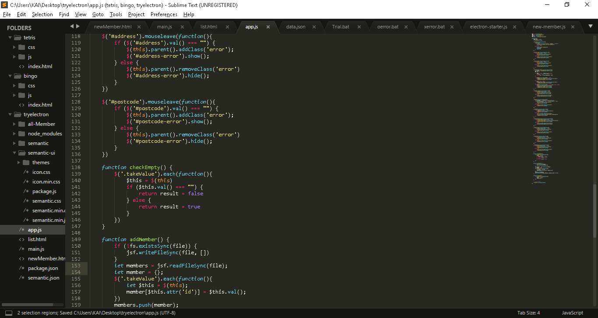

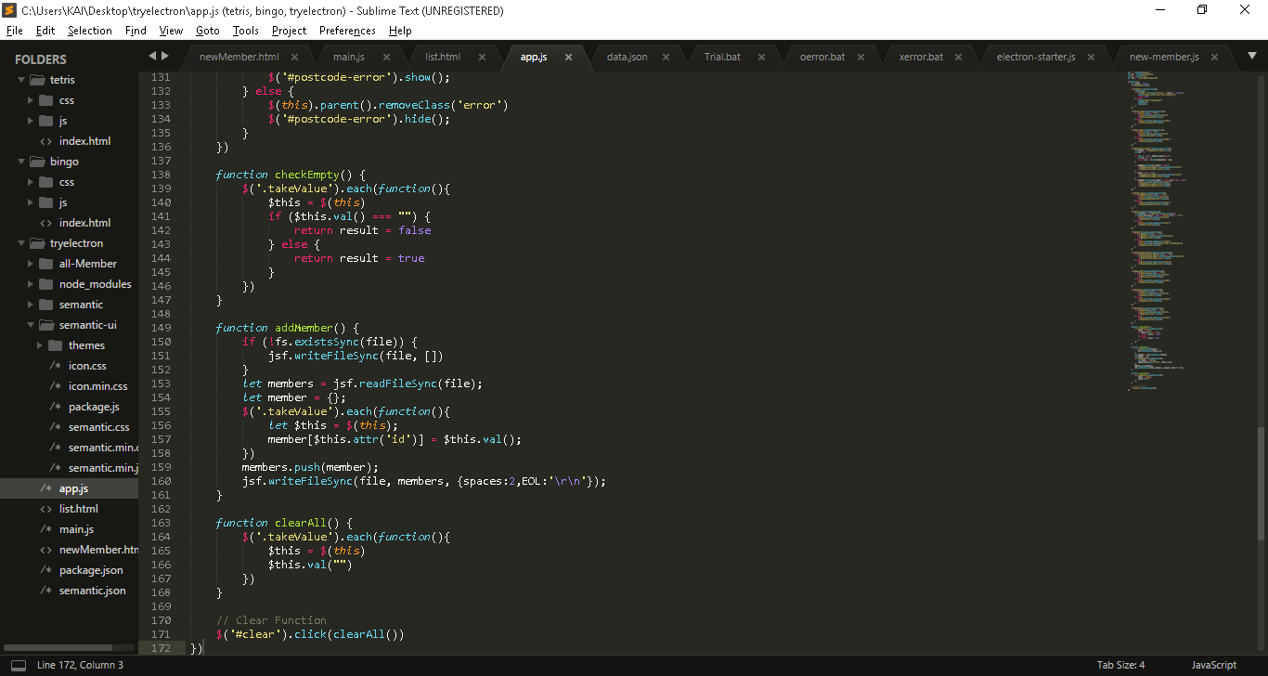

**Task C**

1. **Prepare a test plan to carry out functional testing of the software**

**Answer:**

[Test Plan](hyperlink/test_plan.docx)

1. **Prepare the test data to be used with the test plan**

**Answer:**

[Test Data](hyperlink/testData.docx)

1. **Use the test plan and test data to carry out a series of tests and record the test results in a test log.**

**Answer:**

[Test Log](hyperlink/testLog.docx)

1. **Use the test log to produce a report which specifies the presence or absence of errors and makes proposals for rectifying errors and reports on the success of the test against the original software specification**

**Answer:**

[Test Report](hyperlink/report.docx)

**Task D**

1. **The test plan contains a test number, date, purpose and type of test and expected outputs for stated inputs.**

**Answer:**

[Test Plan](hyperlink/testPlan.docx)

1. **The test data tests the software execution under normal and exceptional circumstances**

**Answer:**

[Test Data](hyperlink/testData.docx)

1. **Evidence of printed output, screen prints and file output must be cross referenced the correct test number**

**Answer:**

[Evidence](hyperlink/evidence.docx)