Undertaking

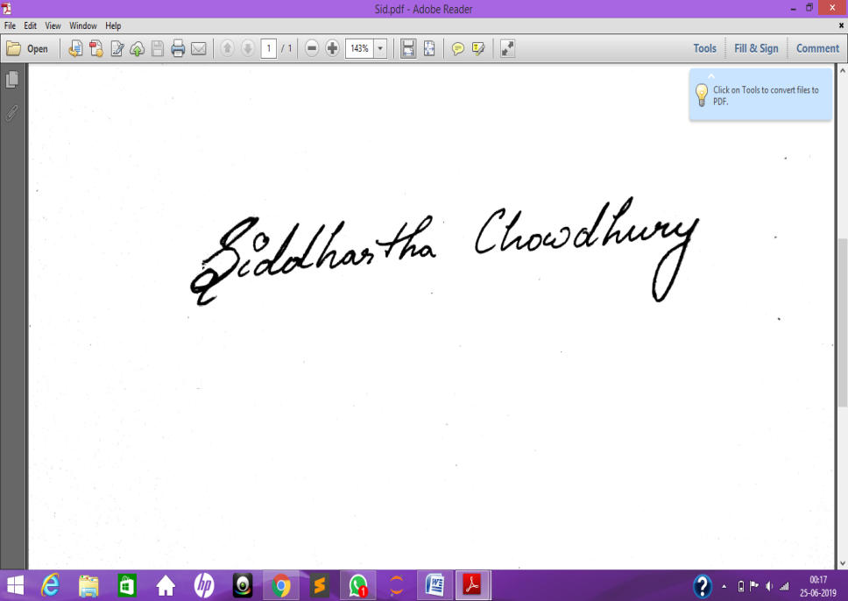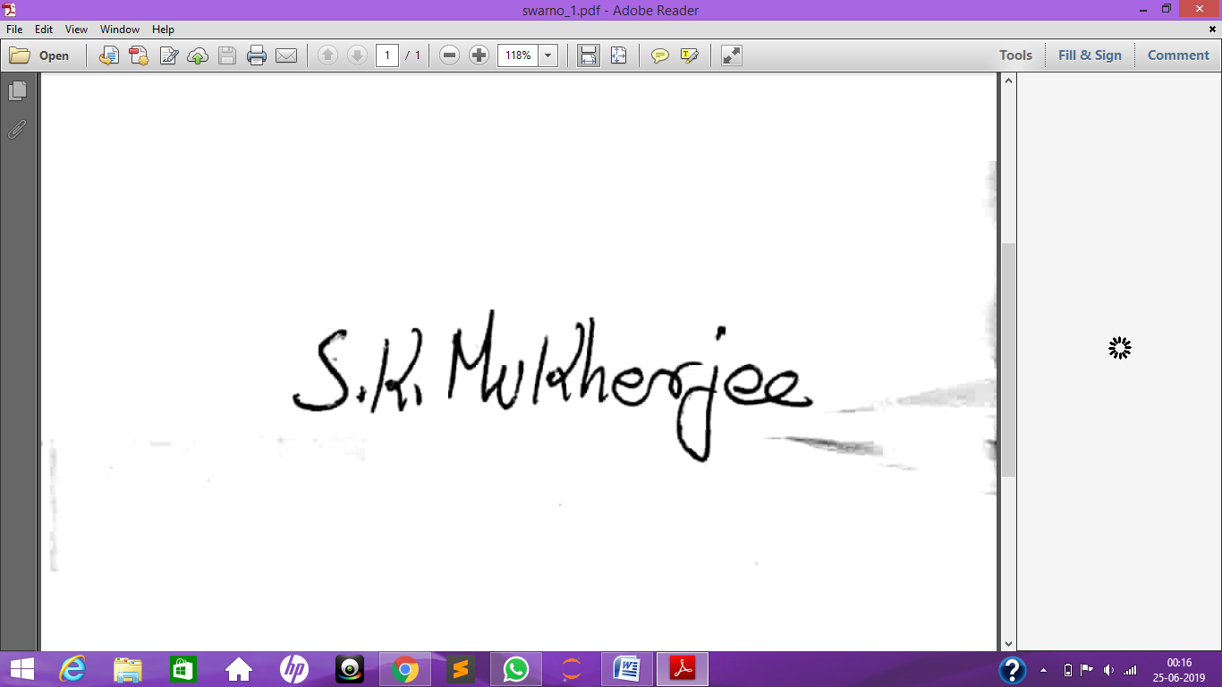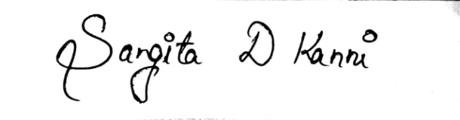We, Team NS3, state our work as a pure novel approach by the best of our knowledge.

