1. Pattren-1

****Problem Statement:**** Given an integer ****N,****print the following pattern.



Explation: 1.first read a Input

1. Focus on outer loop and count how many rows and lines
2. Inside loop to print shape .
3. Print the output
4. Every time it would be new line after condition satisfy.

Code and output:

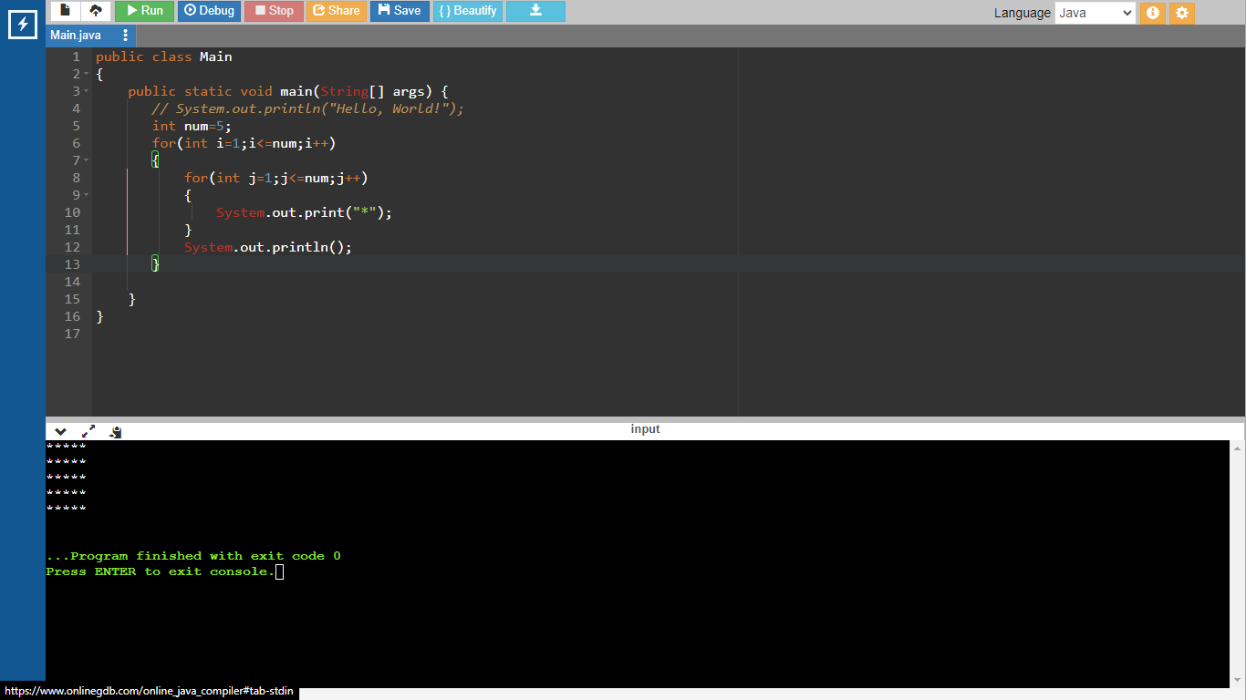

2.

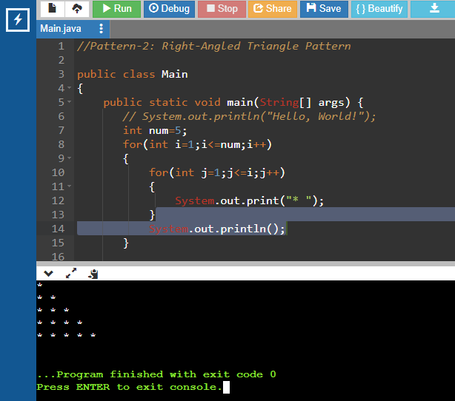

3.

# Pattern – 3: Right-Angled Number Pyramid

****Problem Statement:**** Given an integer ****N,****print the following pattern :

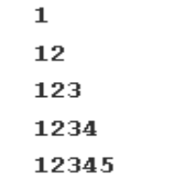

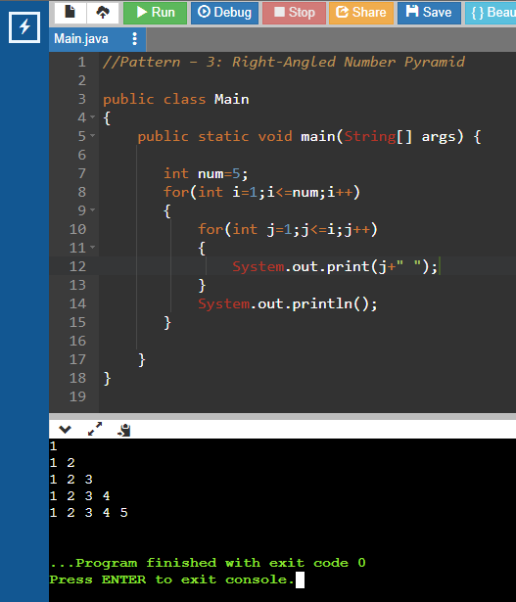

1. Pattern – 4: Right-Angled Number Pyramid – II

Input Format: N = 6

Result:

1

2 2

3 3 3

4 4 4 4

5 5 5 5 5

6 6 6 6 6 6

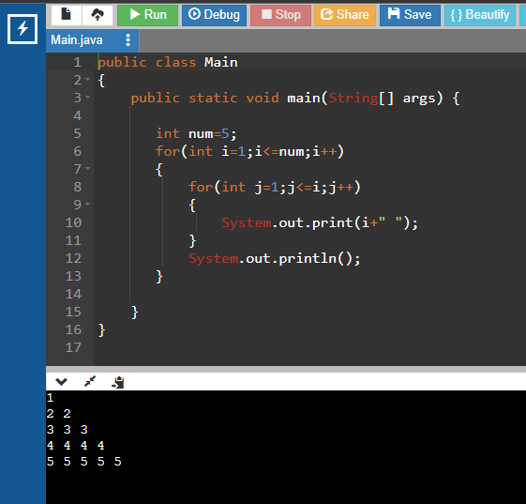

Pattern – 5: Inverted pattern Right Pyramid

Problem Statement: Given an integer N, print the following pattern :



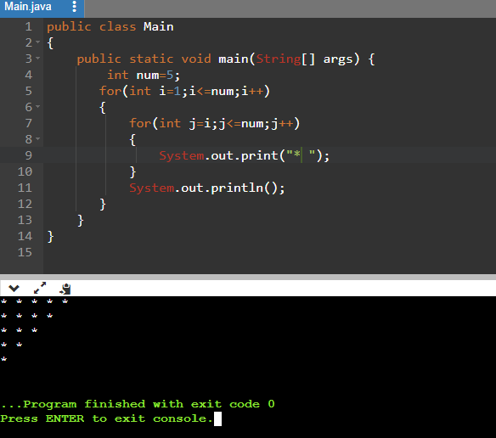

6: Inverted Numbered Right Pyramid

Problem Statement: Given an integer N, print the following pattern :

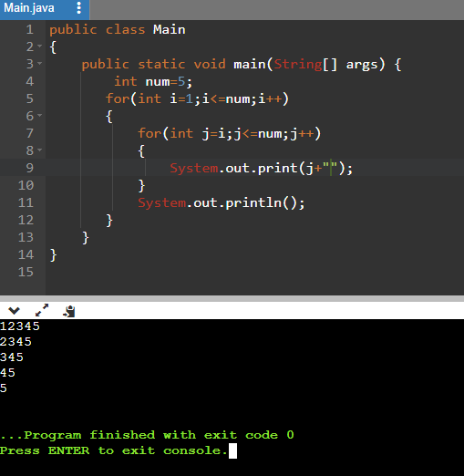

Pattern – 7: Star Pyramid

Problem Statement: Given an integer N, print the following pattern :



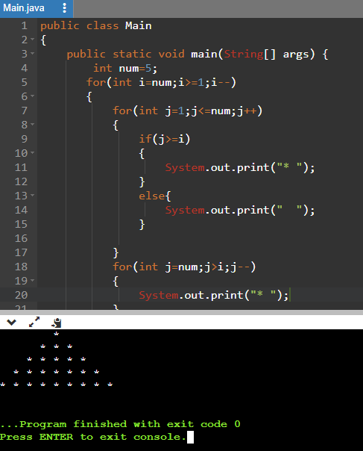

8.Star Pyramid reverse



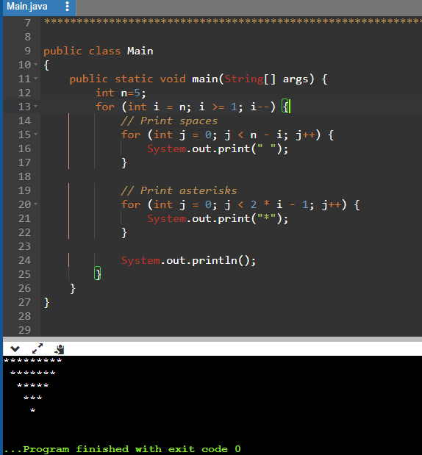

9: Diamond Star Pattern

****Problem Statement:**** Given an integer ****N,****print the following pattern :



public class Main

{

public static void main(String[] args) {

int n=5;

//pyirmid

for(int i=n;i>=1;i--)

{

/**/

for(int j=1;j<n;j++)

{

if(j>i)

{

System.out.print("*");

}

else{

System.out.print(" ");

}

}

//right tring angle

for(int j=n;j>i;j--)

{

System.out.print("*");

}

System.out.println("");

}

//reverse pyrimud

for (int i = n; i >= 1; i--) {

// Print spaces

for (int j = 0; j < n - i; j++) {

System.out.print(" ");

}

// Print asterisks

for (int j = 0; j < 2 * i - 1; j++) {

System.out.print("*");

}

System.out.println();

}

}

}

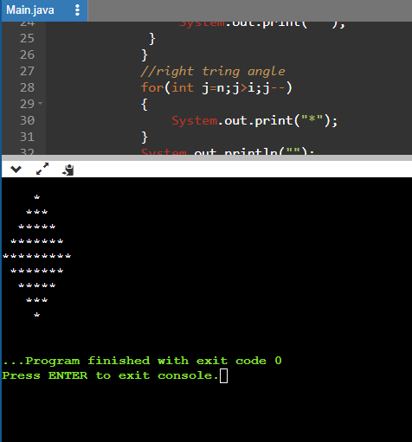

10: Half Diamond Star Pattern



public class Main

{

public static void main(String[] args)

{

int N=5;

for(int i=1;i<=2*N-1;i++){

int stars = i;

if(i>N) stars = 2*N-i;

for(int j=1;j<=stars;j++){

System.out.print("*");

}

System.out.println();

}

}

}

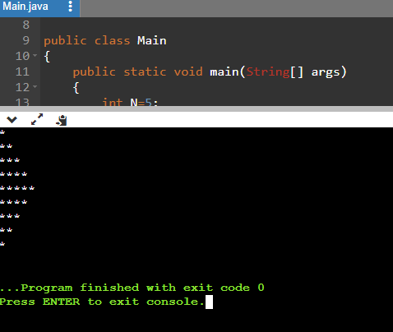

# 11.Binary Number Triangle Pattern

****Problem Statement:**** Given an integer ****N,****print the following pattern :

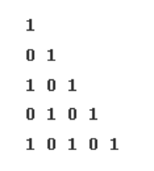

Code:

public class Main

{

public static void main(String[] args) {

int n=5;

int x=1;

for(int i=1;i<=n;i++)

{

if(i%2==0)

{

x=0;

}

else

{

x=1;

}

for(int j=1;j<=i;j++)

{

System.out.print(x+" ");

if(x==0)

{

x=1;

}

else{

x=0;

}

}

System.out.println();

}

}

}

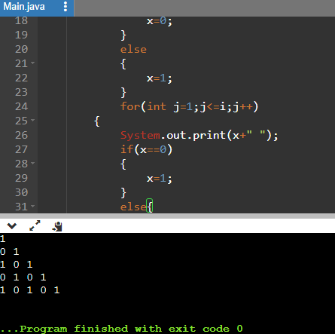

12:

# 13.Increasing Number Triangle Pattern

****Problem Statement:**** Given an integer ****N,****print the following pattern :

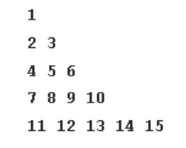

public class Main

{

public static void main(String[] args)

{

int num=5;

int n=1;

for(int i=1;i<=num;i++)

{

for(int j=1;j<=i;j++)

{

System.out.print(n+" ");

n=n+1;

}

System.out.println();

}

}

}

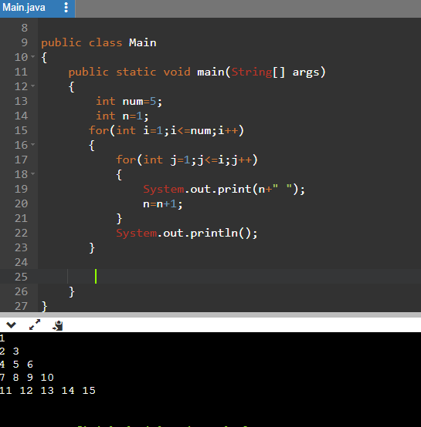

14.

public class Main

{

public static void main(String[] args)

{

int N=5;

for(int i=0;i<N;i++){

for(char ch = 'A'; ch<='A'+i;ch++){

System.out.print(ch + " ");

}

System.out.println();

}

}

}

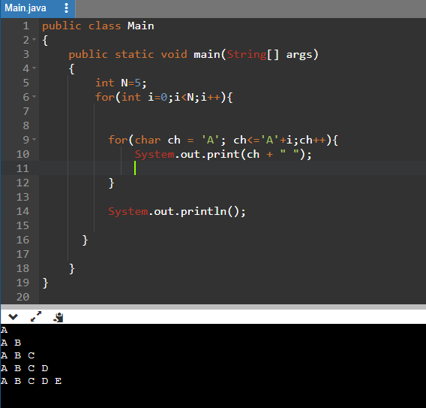

15.

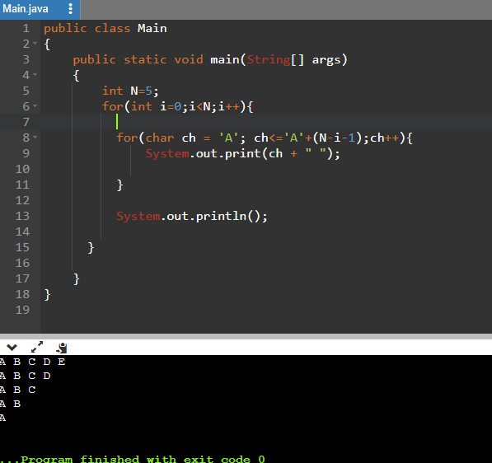

16.Alpha-Ramp Pattern

Problem Statement: Given an integer N, print the following pattern :

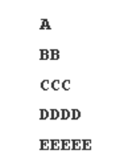

public class Main

{

public static void main(String[] args)

{

int N=5;

char ch='A';

for(int i=1;i<=N;i++){

for(int j=1;j<=i;j++)

{

System.out.print(ch+"");

}

ch++;

System.out.println();

}

}

}

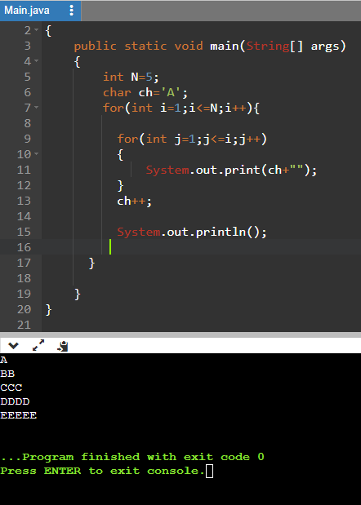

17: Alpha-Hill Pattern

Problem Statement: Given an integer N, print the following pattern :

****Input Format****: N = 3

****Result****:

A

ABA

ABCBA

Code:

class Program

{

static void Main(string[] args)

{

int N = 6;

for (int i = 1; i <= N; i++)

{

// Print spaces

for (int j = 1; j <= N - i; j++)

{

Console.Write(" ");

}

// Print increasing characters

for (char ch = 'A'; ch < 'A' + i; ch++)

{

Console.Write(ch);

}

// Print decreasing characters

for (char ch = (char)('A' + i - 2); ch >= 'A'; ch--)

{

Console.Write(ch);

}

Console.WriteLine();

}

}

}

Output:

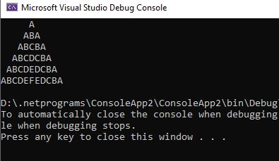

18:Alpha-Triangle Pattern

Problem Statement: Given an integer N, print the following pattern :

Input Format: N = 3

Result:

C

B C

A B C

class Program

{

static void Main(string[] args)

{

int N = 3;

for (int i = 0; i < N; i++)

{

char ch = 'C';

for (int j = 0; j < N - i - 1; j++)

{

Console.Write(" ");

}

for (int j = 0; j <= i; j++)

{

Console.Write(ch);

if (j < i)

Console.Write(" ");

ch--;

}

Console.WriteLine();

}

}

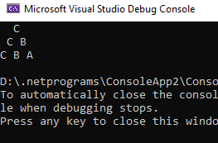

19:

Symmetric-Void Pattern

Problem Statement: Given an integer N, print the following pattern :

Code:

using System;

public class Program

{

static void Main(String[] args)

{

int n;

Console.WriteLine("Enter n value:");

n = Convert.ToInt32(Console.ReadLine());

for (int i = n; i >= 1; i--)

{

for (int j = 1; j <= i; j++)

{

Console.Write("*");

}

for (int k = 1; k <= (2 * n) - (i * 2); k++)

{

Console.Write(" ");

}

for (int l = i; l >= 1; l--)

{

Console.Write("*");

}

Console.WriteLine();

}

for (int i = 1; i <= n; i++)

{

for (int j = 1; j <= i; j++)

{

Console.Write("*");

}

for (int k = 1; k <= (2 * n) - (i * 2); k++)

{

Console.Write(" ");

}

for (int l = i; l >= 1; l--)

{

Console.Write("*");

}

Console.WriteLine();

}

}

}

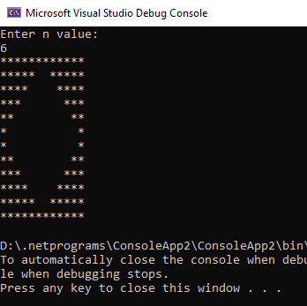

20: Symmetric-Butterfly Pattern

Problem Statement: Given an integer N, print the following pattern :

using System;

public class Program

{

static void Main(String[] args)

{

int n;

Console.WriteLine("Enter n value:");

n = Convert.ToInt32(Console.ReadLine());

for (int i = 1; i <= n; i++)

{

for (int j = 1; j <= i; j++)

{

Console.Write("*");

}

for (int k = 1; k <= (2 * n) - (i * 2); k++)

{

Console.Write(" ");

}

for (int l = i; l >= 1; l--)

{

Console.Write("*");

}

Console.WriteLine();

}

for (int i = n; i >= 1; i--)

{

for (int j = 1; j <= i; j++)

{

Console.Write("*");

}

for (int k = 1; k <= (2 * n) - (i * 2); k++)

{

Console.Write(" ");

}

for (int l = i; l >= 1; l--)

{

Console.Write("*");

}

Console.WriteLine();

}

}

}

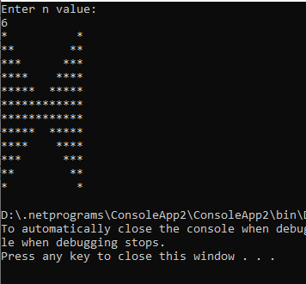

21:

1: Hollow Rectangle Pattern

Problem Statement: Given an integer N, print the following pattern :

Code:

using System;

public class Program

{

static void Main(String[] args)

{

int n;

Console.WriteLine("Enter n value:");

n = Convert.ToInt32(Console.ReadLine());

for (int i = 0; i < n; i++)

{

for(int j=0;j<n;j++)

{

if(i==0 || j==0 || i==n-1 || j==n-1)

{

Console.Write("*");

}

else

{

Console.Write(" ");

}

}

Console.WriteLine();

}

}

}

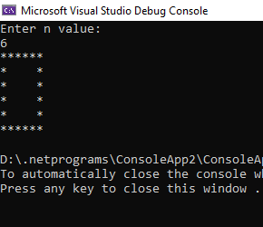

22: The Number Pattern

Problem Statement: Given an integer N, print the following pattern :

using System;

namespace NumberPattern

{

class Program

{

static void Main(string[] args)

{

int N = 6;

int size = 2 * N - 1;

for (int i = 1; i <= size; i++)

{

for (int j = 1; j <= size; j++)

{

int distance = Math.Min(Math.Min(i, j),

Math.Min(size - i + 1, size - j + 1));

int number = N - distance + 1;

Console.Write(number + " ");

}

Console.WriteLine();

}

}

}

}

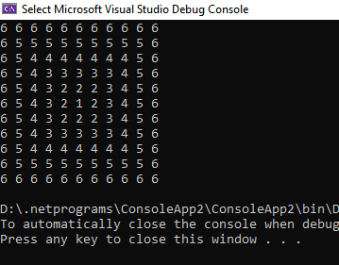

23.

using System;  
using System.Collections.Generic;  
using System.Linq;  
using System.Text;  
using System.Threading.Tasks;

namespace Pattern23HollowRightAngleTriangle  
{  
    internal class Class1  
    {  
        static void Main(string[] args)  
        {  
            var n = int.Parse(Console.ReadLine());

            for(int i=1;i<=n; i++)  
            {  
                for(int j =1;j<=i; j++)  
                {  
                    if (j == 1 || j == i || i==n)  
                    {  
                        Console.Write("* ");  
                    }  
                    else  
                        Console.Write("  ");  
                }  
                Console.WriteLine();  
            }  
        }  
    }  
}

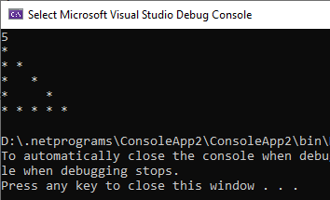

24.

using System;  
using System.Collections.Generic;  
using System.Linq;  
using System.Text;  
using System.Threading.Tasks;

namespace Pattern24House  
{  
    internal class Class1  
    {  
        static void Main()  
        {  
            var num = int.Parse(Console.ReadLine());

            for(int i=num; i>=1; i--)  
            {  
                for(int j=1; j<=num; j++)  
                {  
                    if (j >= i)  
                    {  
                        Console.Write("* ");  
                    }  
                    else  
                        Console.Write(" ");  
                }  
                Console.WriteLine();  
            }  
            for(int i = 2; i <= num; i++)  
            {  
                for (int j = 1; j <= num; j++)  
                {  
                    if (j == 1 || i == num || j == num || j == i  || (i + j == num + 1)){  
                        Console.Write("* ");  
                    }  
                    else  
                    { Console.Write("  "); }  
                }  
                Console.WriteLine();  
            }  
        }  
    }  
}

