inlabru : Convenient fitting of Bayesian digital soil mapping models using INLA-SPDE

Nicolas Saby1, and Thomas Opitz2

4/24/23

1 INRAE, Info&Sols, Orléans, France  
2 INRAE, BioSP, Avignon, France

# Introduction

Pedometricians are nowadays big fans and heavy users of Machine Learning (ML) approaches, with on the top the widely used random forest algorithm, see for example L. Poggio et al. (2021). These algorithms are indeed particularly well adapted to the management of large data sets for mapping soil properties on large geographic areas in a wide range of situations. The techniques are based on classification and regression algorithms, but they do not take account of spatial correlations in residuals (Heuvelink and Webster 2022). This trend towards heavy use of ML tools seems to be accompanied by a diminished use of geostatistical techniques that often require more computer resources but also profound statistical skills to construct and fine-tune models. In many applications, prediction is performed in several steps (*eg* regression or any other machine learning prediction in step 1, followed by spatial kriging of the residuals in step 2), but then an accurate assessment of the prediction uncertainties is difficult since uncertainties from the first step must be propagated through to the second step.

In this paper, we propose to solve these issues by using the fully Bayesian estimation framework based on the integrated nested Laplace approximation (INLA,(Rue, Martino, and Chopin 2009)), combined with the so-called stochastic partial differential equation approach (SPDE, Lindgren, Rue, and Lindström 2011) that provides numerically convenient representations of Gaussian processes over continuous space. Over the last decade, the INLA method has become the most popular tool in spatial statistics for estimating a wide variety of Generalized Additive Mixed Models (i.e., Generalized Additive Models with random effects) in a Bayesian setting. It is a relatively easy-to-use alternative to traditional Markov chain Monte Carlo methods since it provides off-the-shelf implementation of fast and accurate deterministic approximations of posterior inferences for a large class of models. INLA with SPDE is a powerful combination to handle very large spatial datasets. Models are formulated as Bayesian hierarchical models where covariate effects and Gaussian processes can be additively included in a latent process (that is not directly observed), whereas the probability distribution of observations can be of different types (continuous such as Gaussian, skew-Gaussian, Gamma, extreme-value, or discrete such as Poisson, binomial, negative binomial), and the latent Gaussian process is embedded into a key parameter of the probability distribution, such as the mean.

INLA-SPDE was already introduced by Poggio et al. (2016) or Huang et al. (2017) to the pedometrics community. However, wider use of this approach by the community was probably hindered by the complexity of the INLA R package. Recently, the inlabru R package (Yuan et al. 2017), an add-on package to INLA originally developed with a strong focus on point process models for discrete data in ecology, has integrated a range of functions to help implement INLA-SPDE models in a more convenient way through a more ergonomic interface. We propose here to illustrate how this package works by using a simple and classical regression kriging approach as an example.

# Set-up

## Load packages

We use here the set of R packages given in the list below.

The latest version of R (eg >4.2) should be installed on your computer for using the inlabru package. The classical soil dataset for the Meuse area that we use here is available in the gstatpackage.

library(INLA)  
library(inlabru)  
library(dplyr)  
library(tmap)  
library(gstat) # for the meuse data  
library(tmap)  
library(ggplot2)

The inlabru method is a convenient wrapper for the INLA::inla function and provides multiple enhancements, such as an improved integration of spatial object classes of type sp in R, more convenient syntax for defining the structure of the model, convenient functions to perform Bayesian prediction using simulations from the estimated posterior model, and estimation facilities for certain model structures that are not possible with the classical INLA package.

## Point data and rasters

We use the open data meuse from the gstat package.

data(meuse)  
data(meuse.grid)  
  
str(meuse)

'data.frame': 155 obs. of 14 variables:  
 $ x : num 181072 181025 181165 181298 181307 ...  
 $ y : num 333611 333558 333537 333484 333330 ...  
 $ cadmium: num 11.7 8.6 6.5 2.6 2.8 3 3.2 2.8 2.4 1.6 ...  
 $ copper : num 85 81 68 81 48 61 31 29 37 24 ...  
 $ lead : num 299 277 199 116 117 137 132 150 133 80 ...  
 $ zinc : num 1022 1141 640 257 269 ...  
 $ elev : num 7.91 6.98 7.8 7.66 7.48 ...  
 $ dist : num 0.00136 0.01222 0.10303 0.19009 0.27709 ...  
 $ om : num 13.6 14 13 8 8.7 7.8 9.2 9.5 10.6 6.3 ...  
 $ ffreq : Factor w/ 3 levels "1","2","3": 1 1 1 1 1 1 1 1 1 1 ...  
 $ soil : Factor w/ 3 levels "1","2","3": 1 1 1 2 2 2 2 1 1 2 ...  
 $ lime : Factor w/ 2 levels "0","1": 2 2 2 1 1 1 1 1 1 1 ...  
 $ landuse: Factor w/ 15 levels "Aa","Ab","Ag",..: 4 4 4 11 4 11 4 2 2 15 ...  
 $ dist.m : num 50 30 150 270 380 470 240 120 240 420 ...

str(meuse.grid)

'data.frame': 3103 obs. of 7 variables:  
 $ x : num 181180 181140 181180 181220 181100 ...  
 $ y : num 333740 333700 333700 333700 333660 ...  
 $ part.a: num 1 1 1 1 1 1 1 1 1 1 ...  
 $ part.b: num 0 0 0 0 0 0 0 0 0 0 ...  
 $ dist : num 0 0 0.0122 0.0435 0 ...  
 $ soil : Factor w/ 3 levels "1","2","3": 1 1 1 1 1 1 1 1 1 1 ...  
 $ ffreq : Factor w/ 3 levels "1","2","3": 1 1 1 1 1 1 1 1 1 1 ...

The first action is to create sp objects:

* a SpatialPointsDataFrame corresponding to the regression matrix and,
* the prediction grid, here already provided in the meuse.grid-object along with covariates.

coordinates(meuse) <- c('x','y')  
  
coordinates(meuse.grid) <- c("x","y")  
gridded(meuse.grid) = TRUE

# Fully Bayesian DSM approach

## The hierarchical DSM model

We construct a hierarchical model for the soil property at spatial locations in the setting of prediction in the presence of exhaustively observed ancillary information (i.e., one or several covariates). We will assume the following linkage between model components and observations, where we denote the latent process by . In this paper, will correspond to the organic matter provided in the variable om.

The spatial field captures autocorrelation not explained by the covariates. The latent process will then be used in the observation likelihood, which is here chosen, as a Gamma distribution since soil carbon is a non-negative variable and is known to present a relatively heavy-tailed distribution.

We use the | notation to indicate conditioning of the property at the left side of | on the parameters given at the right side of |. This leads to the following hierarchical formulation for the observations,

where the Gamma distribution is parametrized in a way such that is its mean and is a precision parameter related to the variance around the mean. The hyperparameter vector is with the hyperparameters controlling the linear predictors .

Moreover, different observations are conditionally independent given the latent process and the hyperparameters in controlling it. Therefore, the precision parameter controls how smoothly the observations are dispersed around the latent log-Gaussian mean .

## Construction of the mesh for the SPDE model

INLA and inlabru use a space triangulation method to estimate spatial Gaussian effects with a Matérn covariance function. The latent spatial Gaussian random field is computed at the mesh nodes by solving a Stochastic Partial Differential Equation (SPDE), while elsewhere it is computed by linear interpolation of the values at the mesh nodes. The mesh definition usually presents a trade-off between a high resolution to capture variability of the spatial effect at fine spatial scale and a lower number of nodes that usually comes with faster and potentially also numerically more stable calculations. Many applications already come with a regular grid used to discretize space, such as the meuse.grid object here, but often it still makes sense to choose different nodes for the space triangulation used to represent the Gaussian field , especially in cases where the resolution of the grid from the data is too high for being handled directly by INLA. Below, we present how to build a mesh where the construction of the mesh nodes is initialized using the set of coordinates of the calibration sites. This makes sense since can be useful to have a mesh that is relatively denser in areas with many calibration sites (where data provide more information).

First, we create a matrix xyMesh with coordinates of the sites. Next, we define the boundaries of the domain used for computing the spatial latent effect with the SPDE approach. Generally, it is a good strategy to compute an internal boundary (delimiting the study area where we want to predict) and an external boundary (providing an extension zone around the study area that is necessary to avoid strong boundary effects from the SPDE) with different resolutions. The purpose of the extension zone is to push the outer boundary away from the study area, and we can set a lower mesh resolution in this extension zone where we do not want to predict the soil property.

The INLA::inla.mesh.2d function creates a triangle mesh based on initial point locations, user-specified or automatically calculated boundaries, and parameters controlling the mesh structure, in particular the cutoff parameter. This tuning parameter sets the minimum length of edges between two nodes and allows us to keep the number of nodes at most moderately high and to avoid instabilities in computations related to the covariance structure that could arise because of very high Gaussian correlations at nodes that are very close in space. More information is provided here: https://rpubs.com/jafet089/886687

cutoffValue = 50 # in meter  
  
xyMesh <- rbind(coordinates(meuse)) # transform into matrix  
  
max.edge = diff(range(xyMesh[,1]))/(3*5)  
bound.outer = diff(range(range(xyMesh[,1])))/3  
  
bndint <- inla.nonconvex.hull(meuse, convex=-.05)  
bndext <- inla.nonconvex.hull(meuse, convex=-.3)  
  
# Use of inla.mesh.2d   
mesh = inla.mesh.2d(loc=xyMesh,  
 boundary = list(int = bndint,  
 out = bndext),  
 max.edge = c(1,3)*max.edge,   
 cutoff = cutoffValue,  
 crs = meuse@proj4string@projargs)  
ggplot() +  
 gg(mesh) +  
 gg(meuse) +  
 coord_equal()

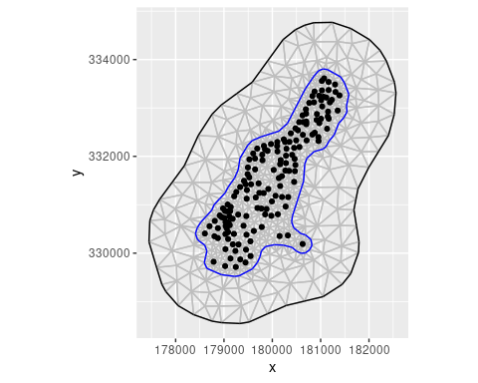

## Defining the spatial Gaussian random field

We choose the Matérn covariance function for the Gaussian random field because it can be easily used within INLA through the SPDE approach that provides convenient numerical representations for estimation with large numbers of observations and up to several thousand mesh nodes. The Matérn covariance in INLA depends on three parameters: - a fractional order parameter *alpha* in the SPDE linked to the smoothness of the solution (which has to be fixed by the user), - a standard deviation parameter *sigma* and, - a spatial correlation parameter known as the *range*.

The parameter must be fixed by the user, and we here choose (which is also the default value in the INLA package) corresponding to a Matérn regularity parameter of . We specify the other two parameters in our model by selecting a penalized complexity prior using the INLA::inla.spde2.pcmatern function. For more details, please read the introduction to spatial models with INLA in chapter 7 at <https://becarioprecario.bitbucket.io/inla-gitbook/ch-spatial.html>.

matern <-  
 INLA::inla.spde2.pcmatern(mesh,  
 alpha = 2,  
 prior.sigma = c(1, 0.5),# P(sigma > 1) = 0.5  
 prior.range = c(10000, 0.9) # P(range < 10000 m) = 0.9  
 )

## Specifying the hierarchical model

We then specify the model components in the cmp object using the convenient inlabru approach. In this example implementation, we include the following latent effects: two fixed effects (an intercept, and a linear relationship with the covariate corresponding to the distance to the river), and the Gaussian random field as a random effect.

cmp <- om ~   
 field(coordinates, model = matern) +   
 Intercept(1) +   
 dist(dist, model = 'linear' )

Finally, we fit the hierarchical model to the data using the bru function of the inlabru package. This function requires the model components defined earlier (cmp), the dataset (meuse), the mesh (mesh) where the model will be evaluated, and several options to control the INLA algorithm.

For handling the uncertainty stemming from the prior distributions of the three hyperparameters in , we use the eb strategy as it is much quicker to compute but a bit less accurate. This empirical Bayes approach sets the hyperparameters to their maximum a posteriori for some of the calculations performed during the estimation algorithm, that is, it uses a mechanism similar to frequentist inference techniques for handling the hyperparameters.

fit <- inlabru::bru(  
 components = cmp,  
 data = meuse,  
 family = "gamma",  
 domain = list(coordinates = mesh),  
 options = list(  
 control.inla = list(int.strategy = "eb"),  
 verbose = FALSE  
 )  
)

The summary of the fitted model gives the posterior estimates of fixed effects (intercept and distance to the Meuse river) and of hyperparameters (standard deviation and correlation range of the spatial field, and precision parameter of the Gamma distribution).

summary(fit)

inlabru version: 2.7.0  
INLA version: 22.12.16  
Components:  
field: main = spde(coordinates)  
Intercept: main = linear(1)  
dist: main = linear(dist)  
Likelihoods:  
 Family: 'gamma'  
 Data class: 'SpatialPointsDataFrame'  
 Predictor: om ~ .  
Time used:  
 Pre = 1.39, Running = 1.11, Post = 0.0576, Total = 2.56   
Fixed effects:  
 mean sd 0.025quant 0.5quant 0.975quant mode kld  
Intercept 2.349 0.223 1.912 2.349 2.785 2.349 0  
dist -1.311 0.390 -2.076 -1.311 -0.547 -1.311 0  
  
Random effects:  
 Name Model  
 field SPDE2 model  
  
Model hyperparameters:  
 mean sd 0.025quant  
Precision parameter for the Gamma observations 14.227 2.487 9.969  
Range for field 1760.208 831.851 781.670  
Stdev for field 0.555 0.175 0.318  
 0.5quant 0.975quant mode  
Precision parameter for the Gamma observations 14.01 19.738 13.58  
Range for field 1558.31 3944.193 1227.82  
Stdev for field 0.52 0.996 0.45  
  
Deviance Information Criterion (DIC) ...............: 664.90  
Deviance Information Criterion (DIC, saturated) ....: 203.62  
Effective number of parameters .....................: 47.08  
  
Watanabe-Akaike information criterion (WAIC) ...: 661.10  
Effective number of parameters .................: 35.86  
  
Marginal log-Likelihood: -366.62   
 is computed   
Posterior summaries for the linear predictor and the fitted values are computed  
(Posterior marginals needs also 'control.compute=list(return.marginals.predictor=TRUE)')

# Spatial predictions

Next, we use the fit to predict the field on a regular lattice, and we therefore generate a set of results using 100 realizations from the posterior distribution of the model. The approach of using posterior simulation for prediction allows us to appropriately represent the uncertainties in the predictions, and we can choose very flexibly for which parameters and properties we would like to provide predictions. In the predictor formula, we use the exp function to take into account the log-link between the mean of the Gamma distribution of the om variable and our linear predictor. This approach provides predictions of the mean surface of the Gamma distribution.

pred <- predict(  
 fit,  
 n.samples = 100,  
 meuse.grid,  
 ~ exp(field + Intercept + dist) ,  
 num.threads = 2  
)

Internally, the predict function draws samples from the posterior distribution and then combines them to provide the requested predictions. It is also very simple to perform the sampling step directly to obtain the posterior samples using the generate function. For illustration, we here we draw 5 samples and select the first one.

samp <- generate(fit,   
 meuse.grid,  
 ~ exp(field + Intercept + dist) ,  
 n.samples = 5  
)  
  
str(samp)

num [1:3103, 1:5] 14.3 16.6 14.2 11.8 17.7 ...

pred$sample <- samp[, 1]

# Plotting results

## The different effects

We can plot the posterior densities for the latent effect Intercept and the distance dist to the Meuse river.

To this end we will use the inlabru::plot() function,

p1 <- plot(fit, "Intercept")  
p2 <- plot(fit, "dist")  
multiplot(p1, p2)

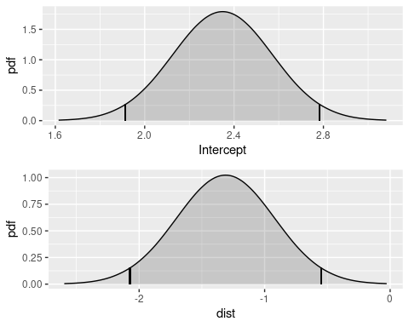

As the credibility interval of the dist coefficient does not contain , we can conclude that the covariate effect of dist is significant.

We can also plot the posterior distribution of the parameters of the Gaussian field, here given as correlation range and variance.

spde.range.W0 <- spde.posterior(fit, "field", what = "range")  
spde.logvar.W0 <- spde.posterior(fit, "field", what = "variance")  
range.plot.W0 <- plot(spde.range.W0)  
var.plot.W0 <- plot(spde.logvar.W0)  
multiplot(range.plot.W0, var.plot.W0)

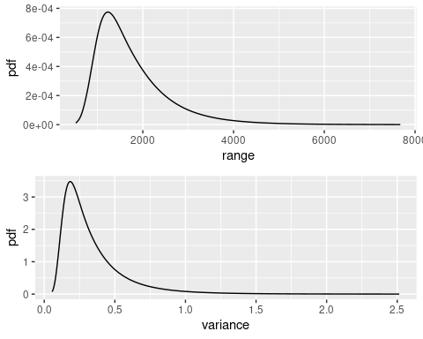

## Spatial predictions with uncertainty bounds

We can plot the spatial surfaces corresponding to the pointwise median and to the lower and upper bounds of a 95% credible interval as follows (assuming that the predicted intensity is in the object pred).

tm_shape(pred) +  
 tm_raster(  
 c("q0.025","median","q0.975")  
 )

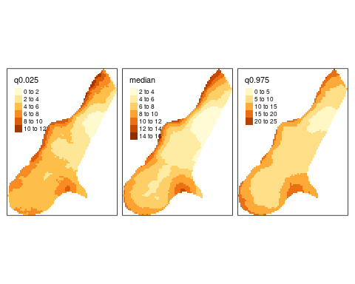

## One realization of the posterior distribution

The first sample that we have drawn from the posterior distribution can be mapped as follows.

tm_shape(pred) + tm_raster("sample")

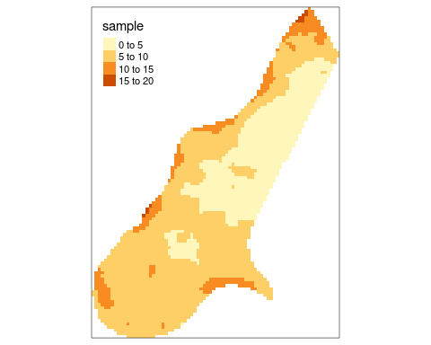

## The maps of the random and the fixed effects

Next, we plot the 2 effects of the model:

* the spatial Gaussian random field ,
* the combination of the two fixed effects.

pred <- predict(  
 fit,  
 n.samples = 100,  
 meuse.grid,  
 ~ field ,  
 num.threads = 2  
)  
  
fixed <- predict(  
 fit,  
 n.samples = 100,  
 meuse.grid,  
 ~ exp(Intercept + dist) ,  
 num.threads = 2  
)  
  
pred$FixedEffect <- fixed$median  
pred$W <- pred$median  
  
tm_shape(pred) +  
 tm_raster(c("W","FixedEffect"))

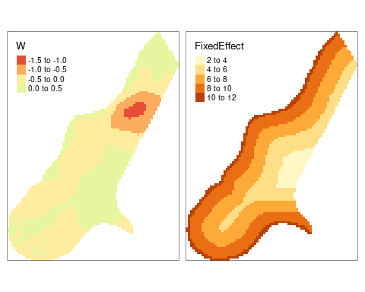

# Final remarks

Heuvelink and Webster (2022) listed a set of challenges for pedometricians and spatial statisticians to strengthen the role of spatial statistics and to fully exploit its modern cutting-edge tools. While not being able to solve all of them, we are convinced that fully Bayesian modelling using INLA with its numerically highly efficient implementation can provide satisfactory answers to some of these challenges, in particular regarding improved uncertainty quantification, the change of the support, and the incorporation of attribute and positional measurement uncertainty.

The goal of [inlabru](http://inlabru.org/) is to further facilitate spatial modeling using integrated nested Laplace approximation via the [R-INLA package](https://www.r-inla.org/). The recent developments made available through inlabru allow for an even more convenient construction of Bayesian spatial models of soil properties along with precise uncertainty assessments through the INLA-SPDE approach. Various types of model components can be specified based on various predictors used as inputs, and internally these components are represented through a set of latent Gaussian variables. The predictors are specified via general R expressions. Most of the technical details of the implementation are hidden and handled internally by inlabru.

The user can choose a likelihood family, such as gaussian, poisson or binomial, from a long list of possible choices. The default family is gaussian. A list of possible alternatives can be seen by typing names(inla.models()$likelihood). Therefore, it is possible to fit a wide range of models allowing to tackle a great diversity of data types and problems in soil science. Here we used the gamma family to impose nonnegativity and cope with heavy tails.

In their studies, Poggio et al. (2016) and Huang et al. (2017) reported that INLA-SPDE became quite slow when estimating the posterior marginal distributions of the environmental variables when datasets were large. When the number of observations is huge, it is important hat one can improve the performance of the high-dimensional matrix computations conducted in INLA by using the PARDISO solver library. It is already fully included in the standard INLA installation but has to be activated through a licence key. To activate it (note that it is free for non commercial uses), go to https://www.pardiso-project.org/r-inla/#license to obtain the license, which will take you at most several minutes. Also, you can type inla.pardiso() at the R command line for viewing the (very simple) instructions on how to enable the PARDISO sparse library. Moreover, additional methodological developments have become available in the latest INLA versions for handling especially data-rich models to achieve even faster inference, improved numerical stability and scalability (Van Niekerk et al. 2023).

# Code availability

The code is also available on github : https://github.com/nsaby/pedometron042023

More codes are available here: https://inlabru-org.github.io/inlabru/articles/web/random_fields_2d.html

# References

Heuvelink, Gerard B. M., and Richard Webster. 2022. “Spatial Statistics and Soil Mapping: A Blossoming Partnership Under Pressure.” *Spatial Statistics* 50: 100639. https://doi.org/<https://doi.org/10.1016/j.spasta.2022.100639>.

Huang, Malone, J. 2017. “Evaluating a Bayesian modelling approach (INLA-SPDE) for environmental mapping.” *Science of The Total Environment* 609: 621--632.

Lindgren, Finn, Håvard Rue, and Johan Lindström. 2011. “An explicit link between Gaussian fields and Gaussian Markov random fields: the stochastic partial differential equation approach.” *Journal of the Royal Statistical Society: Series B (Statistical Methodology)* 73 (4): 423–98.

Poggio, Laura, Alessandro Gimona, Luigi Spezia, and Mark J Brewer. 2016. “Bayesian spatial modelling of soil properties and their uncertainty: The example of soil organic matter in Scotland using R-INLA.” *Geoderma* 277: 69–82.

Poggio, L., L. M. de Sousa, N. H. Batjes, G. B. M. Heuvelink, B. Kempen, E. Ribeiro, and D. Rossiter. 2021. “SoilGrids 2.0: Producing Soil Information for the Globe with Quantified Spatial Uncertainty.” *SOIL* 7 (1): 217–40. <https://doi.org/10.5194/soil-7-217-2021>.

Rue, Håvard, Sara Martino, and Nicolas Chopin. 2009. “Approximate Bayesian inference for latent Gaussian models by using integrated nested Laplace approximations.” *Journal of the Royal Statistical Society: Series b (Statistical Methodology)* 71 (2): 319–92.

Van Niekerk, Janet, Elias Krainski, Denis Rustand, and Håvard Rue. 2023. “A New Avenue for Bayesian Inference with INLA.” *Computational Statistics & Data Analysis* 181: 107692. https://doi.org/<https://doi.org/10.1016/j.csda.2023.107692>.

Yuan, Y., F. E. Bachl, F. Lindgren, D. L. Brochers, J. B. Illian, S. T. Buckland, H. Rue, and T. Gerrodette. 2017. “Point Process Models for Spatio-Temporal Distance Sampling Data from a Large-Scale Survey of Blue Whales.” <https://arxiv.org/abs/1604.06013>.