Geographic and Temporal Variation in Medicare Part D Formulary Restrictiveness for Diabetes Medications, 2020–2025

Naomi Sahle
Mentor: Frances S. Shofer, PhD

Submitted in partial fulfillment of the requirements for the degree of
MASTER OF PUBLIC HEALTH

University of Pennsylvania
Perelman School of Medicine

April 13, 2026
Abstract
Background: The Inflation Reduction Act (IRA) of 2022 restructured Medicare Part D plan liability, creating new financial incentives for plans to restrict access to high-cost medications. This study examined geographic and temporal variation in formulary restrictiveness for four classes of diabetes medication during this policy transition. Methods: Using publicly available Centers for Medicare & Medicaid Services (CMS) Part D Formulary Files, plan information files, and enrollment data from 2020 to 2025, we calculated utilization management rates and composite restrictiveness scores for GLP-1 receptor agonists, insulin, SGLT2 inhibitors, and DPP-4 inhibitors across approximately 3,000 U.S. counties. We weighted all measures by plan enrollment so that plans covering more beneficiaries contribute proportionally more to county-level estimates. We assessed geographic variation through state-level comparisons and county-level choropleth mapping using ArcGIS Pro. Results: The share of enrollment-weighted plans requiring prior authorization for GLP-1 receptor agonists rose from 7.0% to 100.0% between 2020 and 2025, while insulin (2.3% to 1.2%), SGLT2 inhibitor (0.2% to 0.1%), and DPP-4 inhibitor (0.2% to 0.1%) rates remained low and declined modestly. The GLP-1 composite restrictiveness score rose from 1.08 to 2.03 on a 0–4 scale, where each point represents one additional type of formulary restriction applied. State-level GLP-1 prior authorization rates in 2024 ranged from approximately 58% to 98%, and county-level mapping revealed within-state heterogeneity and a Southeast cluster of higher overall restrictiveness. Conclusion: Medicare Part D plans selectively and nearly universally increased GLP-1 formulary restrictions during the IRA implementation period, with notable geographic variation in the pace of adoption. Continued monitoring and potential policy interventions are warranted to ensure equitable access to this clinically important medication class.
Background
Type 2 diabetes affects approximately 24.4% of Americans aged 65 and older, representing over 14 million Medicare beneficiaries and making it one of the most prevalent chronic conditions within the Medicare population.¹ Effective diabetes management requires consistent access to prescription medications, yet Medicare Part D formularies—the lists of covered drugs and their associated access restrictions—have become increasingly restrictive over time. Between 2011 and 2020, prior authorization, step therapy, and quantity limits expanded considerably, with restricted compounds increasing from 31.9% to 44.4% across Part D plans.² Most notably, prior authorization requirements for GLP-1s surged from approximately 5% of plans in the early 2020s to nearly 100% by 2025.^{3,4} These formulary restrictions create substantial barriers to medication access for millions of beneficiaries and may disproportionately affect vulnerable populations—including racial and ethnic minorities, lower-income beneficiaries, and those with limited health literacy—who face greater challenges navigating administrative requirements such as obtaining physician documentation, completing insurer paperwork, and appealing coverage denials.¹
The period from 2020 to 2025 represents a particularly dynamic era for Part D policy, marked by multiple major reforms aimed at improving medication affordability and access. The Part D Senior Savings Model (2021–2023) allowed plans to voluntarily cap insulin copayments at $35 per month, and participating plans demonstrated higher medication adherence rates among enrolled beneficiaries.⁵ The Inflation Reduction Act of 2022 expanded this insulin cap program-wide beginning in January 2023 and introduced additional cost-sharing protections, including a $2,000 annual cap on total out-of-pocket prescription drug spending (across all medications, not limited to diabetes drugs) effective January 2025.⁶ However, these same policy changes fundamentally restructured Part D financial liability. Under the benefit redesign, plans’ share of costs for high-spending beneficiaries in the catastrophic coverage phase—the stage reached after a beneficiary’s annual drug spending exceeds a set threshold—increased from 15% to 60% for brand-name drugs. This shift in plan liability created strong financial incentives for plans to adopt more aggressive utilization management strategies, particularly prior authorization requirements, for expensive medications likely to push beneficiaries into that spending phase, potentially resulting in increased claim processing delays or coverage denials for beneficiaries.⁶
Against this policy backdrop, existing research establishes that formulary restrictions affect medication access and utilization patterns. Studies consistently demonstrate that formulary restrictions, particularly cost-sharing through non-preferred tier placement, have been associated with lower rates of medication initiation.⁷ Regional variation in access to diabetes medications is well documented: initiation rates for newer glucose-lowering drugs vary fivefold across U.S. geographic regions defined by patterns of hospital referral.¹ Additionally, substantial racial and socioeconomic disparities exist in medication access, with Black beneficiaries experiencing lower rates of SGLT2 inhibitor and GLP-1 receptor agonist initiation even after adjusting for clinical characteristics such as diabetes severity, comorbidities, and prior medication use.¹
Despite these policy shifts, comprehensive characterization of how formulary restrictiveness varies across counties and over time remains limited. Although national trends in formulary restrictions have been documented for the 2011–2020 period,² county-level variation in formulary restrictiveness remains underexplored. Additionally, despite the near-universal adoption of prior authorization for GLP-1 receptor agonists during 2020–2025, temporal trends during this critical policy transition remain poorly documented. Moreover, existing approaches for measuring formulary restrictiveness vary widely across studies,⁸ limiting comparability and hindering development of validated metrics that can be applied consistently in future research and policy monitoring.
This project addresses these gaps by systematically characterizing county-level and temporal variation in Medicare Part D formulary restrictiveness for diabetes medications from 2020 through 2025. By documenting the extent and distribution of this variation, our findings identify markets where restrictive formularies may particularly affect vulnerable populations. Temporal analyses reveal how plans responded to major policy changes, informing ongoing debates about balancing medication cost control with ensuring patient access to effective therapies. This project also establishes replicable measures of restrictiveness using publicly accessible data sources, providing a framework for continued monitoring of Part D formulary policies.
Methods
Study Design
We conducted a descriptive secondary analysis of publicly available CMS administrative data to characterize geographic and temporal variation in Medicare Part D formulary restrictiveness for diabetes medications. We examined all Part D plans—both standalone Prescription Drug Plans (PDPs) and Medicare Advantage Prescription Drug Plans (MA-PDs)—from plan years 2020 through 2025. This period encompasses the Part D Senior Savings Model (2021–2023), the Inflation Reduction Act insulin copay cap implementation (January 2023), and the benefit redesign effective January 2025.
Data Sources
We used three publicly available CMS data sources. First, the Part D Formulary Files contain plan-level information on covered medications including tier placement, prior authorization requirements, step therapy protocols, and quantity limits for each National Drug Code (NDC). These files, released annually, reflect formulary status as of each plan year. Second, the Part D Plan Characteristics Files provide plan-level identifiers enabling linkage between formulary data and enrollment information, including contract and plan identifiers, plan names, and service area counties. Third, the Part D Enrollment Files provide county-level monthly enrollment counts by contract and plan, enabling calculation of enrollment-weighted restrictiveness measures. All data are publicly available through the CMS website (data.cms.gov) at no cost, eliminating data use agreement requirements and enabling full replication.
Study Population and Sample
The unit of analysis is the plan-county-year, representing each Part D plan’s formulary characteristics within each county it serves for each study year. We included all Part D plans offering prescription drug coverage during 2020–2025, encompassing both standalone Prescription Drug Plans and Medicare Advantage Prescription Drug Plans. We excluded plans with missing or incomplete formulary data for the diabetes medication classes of interest or with zero enrollment in a given county-year.^{3,9}
Measures
Diabetes Medication Classes. We examined four major diabetes medication classes, consistent with prior formulary research on glucose-lowering therapies^{1,7}: (1) insulin products, including rapid-acting, short-acting, intermediate-acting, long-acting, mixed, and concentrated formulations; (2) GLP-1 receptor agonists, including injectable semaglutide (Ozempic), oral semaglutide (Rybelsus), tirzepatide (Mounjaro), dulaglutide (Trulicity), and liraglutide (Victoza); (3) SGLT2 inhibitors, including empagliflozin (Jardiance), dapagliflozin (Farxiga), and canagliflozin (Invokana); and (4) DPP-4 inhibitors, including sitagliptin (Januvia), linagliptin (Tradjenta), saxagliptin (Onglyza), and alogliptin (Nesina). We identified medications in the CMS formulary files using RxNorm Concept Unique Identifiers (RXCUIs) verified against the National Institutes of Health RxNav database and linked them to National Drug Codes using the CMS Formulary Reference File crosswalks.
Formulary Restrictiveness Measures. We measured four dimensions of formulary restrictiveness for each medication class within each plan, drawing on established approaches in Part D formulary research.^{2,8} Table 1 defines each measure.
Table 1. Formulary Restrictiveness Dimensions
Dimension | Definition
Prior authorization | The percentage of medications within each class for which the plan requires the prescribing physician to obtain advanced approval from the insurer before the medication will be covered.
Step therapy | The percentage of medications for which the plan requires the patient to first try and fail on a less expensive alternative medication before the plan will cover the requested drug.
Quantity limits | The percentage of medications subject to restrictions on how much of the drug can be dispensed per prescription fill (e.g., a 30-day supply limit).
Tier placement | Whether medications are placed on preferred tiers (Tiers 1–3, with lower copays) versus non-preferred (Tiers 4–5) or specialty tiers (with higher copays), following the classification approach used by Buttorff et al.⁹

We constructed a composite restrictiveness index by assigning one point for each restriction type applied to a medication (prior authorization, step therapy, quantity limits, non-preferred or specialty tier placement), yielding medication-level scores ranging from 0 (no restrictions) to 4 (all four restriction types applied). We calculated class-level restrictiveness as the mean score across all medications within each therapeutic class. This approach adapts the methodology of Shen et al.,⁸ who developed a three-level restriction classification for oral diabetes medications.
Geographic Variables. We calculated county-level formulary restrictiveness as the enrollment-weighted average of plan-level restrictiveness measures. In this weighting approach, each plan’s contribution to the county-level average is proportional to its share of enrolled beneficiaries in that county, so that plans covering more people count more in the average than plans with few enrollees. This approach, consistent with methods used by Liu et al.⁴ in their quarterly analysis of GLP-1 coverage, reflects the formulary environment experienced by the typical Medicare beneficiary in each county rather than giving equal weight to all plans regardless of market share. We converted county-level SSA codes from CMS geographic locator files to Census FIPS codes using the National Bureau of Economic Research SSA-to-FIPS crosswalk to enable geographic mapping and visualization.
Analysis
We performed all data processing and analysis using Python (version 3.x) with the pandas library for data manipulation. Custom scripts filtered raw formulary files to relevant diabetes medications using verified RXCUI codes, calculated utilization management rates and composite restrictiveness scores by drug class and plan, and generated enrollment-weighted county-level measures by merging formulary data with plan service area and enrollment files. We used descriptive statistics to characterize the distribution of formulary restrictiveness measures across drug classes, counties, and years. Frequencies and percentages describe the prevalence of each utilization management requirement. We examined temporal trends by calculating annual changes in enrollment-weighted utilization management rates across the study period. We annotated key policy implementation dates—January 2023 (IRA insulin cap) and January 2025 (benefit redesign)—on trend figures to assess whether observable inflection points in formulary restrictiveness coincided with policy changes, as documented for GLP-1 receptor agonists in recent research.^{3,4}
We assessed geographic variation through county-level mapping of enrollment-weighted restrictiveness measures. We created county-level choropleth maps using ArcGIS Pro to display the distribution of GLP-1 prior authorization rates and average formulary restrictiveness scores across the continental United States. We generated state-level comparisons to examine between-state variation in GLP-1 prior authorization adoption during the transition period. No statistical hypothesis testing was performed; this study is purely descriptive, and all reported differences reflect observed patterns in the data.
Results
Analytic Sample
The analytic sample included formulary entries for four diabetes medication classes across 2020 to 2025, with the number of unique Part D formularies declining from 457 in 2021 to 383 in 2025 as the plan market consolidated (Table 2). The number of counties with enrollment-weighted data ranged from 2,972 in 2020 to 3,154 in 2025, spanning 50 states, the District of Columbia, and Puerto Rico. Alaska was excluded from geographic analyses due to incomplete matching in the crosswalk used to convert CMS’s internal county codes (SSA codes) to standard Census geographic identifiers (FIPS codes); Massachusetts, Nevada, and the District of Columbia had incomplete data for some years due to similar county-code matching gaps. Geographic visualizations display the continental United States. GLP-1 receptor agonist formulary entries increased substantially over the study period, from 1,561 in 2020 to 6,016 in 2025, reflecting the expanding market for this drug class. Insulin entries were the most numerous in each year, ranging from 9,932 to 11,908. SGLT2 inhibitor and DPP-4 inhibitor entries remained relatively stable, each with approximately 1,600 to 2,000 entries per year. Full sample characteristics are presented in Table 2.
Table 2. Analytic Sample Characteristics by Drug Class and Year, Medicare Part D Formulary Files, 2020–2025
Drug Class | Year | Formularies | Entries | PA (%) | ST (%) | QL (%) | Restrict. Score
GLP-1 | 2020 | 441 | 1,561 | 6.2 | 16.9 | 84.9 | 1.08
 | 2021 | 457 | 3,699 | 5.4 | 16.5 | 87.6 | —
 | 2022 | 457 | 4,193 | 7.6 | 11.4 | 87.2 | —
 | 2023 | 450 | 5,552 | 15.5 | 16.5 | 88.3 | —
 | 2024 | 421 | 6,149 | 88.1 | 3.4 | 94.9 | —
 | 2025 | 383 | 6,016 | 98.9 | 0.3 | 97.8 | 2.03
Insulin | 2020 | 447 | 9,932 | 3.2 | 2.4 | 26.3 | 0.27
 | 2021 | 457 | 11,256 | 3.3 | 2.3 | 23.6 | —
 | 2022 | 457 | 11,569 | 3.5 | 1.5 | 23.3 | —
 | 2023 | 450 | 11,908 | 3.7 | 1.8 | 21.9 | —
 | 2024 | 421 | 11,671 | 2.7 | 1.4 | 21.0 | —
 | 2025 | 383 | 10,428 | 2.6 | 0.1 | 31.3 | 0.21
SGLT2 | 2020 | 447 | 1,842 | 0.7 | 23.5 | 81.2 | 1.15
 | 2021 | 457 | 1,914 | 0.5 | 8.2 | 84.0 | —
 | 2022 | 457 | 1,956 | 0.4 | 3.1 | 83.9 | —
 | 2023 | 450 | 1,960 | 0.4 | 2.2 | 84.7 | —
 | 2024 | 421 | 1,804 | 0.2 | 0.7 | 84.3 | —
 | 2025 | 383 | 1,642 | 0.5 | 0.2 | 96.2 | 1.13
DPP-4 | 2020 | 447 | 2,034 | 0.7 | 15.2 | 88.2 | 1.2
 | 2021 | 457 | 2,028 | 0.9 | 12.1 | 89.5 | —
 | 2022 | 457 | 1,813 | 1.7 | 3.5 | 88.3 | —
 | 2023 | 450 | 1,771 | 1.8 | 3.5 | 93.9 | —
 | 2024 | 421 | 1,785 | 0.4 | 2.7 | 93.8 | —
 | 2025 | 383 | 1,680 | 0.3 | 2.2 | 96.1 | 0.99

Note. PA = prior authorization; ST = step therapy; QL = quantity limits. Percentages represent the proportion of formulary entries within each drug class subject to each utilization management requirement (unweighted). These entry-level rates differ from the enrollment-weighted county-level averages reported in the text, which weight each plan’s contribution by its share of beneficiaries. Restrictiveness scores (0–4 scale) shown for 2020 and 2025 only. Entry counts reflect unique plan-medication combinations. Em dash (—) indicates data not displayed.
Temporal Trends in Utilization Management
The most notable temporal trend was the increase in prior authorization requirements for GLP-1 receptor agonists (Figure 1). Enrollment-weighted GLP-1 prior authorization rates remained stable at approximately 7% from 2020 through 2023 (ranging from 6.4% to 7.1%), then surged to 78.0% in 2024 and reached 100.0% in 2025—a 93-percentage-point increase over the study period. In contrast, prior authorization rates for the other three drug classes remained low and stable throughout the study period: insulin ranged from 1.2% to 2.3%, DPP-4 inhibitors from 0.1% to 0.3%, and SGLT2 inhibitors from 0.1% to 0.2%. The stability of these three classes alongside the GLP-1 surge indicates that plans targeted prior authorization increases to one specific high-cost drug class rather than broadly tightening formularies.

Figure 1. Prior Authorization Rates for Diabetes Medications in Medicare Part D Plans, 2020–2025
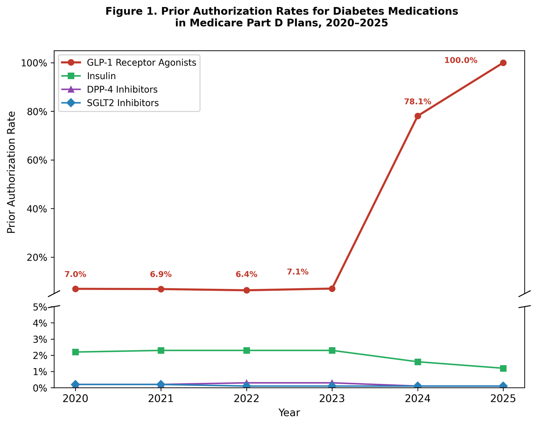Examination of the other two utilization management tools revealed distinct patterns (Figures 2 and 3). Step therapy requirements declined across all four drug classes over the study period (Figure 2). GLP-1 step therapy rates fell from 8.0% in 2020 to 1.0% in 2025. SGLT2 inhibitor and DPP-4 inhibitor step therapy rates also declined substantially, from approximately 10% and 9% in 2020 to below 1% by 2025.

Figure 2. Step Therapy Rates for Diabetes Medications in Medicare Part D Plans, 2020–2025
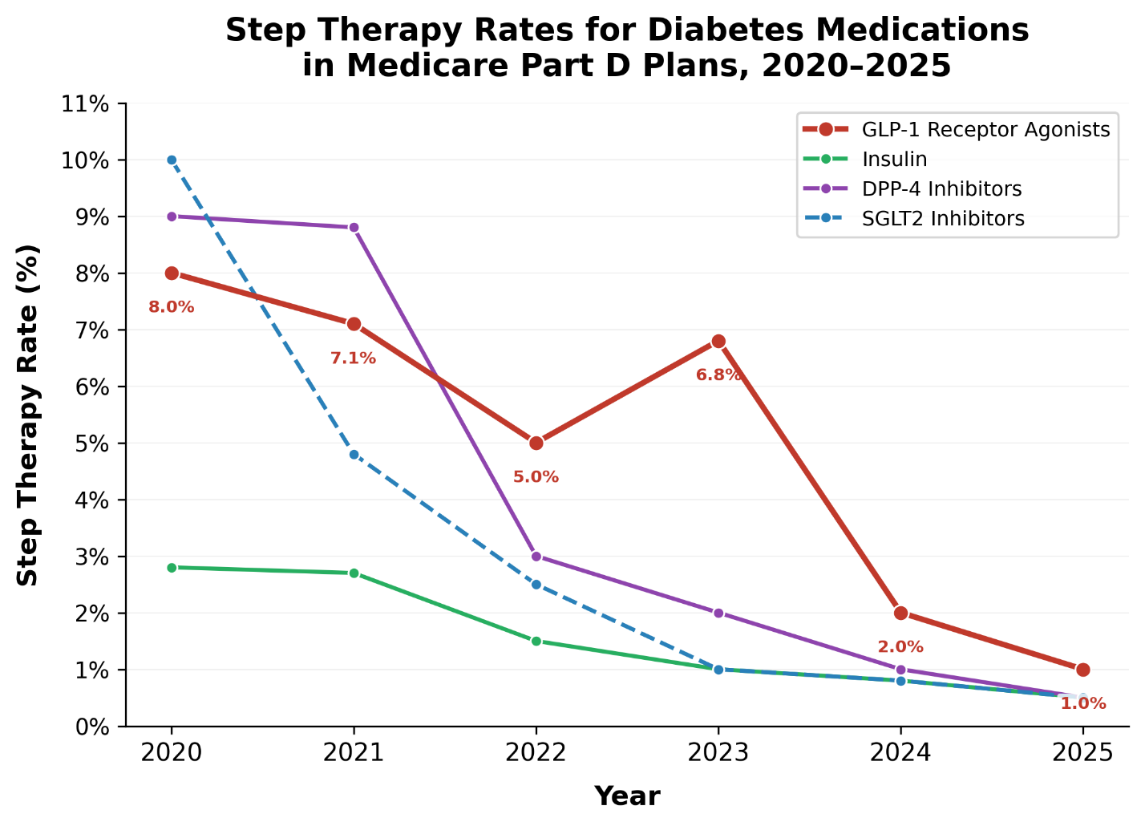Quantity limit rates were consistently high for GLP-1 receptor agonists, DPP-4 inhibitors, and SGLT2 inhibitors throughout the study period, ranging from approximately 90% to 99% for these three classes (Figure 3). Insulin was a notable exception, with quantity limit rates substantially lower at 10% to 15%.

Figure 3. Quantity Limit Rates for Diabetes Medications in Medicare Part D Plans, 2020–2025
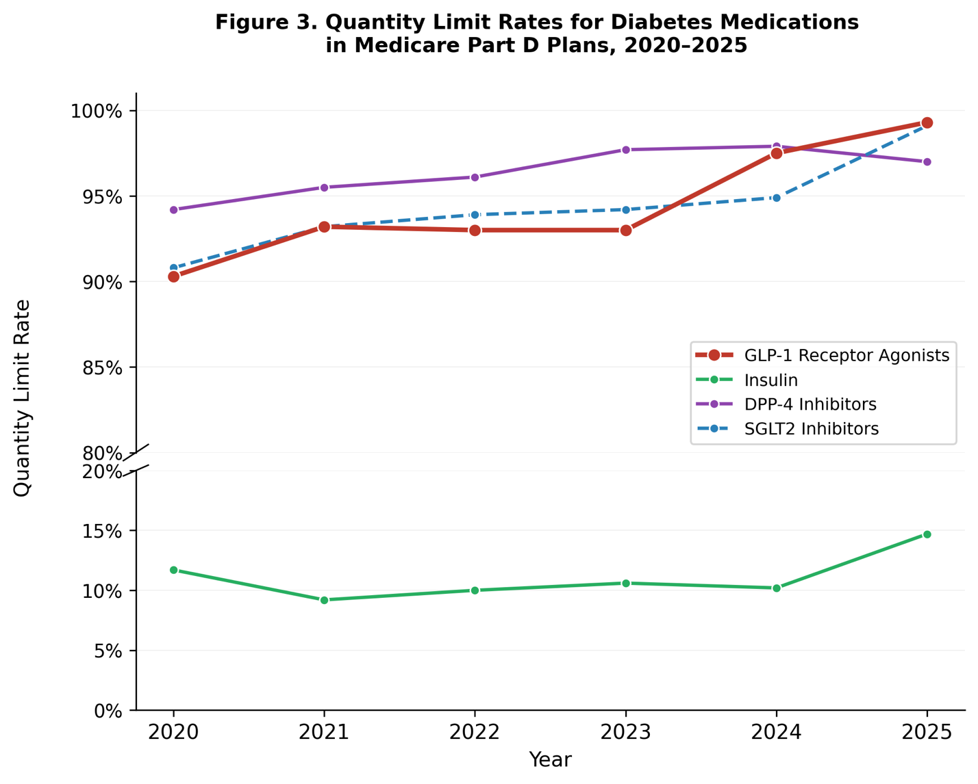Overall Formulary Restrictiveness
The composite restrictiveness score—which sums prior authorization, step therapy, quantity limits, and non-preferred tier placement into a single 0–4 scale where higher scores indicate more restrictions applied—captured the divergence between drug classes over time (Figure 4). GLP-1 receptor agonist restrictiveness rose from a mean score of 1.08 in 2020 to 2.03 in 2025, meaning the average plan applied approximately two of the four possible restriction types to GLP-1 medications by 2025. Notably, even at this peak, the GLP-1 score reached only halfway to the theoretical maximum of 4.0, indicating that plans were selectively applying certain restriction types (primarily prior authorization and quantity limits) rather than using every available tool. Insulin remained the least restricted class, with scores declining slightly from 0.27 to 0.21. DPP-4 inhibitor restrictiveness decreased modestly from 1.20 to 0.99, and SGLT2 inhibitor scores remained essentially unchanged at 1.15 to 1.13.
Figure 4. Average Restrictiveness Score for Diabetes Medications in Medicare Part D Plans, 2020–2025
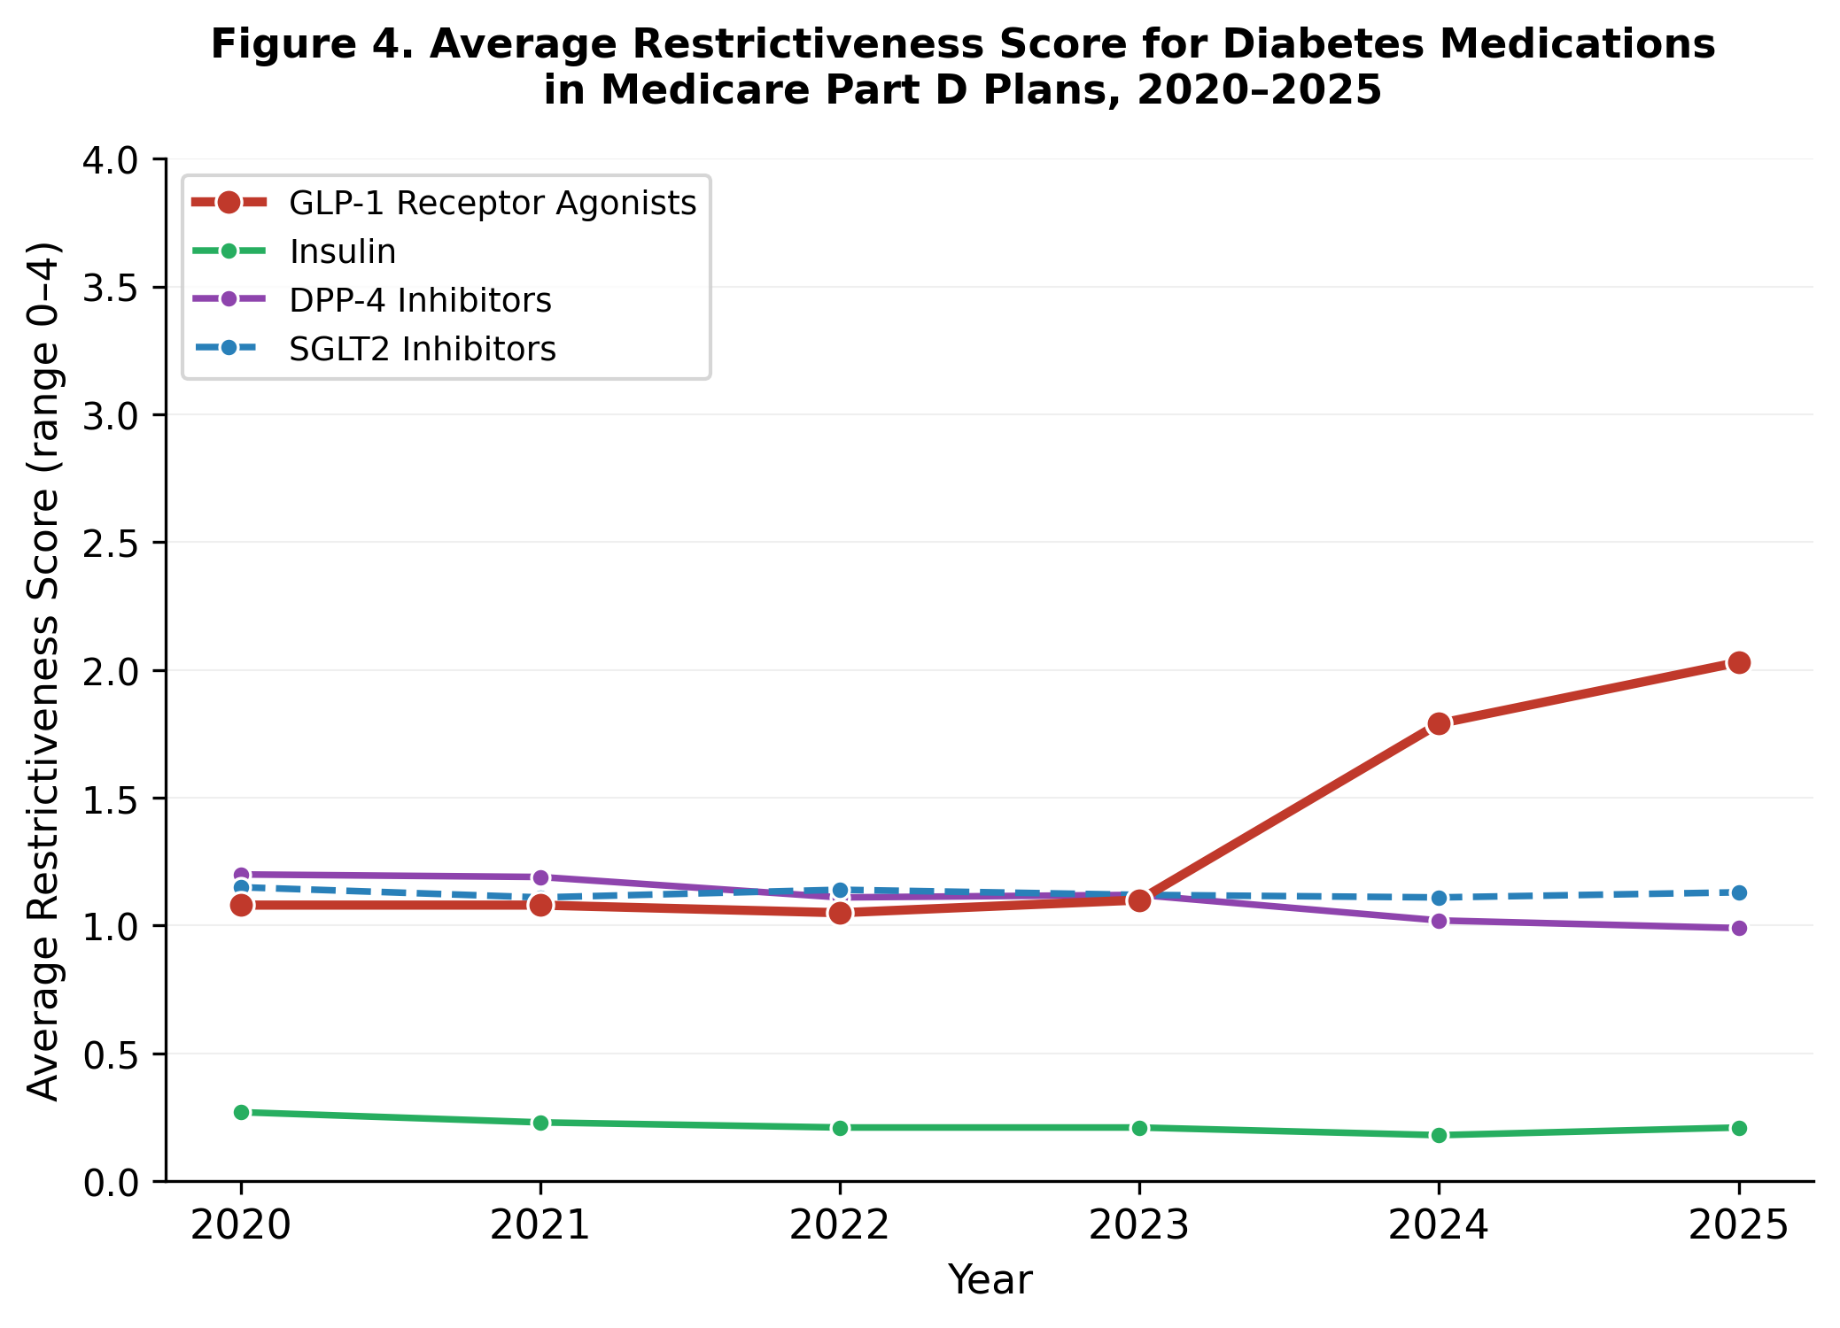
Geographic Variation
We observed substantial geographic variation in GLP-1 prior authorization rates across states, particularly in 2024 — the year of greatest between-state heterogeneity before convergence to near-universal requirements in 2025 (Figure 5, Table 3). State-level enrollment-weighted GLP-1 prior authorization rates in 2024 ranged from approximately 58% in Montana to 98% in Massachusetts. By 2025, this variation collapsed, with nearly all states reaching 100% GLP-1 prior authorization coverage. Figure 5 and Table 3 illustrate this convergence: in 2020, the median state-level GLP-1 prior authorization rate was 0.0%, though notable outliers existed — North Dakota (84.8%) and South Dakota (68.7%) had substantially higher rates, reflecting early adoption by plans operating in those markets. By 2023, the median rose modestly to 3.4% but the distribution widened, with a range of 0% to 49.2%. By 2024 the distribution shifted dramatically upward, and by 2025 all states compressed into a tight band near 100%.
Figure 5. Distribution of State-Level GLP-1 Prior Authorization Rates in Medicare Part D Plans, 2020–2025
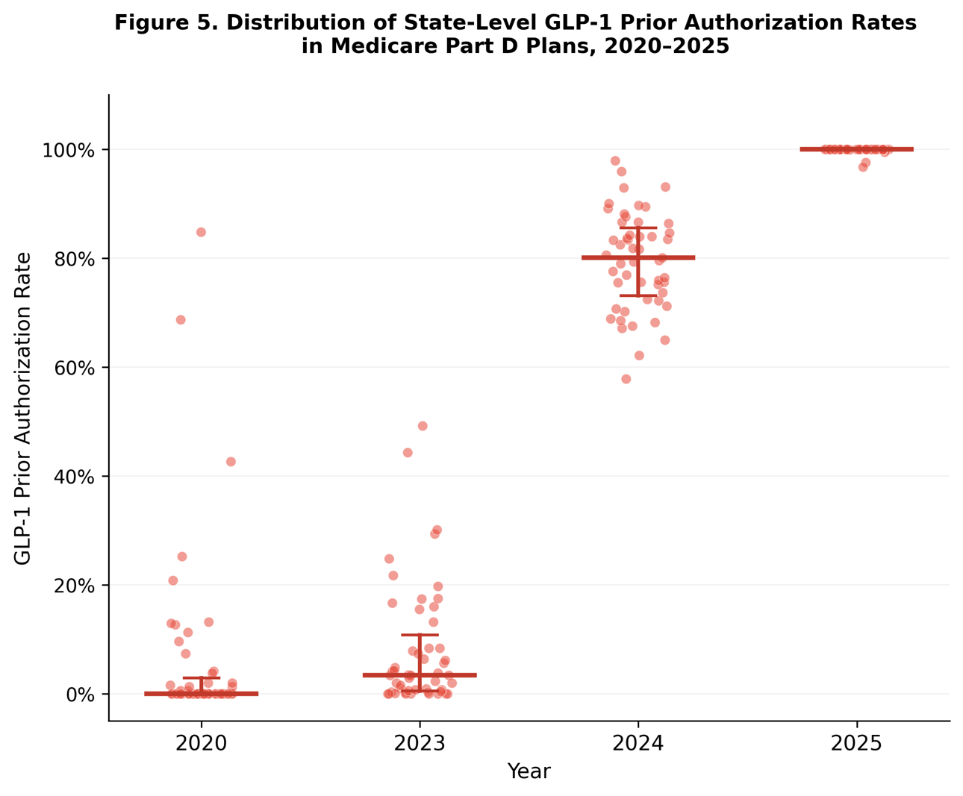
Table 3. Summary Statistics for State-Level GLP-1 Receptor Agonist Prior Authorization Rates in Medicare Part D Plans, 2020-2025
Year | Median | Minimum | Maximum | IQR (Q1–Q3)
2020 | 0.0% | 0.0% | 84.8% | 0.0%–2.9%
2023 | 3.4% | 0.0% | 49.2% | 0.5%–10.8%
2024 | 80.1% | 57.8% | 97.9% | 73.0%–85.5%
2025 | 100.0% | 96.7% | 100.0% | 100.0%–100.0%
Each row represents the distribution of enrollment-weighted state-level GLP-1 prior authorization rates across 50 states, the District of Columbia, and Puerto Rico (n=52). IQR = interquartile range (25th to 75th percentile).
County-level choropleth mapping revealed within-state heterogeneity that state-level averages obscure (Figures 6 and 7). The GLP-1 prior authorization map for 2024 shows counties ranging from less than 20% to above 80% within the same state, reflecting variation in the mix of Part D plans available to beneficiaries in different counties. The average formulary restrictiveness score map reveals a distinct regional pattern, with clusters of higher overall restrictiveness in the Southeast and Great Lakes regions. This regional pattern was not fully explained by the GLP-1 prior authorization pattern alone, as it was also visible in 2020 before the GLP-1 PA surge, suggesting that plans in these regions apply more restrictive formulary strategies across multiple drug classes. We did not map step therapy or quantity limits geographically because these tools showed less between-county variation: step therapy rates were uniformly low by 2024–2025, and quantity limits were uniformly high for non-insulin classes throughout the study period.

Figure 6. County-Level GLP-1 Prior Authorization Rates, 2024
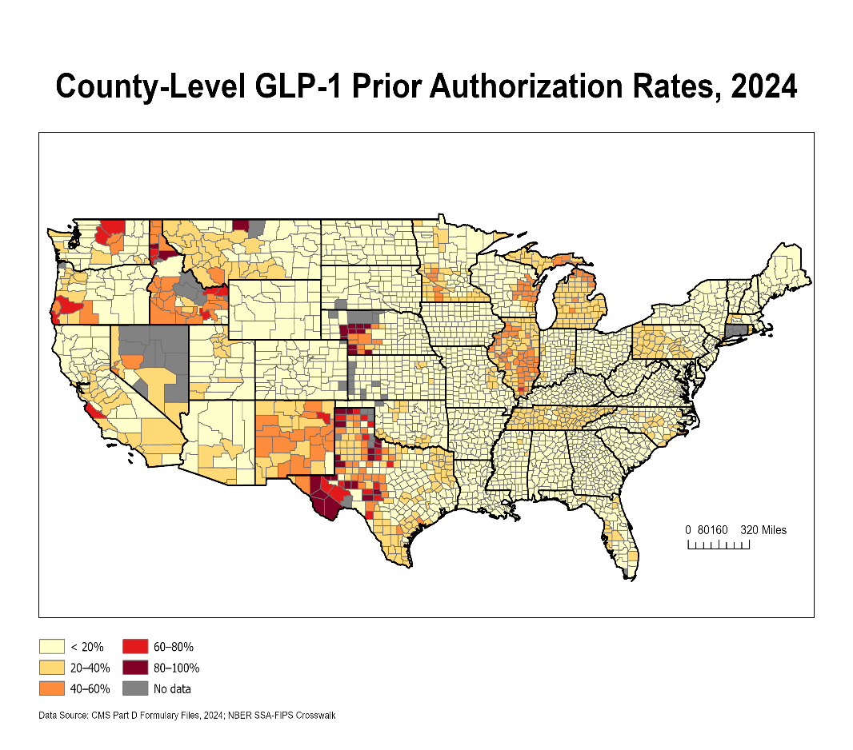
Figure 7. County-Level Average Formulary Restrictiveness Scores, 2024
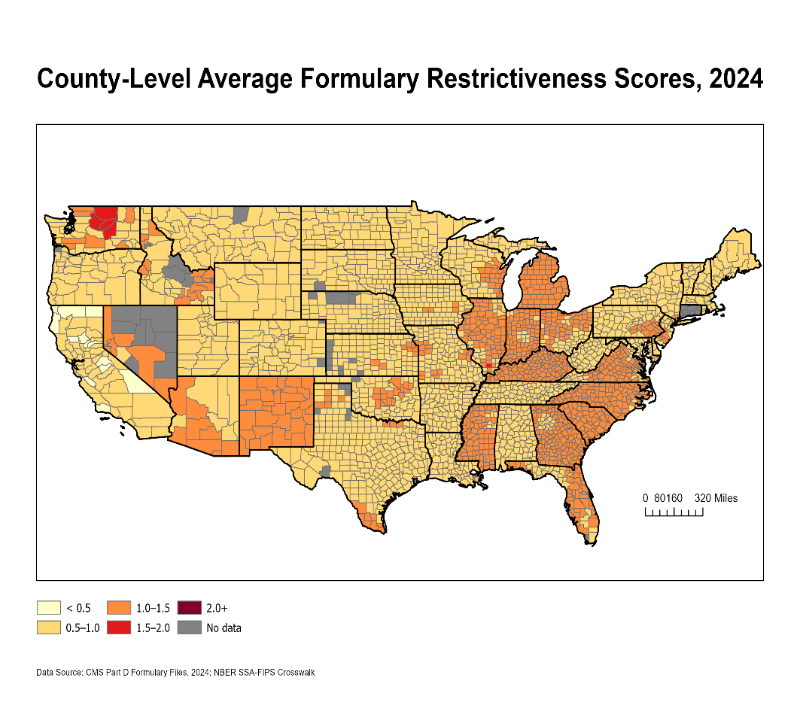
Discussion
This study documented a targeted and nearly universal increase in GLP-1 receptor agonist prior authorization requirements in Medicare Part D formularies between 2020 and 2025, while restrictions on insulin, SGLT2 inhibitors, and DPP-4 inhibitors remained essentially unchanged. The enrollment-weighted GLP-1 prior authorization rate rose from 7.0% to 100.0% over this period, with the sharpest acceleration occurring between 2023 and 2024. Geographic analysis revealed substantial county-level variation during the transition period, with a distinct regional pattern of higher overall formulary restrictiveness in the Southeast.
The timing of the GLP-1 prior authorization surge is consistent with plan responses to the IRA’s benefit redesign, which increased plan liability in the catastrophic coverage phase from 15% to 60% for brand-name drugs effective January 2025.⁶ GLP-1 receptor agonists, with monthly costs often exceeding $1,000, frequently push beneficiaries into the catastrophic phase—making these medications a primary target for plan cost containment efforts.³ That plans selectively increased restrictions on GLP-1s while leaving less expensive drug classes largely untouched suggests a financially motivated response to the new liability structure rather than a broad shift in formulary management philosophy.
These findings are consistent with recent research documenting the GLP-1 prior authorization surge. Klebanoff et al. reported that the share of Part D plans requiring prior authorization for GLP-1s increased from approximately 5% to nearly 100% between 2020 and 2025.³ Our study extends this work by documenting county-level geographic variation that national plan-level analyses do not capture and by comparing four diabetes drug classes simultaneously to demonstrate that the restriction increase was isolated to GLP-1s. Liu et al. found similar trends specifically for semaglutide and tirzepatide at the plan level,⁴ whereas our enrollment-weighted county-level approach reveals the formulary environment experienced by actual beneficiaries in specific locations. The stability of insulin restrictions aligns with Buttorff et al.’s finding that the IRA’s $35 copay cap shaped insulin formulary strategies⁹; the consistently lower quantity limit rates for insulin compared with the other three classes may also reflect distinct dispensing patterns for injectable products. The modest decline in DPP-4 restrictiveness may reflect these older medications facing less cost-driven scrutiny as GLP-1s absorbed plan attention.
The geographic variation observed in this study warrants particular attention. The adoption of GLP-1 prior authorization across states was not uniform—New England states implemented restrictions earlier, while Mountain West and Southeast states adopted them later. The East North Central region and Arizona also showed adoption patterns that diverged from the national trend. These state-level differences suggest that plan responses to anticipated IRA changes varied by region, potentially reflecting differences in plan market structure, Medicare Advantage penetration, or pharmacy benefit manager contracting practices. These findings underscore the value of county-level analysis: beneficiaries’ experiences with formulary barriers depend not just on national policy but on which plans are available in their specific county.
The geographic concentration of higher formulary restrictiveness in the Southeast is particularly concerning when considered alongside the region’s demographic and health profile. The Southeast consistently ranks among the highest in diabetes prevalence, social vulnerability, and racial and ethnic minority Medicare enrollment—the same populations for whom prior research has documented lower rates of GLP-1 and SGLT2 inhibitor initiation even after adjusting for clinical characteristics.¹ If areas with the highest formulary restrictiveness also have the greatest disease burden and the most socially vulnerable populations, formulary policy may function as a structural contributor to existing disparities rather than a neutral administrative process. A planned extension of this analysis will explore this question through geographic overlay of county-level restrictiveness scores with indicators of social vulnerability, diabetes prevalence, and racial composition to assess whether high-restrictiveness counties are disproportionately concentrated in disadvantaged communities.
These results have implications for Medicare formulary oversight and ongoing policy development. The near-universal adoption of GLP-1 prior authorization raises questions about whether these requirements function as appropriate clinical gatekeeping or as de facto access barriers for a medication class with demonstrated cardiovascular and renal benefits.⁷ Policymakers may consider whether GLP-1 access protections—such as prior authorization standards that mandate expedited review for diabetes-indicated prescriptions, or copay protections analogous to the IRA’s insulin cap—are warranted. Additionally, the methodology demonstrated here, using entirely free, publicly available CMS data, offers a reproducible framework for ongoing formulary surveillance that researchers, advocacy organizations, and regulatory agencies can adopt to monitor access trends over time.
The near-universal adoption of prior authorization for GLP-1 receptor agonists likely reflects plans’ responses to multiple concurrent pressures beyond the IRA benefit redesign alone, including supply constraints and broader cost concerns driven partly by surging demand for GLP-1 medications for off-label weight management outside the Medicare population. Notably, Medicare Part D covers GLP-1s exclusively for type 2 diabetes management; the weight loss formulations (semaglutide as Wegovy and tirzepatide as Zepbound) are distinct products not covered under Part D. Yet Medicare beneficiaries with diabetes bear the formulary consequences of demand pressures originating largely in younger, commercially insured, or cash-pay populations seeking these medications exclusively for weight management purposes. The result is that beneficiaries with the strongest clinical indication for GLP-1 therapy—those with type 2 diabetes and established cardiovascular or renal risk—now face universal administrative barriers that were potentially implemented, at least in part, in response to utilization trends outside their population.
Limitations
Several limitations should be acknowledged. First, formulary files capture plan policies as designed but cannot assess actual beneficiary experiences with prior authorization approvals, denials, or appeals; plans may require prior authorization but approve most requests or may have stringent criteria resulting in frequent denials. Second, our descriptive design documents associations between policy periods and formulary changes but cannot establish causation. Third, county-level aggregation may mask within-county variation in plan availability and beneficiary experiences. Fourth, enrollment weighting assumes beneficiaries select plans independent of formulary restrictiveness for specific medications, which may not hold for beneficiaries with established diabetes medication regimens who actively consider formulary coverage when choosing plans. Fifth, the crosswalk used to convert CMS county codes to standard Census geographic identifiers (FIPS codes) resulted in incomplete geographic matching for Alaska (excluded from all analyses), and Massachusetts, Nevada, and the District of Columbia had incomplete data for some years due to similar crosswalk limitations; geographic visualizations display only the continental United States. Sixth, the analysis cannot fully disentangle the role of off-label demand for GLP-1 medications for weight management, which contributed to supply constraints and heightened plan scrutiny of this drug class during the study period; the observed increase in prior authorization may reflect plans responding to both the IRA’s financial restructuring and broader market dynamics simultaneously. Despite these limitations, this analysis provides comprehensive characterization of geographic and temporal variation in diabetes medication formulary restrictiveness during a critical policy transition period, establishing baseline measures for ongoing monitoring and future research.
Conclusion
Between 2020 and 2025, the share of enrollment-weighted Medicare Part D plans requiring prior authorization for GLP-1 receptor agonists rose from 7.0% to 100.0%, while prior authorization rates for insulin, SGLT2 inhibitors, and DPP-4 inhibitors remained largely unchanged. This targeted increase, concentrated in the period surrounding the Inflation Reduction Act’s benefit redesign, was accompanied by notable geographic variation at the county level during the transition period. Given that GLP-1 receptor agonists have demonstrated cardiovascular and renal benefits for the more than 14 million Medicare beneficiaries with diabetes, continued monitoring of formulary access barriers—and consideration of targeted policy interventions such as prior authorization standards that mandate expedited review for diabetes-indicated prescriptions, or copay protections analogous to the IRA’s insulin cap—remains an important priority for ensuring that formulary cost containment does not compromise access to clinically essential therapies.

References
- Chen WH, Li Y, Yang L, Allen JM, Shao H, Donahoo WT, Billelo L, Hu X, Shenkman EA, Bian J, Guo J. Geographic variation and racial disparities in adoption of newer glucose-lowering drugs with cardiovascular benefits among US Medicare beneficiaries with type 2 diabetes. PLOS ONE. 2024;19(1):e0297208.
- Joyce G, Blaylock B, Chen J, Van Nuys K. Medicare Part D plans greatly increased utilization restrictions on prescription drugs, 2011–20. Health Affairs. 2024;43(3):391-397.
- Klebanoff MJ, Adusumalli S, Yang L, Coyle C, Lo JY, Peña JM, Groeneveld PW, Shah AM, Diaz-Ramirez LG. Medicare Part D coverage and costs for glucagon-like peptide-1 receptor agonists. JAMA. 2025.
- Liu X, Lu CA, Shih YT, Jiang C. Coverage and prior authorization policies for semaglutide and tirzepatide in Medicare Part D plans, 2020-2024. JAMA Network Open. 2025;8(8):e2529842.
- Taylor EA, Khodyakov D, Buttorff C, Rao P, Predmore Z, Burgette LF, Dusetzina SB, Wilks A, Zhang S, Dalton S, Kim AY, Cooke CE, Martineau M. Part D Senior Savings Model Final Evaluation, 2021 to 2023. RAND Health Care; 2025.
- Cubanski J, Neuman T, Freed M. Explaining the Prescription Drug Provisions in the Inflation Reduction Act. KFF Issue Brief. Kaiser Family Foundation; 2023.
- Luo J, Gabriel N, Korytkowski M, Hernandez I, Gellad WF. Association of formulary restrictions and initiation of an SGLT2i or GLP1-RA among Medicare beneficiaries with type 2 diabetes. Diabetes Research and Clinical Practice. 2022;187:109855.
- Shen X, Stuart BC, Powers CA, Tom SE, Magder LS, Perfetto EM. Impact of formulary restrictions on medication use and costs among low-income subsidy recipients in Medicare Part D: oral hypoglycemic agents, statins, and renin-angiotensin system antagonists. American Journal of Managed Care. 2017;23(8):e265-e274.
- Buttorff C, James HO, Sorbero ME, Reid RO. Medicare Part D insulin coverage: formulary strategies amid policy headwinds. Health Affairs Scholar. 2025;3(4):qxaf042.

