**CREATE A GOOGLE**

**MY BUSINESS PROFILE**

**Our To Know US**

Our team is made up of 4

Creative, Passionate

Enthusiastic Members.

Arunkumar.S

Harini.G

Arulsaravanan.M

Balachandra.M

We are from

Annai College Of Engineering And Technology

Electronic and Communication Engineering

Kovilacherry In Kumbakonam.

***Title***

Create a

Google My Business Profile

***My Business Logo***



**How we create a Google my business profile.**

**1.Type** [**www.googlemybussiness.com**](http://www.googlemybussiness.com) **at chrome page.**

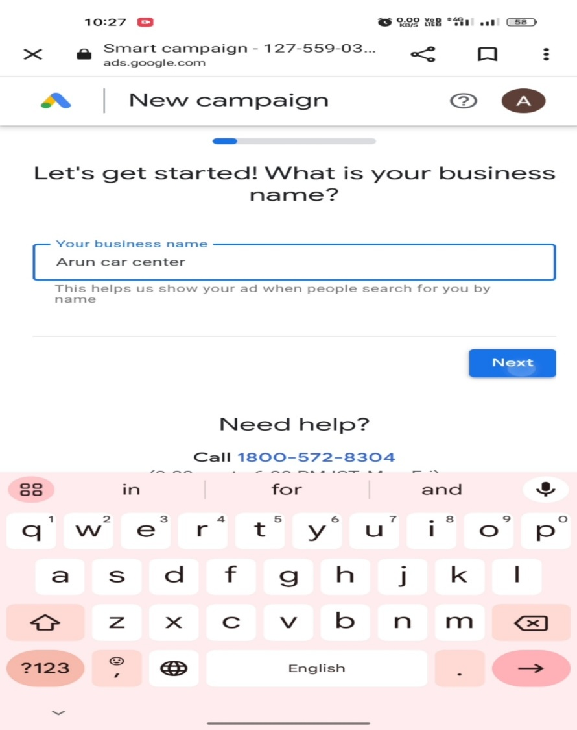**2.Type your business name.**

**3.Create your business website in ‘Wix.com’.**

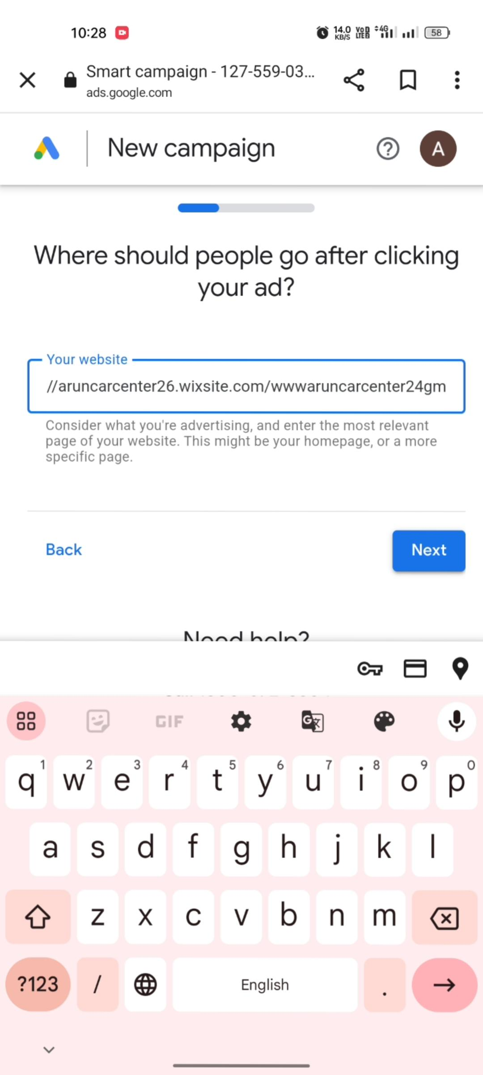

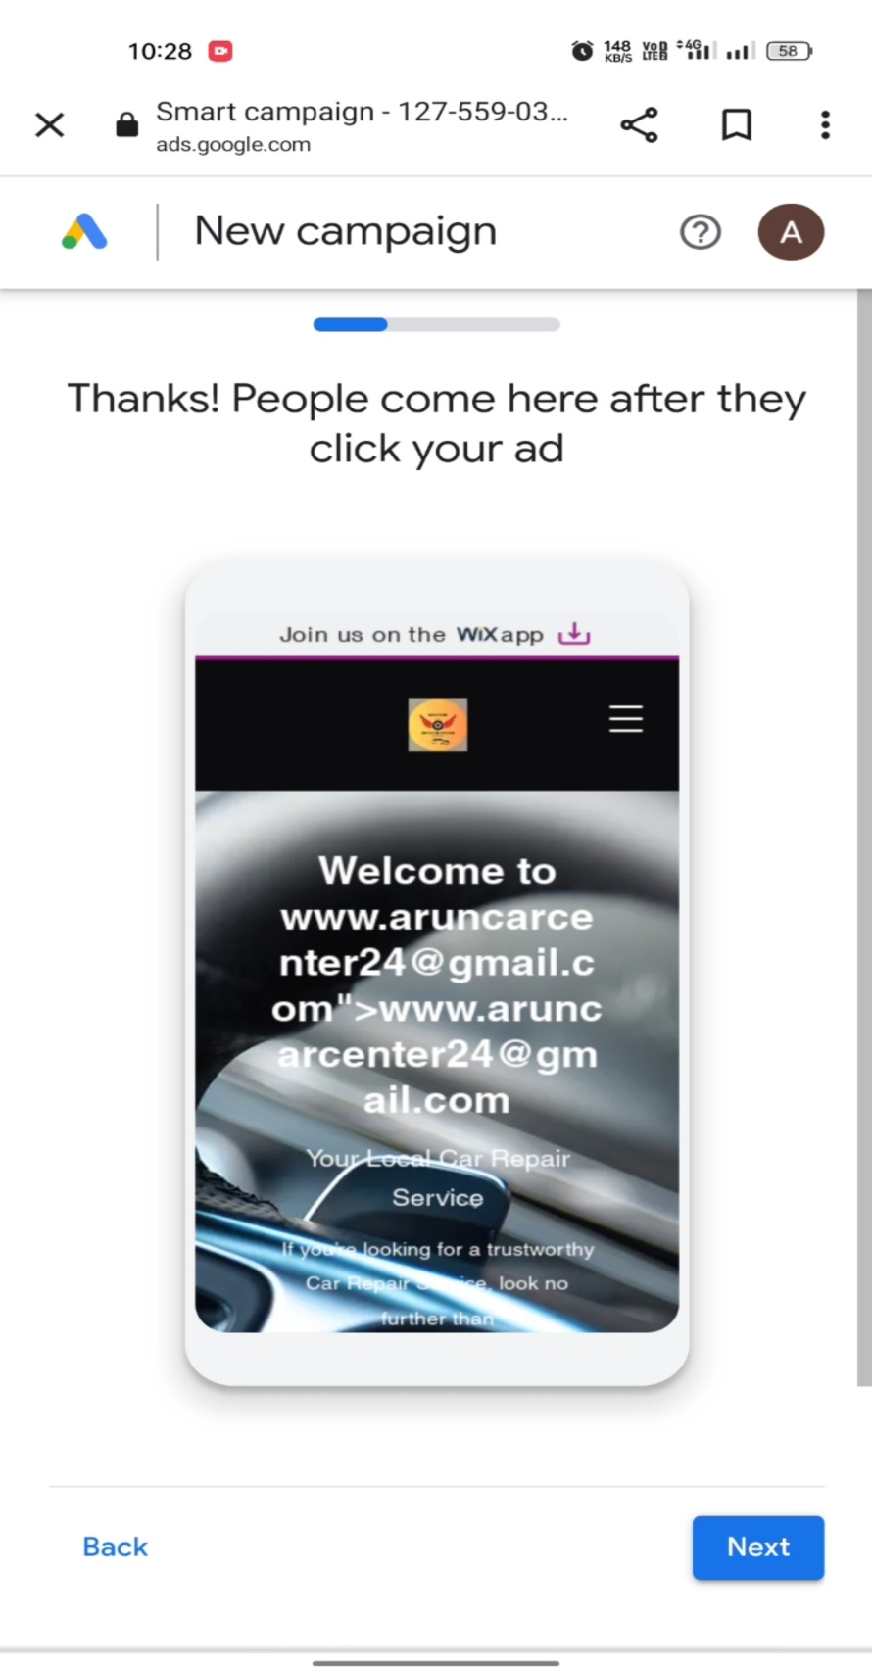**4.Check out your website.**

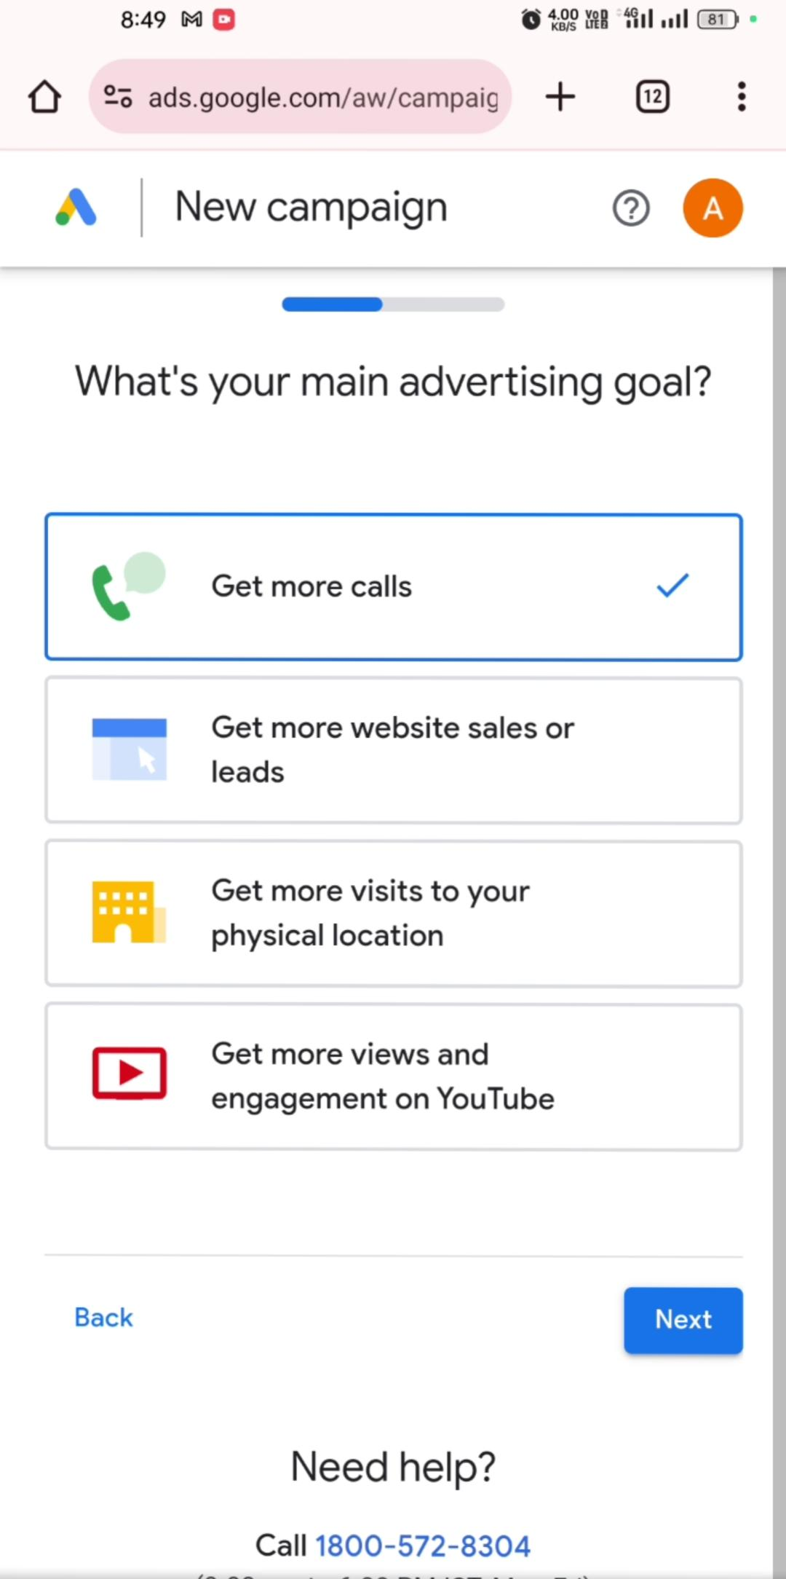**5.select your goals contact.**

**6.Type your business headlines.**

**7. Type your contact number.**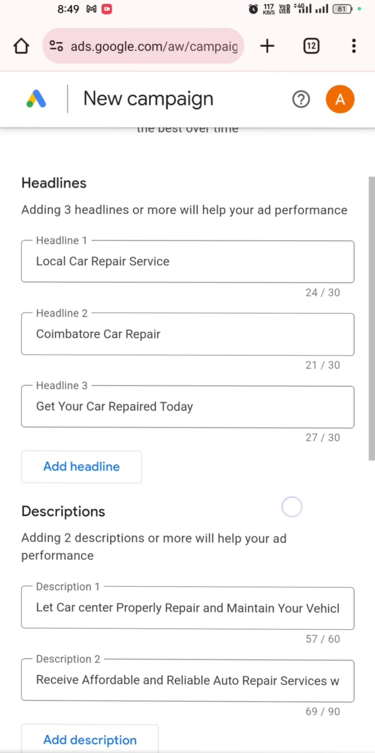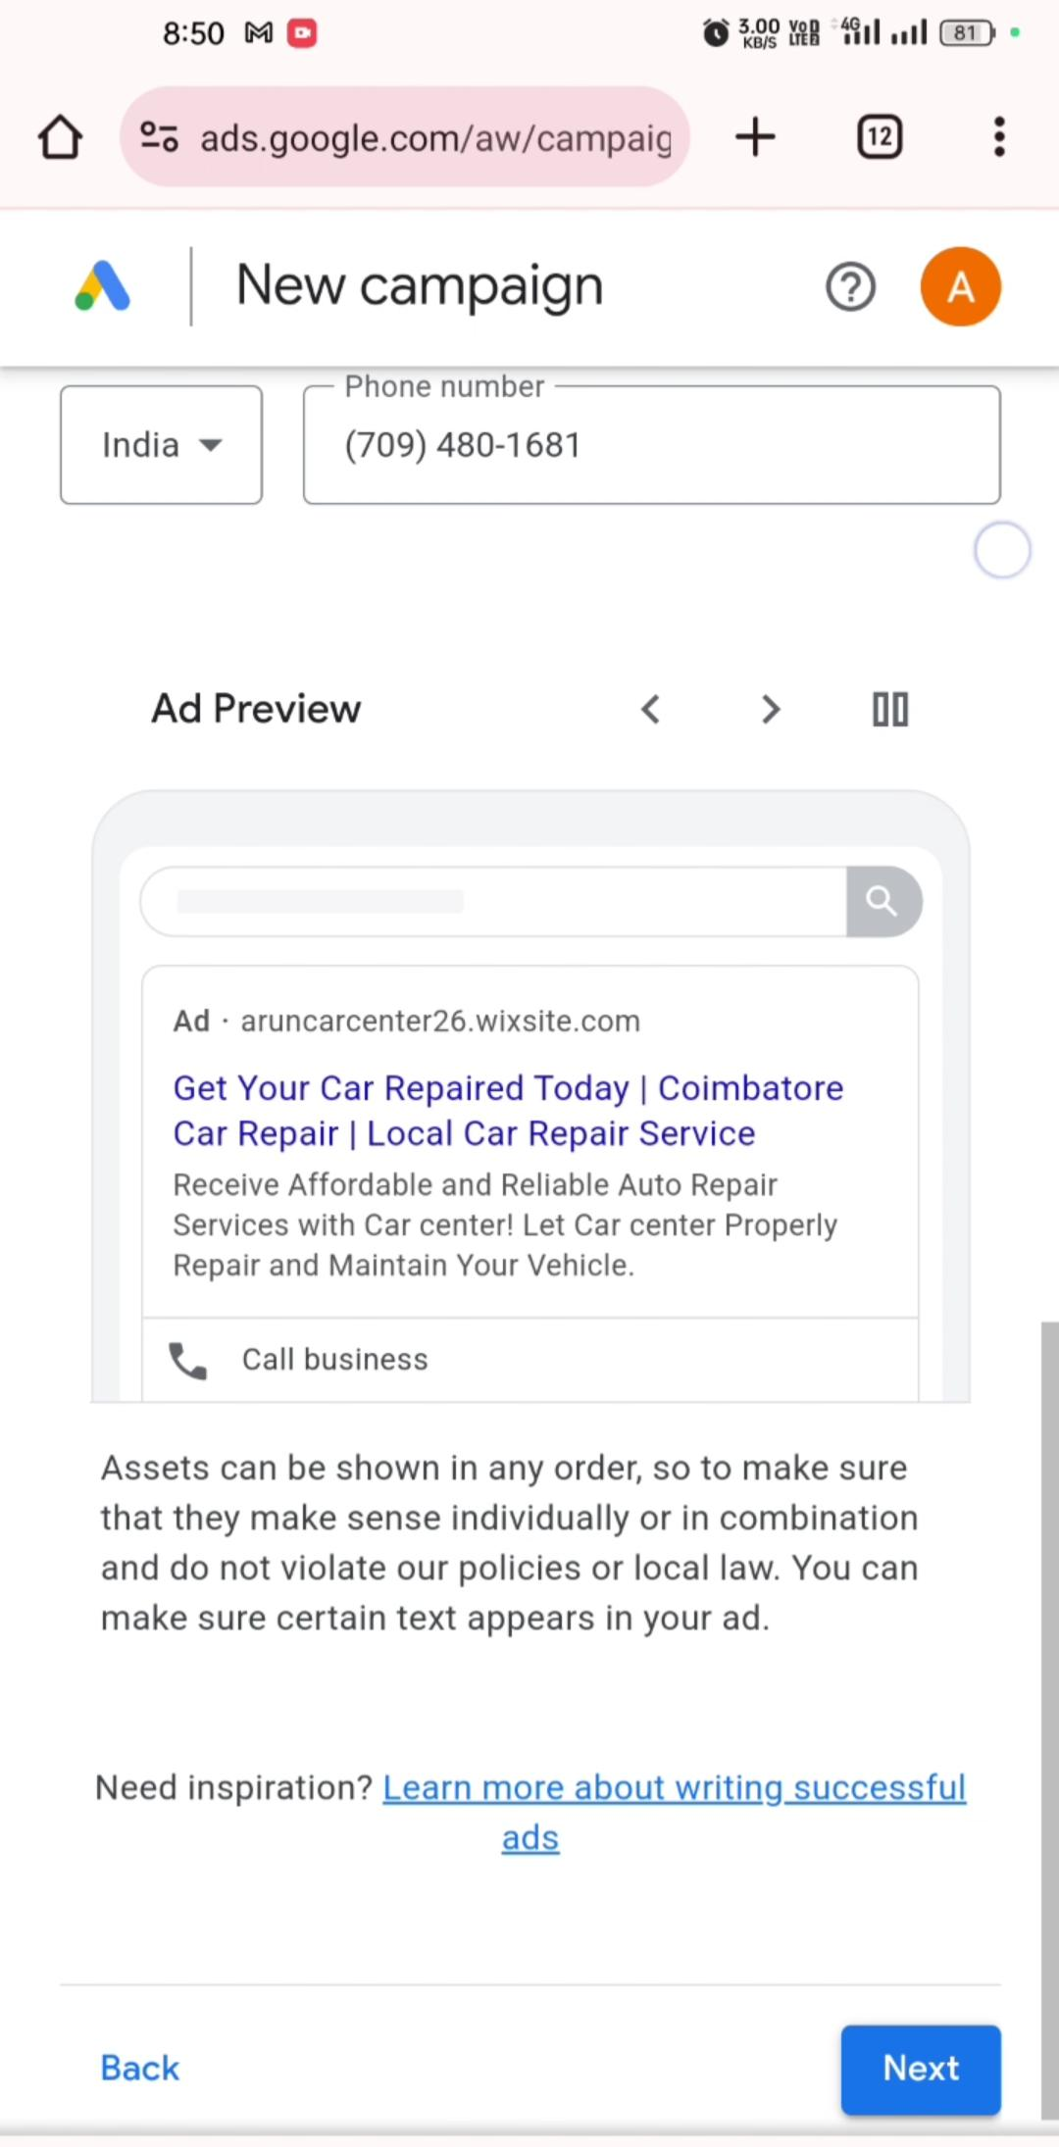

**8. Upload your business image &Logo.**

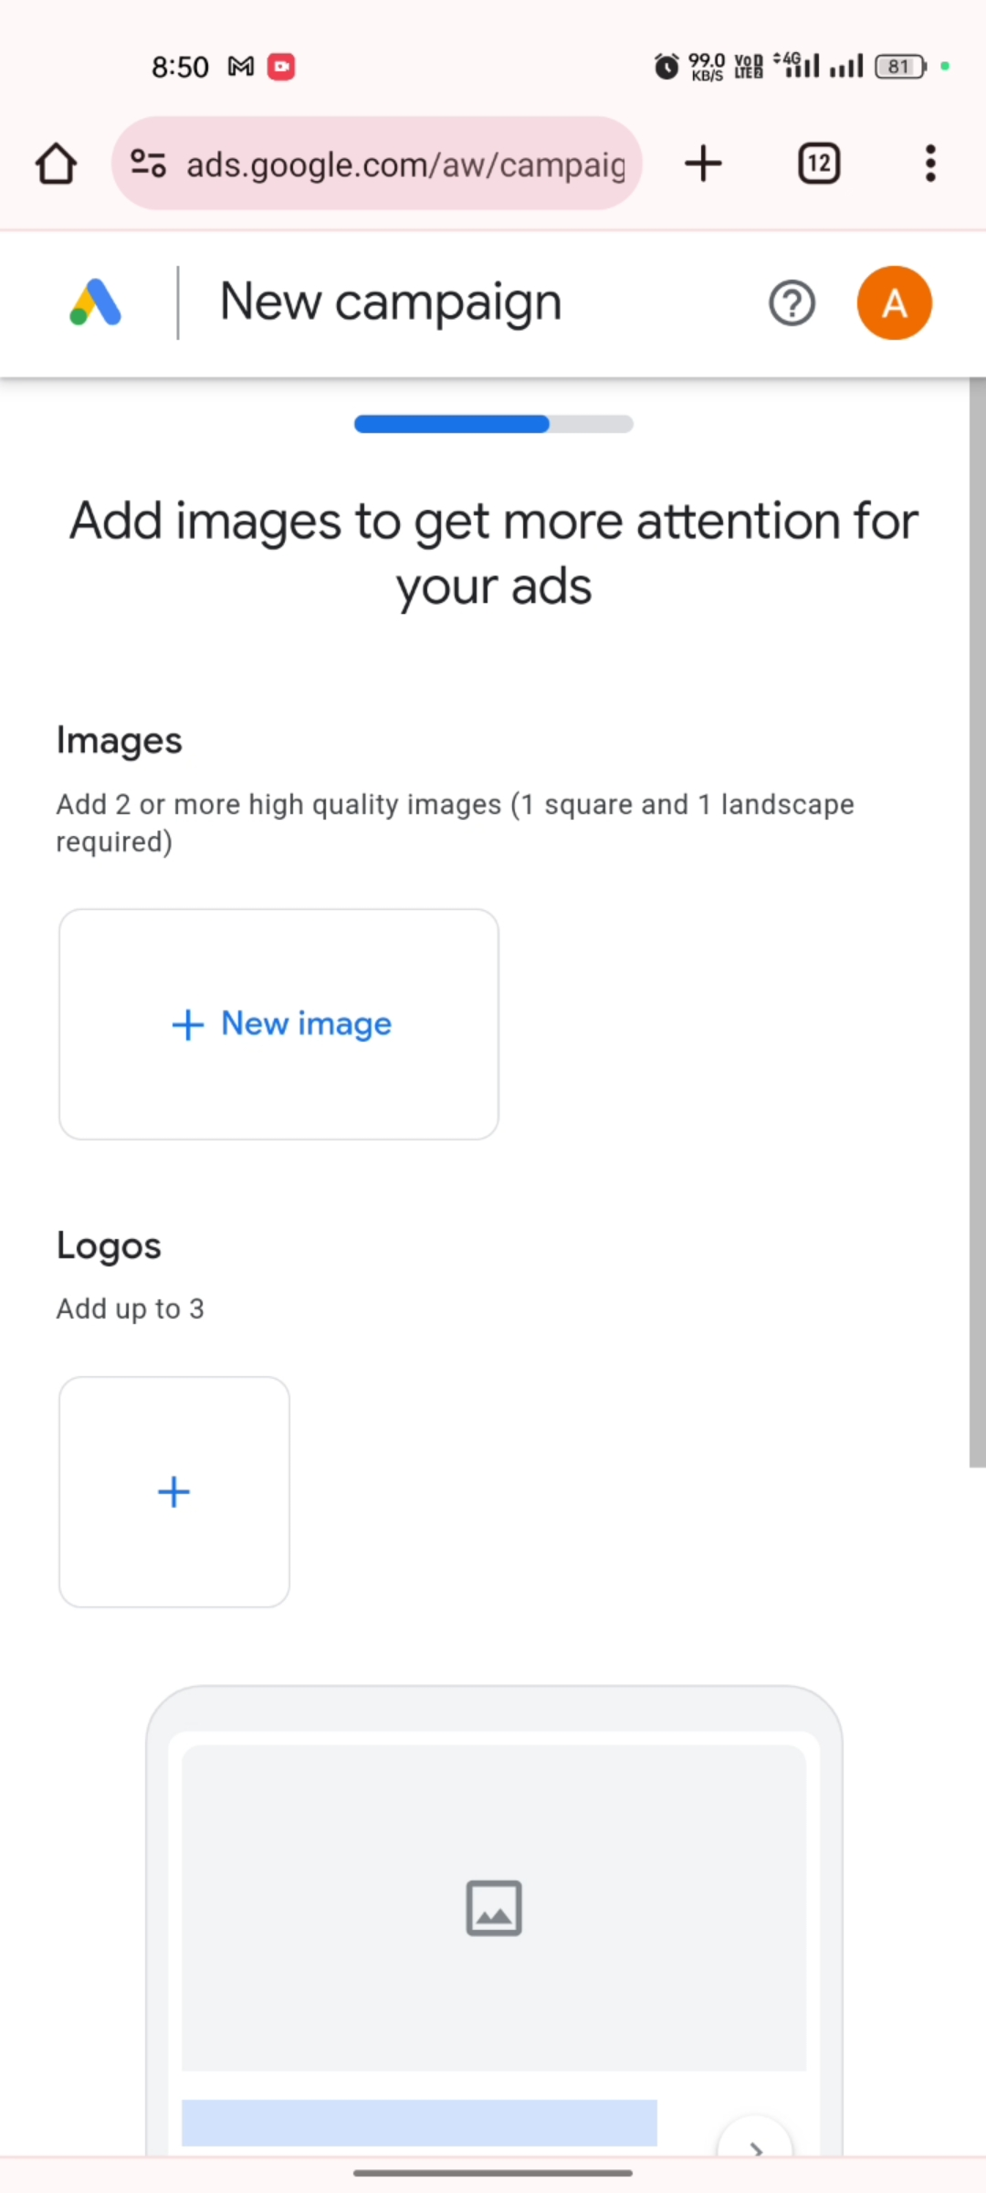

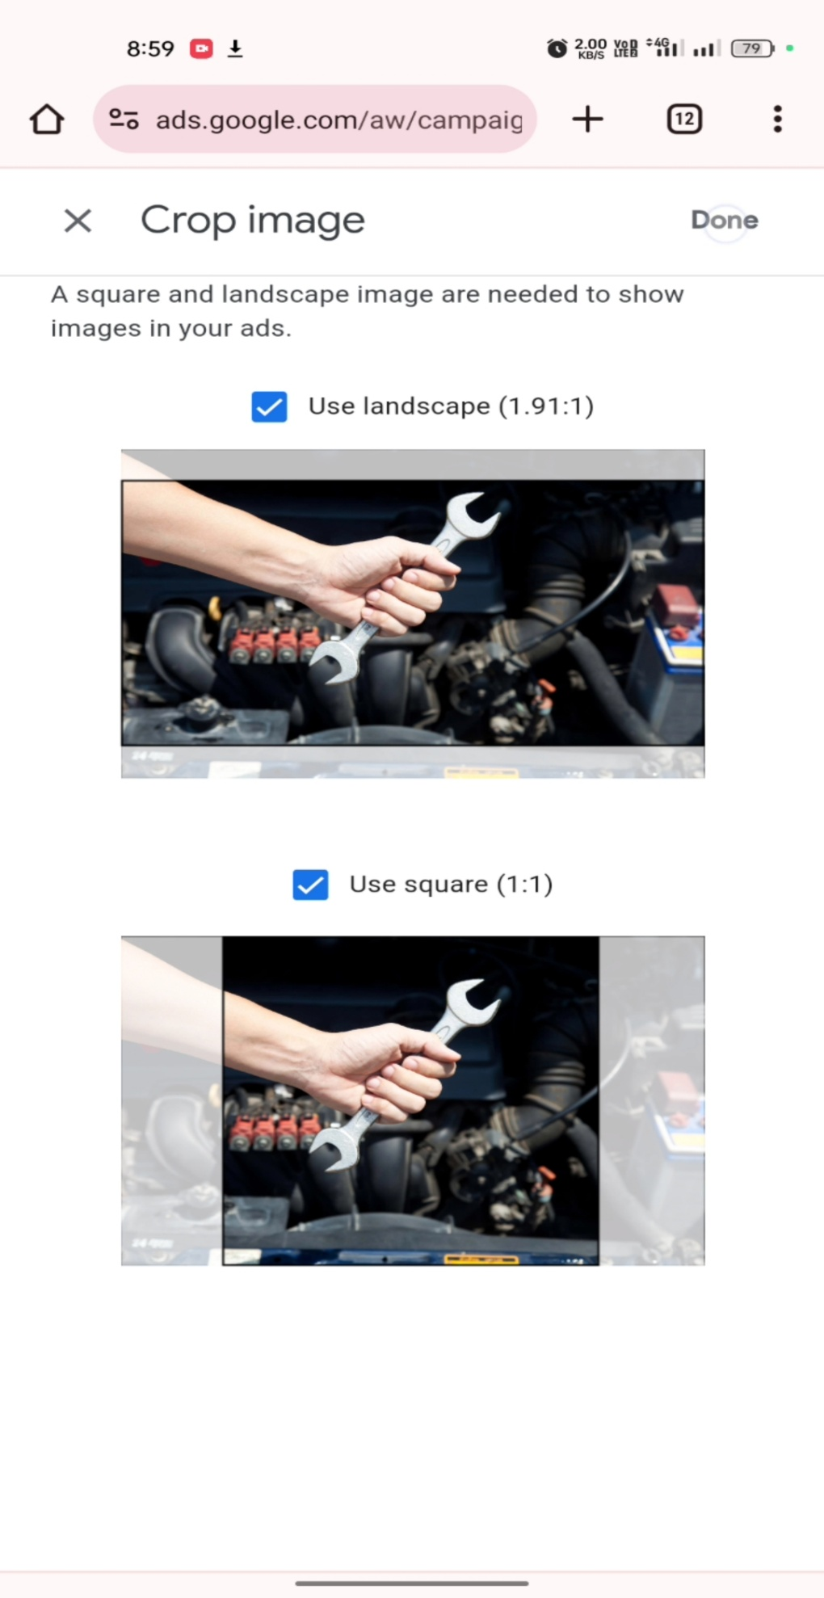

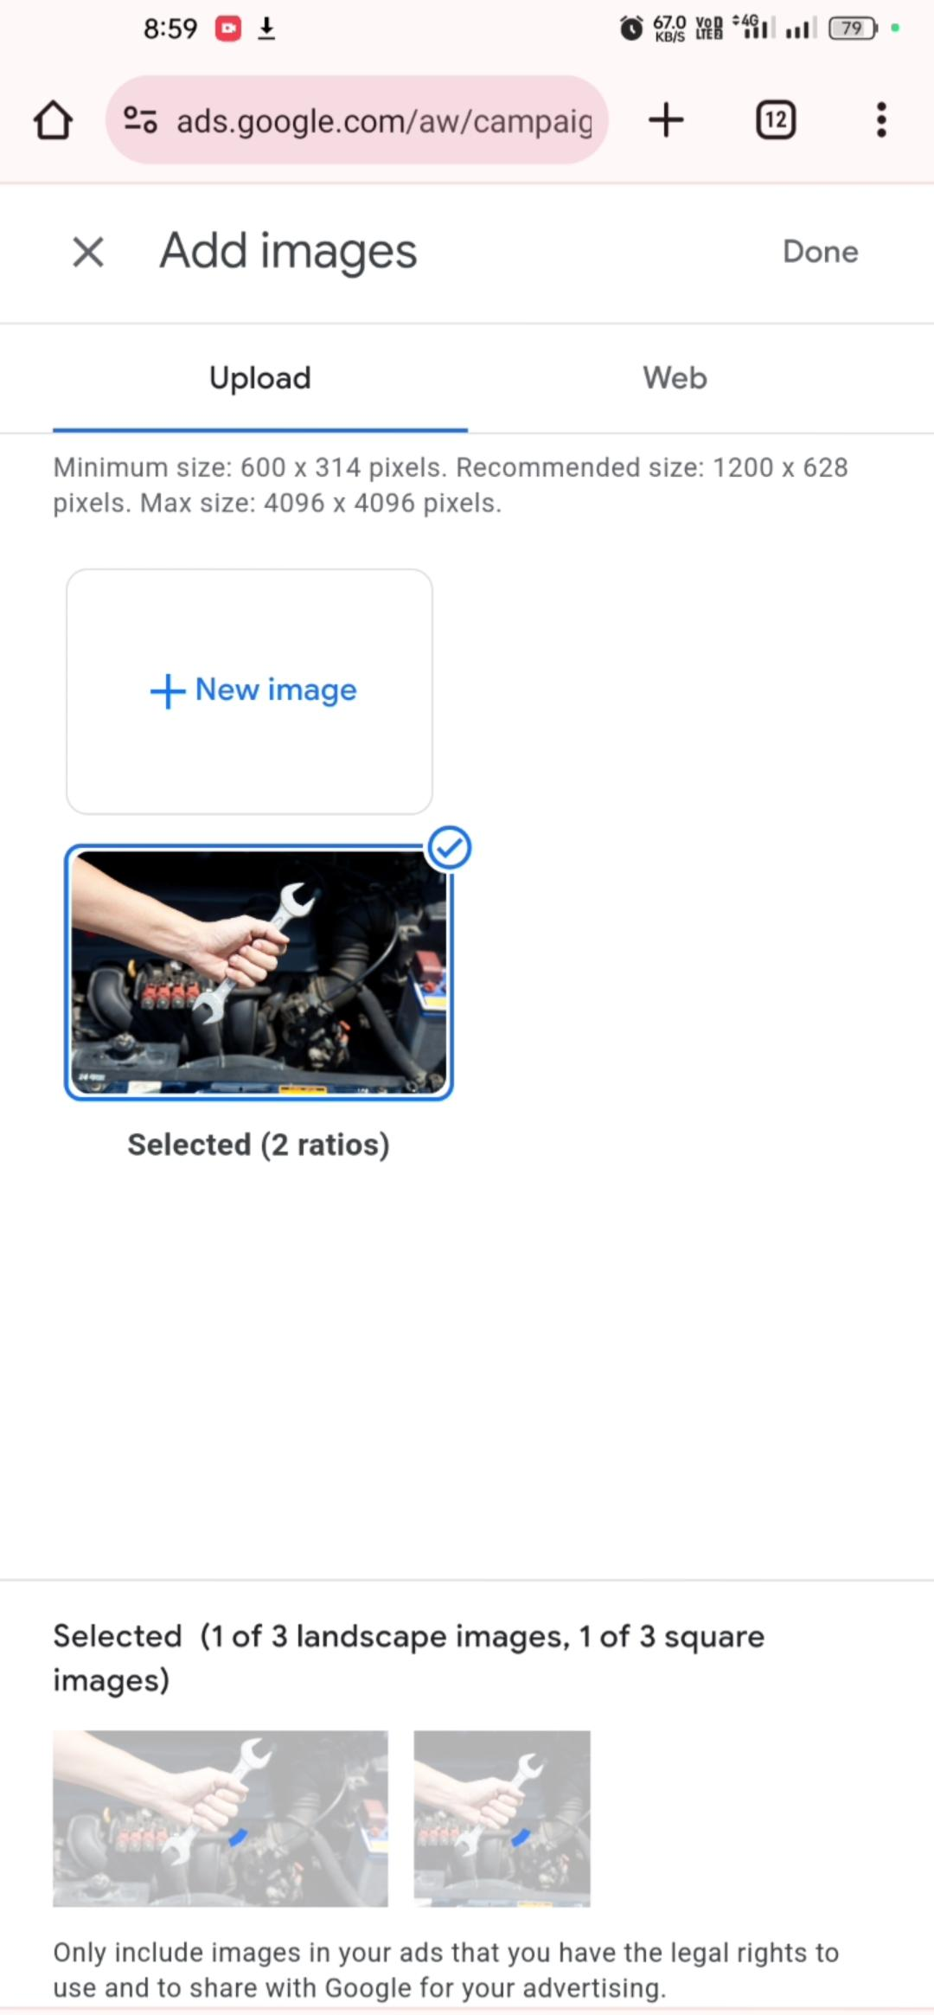

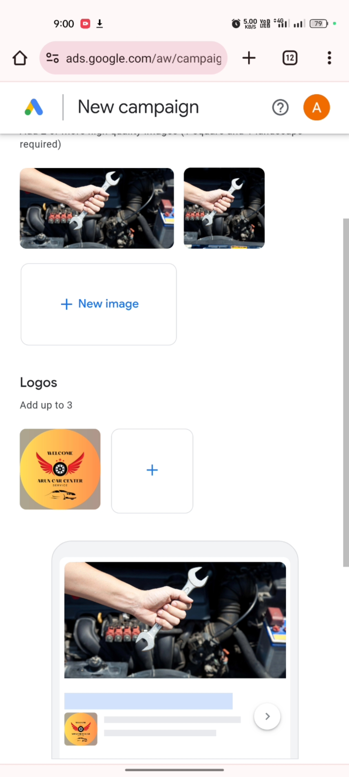

**8.Selective your business specifications.**

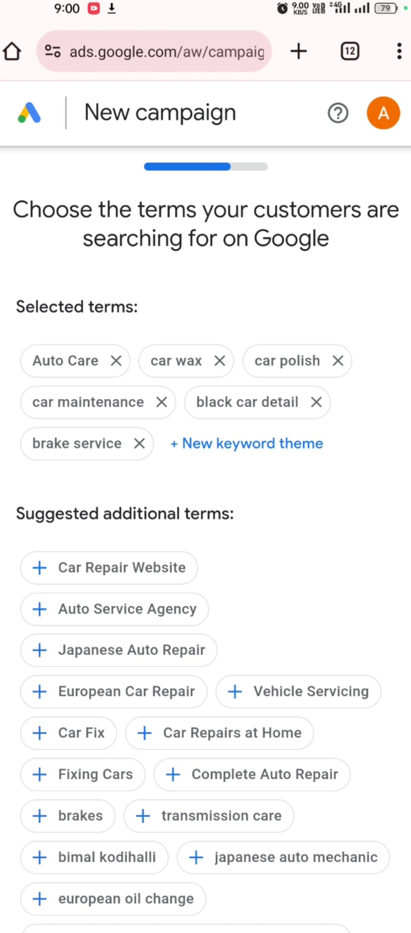

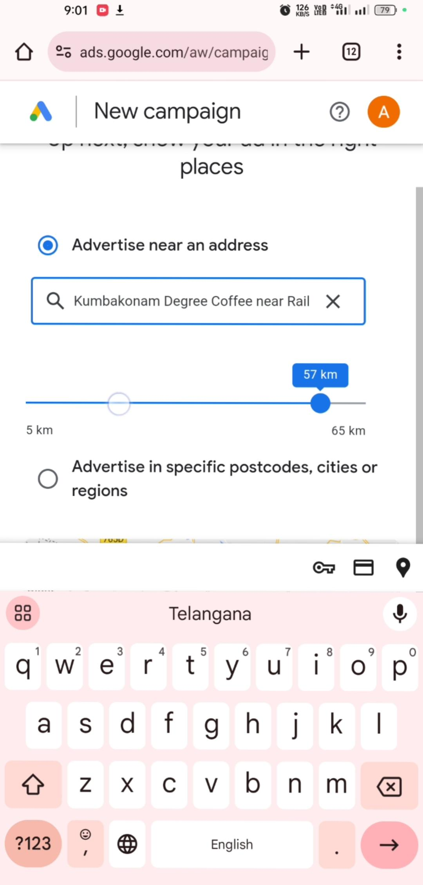**9.Set your current or permanent location.**

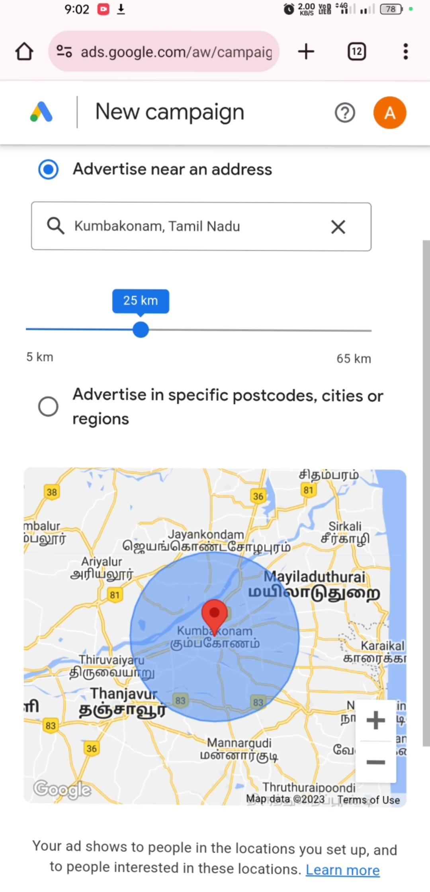

**10. Check your business details.**

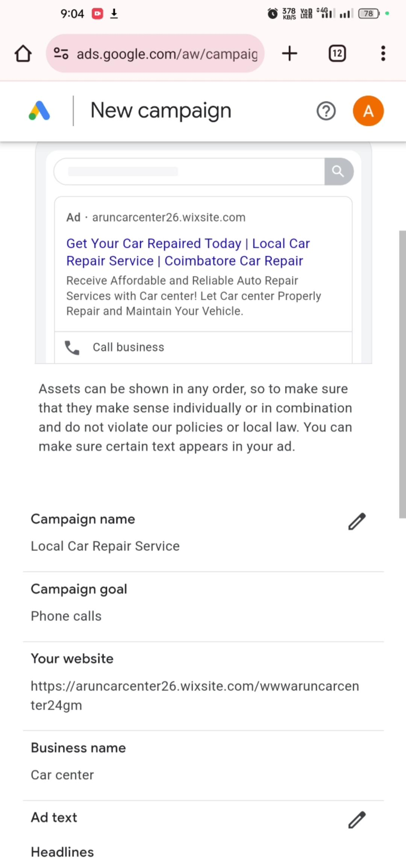

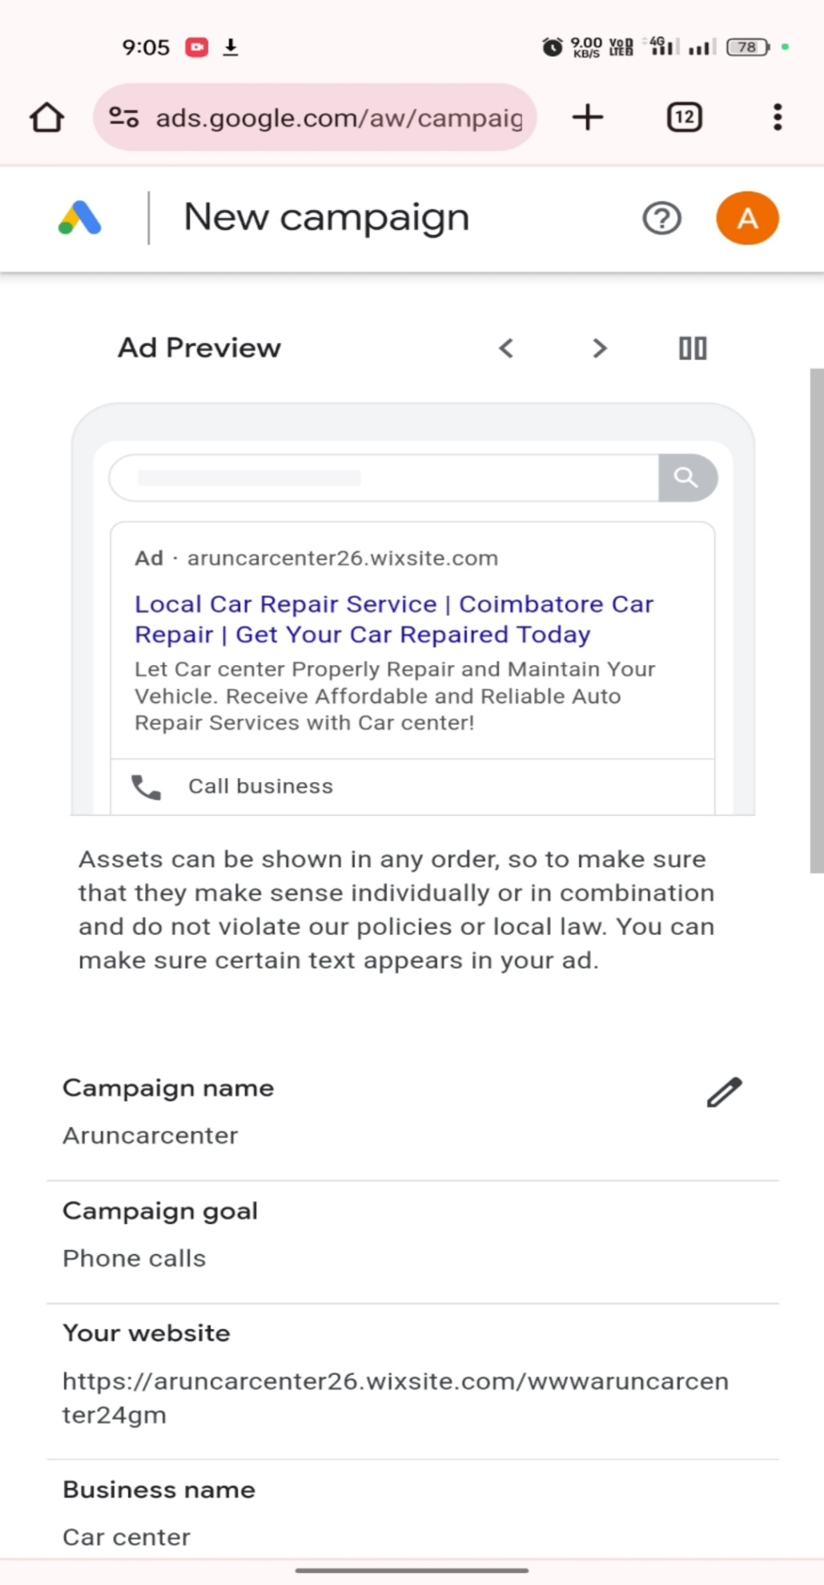

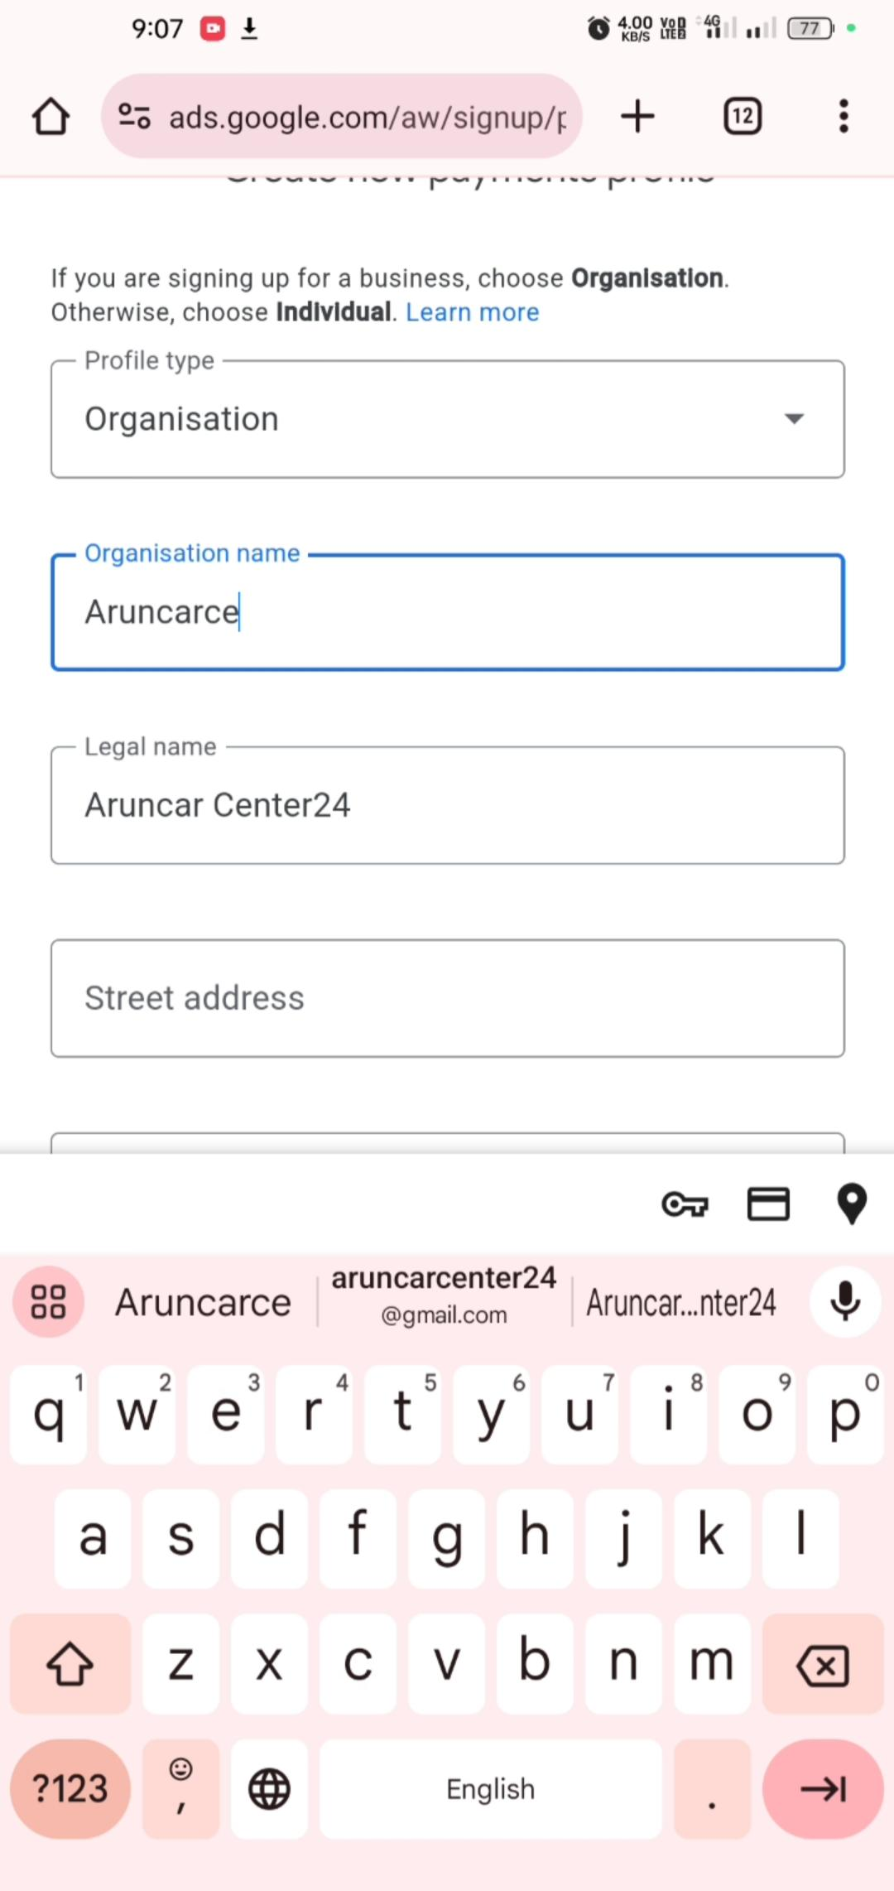**11. Select your profile types,name , address,state**

**12. Search in my business.**

**13. View your business profile in Visible.**

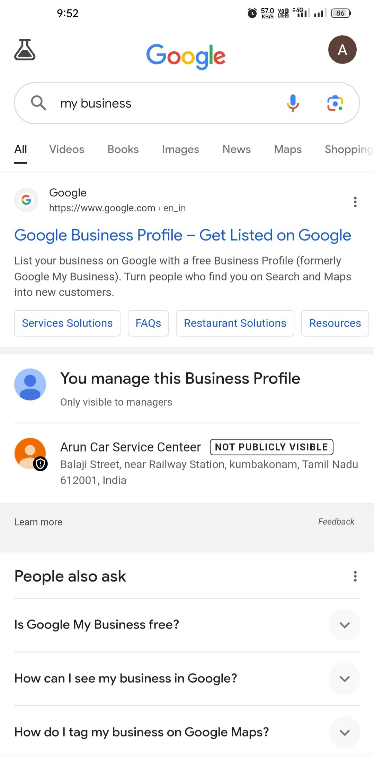

***FINAL REPORT***

**BLOG NAME:** GOOGLE MY BUSINESS PROFILE

**EMAIL:** [aruncarcenter68@gmail.com](mailto:aruncarcenter68@gmail.com)

***WORDPRESS BLOG URL:***

<https://aruncarcenter26.wixsite.com/wwwaruncarcenter68gm>

**THANK YOU....**