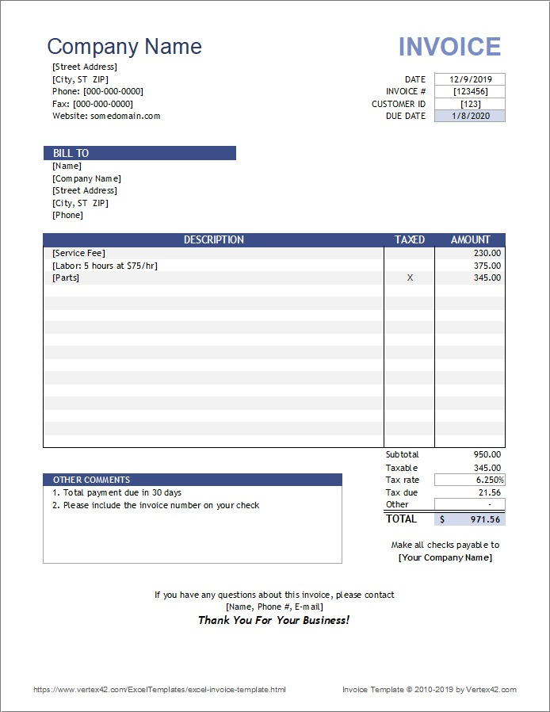
- Company Name: MIM Enterprise
- Address: Karwan Bazar, Dhaka
- Taxable, tax rate, tax due not needed
- Paid
- Discount
- Due
- If due the give Due Date if not due amount remain the no Due Date will be appear

