**Creative Brief**

Neema Samawi   
11/8/2017

**Project Title: Tea Website**

1. **Project Overview**

This website will give a clear, basic introduction to the types of tea and what makes each one different, as well as a brief history of tea and the role it plays in different cultures.

1. **Resources**

The Wikipedia page on tea: <https://en.wikipedia.org/wiki/Tea> as well as many wikipedia pages on specific types of tea, such as this one that describes various types of scented/flavored teas:

<https://en.wikipedia.org/wiki/Tea_blending_and_additives>

Some good photos can be found on these Wikipedia pages, such as this, which might make for an interesting backdrop: 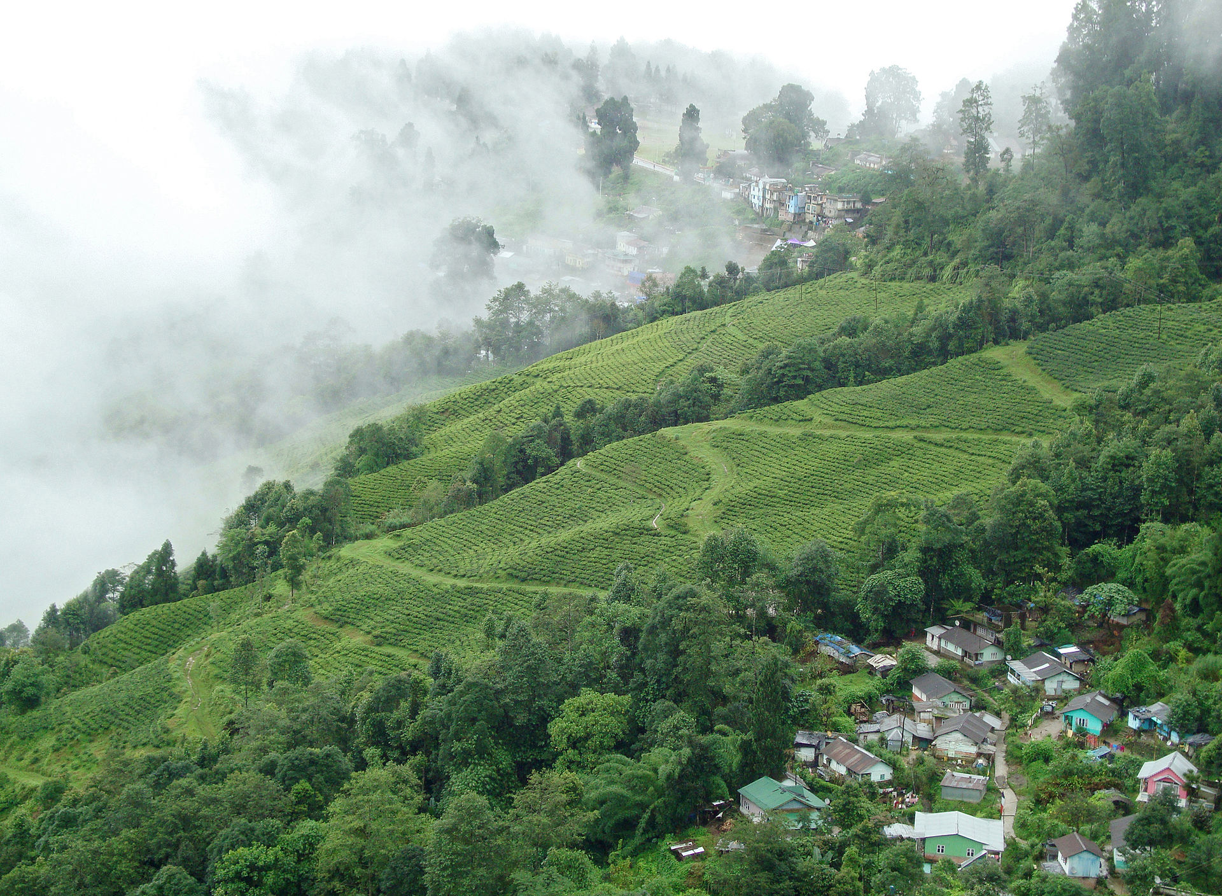

And this one, which has an illustrative quality that could be a visual theme for some of the imagery used on the site (especially on the page that details different types of flavored teas):

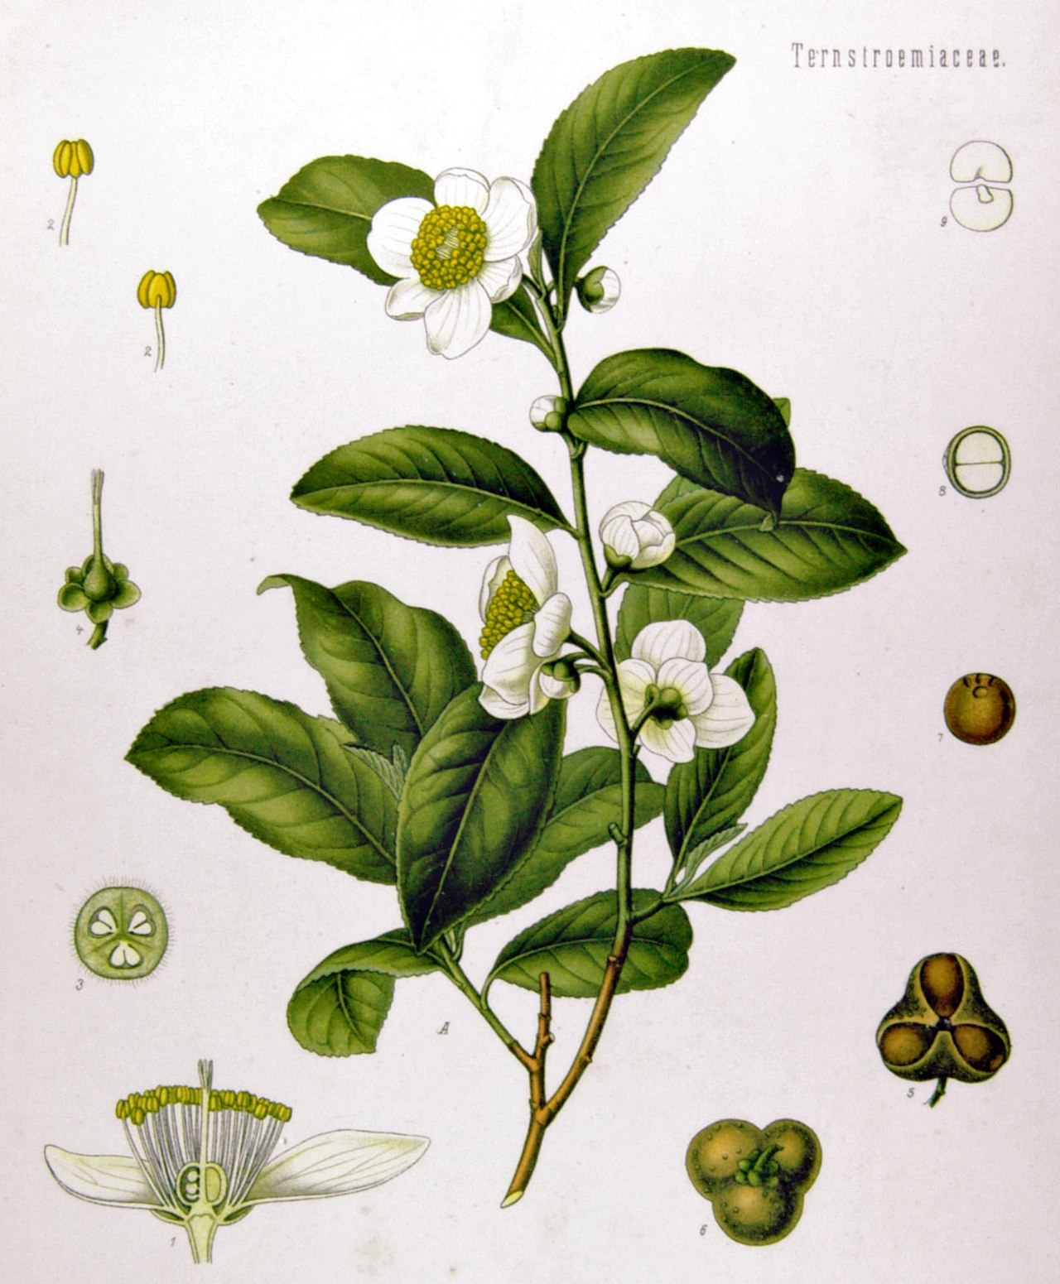

1. **Audience**

This site is intended for people who are just getting into tea drinking and want to learn about and explore different types of teas that they might like. It is meant to be a visual introduction that is clear, simple, and easy to navigate for people of all ages and cultures. It will not be meant to promote any specific brand of tea or line of products, but it will “market” tea in the sense that it will present it in an appealing and aesthetically pleasing way.

1. **Message**

The underlying message of this site will have two components: how tea can and has been enjoyed by people of all cultures throughout history, and how, with all the types of tea out there, you can most likely find a kind that you really like. Tea can connect people to each other when participating in traditions centered around the drink, but it can also play a role in your identity when a certain tea becomes a part of your daily routine. This isn’t a message that needs to be explicitly communicated, but rather an overarching idea to keep in mind when creating the site.

1. **Tone**

The tone should complement the message and highlight the diverse range of teas (without getting too complicated and bogging the viewer down with information) and the power of tea to bring people together.

1. **Visual Style**

Visual style can be soft and atmospheric, like the photo included above, or more illustrative, like the second image. These styles could also be combined if done in such a way that they aren’t competing with each other. I am imagining a color palette like the one in those pictures as well, with lots of whites and greys and earthy tones.

An example of a minimal color scheme and an option for how the front page can be laid out: <http://jennymustard.com/>

I couldn’t find a ton of other website examples for what I had in mind, but that one website is just for aesthetic inspiration – the tea website does NOT need to look just like that one.